Robert Arman Bance ~ Able Seaman to Second Lieutenant
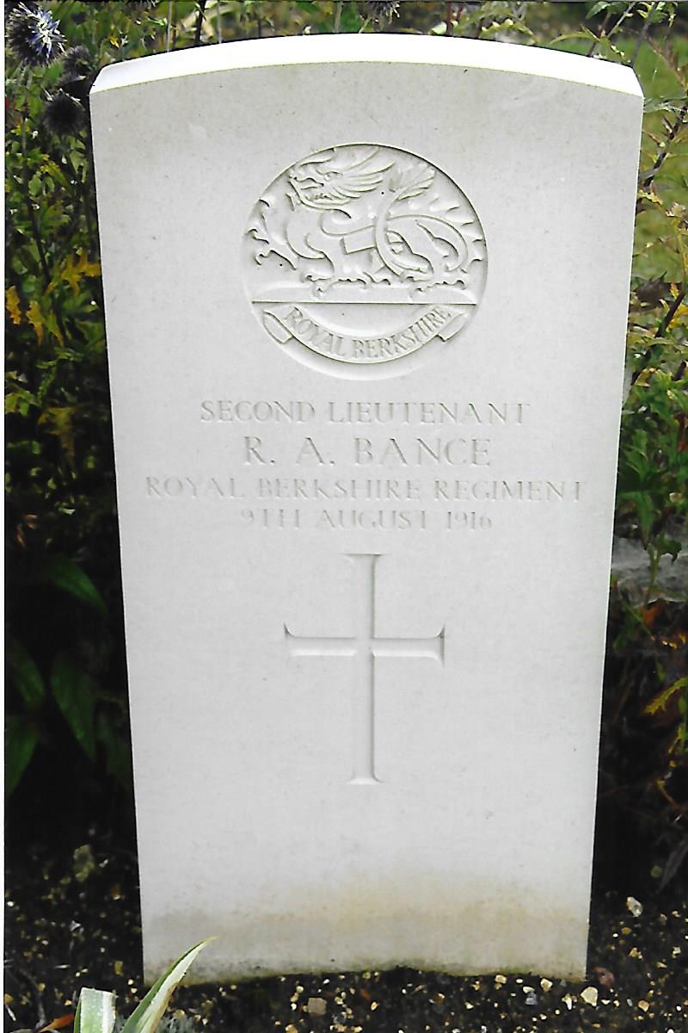
Robert Arman Bance was born on the 21st September, 1892 at East Woodhay, Hampshire the son of Edward and Helen Bance. Robert was one of ten children, three of whom died. The 1901 Census recorded that the family were living at 140 Ball Hill, East Woodhay. Edward, the head of the family was a builder aged 50 years and his wife Helen aged 45 years. Living with them were daughters Eleanor aged 23 years, Eunice aged 10 years, Dorothy aged 4 years and son Robert aged 8 years. Ada Ann Slade who was also living with the family was listed as a general servant aged 14 years. By the time of the 1911 Census, Edward by then aged 60 was a Master Builder, Helen was 56 years of age and they had been married for 34 years. Also recorded were their son’s Edward Harold aged 25 years, an assistant builder to his father as was Robert aged 18 years, daughters Margaret Louise aged 27 years, Dorothy a school girl aged 14 years and Ada Kate Harris aged 15 year a general ‘domestic’.
Robert attended St Bartholomew’s Grammar School, Newbury between 1904 and 1908. There he became a school prefect, was an active participant in the debating society, a ‘sporting’ all-rounder and won a school prize in the last year of his attendance at the school. He was also very interested in amateur dramatics and displayed a talent for acting.
After the outbreak of the First World War, Robert enlisted in to the Royal Naval Volunteer Reserve as an Ordinary Seaman, Service Number Z/967 on the 28th November, 1914. His RNVR service record describes him as being 5ft 11½ins in height, with a chest measurement of 33¾ins with a 2-inch expansion, a fair complexion, dark brown hair, brown eyes, had a linear scar over his right eyebrow and on his forehead, was able to swim, gave his religion as Church of England and occupation as that of a builder. He nominated his father as his next-of-kin.
His service record noted that Robert was on the Nominal Roll of the Public Schools Battalion. He was sent to the Depot at HMS Victory VI to begin his training and in March 1915 was posted to the 3rd Reserve Battalion at Blandford at the beginning of May. On the 10th May, he was rated as an Able Seaman and joined the Hawke Battalion.
The Hawke Battalion was formed in August 1914 as part of the Royal Naval Division which comprised the 1st Royal Naval Brigade, 2nd Royal Naval Brigade and 3rd Royal Marine Brigade. The 1st Royal Naval Brigade comprised the Drake, Hawke, Benbow and Collingwood battalions. With the 2nd Royal Naval Brigade, the Hawk Battalion was sent to Antwerp on the 6th October to support the Belgian Military forces to defend the city and stem the advancing Germans – a task that for several reasons was unsuccessful. Amid confusion and the fog of war, large numbers of the Hawke, Benbow and Collingwood battalions attempting to evade capture by the Germans crossed the Dutch border and were interned there for the duration of the war. The remnants of the Royal Naval Division who managed to avoid capture or internment returned to the United Kingdom between the 10th and 11th October.
A new and rejuvenated Hawke Battalion was reformed at the RND Headquarters at Crystal Palace where all recruits received their initial training. ‘D’ Company of the Hawke Battalion was formed from volunteers from the Public Schools Battalion, including Able Seaman Robert Bance. In February 1916, ‘A’ & ‘B’ Companies moved to Blandford followed by ‘C’ & ‘D’ Companies in March where they underwent further training for active service deployment. On the 8th May the battalion left Blandford and entrained at Shillingstone for Avonmouth docks. ‘A’ & ‘B’ companies embarked on the transport ship Ascania and ‘C’ & ‘D’ companies plus the Collingwood Battalion on the transport ship Ivernia for the voyage to the Aegean Sea. The Ivernia arrived at the island of Lemnos, some fifty miles from Cape Helles on the 17th May, the Ascania two days later and both ships anchored in Mudros Harbour.
The Hawke Battalion left Mudros on the 27th May and landed the following day at Cape Helles to join the 1st Naval Brigade under the command of Brigadier-General Mercer (Later Major General Sir David Mercer Adjutant General Royal Marines). They were quickly deployed digging trenches on the slopes of Achi Baba Nullah and on the 2nd June took over forward trenches. Two days later the battalion were placed in reserve for rest in the early hours of the 4th. Later during the night they relieved the Nelson Battalion after they had sustained heavy casualties in their attack on Achi Baba. On the 7th/8th, the Hawke Battalion were relieved and returned to the rest camp. After a relatively ‘quiet’ period they participated in a night attack on Turkish forward trenches on Achi Baba on the 19th June. The attack was successful, despite heavy casualties but the ground gained could not be consolidated and to prevent further losses the troops were withdrawn. After the attack on the 19th Brigadier Mercer congratulated the battalion on the ‘gallant second attempt on enemy trenches and regret it was impossible to hold on to what had been won’. During the remainder of June and early July the Hawke Battalion were deployed on fatigue and trench duties. The intense fighting at close quarters, heat, lack of good food and water took an inevitable toll on the health of all military personnel deployed on the peninsula. Through July and August all the divisions were depleted through sickness, with many of the sufferers being evacuated from the peninsula. Apart from those who had been wounded, large numbers succumbed to jaundice and enteritis, including Able Seaman Robert Bance of ‘D’ Company, Hawke Battalion.
On the 26th May, 1915 Robert had written to his father: “…. Firstly Dad, I want to thank you very much indeed for all your great kindness you have always shown to me and if by any unlucky chance I don’t get back I want you to know I am very grateful. I have made a short will … and as of course everything I have come from you, it is only right that I should return it but if you have no special use for the insurance and that lying to my credit in the bank I’d like you to see that the girls get some of it as perhaps a little might come in useful to Doll and Eunice for instance. Of course Dad I am looking to come back myself and I think I shall too but you will understand this is only in case the worst should happen …”
Although Robert had passed his medical examination on entry it is apparent from his RNVR service record that he suffered from Catarrh and Jaundice. Reporting sick he was firstly taken to No.11 Casualty Clearing Station and later put aboard the Hospital Ship S.S. Georgian on the 17th August. Ten days later on arrival at Malta, Robert was admitted to the Royal Naval Hospital. His condition did not improve and a decision was made by the medical staff to invalid him to the United Kingdom. His service record noted that his next-of-kin was not informed.
On the 7th October, 1915 he embarked on the Hospital Ship Hunslet for England with a medical diagnosis that the patient had contracted enteritis as well as catarrh, jaundice and general debility. His next-of-kin was not informed of Robert’s circumstances until the 27th October. After hospitalisation and treatment he was discharged and returned to 3rd Reserve Battalion, at Blandford.
His return to Blandford may have caused Robert to consider his future in the RND and perhaps a change to another service might have better prospects for him. Whatever his motivation he applied on the 17th December, 1915 for a Temporary Commission in the Regular Army for the period of the war, and was desirous of serving in the infantry, preferably the Royal Berkshire Regiment. On the application form Robert detailed his service with the RND and gave East Woodhay as his permanent address. For his current correspondence he gave his address as R.A. Bance A/B 446, C/O Church Institute, R.N. Camp Blandford. A character reference was given by a Mr Stephenson-Raine, Engineer and Surveyor of Hungerford and the headmaster of Newbury Grammar School confirmed Robert’s educational achievements. The naval surgeon at Blandford Camp passed him ‘fit’ for service in the Regular Army on the 23rd December and the commanding officer of the 3rd Reserve Battalion, RND certified on the 31st that: ‘I have seen Robert Arman Bance and can recommend him as a suitable candidate for appointment to a temporary commission in the Regular Army for the period of the war’.
A few weeks later on the 11th February, Robert received the following communication from the War Office: ‘Sir, I am directed to inform you that you have been appointed to a temporary Second-Lieutenancy in the New Army on probation. You have been posted to the 9th Reserve Battalion, Royal Berkshire Regiment but prior to joining that Unit you have been selected to attend a class of instruction at Chelmsford and should report yourself without fail to Colonel P.R. Phipps, School of Instruction, Bank Chambers, Chelmsford on the 21st February 1916 between 2 and 4 p.m. Camp kit and bedding need not be taken for use whilst at the School but you are required to be in possession of such when joining your unit at the completion of the course.
‘You should report at the School of Instruction in uniform but if your uniform is not ready report in plain clothes. To enable you to draw your outfit allowance, you should after reporting yourself in person, apply to the Commandant of the School of Instruction at which you have been ordered to attend for a “Joining Certificate” and forward the same, duly completed to your Army Agents. Expenses incurred in travelling to join on first appointment must be paid by yourself. An acknowledgement to the War Office of the receipt of this letter is not required. (Signed) W. Elliot, Colonel, for Military Secretary’.
A letter on the 29th February, from the War Office informed Robert that he had been appointed to a Temporary Second Lieutenancy in the New Army on Probation and posted to the 9th (Reserve) Battalion, Royal Berkshire Regiment who were encamped at Wool. The 9th Battalion had been formed as a ‘Service’ Battalion of the Fourth New Army (K4) at Portsmouth in October 1914, to join the 96th Brigade, 32nd Division. In April 1915 they became the 2nd Reserve Battalion of the 8th Reserve Brigade and moved to Wool in May. On the 1st September, they were designated as the 37th Training Reserve Battalion.
After satisfactorily completing his training with the 9th Battalion he was drafted to the 5th Battalion, Royal Berkshire Regiment, who were serving on the Western Front in France. There is no date in Robert’s service record when he went to France, but it was probably on the 18th July, 1916, when eight officers from the 3rd and 9th Battalions joined the 5th Battalion who were undergoing exercises in attack in a training area at the Bois du Warnimont, France. The 5th Battalion, Royal Berkshire Regiment had been formed at Reading in September, 1914 and arrived in France in May 1915 as part of the 35th Brigade in the 12th (Eastern) Division. During the early months of 1916 the battalion undertook tours in the trenches and training for the Somme Offensive. Transferred to II Corps in June they were deployed at Ovillers on the 3rd July, 1916, where their losses reduced the Battalion’s strength to 340 men. At the beginning of August they endured a determined counter-attack on the 8th. The following is an extract from the 5th Battalion’s War Diary:
August 7th 1916 ~ Left Bouzincourt at 1600 and marched up to relieve the 36th Brigade in the trenches North-West of Pozieres, Battalion occupied 5th, 4th and 3rd Avenue.
August 8th 1916 ~ In the trenches North-West of Pozières. On morning of August 8th the Germans made four counter attacks on our position in 5th Avenue. (1) On our left flank at 3 a.m. they made a bombing attack and got into our trenches but were immediately driven out. (2) At the same place they attempted a second attack at 0730 which was easily repulsed. (3) Subsequently with (1) enemy made a determined attack on the barricade which formed the right flank of our position in 5th Avenue. The enemy employed Flammenwerfer and under cover of the smoke got into the trench. After hand to hand fighting they were driven out and beyond the barricade. (4) At 0530 they repeated the attack and this time succeeded in getting into the trench and compelling our men to withdraw down the trench. A fresh barricade was erected about 50 yards from the old one and the enemy were checked there. While supervising the construction of this barricade the company commander 2 Lt F.A.L. Edwards who had conducted the defence with great gallantry was wounded and succumbed to his wounds two days later, 2 Lt G.M. Hughes who was seen to be wounded during the first attack was found to be missing and 2 Lt H. Crowhurst was wounded by enemy bombs. The operations were preceded by an intense preliminary bombardment in the course of which 2 Lt H.M. Thirston, 2 Lt A. Bidmead and 2 Lt A.J. Shipton were wounded. The net result of the 4 attacks was that the enemy gained about 50 yards of trench with great loss of life. Casualties 6 officers 128 other ranks. Major P.W. North (of 2nd Battalion, Royal Berkshire Regiment) and 2 Lt H.M. Cook (from 9th Battalion) joined the Battalion.
August 9th 1916 ~ In the trenches North-West of Pozières. Owing to attacks of Anzacs and 7th Suffolk Regiment on our right the Battalion was heavily shelled and there were four more officer casualties, all from shell fire in Ration Trench (5th Avenue). 2 Lt R.A. Bance was killed, Lt C. de V. Hinde, 2 Lt A.G.C. Rice and 2 Lt H.C. Togood were wounded. Casualties 4 officers and 39 other ranks.
Second Lieutenant Robert Bance was 23 years of age and it was not until the 21st August that the sad news of his death was delivered by telegram to his father. ‘Deeply regret to inform you report just received states 2/Lt R.A. Bance Royal Berkshire Regt was killed in action August 9th. The Army Council express their sympathy’.
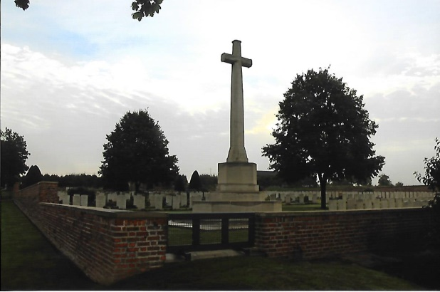
Robert was buried in Bapaume Post Military Cemetery, Albert. Grave Location: Section 1, Row D, Grave No.17. The cemetery lies on the west side of ‘Tara Hill’ and to the south-west of ‘Usna Hill’ as they were known during the First World War. In June 1916 the front line ran across the Bapaume Road between what is now the cemetery and the village of La Boiselle. Over four hundred casualties of the First World War lie in the cemetery, eighteen of which are unidentified and three special memorials commemorate casualties believed to be buried among them.
After his death the process began to assemble documentation and crediting to his estate the balance of his Army pay and allowances for Letters of Administration and Probate. At the beginning of September 1916 his Army Agent, Cox & Co of 16 Charing Cross, London acknowledged receipt of £51 2s 6d to Robert’s account from the Assistant Financial Secretary at the War Office. His gratuity, based on Robert’s period for which he had received full pay from the 17th February to 31st August, 1916 amounted to £46 10s.
Edward Bance wrote to the Army Council on the 8th September, 1916 that he was prepared to pay any outstanding charges against the estate of his son and any personal effects should be forwarded to him as father of the deceased. B. & J.C. Pinniger of Newbury, the solicitors who were administering Robert’s estate wrote the Secretary at the War Office on the 1st November, 1916: ‘Sir, The deceased – 2/Lt. R.A. Bance – died a bachelor on the 9th day of August last in France. On the 26th May, 1915 when he was a private in the Public Schools Naval Brigade Z967 A.B. on board the R.M.S. Ivernia on his way to Gallipoli he wrote to his father stating that he had made a Will in his pay book and appointed his father Executor. This pay book cannot be found although application has been made to Messrs Cox and the Commanding Officer of deceased’s regiment. It is thought possible that this pay book was returned to the War Office on his appointment as Lieutenant in February 1916, if this is so would you please send us the Will in such book. We shall also be glad to receive the necessary recommendation that estate duty on his estate be remitted. (Signed) B. & J.C. Penniger’
In response to this letter the War Office wrote to the Secretary of the Admiralty on the 21st November: ‘Sir, I am commanded by the Army Council to transmit herewith for the information of the Lords Commissioners of the Admiralty, copy of a letter received in this Department regarding a Will stated to have been executed in his Service Pay Book by the late Second Lieutenant R.A. Bance, 5th Battalion, Royal Berkshire Regiment (formerly A.B Seaman “D” Company, Hawke Battalion, Royal Naval Division). If the Lords Commissioners have any information as to the whereabouts of the Will, I am to suggest that the document should be forwarded to Messrs B. & J.C. Pinniger direct. (Signed) B.B. Cubitt ~ for the Secretary of the Admiralty.
From Robert’s service record it appears that his Will could not be traced and he died intestate. However this did not curtail the preparation for the Letters of Administration. Careful checks must have been carried out by the Paymaster to ensure there were no debts owed by Robert and a small residue of allowances were credited to his estate. His personal effects were retrieved and sent to Cox & Co for forwarding to his next-of-kin.
On the 7th December, 1916 the Records Officers of the RNVR wrote to Mr Edward Bance enquiring on behalf of the Senior Accounts Officer as to where 2nd Lieutenant R.A. Bance was serving. As the next-of-kin, Mr Bance replied on the 11th that: “My son 2nd Lieutenant R.A. Bance was in the 9th attached 5th Battalion, Royal Berkshire Regiment. He fell in France on the 9th August, 1916”.
The solicitor wrote to the Secretary at the War Office on the 5th February, 1917: ‘We forwarded to Probate Court the usual papers to obtain grant of administration to this deceased’s estate and they ask for the usual War Office certificate of death to be produced, kindly let us have the same. Deceased was killed in France on 9th August and was in 9th Reserve Battalion, Royal Berkshire Regiment. (Signed) B. & J.C. Penniger. A few days later on the 12th the War Office responded:
Certified that it appears from the records of this Office that Temporary Second Lieutenant Robert Arman Bance 5th (Service) Battalion, Royal Berkshire Regiment was killed in action in France on the 9th day of August 1915 and was buried in Bapaume Post Military Cemetery near Albert. (Signed) Percy Taylor ~ for the Secretary War Office. Copies of the certificate were duly forwarded to the solicitors.
On the 24th February, 1917 the Letters of Administration were granted at Winchester Probate Court to the estate of Robert Arman Bance of Ball Hill, East Woodhay, Hampshire who died on the 9th August 1915 in France on active service, intestate and a bachelor to his lawful father and next-of-kin Edward Arman Bance. The gross value of his estate was £2,308 15s 3d. A copy of the Letters of Administration requested by the War Office was sent to London by the solicitors on the 26th February, 1917.
The Assistant Financial Secretary at the War Office Imperial Institute in South Kensington, London wrote on the 29th January, 1919 to Edward Bance: ‘Sir, with reference to the late 2/Lt. R.A. Bance, 9/att 5/Royal Berkshire Regiment and with a view to the issue of the Plaque and Scroll which are to be sent to the next-of-kin of those who have fallen, I am to enquire whether you are still living at the address given. Owing to the great number of cases to be dealt with it is impossible to say how soon the distribution will be effected in any individual case. (Signed) A.J. Major ~ for the Assistant Secretary. Mr Edward Bance replied on the 3rd February confirming his address and was looking forward to receiving his son’s Plaque and Scroll. He would also have received Robert’s 1914-15 Star, British War Medal 1914-1920 and Allied Victory Medal 1914-1919.
Robert Arman Bance, one of forty-four former pupils who lost their lives during the First World War is commemorated on the St Bartholomew’s School War Memorial in Newbury. His name is also inscribed on the War Memorial at East Woodhay and at St Martin’s Church.
+++

[Sources: Commonwealth War Graves Commission Web-Site ~ www.cwgc.org
2nd Lieutenant R.A. Bance Service File (RNVR) ~ National Archives Ref: ADM/339/1; Medal Entitlement Ref: WO/372/1
2nd Lieutenant R.A. Bance Service File (Army) ~ National Archives Ref: WO 339/51792
East Woodhay Parish Council Web-Site ~ www.eastwoodhay.org.uk
St Martin’s Church East Woodhay Web-Site ~ www.stmartinschurch.hampshire..org.uk
St Bartholomew’s School Web-Site ~ www.stbbarts.con.uk
St John’s Church Earlestown Web-Site ~ www.nlwmemorial.tripod.com
Wikipedia Web-Site ~ www.wikipedia.co.uk
Long Trail Web-Site ~ www.1914-1918.net
War Diary 5th Battalion Royal Berkshire Regiment August 1915 – April 1919
War Diary 8th Battalion Royal Berkshire Regiment May 1915 – May 1919
British Battalions on The Western Front January-June 1915 by Ray Westlake. Published by Leo Cooper in 2001; ISBN 0 850527 68 6.
British Battalions on The Somme by Ray Westlake. First published in 1994; reprinted in 1995 and 1998 by Leo Cooper; ISBN 0 850523 74 5.
Personal Notes/References/Photographs]
R.G. Coleman

