CEF Driver Lost Control & His Life In Car Accident
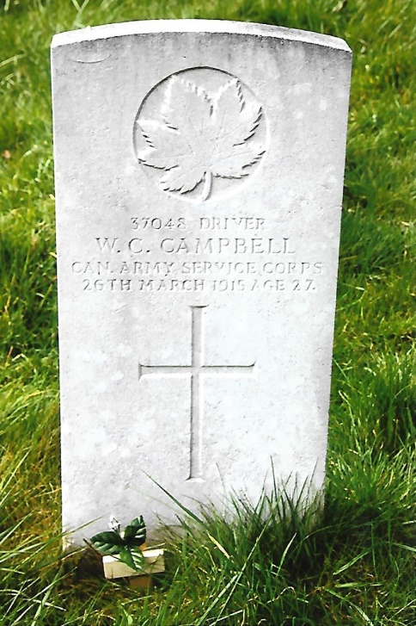
William Campbell was born on the 23rd June 1889 at Midland Ontario, the son of Mr and Mrs Robert Campbell. There is little information about his early formative years, but after the outbreak of the First World War William enlisted at Valcartier into the Canadian Overseas Expeditionary Force on the 23rd September, 1914. Valcartier, Quebec was established in August, 1914 as a military training camp to recruit and train 25,000 men for overseas service with the First Canadian Contingent.
William Campbell was described on his attestation form as being 5ft 7ins in height, had a chest measurement of 37½-inches with a 2-inch expansion, a fair complexion, green eyes, dark brown hair, and distinctive scarring on his left wrist, forehead and left shoulder. William, a single man gave his occupation as that of a ‘gentleman’, religion Presbyterian, no previous military service and had been vaccinated. At his medical examination on the 8th September, he was declared fit for overseas service. He acknowledged that he understood the terms of engagement and signed the attestation form.
William was assigned to the Canadian Army Service Corps and posted to the Divisional Ammunition Park. The latter had been formed at Valcartier during September and the unit left Canada embarking on the RMS Franconia on the 30th September, 1914. On arrival in the United Kingdom on the 14th October, they were sent to Bulford. By March 1915 William was stationed at the Canadian Base Veterinary Supply, at Netheravon for motor transport duties. On the 26th March he was driving two officers in a Ford motor car from Salisbury towards Winterbourne. Whilst negotiating an S-bend over a railway bridge, at a place known locally as Broken Cross, the car overturned and William Campbell was fatally injured dying at the scene of the accident shortly afterwards. He was 26 years of age.
The circumstances which culminated in the accident were established at the inquest held at the Council Chamber, Market Place, Salisbury by the City Coroner, Mr S. Buchanan Smith on the 27th. The first witness to give evidence was Lieutenant James Warren, who was one of the passengers in the car. He told the Coroner under oath that: “I am a Lieutenant in the Divisional Park Canadian Expeditionary Force, stationed at Netheravon. On Friday the 26th March, 1915, I left Salisbury with Lieutenant Frape about 3 p.m. in a Ford car driven by Corporal William Campbell belonging to the Divisional Ammunition Park. I have known Campbell since he came with us from Canada and he was a very careful driver and a good mechanic. All went well until we came to the railway bridge on the Winterbourne Road and we got round the first curve on the bridge alright, but in taking the curve to the right after crossing the bridge the car skidded and turned turtle, the car was over me, and Lieutenant Frape jumped clear. Campbell was lying on the road underneath the car and the door was on his head. Other assistance arrived and the car was lifted off Campbell. Campbell was 25 years of age when he joined the Canadian Contingent and I produce a copy of his Military record. His home address was Midland, Ontario. We were travelling at an ordinary pace and passed several passengers on and near the bridge. Deceased was well acquainted with the road.”
Lieutenant Arthur Frape the commanding officer of the Canadian Base Veterinary Supply stationed at Netheravon, was the other passenger in the car. William was not well known to him personally although the Lieutenant he knew him to be a conscientious driver. He stated under oath: “I am the officer commanding the Canadian Base Veterinary Supply stationed at Netheravon. On Friday the 26th March, 1915 I left Salisbury with Lieutenant Warren in a car driven by Campbell who I have known as a careful driver. On reaching the bridge over the railway on the Winterbourne Road where there are two very sharp curves, we went round the first curve on to the bridge all right and in taking the curve to the right the car jolted and turned over, as the car was turning over I jumped clear and on recovering myself I saw the car was upside down on Lieutenant Warren and the driver. I first went round the car to see what had occurred and saw the drivers head pinned to the road by the door of the car and a large flow of blood running from the head. I then turned my attention to Lieutenant Warren who was pinned underneath the rear side of the car, I lifted the car up and he was able to crawl out. Other assistance then arrived and the car was lifted off and the driver Campbell was found to be dead. We were travelling round the second bend slower than round the first. I cannot say what happened to cause the car to overturn. I don’t think the deceased was taking the corner too fast.”
Mr Frederick Reedhead, a motor engineer of Winchester Street, Salisbury was driving towards Salisbury from Winterbourne at approximately 3.15 p.m. Approaching the bridge over the railway he saw a motor car upside down on the Winterbourne side of the bridge. Realising an accident had occurred he stopped, got out of his car to see if he could help in any way. Lieutenant Warren remarked to him that the driver was dead and that the car had overturned. Mr Reedhead saw the inert body of the deceased lying by the roadside and another person helping at the scene. On oath Mr Reedhead said: “I am a Motor Engineer carrying on business at and reside at 26-30 Winchester Street in this city. On Friday the 26th instant about 3.15 p.m., I was motoring towards Salisbury from Winterbourne and when I got to Broken Cross, near the Bridge over the railway, I saw a car upside down in the roadway on the Winterbourne side of the Bridge. I saw that Lieutenant Warren and Frape, whom I knew, had met with an accident. I got out the car and went to Lieutenant Warren, who said that the driver ‘Campbell’ had tipped the car over. I saw Campbell lying in the road dead. I lent all the assistance I could and Dr Gordon who was present, advised the removal of the body to the Mortuary which I did. I examined the overturned car and found that the front axle had bent and had given away, evidently caused through skidding. This would cause the driver to have no control over the steerage of the car and he would be unable to right it himself.”
The other person present at the scene of the accident was Dr William Gordon of Salisbury who was driving his car towards Winterbourne. He was passed by a car driven by the deceased at about 3.30 p.m. When he got to the bridge he stopped and hurried towards the overturned car where the two officers and a shepherd were trying to lift the car off the driver, who was pinned beneath it. The deceased was unconscious and bleeding profusely from his head injuries. They managed to remove William and placed him into field alongside the road where he died. Dr Gordon examined the deceased who had died from lacerations of the brain, a large scalp wound and extensive skull fractures.
Dr Gordon told the Coroner on oath that: “I am a Medical Practitioner practising in Salisbury. I was on my way to Winterbourne yesterday and about 3.30 p.m., a car containing three soldiers overtook and passed me near the first milestone on the London Road. They proceeded in front of me to Winterbourne. As I came over the Bridge at Broken Cross, the first thing I saw was the car lying right across the road upside down. As I stopped my car and ran towards it, I saw the two officers and another man raising the car off the driver who was lying beneath it. He was unconscious and bleeding profusely from the mouth, nose and ears, and died a few minutes after removal. I found large scalp wounds and extensive fracture of the skull and he died of laceration of the brain caused by this fracture. Someone suggested the removal of the body to Salisbury, I did not.”
The Coroner questioned Dr Gordon as to who and why the body of the deceased had been brought to Salisbury. The doctor was non-committal. It became apparent that as Mr Reedhead was going to Salisbury it seemed logical for him to take the body there as the two officers wanted another car to get them back to their camp. The Coroner asked the witness how fast he was traveling in his car and the doctor replied about 15 mph. In reply to a further question about the speed of the overtaking car, Dr Gordon stated that they were on a straight clear section of the road to Winterbourne at a pace which was not over 30 mph.
After considering the evidence the Coroner said that the cause of death was due to an accident and the jury returned a verdict of “Accidental Death.”
William Campbell was buried with full military honours on Monday the 29th March, in London Road Cemetery, Salisbury. Grave Location: Section K, Grave 86. The service was conducted by the Reverend J.W.V. Reynolds of St Martins Church, Salisbury. At the conclusion the Last Post was sounded and three volleys fired over the grave. The Deputy Mayor, Chief Constable and officers and men from the CEF attended the funeral and laid floral tributes on the grave.
William had nominated his mother as next-of-kin and she was informed that her son had been involved in a car accident and died from his injuries. Subsequently she received from the officer-in-charge of the CEF base records in London, William’s effects which comprised: a tobacco pouch, two pipes, cigarette case, whistle and lanyard, watch, three pocket wallets, pliers, two chevron bars, note book, pay book, £2 7s 3½d in cash, letters and fountain pen. After settlement of his Army pay account Mrs Campbell received the sum of £11 10s 3d in May 1915.
Before his death William had placed an order with V.W. Sims & Co., Watchmakers and Manufacturing Jewellers of 57 East Street, Southampton for them to make a cigarette case for a presentation. The cost of the box was 55/- and V.W. Sims made a claim on William’s estate for payment. A letter was sent to the Pay and Records Office of the Canadian Contingent at 7 Millbank, London. The company’s claim was successful as an amicable agreement was reached though no details appear about it in William’s service file.
William was eligible for the British War Medal but it is not clear from his service papers as to whether his mother claimed or received it. An entry is marked “Returned” May 1921. She did receive the Bronze Memorial Plaque, Memorial Scroll and subsequently the Canadian Silver Memorial Cross in November 1922.
Witnesses at the inquest referred to Corporal William Campbell, but there is no indication in his record that he held that rank. The fact that two chevrons were amongst his effects may indicate that he was locally promoted for undisclosed reasons. The Commonwealth War Graves Commission, record his full name as William Constantine Campbell. His middle name does not appear on his attestation form.
37048 Driver William Constantine Campbell CASC, 1st Divisional Ammunition Park is commemorated on Page 8 of the First World Book of Remembrance held in the Memorial Chamber of the Peace Tower on Parliament Hill, Ottawa.
[Sources: The Salisbury & Winchester Journal & General Advertiser – Saturday, 3rd April 1915.
Veterans Affairs of Canada Web-Site ~ www.veterans.gc.ca
Library & Archives of Canada Web-Site ~ www.bac-lac.gc.ca – Service Record 37048 Driver William Campbell Ref: RG 150 Accession 1992-93/166 Box 1458-18 Item No.85831 PDF File B1458-5018]
R.G. Coleman

