Dark Evenings ~ Dangerous Roads
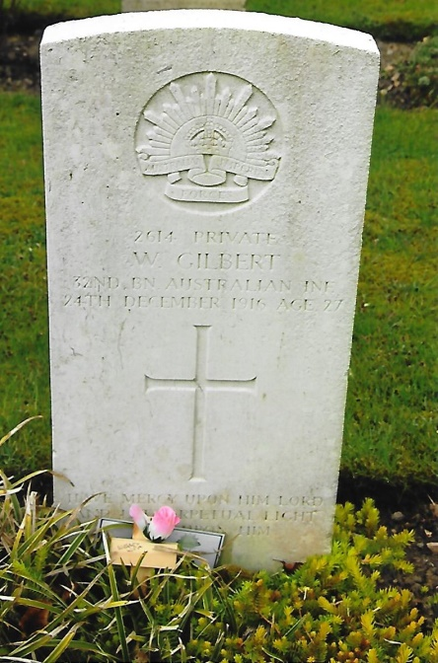
William Gilbert was born c.1888 at Launceston, Tasmania the son of John and Florence Gilbert. William later moved to Adelaide, South Australia, where he met and married his wife Hannah. They resided at 5 Tavistock Street and had no children. After the outbreak of the First World War, William enlisted at Adelaide for service abroad with the AIF on the 3rd January, 1916. He was described as being 5ft 6ins in height, weighed 122lbs, and had a chest measurement of 33½inches with a 1-inch expansion, dark hair, of medium complexion and good vision. There were three distinctive marks on his back, gave his religion as Church of England, nominated his mother as next-of-kin and occupation as that of a labourer with the South Australian Railway at the Islington Workshops. After being medically examined he was declared ‘fit’ for overseas service. Having agreed to the terms of his military engagement he took the Oath to serve the King in the AIF until the end of the war and for a period of four months unless sooner discharged and signed his attestation paper.
On the 6th January he was posted to ‘B’ Company, 2nd Depot Company and then to the 1st Company ten days later. William agreed to allocate no less than two-fifths of his Army pay to Hannah from the day of his posting. He undertook a short period of basic training before embarking for Egypt in H.M.A.T. Shropshire on the 25th March, 1916, as part of the 5th Reinforcement Draft for the 32nd Battalion. It is not clear from his service record when he arrived in Egypt but on the 10th June he was admitted to the 3rd Australian Hospital at Abbassia with a mild cardiac condition. His wife was informed that he had been admitted to hospital and that unless further advised she should assume her husband was making satisfactory progress. Two weeks later William was transferred to the convalescent depot at Montazah and from there was discharged for duty on the 17th July. For a lapse in discipline he received 24 hours Field Punishment No.2 and forfeiture of two day’s pay for drunkenness, being absent without leave from 0900 hours 16-7-1916 to 0900 hours 17-7-1916 and not in possession of his pass the day before he left the convalescent unit. He re-joined his unit at Tel-el-Kebir.
Unfortunately there is no indication in his service record when he left Egypt for England. However, he was taken on the strength of the 8th Training Battalion, on the 22nd August, 1916 and sent to Codford. Whilst there he was absent without leave from midnight on the 29th October to 0630 hours on the 31st and was deprived of 7 day’s pay. On leaving Codford, William was stationed for a few weeks at Fovant camp and was then transferred to Hurdcott Camp. The latter was established in 1915 for training of soldiers from numerous British units. In August 1916 the AIF took over the camp and expanded its facilities including a hospital for treating Australian casualties wounded on the Western Front. No.3 Australian Command Depot Headquarters were established at Farm House.
On Saturday, 23rd December Private William Gilbert and Private Joseph Mayfield were walking from a public house at Barford to Hurdcott Camp. At 2200 hours they heard a car approaching in the opposite direction and Private Mayfield took hold of William’s arm to guide him to the near side of a narrow part of the road. William appeared to push away Mayfield or he may have slipped and was struck by the car and knocked down. The driver of the car, Mr Tom Whatley of Shaftsbury, stopped the car and he and his two passengers got out to render assistance. It was apparent to those present that William was very seriously injured. A passing car was stopped and he was taken by this car to Fovant Military Hospital where he died the following morning.
An inquest was held at the hospital by the Coroner for South Wiltshire, Mr F.H. Trethowan. He had written to the commanding officer of the 8th Training Battalion informing him that he would be holding the inquest on Tuesday 28th December at 1130 hours and that it would be concluded within the hour! He requested that a representative from the battalion should be present who could give personal details about the deceased, Private William Gilbert. Captain Eustace Murphy, 32nd Battalion, AIF attended the inquest on behalf of the Commanding Officer.
In answer to the Coroner’s questions Sergeant Clyde Watson one of the passengers in the car who was sitting behind the driver, stated although it was dark as the car approached the two soldiers, Gilbert was in the middle of the road and he thought he appeared to be drunk as he seemed to be struggling with the other man. The car was travelling at about eight miles an hour when the mud-guard of the car struck Gilbert causing him to fall and the front wheel ran over him. Such was the car’s speed that it pulled up within its own length. The other passenger in the car corroborated Watson’s evidence and confirmed that the driver was not driving carelessly. Mr Whatley, the driver said that Gilbert suddenly lurched across the road and he could not avoid hitting him. Captain Huntley of the R.A.M.C., stationed at Fovant Hospital was on duty when William was admitted. He was in a state of collapse and his death was due to internal injuries and shock. William was aged 28 years. After considering the evidence the inquest jury returned a verdict of “Accidental Death.”
After attending the inquest Captain Eustace Murphy submitted the following report to the commanding officer of the 8th Training Battalion concerning the death of 2614 Private William Gilbert:
‘The evidence at the inquiry of the above deceased stated he was walking back to camp, Hurdcott, about 9.20 p.m. with one of his mates. It was not proved if deceased was drunk or sober but he had had some drinks. A charabanc came along the road travelling about 8 miles an hour. As it came within about 6 or 8 yards of deceased his mate gave him a tug on his left arm to bring him closer to the left of the road, upon which side they were walking. The deceased however staggered from the left towards the centre of the road in front of the charabanc and was knocked down by it. He was promptly removed to the Fovant Hospital and died the next morning without making any statement regarding the accident. Two Australian soldiers were passengers in the charabanc and stated the deceased appeared to stagger in front of it. This was also stated by the driver.
‘The Coroner in summing up stated no blame appeared to be attributable to the charabanc driver and the jury gave a decision to this effect, the Coroner taking all documents to Salisbury. In my opinion the jury could not have arrived at any other decision but how the deceased came to stagger suddenly right into the charabanc seems unaccountable. These particulars will I trust be sufficient for your purpose and were all that I could ascertain at the hearing of the Inquiry which I attended’.
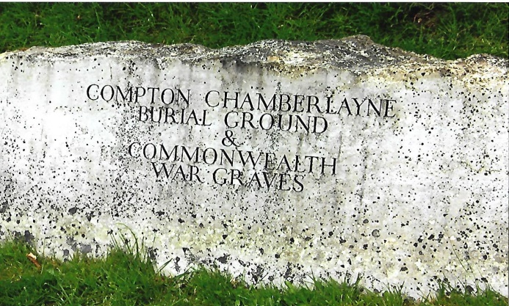
(Signed) Eustace Murphy 32nd
Private William Gilbert was buried on the 26th December, 1916 in Compton Chamberlayne Burial Ground, Wiltshire on the 26th December, with full military honours. Grave Location: Row A, Grave No.226 F. Mrs Gilbert was informed of the circumstances surrounding her husband’s death and given the details of his burial. From the 1st March, 1917 she was granted a pension of £2 per fortnight. After William’s death she moved to Rosewater, where she received William’s effects sent via the AIF Kit Store in London, in July 1917. His effects comprised a photo, wallet, pocket book, needle case, letter, identity disc, a damage ring and cash amounting to 7½d (5 coins). Four years later she received written communication about the erection of a permanent headstone over William’s grave. She wrote to the Base Records Officer at Victoria Barracks, Melbourne concerned about the cost. In reply the Base Records Officer informed her that the government would pay for the headstone. If she wanted a personal inscription the cost to her would be 3d per letter.
Mrs Gilbert had moved in 1921 and was living in Alfred Street, Birkenhead, Port Adelaide, to where William’s British War Medal 1914-20 (his only entitlement) was forwarded to her in December 1921. She also received the ‘Where Australians Rest’ Pamphlet, Bronze Memorial Plaque and Scroll in June 1922.
Private William Gilbert’s name is inscribed on Panel 120 in the Commemorative Area of the Australian War Memorial and on a memorial to railwaymen at Adelaide Railway Station.
+++
[Sources: The Salisbury Times & South Wilts Gazette – Friday, 29th December 1916.
National Archives of Australia – Service Record of 2614 Private William Gilbert: Series No.B2455, Barcode 5033860
Discovering ANZACS Web-Site ~ www.discoveringanzacs.naa.gov.au]
R.G. Coleman

