A Tragic End To A Short Army Career
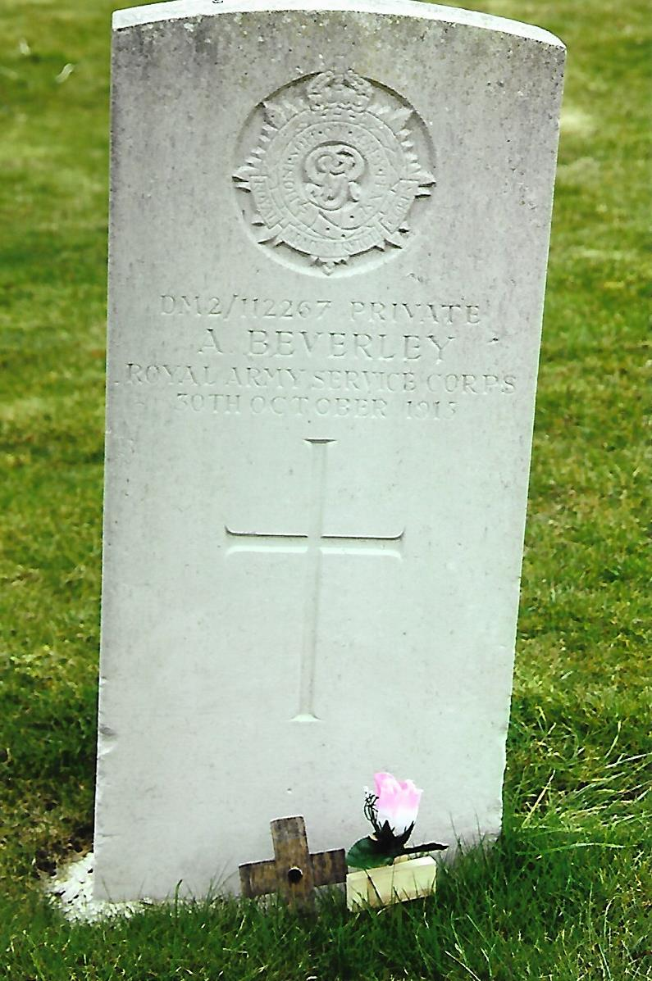
Albert Beverley was born c.1874 the son of Samuel and Emma Beverley at Leeds, Yorkshire. His father was a butcher and the 1881 Census recorded that he was aged 53 years, his wife Emma aged 50 years and their three children Clara aged 15 years and Martha aged 10 years and Albert aged 7 years. The family at that time were living at 5 Brown Square, Leeds. Their two daughters had left the family by 1891 and Albert was living with parents at 2 Chapman Square.
In 1897 Albert married his fiancée Rose (neé Shaw) and he was employed as a Horse and Trap Driver. The 1901 Census listed them living at 17 Yard End Place with their daughter Winifred aged 2 years and son Sidney aged 1 year. By 1911 the family had increased in size and were living at 24 Nowell Walk, Harehills Lane. Albert was 37 years of age, Rose a year younger, daughters Winifred aged 12 years, Emma aged 5 years and Marjorie aged 11 months their sons Sydney, Stephen and Charles were aged 11, 9 and 7 years respectively. Albert had forsaken horse transport and was employed as a Corporation Car Driver.
When Great Britain declared War on Germany in August 1914, Albert was not among those who flocked to join the fighting services to serve King and Country. Perhaps he considered at first that he was too old for active service, but in August 1915 he enlisted at Leeds aged 42 years into the Army Service Corps. He was posted to Wilton, near Salisbury as a private, regimental number DM2/112267 – the DM2 prefix indicates a Mechanical Transport Learner – with the 348th Company, Mechanical Transport. Sadly his army career ended prematurely a few weeks later as Albert committed suicide on the 30th October, 1915. His body was found beside the railway line at Bremerton near Salisbury. The events as far as could be ascertained were disclosed at Albert’s inquest held at Railway Farm, Bremerton by the Coroner for South Wiltshire Mr F.H. Trethowan on Tuesday, 2nd November, 1915.
Mrs Rose Beverley informed the Coroner that her husband aged 42 years was a private in the 348th Company, Mechanical Transport, Army Service Corps, stationed at Wilton. He had been in the Army for approximately twelve weeks and she last saw him a week previous when he was on leave. They were living at 90 Lower Oxford Street, Castleford and he had appeared to be quite normal, saw several of his friends and loved being at home with his children. Before entering the Army he had driven cars in Leeds for fourteen years. As far as she knew he had no health problems, never saw a doctor and consequently had no reason to think there was anything wrong with his mind either.
Private Norman Buckley of the 348th Company stated at the inquest that he last saw the deceased at about 2030 hours on Saturday evening near Wilton Town Hall. Albert, he continued was a quiet man and had been in the Coffee Tavern writing letters. Being of sober habits he only ever drank one glass a beer a day. Private Buckley thought that on the evening in question Albert appeared to be quieter than usual. He was not aware the deceased was troubled in any way but he knew that Albert was not pleased about being unable to drive one of the transports and thought he had been treated unfairly. The witness was questioned by the Coroner about Albert’s treatment. Private Buckley said that there had been no improper conduct other than the occasional sharp words from his superiors. Albert had remarked to him on one occasion that “it was enough to drive a fellow to anything.” Further questioned by the Coroner, Private Buckley was adamant that he did not consider things had been serious enough for Albert to take his own life.
The next witness to give evidence was Mr William Vincent, a platelayer with the London and South Western Railway, who found the body at 0715 hours on Sunday morning a quarter of a mile along on the Wilton side of Skew Bridge and near to the level crossing which led up to Railway Farm. He described the horrific injuries to the deceased. It was apparent that he had been lying across the railway line and as the train passed the deceased’s head was severed from his body. There was nothing to suggest that Albert had been knocked down or dragged along the line.
Mrs Bessie Musselwhite of 13 St John’s Square, Wilton told the inquiry that Private Beverley had been billeted with her for several weeks. When she last saw him on Saturday morning he was downhearted and had a heavy cold. Albert told her that he had got on to the wrong side of Mr Parnall, one of the Warrant Officers who should not be allowed to talk to men as he did in time of war. Mrs Musselwhite told Albert to take no notice but he was very emotional about it and crying. Being a quiet man he took things to heart when spoken to in phrases which he was not accustomed to. He was upset over being told “never to let them see his face again.” The Coroner asked her if she thought he would take his own life. “No,” she replied. “He got over it and when he left he was going to the barbers and then report for roll call.
Dr Kempe told the Coroner he had seen the body on Sunday morning after it had been taken to Railway Farm. He described graphically the injuries which were the cause of the deceased’s death.
Police Constable Titt related that on inspecting the deceased he had found two pieces of paper on the body giving his Wilton and Yorkshire address and a cutting from a Yorkshire newspaper. No witness’s had come forward who saw the deceased at or near the railway line.
Mr H. Meardon, a representative from the L & SWR told the coroner that all the railway engines that had passed along the line had been examined and there was nothing to indicate which engine had run over Private Beverley.
Lieutenant Jack from the Mechanical Transport unit said that there had been some friction between the men and an NCO, but the latter were obliged to speak at times very plainly to soldiers. Warrant Officer Parnall asked the Coroner that as his name had been mentioned he would like to address the inquiry. He made it clear that he had only seen Private Beverley on one occasion for about thirty minutes when taking him through a test procedure. Private Beverley failed the test and he had not seen him since. He denied any harsh treatment towards the deceased.
The Coroner in summing up the evidence for the jury said that Private Beverley appeared to have been an emotional man and “it was extraordinary that a man should come home and weep at what had taken place at the camp.” What had or had not been said was not for the jury to consider. If however his treatment had been unconscionably harsh then more would have been forthcoming from the witnesses. It was quite probable that Warrant Officers did not recognise that a man who had joined the Army at 42, harsh words were difficult to take. He continued, “If you gentlemen of the jury were in the Army you would find that having been your own masters harsh words would not come kindly to you.” After consideration the jury returned a verdict of “Suicide during temporary insanity.”
The day after the inquest Private Albert Beverley was buried in Wilton Cemetery with full military honours. Grave Location: A.244. A firing party from his unit and the band of the Durham Light Infantry from Hurdcott Camp were present. Among the mourners were Mrs Beverley, Officers and Men from Albert’s unit. The graveside service was conducted by the Reverend G.R. Campbell at the end of which the “Last Post” was sounded, followed by three volleys. At the conclusion the mourners laid their floral tributes on Albert’s grave.
At a band concert held during the evening in the Market Place, the Mayor initiated a collection which raised £4 18s 11d for Albert’s widow. Together with a donation of £1 3s 3d from the employees of the Felt Mill she received a total of £6 2s 2d. Subsequently she also received £4 2s 5d from the residue of her husband’s Army pay and 16s 6d was allocated to his eldest daughter, Winifred.
+++
[Sources: The Salisbury Times & South Wilts Gazette – Friday, 5th November 1915.
Ancestry Web-Site ~ Census’s for 1881, 1891, 1901 & 1911. – www.ancestry.co.uk
Howard Williamson’s Great War Collectors Companion – Volume II]
R.G. Coleman

