WESSEX BRANCH WFA ~ GALLIPOLI TOUR 20th-28th MAY 2016
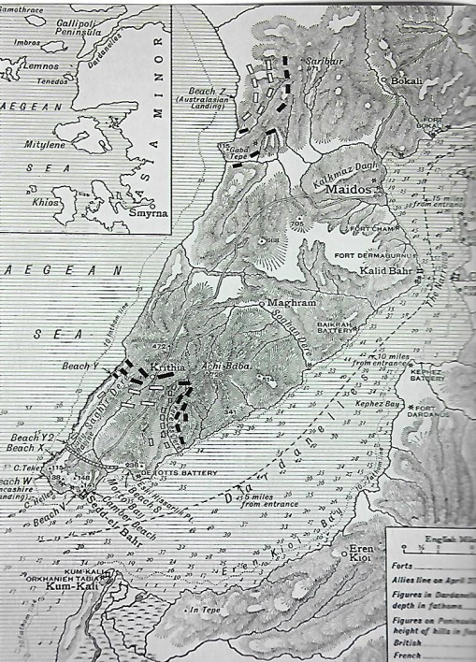
Leaving Wareham on an overcast Friday afternoon, in a 14-seater Homeward Bound Travel Company coach, with Martin, Judy, Steve and Myself, we were driven by Neil to New Milton where Nick joined us and then onto to Romsey for Marc who completed our tour party. Stopping for a break at Chieveley Services we arrived at the Novotel Hotel Heathrow at 1830 hours. After checking in, we enjoyed a drink and evening meal before retiring to bed for an early night.
Gathering in the foyer at 0400 hours the following morning we were taken by a Hoppa Bus to Heathrow airport and by 0530 hours we had passed through baggage handling, security and passport control. We all sat down to an early breakfast at the Giraffe Restaurant before we were taken from the departure gate lounge by an airport bus to our aircraft, a BEA Air Bus 320 for the flight to Istanbul. Taking off at 0730 hours UK time we advanced our watches by two hours and landed at Ataturk airport at 1255 hours. The entry procedure into Turkey was efficient and we quickly collected our baggage. In the entrance hall we were greeted by our friends Ohannes (John) and Terri Karabeytan who act as our agents in Turkey. John introduced us to our driver Moussa who loaded the 14-seater coach with our bags and we left the airport at 1400 hours for Sedd-ul-Bahr. Driving out of the city is quite an adventure as the roads are congested with traffic although for a Saturday afternoon we made good progress through the outskirts of the city. Building construction and road infrastructure improvements continues in this region of Turkey. The weather was somewhat inclement but was ideal for travelling and a welcome break was taken at Tekirdağ for chai and cake. As we journey onwards Martin outlined the Dardanelles and Gallipoli campaign. Large sections of the E90 road down the peninsula to Ecebat is also being upgraded and improved. Passing along Martin drew our attention to the Gulf of Saros, the Line of Bulair and other features of notable interest. Whilst doing so he reminded us as to why Great Britain took the decision to launch a campaign against Turkey. The outcome of which in the Dardanelles and Gallipoli did not accord with political aspirations or military planning.
Improvements to the roads in recent years have made the 350-kilometre journey tolerable and we arrived at the Pansiyon Helles Panorama Sedd-ul-Bahr by 1900 hours to be welcomed as old friends by Erol Baycan and his wife Naile in their garden. Able to relax after the long journey, we had an excellent dinner and retired to our rooms.
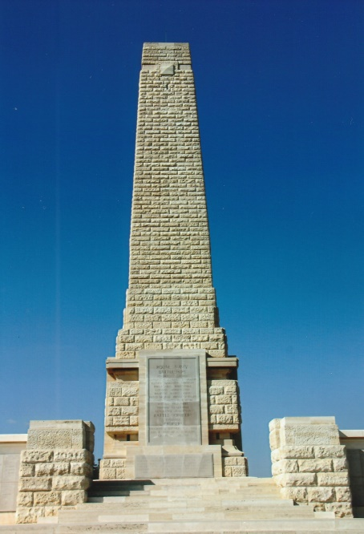
Sunday dawned cloudy and overcast with a warm breeze. Collecting our packed lunches having enjoyed good breakfast we set off in the coach for V-Beach. The old fort at Sedd-ul-Bahr is being renovated and was encompassed with wooden scaffolding. Crumbling stonework has been stabilised and new stone blocks are filling gaps in the old walls. It was difficult to see due to the scaffolding but it appears that new curtain walls are being built between the old towers. Standing on V-Beach, Martin described the landing there and at S-Beach on the 25th April, 1915. The difficulties encountered during the landing and the gallantry of the inexperienced troops was vividly described. It was then with a sombre atmosphere and of remembrance that the graves in the cemetery were viewed. The cemetery contains 696 casualties, mostly of those who landed on the 25th April, 1915. 480 are unidentified and 196 special memorials commemorate those believed and known to be buried there. From V-Beach we drove up to the Helles Memorial and looked across to Hill 138 and Achi Baba, pondering whether the planned objectives for the first day of the landing were achievable. Time was spent looking in and around the memorial on which are inscribed over 20,000 casualties who have no known grave and personal tributes were laid beneath relevant panels.
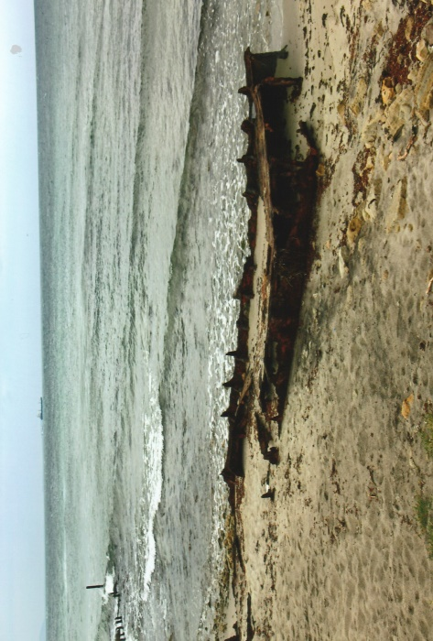
A short drive from the Helles Memorial took us to Lancashire Landing Cemetery containing 1,237 casualties of the First World War of which 135 are unidentified. Some time was spent in the cemetery before we continued on to W Beach where Martin gave a talk about the landing and of the preparations made for its defence by the Turkish troops. A wreck on the beach, probably of a lighter or small vessel used during the campaign and partially uncovered by a storm was of keen interest and speculation. Members walked along the shoreline contemplatively and the relatively confined area of W Beach surprised Steve and Nick who had not been to Gallipoli before.
At X Beach, the 2nd Battalion, Royal Fusiliers were the first to land there followed later by the remainder of the 87th Brigade. The sea and erosion of the cliffs are gradually changing the contours around this beach. We were able to see outline of the road which was built to connect the landing beaches clearly visible beneath the shallow crystal clear sea water. From X Beach we drove on to Pink Farm Cemetery where we consumed our packed lunches. Pink Farm takes its name from the red soil in the area and contains 602 burials of which 205 are unidentified but 219 known or believed to be buried there are marked by special memorials. After walking around the grave plots, areas of topographical interest outside the cemetery were viewed, including old trench lines. Moving on to Twelve Tree Copse Cemetery crosses were laid at selected graves which had a personal interest for members. There are 3,360 casualties buried in the cemetery, brought in from other smaller cemeteries after the Armistice. 2,260 of them are unidentified. Within Twelve Tree Copse Cemetery is a New Zealand Memorial on which are inscribed 180 casualties who have no known grave.
Although the weather was cool and cloudy the opportunity was taken to visit Gully Beach. It was necessary to make a recce for a safe access before we could walk along to the entrance to Gully Ravine. Martin explained to us the salient features of the area and asked members to recall those photographs of the Gallipoli campaign which show the entrance crowded with troops, equipment and dug-outs cut into Gully Spur. Remnants of the stumps of the piers are still visible off shore. We stood by the well dug by Joe Murray and others of the RND and the inscription around the top edge is now practically illegible. From the well we began our ascent up the ravine and did not have to penetrate very far to experience the increase in humidity and a rise in temperature. We were thankful it was not a hot day. On reaching Artillery Road a welcoming committee of goats greeted us with clanging bells and curiosity. It was sensible to leave Gully Ravine via Artillery Road and although the goats followed us for a short distance they were most probably obeying the call of the goatherd. Emerging at the top of Artillery Road, we had a twenty minute walk across field boundaries and along the coastal road back to our coach. To complete a very interesting and absorbing first day it was time for a cool beer or two at the Mocamp on V Beach before returning to the Pansiyon.
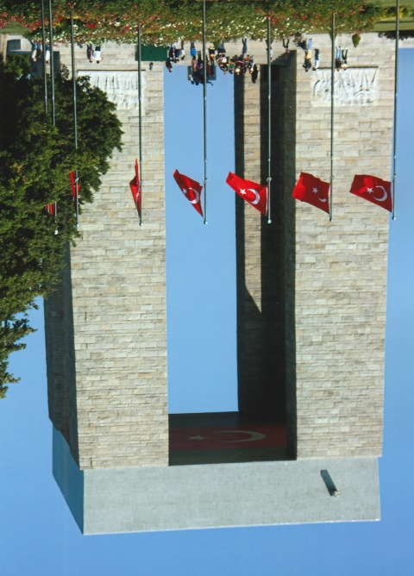
We left the Pansiyon after breakfast on a sunny and bright Monday morning for the Turkish Memorial at Morto Bay. Since last year a new road traffic management system has been introduced for the safety of coaches and visitors. There were very few people in the memorial grounds when we arrived and it gave us sufficient time to walk round the complex to photograph and read information at our leisure. The views across the Dardanelles to the Asian side in the clear morning air were excellent. In the symbolic cemetery the inscribed back-to-back clear Perspex panels on each grave listing the Turkish names of the missing were in previous years difficult to read. A thin red panel bearing the Turkish flag has now been inserted between the two panels making it much easier to read the names. Additional buildings have been erected for pilgrims/visitors in which to pray, one for women and one for men with all the facilities found at a traditional mosque.
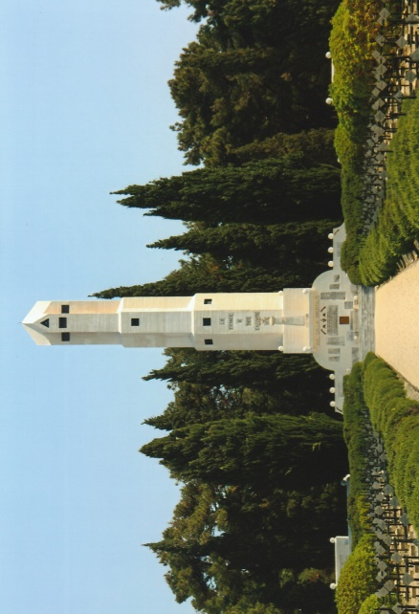
Leaving the Turkish Memorial we drove to the French National Cemetery and Memorial at Morto Bay which is a stark cultural change from those to be found on Western Front and in the CWGC cemeteries on the peninsula. The 2,240 identified graves in the cemetery are marked with blackened metal crosses in ground which is covered with gravel and stone chippings. The 15-metre lantern tower at the head of the cemetery, is an ossuary and has around it are four large tombs containing the remains of 15,000 French dead, mainly colonial troops. Attached to the front façade of the lantern tower are inscribed tablets commemorating losses of French ships and submarines in the Dardanelles. From the main road which passes round the rear of the cemetery a new access road has been laid to a large parking area for vehicles. Access can then be gained through a side gate which makes it much easier for visitors especially those who find ascending the steep steps at the front of the cemetery difficult.
For exercise we walked from the rear of the French National Cemetery, crossed the road into the woodland opposite to the site of Zimmerman’s Farm, named after Commandant Charles Zimmerman of the French 175th Regiment. The ruined farm building, much neglected is obscured by bushes and trees. Close by, and easily overlooked as simply a large rock in the ground is a memorial to a French officer. Practically demolished and long forgotten the French authorities should be ashamed to have neglected this monument to a brave soldier of France. We continued our walk through the forest until we reached the area where RNAS Armoured Rolls Royce Cars were parked below ground level in pits measuring approximately 10m x 5m. Returning to our coach, parked at the front of the French National Cemetery, we drove up to Chunuk Bair. On the way, and to give Steve and Nick a view from the top of Gully Ravine we briefly stopped at the Nuri Yamet Memorial commemorating 10,000 Turkish soldiers who died fighting in the Gully Ravine sector between 26th June and 12th July, 1915.
Arriving at Chunuk Bair at 1245 hours we walked to Chunuk Bair Cemetery and the New Zealand Memorial Wall. Situated on the forward steep slope of Chunuk Bair the cemetery contains 632 casualties of which only 10 are identified. The New Zealand Memorial Wall overlooking the cemetery is inscribed with the names of 850 casualties who have no known grave. Standing by the 20-metre high New Zealand National Memorial and Ataturk’s Statue on Chunuk Bair gives outstanding views over the landscape below. Deciding to have lunch at The Farm Cemetery we descended 540-metres down the western slope of Chunuk Bair to the cemetery. There are 652 casualties buried in the cemetery of whom, only 7 have special memorials and are known to be buried among them.
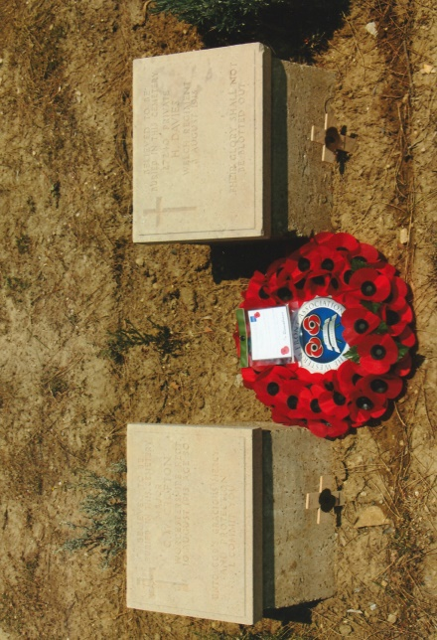
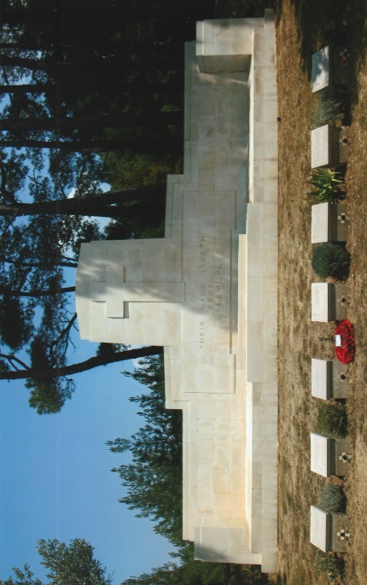
The Farm, which was a shepherd’s stone hutment, was occupied on the 8th August, 1915 by the 10th Battalion, Gurkhas Rifles, 9th Battalion, Royal Warwickshire Regiment and a Maori contingent in readiness for an attack to capture Chunuk Bair. The following day the 6th Battalion, East Lancashire Regiment, 10th Battalion, The Hampshire Regiment and the 6th Battalion, Royal Irish Rifles arrived and the 5th Battalion, Connaught Rangers on the 10th August. During the same morning the Turks launched an attack from the top of Chunuk Bair. They cascaded down the slopes like a ‘human tidal wave’ and swept the Allies off Chunuk Bair.
In the peaceful and pleasant surroundings we ate a thoughtful lunch. Prior to leaving we laid a Wessex Branch WFA wreath and placed seven crosses at the graves. The oration was spoken by Martin and a two minutes silence observed. The descent was fairly easy but the ascent back to the top of Chunuk Bair requires stamina and a measured pace. Our reward was an ice cream of three different flavours eaten the shade of tall pine trees. We drove back to Sedd-ul-Bahr via Ecebat and Kilit Bahr for the benefit of Steve and Nick. Stopping at Kilit Bahr Fort and at Corporal Seyit – the Man with the Shell – Memorial where the views across the Dardanelles at its narrowest point can be appreciated. Before dinner respects were paid at the grave of Lieutenant-Colonel Charles Doughty-Wylie V.C., a short walk from the Pansiyon who was buried where he fell at the summit of Hill 141.
On Tuesday morning for the purpose of obtaining fuel for the coach we drove to Ecebat. It was noticeable that the infrastructure of the town has and is being upgraded. Large apartment blocks have been erected and others are under construction. Our first stop of the day was a visit to the Gaba Tepe Museum. Standing on a high observation walkway in the museum grounds Martin brought to our attention topographical features in the distance of Anzac sector. We left the museum and drove to the Beach Cemetery containing 391 casualties of which 22 are unknown. At the cemetery Martin outlined the Anzac landings on the 25th April 1915. The recognisable feature at Anzac, the Sphinx is slowly being eroded and its outline and shape have changed. Lunch was taken in Shrapnel Valley by the Cemetery. Shrapnel Valley was a main supply route from the beach up to the Anzac front line and took its name from the heavy Turkish shelling on the 26th April, 1915. 638 casualties are commemorated in the cemetery, 85 of them unknown and 23 known or believed to be buried there have special memorials. Two thirds of our group ascended the 450-metre pathway to Plugges Plateau where the spectacular and panoramic views of Anzac area can be observed. Sitting beneath the shade of the trees in the cemetery we ate our lunch and later crosses were placed selected graves after which we drove on to Ari Burnu Cemetery. Situated at the northern end of Anzac Cove there are 252 casualties commemorated here, 42 of them unknown with 5 specials memorials and three Indian graves brought in from Kilit Bahr.
Leaving Anzac we drove up to 400 Plateau for a visit to Lone Pine Cemetery and Memorial. The former contains 1,167 burials, 504 of them unknown, and 183 have special memorials. The latter has the names of 4,932 casualties inscribed on panels who have no known graves. Our next stop was a short distance away at the 4th Battalion Parade Ground Cemetery CWGC signpost. Access to the cemetery is down a 200-metre steep pathway with rough cut steps into the hillside which winter rains often wash away. There are 116 casualties buried here with 7 unknown. Among the casualties lie Colonel H.N. MacLaurin, Commander of the 1st Australian Infantry Brigade and Lieutenant-Colonel A.O. Thompson, Commanding Officer of the 4th Battalion, AIF. Returning to the coach we drove on and parked in the 57th Division Turkish Memorial coach park – which now has a new toilet block! Crossing the road, which was the width No Man’s Land took us to Quinn’s Post Cemetery which was established after the Armistice and contains 473 casualties of which 294 are unidentified. Special memorials commemorate 64 of them known or believed to be buried there. Looking over the cemetery boundary wall we were able see Plugge’s Plateau, Russell’s Top, Popes Hill, the location of the Chess Board, and Bloody Angle. Martin gave details about these features and the desperate struggles which took place at these positions. He also described the role of the RND who held the line for the Australians whilst they were rested and reorganised. Quinn’s Post was named after Major Hugh Quinn, 15th Battalion, AIF who was killed on the 29th May, 1915 and lies buried in Shrapnel Valley Cemetery. Moving on to The Nek Cemetery, north of Quinn’s Post the Nek is the narrow spur from Russell’s Top to Baby 700. There are 326 casualties buried here with 316 unknown with 5 special memorials. The superb views from the cemetery across to the Suvla plain were magnificent. A short walk took us to a viewing-point down Mule Gully towards the beaches. The quite overwhelming panorama of the gully always brings into question how did men live and fight in such terrain overlooked by the enemy who were absolutely determined to drive them out of their positions and into Aegean Sea. On the way back to the coach we stopped at Walker’s Ridge Cemetery, named after Brigadier-General H.B. Walker who commanded the New Zealand Infantry Brigade. Burials here were made during its occupation on either side of a trench system and these are reflected in the cemetery layout by the separation of the two plots. 92 casualties are buried in this cemetery, 16 of them are unknown and 26 special memorials commemorate those known or believed to have been buried among them. Crossing the muddy road from the cemetery we were able to look back over towards Quinn’s Post which gave an entirely different perspective of the positions previously mentioned from there. Concluding another excellent day on the peninsula we left Anzac at 1615 hours looking forward to a cool beer.
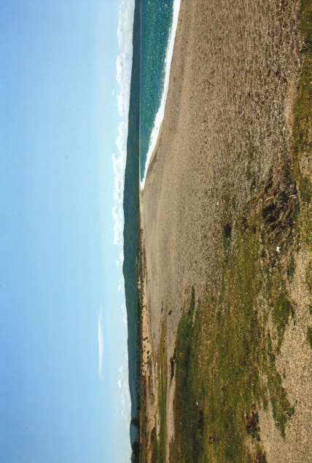
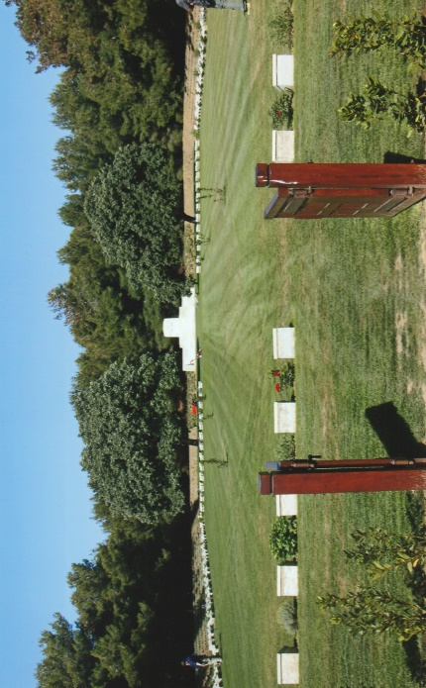
With the prospects of another bright and sunny day before us we left the Pansiyon on Wednesday morning for Suvla. Stops were made at Embarkation Pier and 7th Field Ambulance Cemeteries. In August 1915 a pier was constructed for evacuating the wounded from Sari Bair but subjected to heavy Turkish shell fire it was abandoned after two days. There are 944 burials in Embarkation Pier Cemetery of which 5 are original graves the remainder being brought in from other cemeteries after the Armistice. 262 special memorials commemorate casualties known or believed to have been buried here. The Australian 7th Field Ambulance landed in September 1915 from whom the cemetery takes its name. 640 casualties, mainly of the 54th (East Anglian) Division are buried in the cemetery of whom, 276 are unidentified. 207 of those are commemorated by special memorials. Driving on towards Hill 60 Cemetery, Martin spoke about the Suvla landings and directed out attention to the high ground and ridges dominating the Suvla plain. At Hill 60 he also gave a detailed account of the actions fought in the area during August 1915. Hill 60 Cemetery was constructed amongst the battlefield trench lines and was enlarged after the Armistice. Of the 788 burials here, 712 are unknown and only 34 are commemorated by special memorials. Within the cemetery is Hill 60 New Zealand Memorial on which are inscribed 183 casualties who have no known grave including the Reverend William Grant who was attached to the Wellington Mounted Rifles. Following a rough track round and behind the cemetery we observed the location of a mine crater, now difficult to find due to the undergrowth and trees which has reclaimed much of this former battle ground.
From Hill 60 we drove to ‘C’ and ‘B’ beaches where the 32nd and 33rd Brigades of the 11th Division landed unopposed. The 10th Division were to land at ‘A’ beach but confusion there led to part of the division landing at ‘C’ beach. Once ashore however the troops remained on the beaches instead of moving forward to capture and occupy the high ground beyond. A brief visit was made to Lala Baba Cemetery, situated on a hill to the south of Suvla Bay and the Salt Lake. The hill was captured by the 9th Battalion, West Yorkshire Regiment and the 6th Battalion, Yorkshire on the 7th August, 1915. The cemetery was created after the Armistice and contains 216 casualties, of whom 53 are unknown and 16 special memorials commemorate those known or believed to have been buried there. Among them is Brigadier-General P.A. Kenna V.C., D.S.O., who was mortally wounded by shellfire on the 29th August, 1915.
We broke for lunch at Green Hill Cemetery where graves were brought in from other smaller cemeteries after the Armistice. The cemetery contains 2,971 casualties, of whom 2,472 are unidentified. Among those buried here is Brigadier-General Thomas Longford who commanded the 2nd (South Midland) Mounted Brigade and Private Harry Salter executed on the 11th December 1915 for desertion. At Hill 10 Cemetery Martin talked about the actions fought along Kiretch Tepe and the importance of the Teke Tepe high ground. Hill 10, a small hillock on the north side of the Salt Lake was captured by the 9th Battalion, Lancashire Fusiliers and the 11th Battalion, The Manchester Regiment. There are 699 burial, 150 of them unidentified. Time allowed for quiet reflection in the cemetery before driving on to Azmak Cemetery, the most northerly and possibly least visited cemetery, situated below the Teke Tepe ridge. There are 1,074 casualties buried in the cemetery, 684 unidentified among them 114 officers and men of the 1st/5th Battalion, Norfolk Regiment.
The approach road to Azmak Cemetery bears off to the right of the ‘main road’ which ascends to the Turkish Jandarma Cemetery and Memorial. A year ago the roadway was made of compacted hard core, since then the Turkish authorities have laid a brand new tarmac road, well signed to the top of the Kiretch Tepe Ridge. The road ends abruptly some hundred metres beyond the Jandarma car park. This new road makes the Jandarma Cemetery and Memorial easily accessible for motor vehicles. The Turkish authorities are also planning to build a road from Anzac to Azmak. Descending down from the ridge gives exceptionally fine views over the Suvla plain to the Salt Lake and Lala Baba. To complement a splendid day spent at Suvla ~ a beer at the Mocamp!
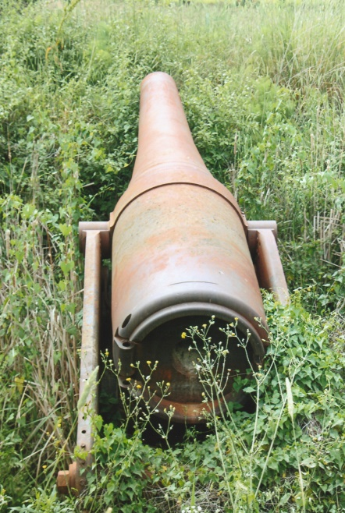
We returned early on Thursday morning to the Helles Memorial, firstly to look at a c.1898 150mm Krupp gun situated a few metres from the rear wall of the memorial. The gun has been placed across the remnants of an original emplacement structure and the securing bolt studs are still clearly visible around the base. Walking from the memorial we crossed the main road and followed field boundaries to the site of a French 240mm naval gun artillery battery positioned to fire across to the Asian side of the Dardanelles. After clearing away dense undergrowth it was possible to examine one the c.1880’s guns mounted on a steel structure. The gun battery arrived in May 1915 and was operational by the 16th June. Prior to the evacuation the guns were disabled and left in situ. Walking back to re-join our coach parked at the Helles Memorial we then drove to Skew Bridge Cemetery, named after a bridge over the Kanli Dere. Begun in August 1915 and later enlarged, the cemetery contains 697 burials, of which 351 are unidentified. There are special memorials commemorating those believed to be buried among them and we placed crosses on personally chosen graves. Martin described to us there the actions fought in the area and directed our attention to Achi Baba Nullah, Krithia Nullah and Observation Hill. At midday we arrived at Redoubt Cemetery. Before entering the cemetery a short walk took us to the area of Vineyard fought over at great cost in lives to both sides. The cemetery’s name was taken from the Turkish Redoubt Line, a series of fortified positions constructed across the southern end of the peninsula. 2,027 casualties lie buried in the cemetery, 1,393 of whom are unidentified with 349 commemorated by special memorials.
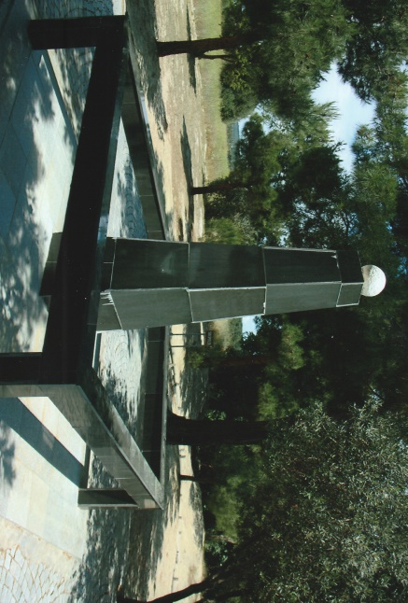
To complete our May 2016 Tour we drove to the Kereves Dere sector and stopped by the Turkish Memorial erected in memory to Major Hüseyin Hilmi Bey, commander of the 6th Division’s 17th Regiment who died on the 13th July, 1915. We walked from the memorial round field boundaries to the edge of the ravine to look down over and across Kereves Dere. By visiting the latter our tour had encompassed large areas of the southern sector of the peninsula and we had visited all the Gallipoli Campaign areas. We returned to the Pansiyon during the afternoon and had free time to walk around Sedd-ul-Bahr. Gathering later at the Mocamp we celebrated another splendid Wessex Branch Gallipoli Tour. During the dinner at the Pansiyon a unanimous expression of thanks was extended to Martin and Judy for making the tour of the peninsula a memorable one.
After breakfast on Friday morning we loaded our baggage on to the coach, bid farewell to Erol, Naile and their granddaughter Nurdan and left at 0930 hours in bright sunshine for Istanbul. The clouds, dull and threatening burst forth with heavy showers and rain as we left the peninsula and turned east on to the E84 towards Tekirdağ. We stopped briefly for chai at a service station and then continued our journey. Despite the showers lovely views of Tekirdağ and the Sea of Marmara could be seen travelling along the by-pass as it descends around Tekirdağ. As we approached Istanbul we plunged into the inevitable heavy and slow moving traffic. Moussa in a valiant attempt to avoid the queues made a detour from the main route to go around the city. It gave us the opportunity to see areas of the city few tourists would ever visit. The rain became a torrent for a period and traffic ground to a halt due to flooding which delayed our progress. Eventually we emerged on to the Kennedy Caddesi, which runs along the Marmara sea front towards the ferry terminals. Extensive road works caused diversions before we passed through one of the old city gates into the Sultanahmet district and arrived at our hotel situated on the Akbiyik Caddesi. John, who had waited patiently for our arrival welcomed us all once again.
The Eternity Boutique Hotel opened in 2011 and offers excellent facilities. Adjacent to the hotel is the I Shak Pasha Turkish Bath built in the late 15th and early 16th centuries, but is no longer in use. To absorb some the cultural atmosphere of Istanbul, John suggested a walk to the Sultanahmet Park Square which has at one end the Blue Mosque and the Hagia Sophia, now a museum at the other end. The opportunity was taken to visit the Basilica Cistern, built during the reign of the Emperor Justinian. The cathedral size underground chamber has a ceiling supported by 336 marble columns arranged in 12 rows, each with 28 columns. Emerging into the light of day we walked to the hippodrome where chariot races, athletics and other activities were held in the old city. Three notable monuments adorn the Hippodrome, a Serpentine Column, an Obelisk of Theodosius and the German Fountain of Kaiser Wilhelm II. The Blue Mosque was closed for prayers but we were able to walk through the forecourt – the same size as the mosque – which is surrounded by a vaulted arcade. The mosque famous for its blue Iznik tiles was built in the name of Sultan Ahmet and is unique with its six minarets. Facing the Blue Mosque is the Hagia Sophia – the Church of Divine Wisdom which was constructed as a basilica in the 6th century by Emperor Justinian. We walked back towards Akbiyik Caddesi through the old city streets and narrow passages.
John’s wife, Terri joined us at the La Vita Bella restaurant where we had dinner and avid conversation. Unlike previous years there was a dearth of tourists due to the activities of terrorists which had reduced tourism by 60%-80%. As a result many of the restaurants face closure. It was also very noticeable on the peninsula where apart from the Turkish day tourists we only saw three other small groups from Çanakkale. Approximately 8,000 Australians cancelled planned trips to Anzac. At the end of a relaxing and enjoyable evening, after bidding farewell to John and Terri we returned to our hotel.
John arranged for us on Saturday morning a tour of Istanbul which meant an early breakfast and departure from the hotel by 0900 hours. We had an enjoyable drive through the old part of the city and crossed over the Galata Bridge to the Asian side of Turkey. There we visited the Haidar Pasha Cemetery. Given by the Turkish Government in 1855 to Great Britain it contains approximately 6,000 mostly unmarked Crimean War graves. The obelisk was erected by the British Government to commemorate the British dead and in 1867 was made available for civilian burials in a separate section. Cared for by the CWGC all these headstones have been recently renovated and cleaned. During the First World War Allied prisoners of war who died in captivity were buried by the Turks in a war grave plot. There are 407 casualties of the First World War buried in this plot, 60 of them unidentified and 39 Second World Graves, 14 of them unidentified. The Haidar Pasha Memorial is inscribed with 108 names of those who have no known grave and a Cremation Memorial commemorates 129 soldiers of the Indian Army who died in 1915-1920. Continuing our tour we were driven up very steep roads to the Istanbul View Park which overlooks the city and has commanding panoramic views of the Golden Horn, Sea of Marmara and the Bosphorus. Descending down to the sea front area we had chai at a waterside restaurant where in the grounds was a 800 year-old-tree, still healthy and providing shade for diners.
Leaving there we drove to the airport where we said good bye to John with grateful thanks for his time and knowledge of Istanbul. Our experience at the airport could have been more efficient. Having arrived at 1245 hours it was not until 1530 that we had completed security and passport checks. Refreshing drinks were consumed in the airport concourse arcade before we made our way to the departure gate lounge. A bus took us a BEA Boeing 767 in which there were plenty of spare seats available. Although take off was delayed by twenty minutes due to air traffic restrictions, we left Istanbul at 1755 hours and landed at Heathrow at 1930 hours UK time. By 2015 hours we had cleared passport control, collected our baggage, rendezvoused with Neil again our coach driver at a collection bay so that by 2030 hours we were homeward bound. Stopping briefly at Winchester Services for refreshments, Mark was the first to leave us at Romsey, followed by Nick at New Milton. At 2315 hours we arrived at Wareham where after alighting at Martin and Judy’s residence and thanking Neil for his services, Steve and Myself, drove onward to our homes in Weymouth and Portland respectively.
The May 2016 Wessex Branch WFA Tour to Gallipoli, was excellent. Each member will be able to reflect and recall many satisfying experiences over the coming weeks and months of Gallipoli and the Dardanelles. This tour could not have taken place without the dedication and determination of our Chairman and Secretary, Martin and Judy Willoughby to ensure that the tour was a success. Thanks must be also be expressed to John and Terri Karabeytan for making the arrangements in Istanbul and with Erol in Sedd-ul-Bahr. For Moussa, our driver it was his first experience on the Gallipoli peninsula and he warmed to the opportunity given to him and was friendly and good company. He took photographs at various locations so he must have enjoyed the trip and was probably for him a break from the horrendous driving conditions in Istanbul. Finally, a big thank you to Martin and Judy who made it possible for us to ensure that all those who lie in the beautifully cared for cemeteries and have their names inscribed on memorials in Gallipoli are not forgotten by the Wessex Branch WFA.
[Sources: Commonwealth War Graves Commission Web-Site ~ www.cwgc.org
Various Turkish Guide Books & Maps
Snippets from Varied Sources too Numerous To Mention & Photographs]
+++
R.G. Coleman

