MAJOR CHARLES JOHN VENABLES D.S.O. ~ GLOUCESTERSHIRE REGIMENT
Charles John Venables was born at New Providence Island in the Bahamas on the 21st January, 1865 the son of Addington Robert Venables, Bishop of Nassau and his wife Elizabeth. His father was born in 1827, educated at Eton and Oxford and ordained in 1851. After ten years of pastoral work in one of the poorest parishes in Oxford he was appointed Bishop of Nassau in 1863. The year before he had married Elizabeth Anne King, born at Long Critchell, Dorset in 1836 and known to the family as ‘Lilla’. To undertake his duties in the Bahamas, the Bishop had an episcopal yacht so that he could visit the islands, which were part of his diocese. A second child, Anne was born a year after Charles in 1866, but along with two other children died in 1875. William, a second son was born in 1873. The Bishop’s health gradually declined and he died in 1876 having been diagnosed with bowel cancer. His wife inherited a substantial sum from her husband’s estate and she returned to England taking up residence at Packham House, Fordingbridge, Hampshire. The 1881 Census recorded that Elizabeth was a Bishop’s widow and along with William and another son James, who was born in 1875, she employed a governess, housekeeper and three domestic servants. Charles at this time was not living at home as he had been sent to a boarding school at Godalming. Two years later Elizabeth married Major-General Charles Cumberland late of the Royal Engineers and moved to Maidstone in Kent.
After boarding school Charles attended Charterhouse where he passed the entrance examination for the Royal Military College, Sandhurst and was commissioned as a Lieutenant into the Gloucestershire Regiment on the 29th August, 1885 and posted at the age of 20 years to the 1st Battalion. During the 1880’s and early 1890’s the Battalion was employed on Home Service Garrison duties in the United Kingdom at York in 1884, Preston in 1886, Dublin in 1888 and Aldershot in 1892, the year in which Charles was promoted to Captain. In November 1893 the 1st Battalion, Gloucestershire Regiment were posted overseas to Malta. Whilst serving there the sad news arrived from home that Charles’ mother had died.
The posting was an enjoyable one for the Battalion who participated with enthusiasm in various sporting activities including rowing and horse racing. When they had been stationed at Malta in 1873 the Battalion had won a prestigious rowing trophy at the annual regatta and they repeated their success in 1894 and again in 1895. Charles enjoyed hunting and was a very good jockey. At a race meeting in April 1895 he won six out of seven races on the first day followed by three more wins a few days later. During November the majority of the Battalion left Malta, for Egypt, one company being sent to Cyprus.
On the 21st March, 1896 Charles married Helen Terry a grand-daughter of Joseph Terry, sweet and chocolate maker of York at the British consulate in Naples. It is probable that his wife returned to England as their first child Lilla Anne was born in 1897 at Winchester. The Battalion, at full strength embarked on the S.S. Victoria at Alexandria on the 6th February, 1897 for India, arriving at Calcutta on the 1st March. After two years’ service there they moved to Allahabad in April 1899.
With the political situation in South Africa deteriorating the Battalion left India in mid-September 1899. Embarking on the S.S. India they arrived at Durban on the 13th October. Signalled from other vessels in the harbour they learned that the Boers had declared war the day before. After disembarking, they boarded two trains, the men seated in overcrowded open trucks the officers in a first class carriage with five to each compartment. They arrived during the evening at Pietmaritzburg railway station where they were provided with tea and a hot meal.
On the 24th October the 1st Battalion, Gloucestershire Regiment, including Charles participated in an action at Rietfontein near Ladysmith to keep open the Newcastle Road for the retirement of the Dundee Column. The Boers occupied well concealed positions in the hills overlooking the road. A large force of two artillery batteries, two cavalry regiments, the Imperial Light Horse, the Natal Field Artillery and a brigade of infantry, including the Gloucesters was assembled to engage the Boers. Advancing up and towards the Boer positions the British force was subjected to shell and accurate rifle fire. After a fierce encounter the Boers were overwhelmed and driven off. The Gloucestershire battalion suffered the heaviest casualties in the engagement. The colonel was killed, one officer wounded, 11 other ranks killed and 52 wounded. On the orders of Lieutenant-General Sir George White V.C., commanding officer of the Garrison at Ladysmith the Battalion withdrew to their encampment there. Two days later the Dundee Column arrived without incident.
At Nicholosn’s Nek on the 29th October, the Battalion suffered further casualties losing 38 killed, 114 wounded, and 350 taken prisoner during the operation against the Boers who were attempting to surround Ladysmith. Captain Venables was one of four officers and 400 men who escaped from this disastrous failure and returned to Ladysmith. Of the 400 other ranks, 180 were hospitalised with wounds or dysentery. A twenty-four hour truce was agreed on the 1st November for a prisoner exchange and the burial of the dead. Two days later the wounded and sick were put on a train at Ladysmith and taken to Pietmaritzburg. On the 4th the Boers completed their encirclement of the town and the Siege of Ladysmith began. The command of the 1st Battalion, Gloucestershire Regiment had devolved to Captain Venables.
Conditions in Ladysmith began to deteriorate as the siege took hold. The Boers randomly shelled the town with what the British soldiers called ‘Long Tom’. Captain Venables posted sentries to watch for its discharge and to blow a whistle to warn the inhabitants of the incoming shell. Despite attempts to break out a malaise began to settle on the besieged. One officer wrote: “… the length of the siege has dulled the initiative of officers …” to take any decisive action. There were exceptions and Captain Venables kept his men alert by discipline and standing to arms at regular intervals. In January 1900 he was taken ill with fever and dysentery but felt well enough a few days later to resume his duties, but succumbed again to illness at the beginning of February. Spirits rose as news reached Ladysmith that Lord Roberts was advancing to relieve the town. There was a desperate shortage of food, which was rationed and the daily death toll continued. However, relief finally came on the 27th February, 1900. Survivors from the 1st Battalion, Gloucestershire Regiment moved to Durban to recover from their ordeal. A reinforcement draft arrived and the Battalion resumed its duties in the field against the Boers. By August and at full strength they took part in operations in the Orange River Colony. At the end of that month the Battalion left South Africa for Ceylon (Sri Lanka) embarking in the transport ships Dilwara, Mongolian and Bavarian. Boer prisoners of war were also put aboard these transport ships and imprisoned in Ceylon under the guardianship of the 1st Battalion, Gloucestershire Regiment until the end of the war.
For his services in South Africa, Captain Charles Venables was Mentioned in Despatches (London Gazette 10th September, 1901 and awarded the Queen’s South Africa Medal with two clasps ‘Cape Colony’ and ‘Defence of Ladysmith’. He was also created a Companion of the Distinguished Service Order (London Gazette, 27th September, 1901) “In recognition of services during the operations in South Africa.” He received the D.S.O., from King Edward VII on the 29th October, 1901.
From 1901 to 1904 he was Adjutant of the 1st Battalion, followed by an appointment to command the Battalion’s Mounted Infantry Company. The Battalion had returned to India in 1903 and were stationed initially at Lucknow, Amballa in 1905 the year in which Charles was promoted to Major, Lahore in 1907 and Dalhousie in 1908. After returning to Lahore in November 1908, the Battalion were then stationed at Bombay from where in October 1910 they embarked for the United Kingdom and Home Service duties.
In 1913 Major Charles Venables retired from the Army after 28 years of service and was placed on the Reserved List of Officers. He had only been retired for a few months when he was recalled on the outbreak of the First World War and posted to the 7th (Service) Battalion, Gloucestershire Regiment. Raised at Bristol in August 1914 the 7th (Service) Battalion became part of 39th Brigade in the 13th (Western) Division. After training at Tidworth they moved to Basingstoke in January 1915 and to Blackdown near Aldershot the following month. A few months later they received orders to prepare for overseas service with the Mediterranean Expeditionary Force. Embarking from Avonmouth in mid-June they arrived at the island of Lemnos, in the Aegean Sea and anchored in Mudros harbour on the 4th July.
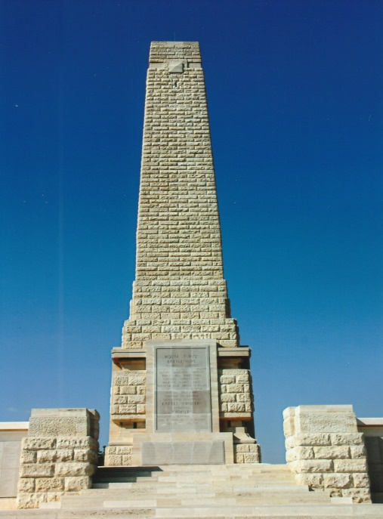
The Battalion landed at ‘Y’ Beach, Gallipoli on the 11th July and quickly experienced the grim realities of war when three men were wounded by sniper fire on the 12th. The following day they moved to the RND’s reserve lines and then to Geogheghan’s Bluff in Brigade Reserve on the 15th. They were late in arriving as a guide mistakenly led them to Gurkha Bluff. On the 17th “B” and “C” companies were attached to the 9th Battalion, Worcestershire Regiment in the firing line in trenches H12 and J11. The Worcestershires were relieved on the 18th and the 7th Battalion, Gloucestershire Regiment on the 21st by the former battalion and moved to the Eski Line in Divisional Reserve. They were in Brigade Reserve at Geogheghan’s Bluff the next day. “C” and “D” Companies entered the firing line in support of the 7th Battalion, North Staffordshire Regiment. From trench J11 “C” Company moved to trench J11B on the 23rd July and with the 7th Battalion, North Staffordshire Regiment fought off a determined Turkish attack. The 7th Battalion, Gloucestershire Regiment relieved the 9th Battalion, Worcestershire Regiment on the 24th and two days later returned to Geogheghan’s Bluff, “A” and “B” Companies Helles Memorial to Trolley Ravine. The Battalion was relieved on the 28th and moved to Gully Beach and embarked the following day for Mudros.
On the 3rd August, with the rest of the 13th Division they sailed from Mudros to Anzac Cove to reinforce the AIF and New Zealand Army Corps. The 7th Battalion, Gloucestershire Regiment landed at Rest Gully and moved to Aghyl Dere on the 6th. Two days later they were in action along Rhododendron Spur to Chunuk Bair with a New Zealand Battalion. Although the crest of Chunuk Bair was briefly captured by the New Zealanders the 7th Battalion, Gloucestershire Regiment were driven back by heavy Turkish fire and only 180 men of the Battalion escaped injury. It took three days for the survivors to rejoin their Battalion in Overton’s Gulley where they dug in.
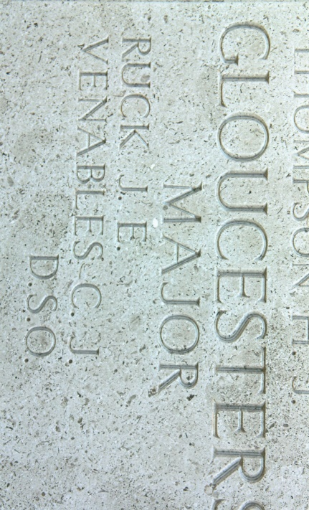
After further casualties they were relieved and sent to Aghyl Dere in reserve. Temporarily amalgamated with the 9th Battalion, Worcestershire Regiment they were relieved at the end of August and moved to the Salt Lake. Amongst the fatal casualties on the 8th August was Major Charles Venables.
The Battalion’s War Diary recorded:
11th July 1915. 10.30 pm. The Battalion landed from 2 steamships at Y beach and marched to Gallipoli beach.
12th July 1915. Two men wounded by rifle bullets from long range at this beach. Major C.J. Venables DSO ~ Name Inscribed Another man the same evening. On Helles Memorial Panel No.102
13th July 1915. 8.30 pm. Battalion marched to Naval Divisional HQ with North Staffords where they remained in Corps Reserve.
15th July 1915. 8.30 pm. Battalion marched to Geoghan Bluff in Brigade Reserve, being led by a guide in error to Ghurkha Ravine, eventually arriving at destination at 6 am 16 July 1915.
17th July 1915. 6 pm. “B” & “C” Company move to right section of Bde line coming under command of OC 9th Worcester Regt. One man slightly wounded.
18th July 1915. 2 pm. HQ and remaining 2 Companies moved into right section of Brigade line which then came under command of Lt-Col. R.P. Jordan, DSO. The Worcesters moved out. 5 pm. A sniper laid a corner of Gully Ravine, the main communication dead. The Worcesters moving out sustained 1 killed and 4 wounded from this man. An RE was wounded in the same way. During night one man was wounded in firing trenches, 2nd Lt. H.C. Bernard & Company Sergeant Major Jones perform good work at great personal risk in taking a wounded man of the Worcesters under cover.
19th July 1915. The body of Lt. Bourne, Worcester Regt, was recovered by Sergeant Shermer and Sergeant Major Scaife at their personal risk. Four men were wounded during the day.
20th July 1915. Remained in trenches. One killed, 4 wounded.
21st July 1915. 9 pm. Relieved by 9th Worcesters and moved to Eski Lines in Divisional Reserve.
22nd July 1915. Moved to Geoghan’s Bluff in Bde Reserve. “C” & “D” Companies moved at same time in support of North Staffords, 2 platoons of “A” Company J11 in support of Worcesters at 7 pm. Remainder of “A” to Worcesters HQ at 7.15 pm. HQ and “B” Company to Brigade HQ at 9.30 pm. 3 wounded.
23rd July 1915. 5 am. HQ and “B” Company to Geoghan’s Bluff followed by “A” Company about 10 am. 2 pm Turks attacked left of Brigade line held by North Staffords. “C” Company, 7th Glosters from J11 moved into firing line at J11b. Attacked defeated. 2 killed 1 wounded. Lt. Phillpotts rejoined from Hospital.
24th July 1915. Noon. Relieved Worcesters in forward line. Five wounded.
25th July 1915. 1 killed, 2 wounded.
26th July 1915. 9 am. Moved to Geoghan’s Bluffs “A” & “B” Companies to Trolley Ravine.
28th July 1915. Moved to Gully Beach. 8.15 pm embarked at Y Beach for Mudros.
29th July 1915. 5 am. Landed at Mudros.
30th-31st July 1915. Still at Mudros.
1st-2nd August 1915. At Lemnos.
3rd August 1915. Embarked for Anzac.
4th-5th August 1915. Rest Gully.
6th August 1915. Moved from Rest Gully to Aghyl Dere.
7th August 1915. About 10 am. Battalion reinforced N.Z. Battalion Rhododendron Spur. Capt. Vassall slightly wounded. 3 killed 24 wounded in the ranks.
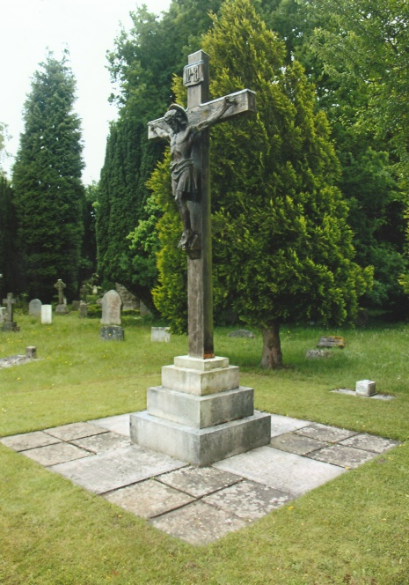
8th August 1915. Battalion received orders to stand to arms at 3 a.m. to form the left of an attacking front line, the Wellington Battalion being on the right. Other battalions formed lines in the rear. The Wellingtons started forming up at 3.30 a.m. with their left on 80.k.1 with two Companies “B” & “D” (“B” on the right) in the first line and “A” & “C” Companies in the second line. The advance started at 4.15 a.m. before “D” Company was quite in position and “C” Company (less 2 platoons on detachment) still filing up the mule track. Longer time would doubtless have been given for the preliminary formations had it been realized how difficult filing along the mule track in the dark with dug outs on either side was. The advance started. A short while after starting the two left platoons of the first line came under enfilade Machine Gun Fire from the left and were practically wiped out, the few remaining men of these platoons remaining in this place. The advance was continued for some distance when the ground began to fall away steeply which in conjunction with the fact that the Companies were under enfilade fire caused the Company Commanders to wheel into file. About this time a staff officer of the New Zealand Brigade came up and ordered the Companies to move to the right and gave the information that the Wellington Battalion had taken the hill CHANAK BAIR. This movement brought the line of Gloucesters advancing towards SAZLI BEIT DERE which they crossed with the right rather advanced. Beyond the southern slope of this DERE the line entrenched with the left about 60 yds beyond the DERE and the right about 200 yds. Owing to change of direction there was a considerable intermixing of Companies and Units. The right of this line had afterwards to retire and dig in further back to escape enfilade fire (shell) from the right. The Turks were continuously attacking the line which in many cases had not time to entrench more than 6". In spite of these attacks and heavy losses especially in officers and senior N.C.Os the line held until relieved. Every officer and every C.S.M. & C.Q.M. Sgt were either killed or wounded and the Battalion consisted of groups of men commanded by Junior N.C.Os or Privates. When the relieving troops arrived at dusk most of these groups either went back or were sent back by officers of other Corps and continued for three days to rejoin the Battalion Head Pirbright War Memorial Quarters in OVERTONS Gully. About 30 of various companies found their way into the left of the line of trenches which had originally been taken by the Wellingtons and remained there throughout the day.
The Casualties were as follows:-
Lieut. Colonel R.P. Jordan D.S.O. ~ Severely Wounded
Major C.J. Venables D.S.O. ~ Killed
Major J.E. Ruck ~ Killed
Captain E.H. Burnaby ~ Slightly Wounded
Captain E.C. Willoughby ~ Slightly Wounded
Captain W.F. Darke ~ Slightly Wounded
Captain G.F. Squire ~ Seriously Wounded
Lieut. F.S.C. Hodson ~ Seriously Wounded
Lieut. F.C. Philpotts ~ Seriously Wounded
Lieut. F.S. Tomkins ~ Wounded, believed Killed
2nd Lieut. W.C. Pickering ~ Slightly Wounded
In the ranks:- (Approximately)
Killed:- 45; Wounded:- 115; Missing:- 190;
Private Leonard Domican, a Bristol man, who as a result of a wound during the action had to have his right hand amputated recalled later:- “The big attack took place on Sunday morning. As soon as day broke we had orders to rush for the ridge, about 600 yards away, in extended order and this we did amidst a hail of shrapnel. Our orders were to extend out two yards, take all possible shelter, and one man was to dig and the next one to open fire on the enemy who were about forty yards away. It was my duty to follow out the firing order while my companion was digging. I was struck in the face by shrapnel early in the attack and my wrist was shattered. With some 250 Australians (sic New Zealanders), Ghurkhas and Gloucesters, I remained in the gully until eight o’clock in the evening, shells continually bursting in the vicinity. When sunset came those of us who were able crawled back to our lines and had our wounds attended to. We, of course, heard the firing all day on the ridge and afterwards learnt of the terrible losses which the 7th Gloucesters and other regiments had suffered both in men and officers.”
Major Charles Venables was 50 years of age when he was killed. His body was not recovered and his name is inscribed on the Helles Memorial ~ Panel No.102.
Charles’ brother William fought in the Boer War as a Lieutenant with Nesbitt’s Horse, and was wounded in May 1900. He later served as a Second Lieutenant in a Gloucestershire Militia battalion. Like his brother he married his wife Majorie in Italy at the British Consulate in Florence. The 1911 Census recorded them living at Fords Farm, Pirbright with their three children and four servants. William was employed at the War Office. This family connection with Pirbright may explain why Charles has his name inscribed on the Pirbright War Memorial. Charles and his wife having spent some time living there when he was on leave and had retired from the Army.
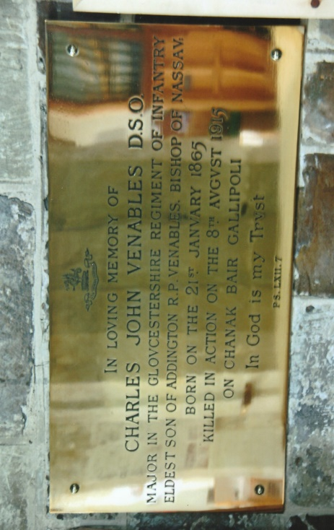
After his death Probate was granted to Charles’ wife Helen on the 20th November, 1915, leaving her a substantial amount of money (approximately £500,000 in today’s money). She spent most of her later life living in London and died in 1996 aged 97. In St Mary’s Church, Fordingbridge Charles’ name is commemorated on a brass plaque, beneath a stained glass window. The window was dedicated to the memory of Anne Venables the young daughter of Bishop Venables and his wife Elizabeth. She had initiated the erection of the window in the church although by the time it was completed she had left Packham House after marrying her second husband.
+++
Sources: Soldiers Of Gloucestershire Museum – Web-Site ~ www.glosters.org.uk
Mr David Read Collections Manager & Archivist of the Soldiers Of Gloucestershire Museum For His Generous Help & Time With Information About Major Charles John Venables DSO
British Regiments At Gallipoli by Ray Westlake Published In 1996 by Pen & Sword Books Limited, 47 Church Street, Barnsley, South Yorkshire S70 2AS. ISBN 085052511X.
The Distinguished Service Order 1886-1923 by Sir O’Moore Creagh V.C, G.C.B., G.C.S.I., & E.M. Humphris. First Published in 1924. Published in 1978 by J.B. Hayward & Son, 17 Piccadilly Arcade. Piccadilly, London SW1Y 6NL. ISBN 0903754126
Wikipedia Web-Site ~ www.wikipedia.co.uk
Ancestry Web-Site ~ www.ancestry.co.uk
Personal Photographs]
++++++
R.G. Coleman

