NETLEY MILITARY CEMETERY
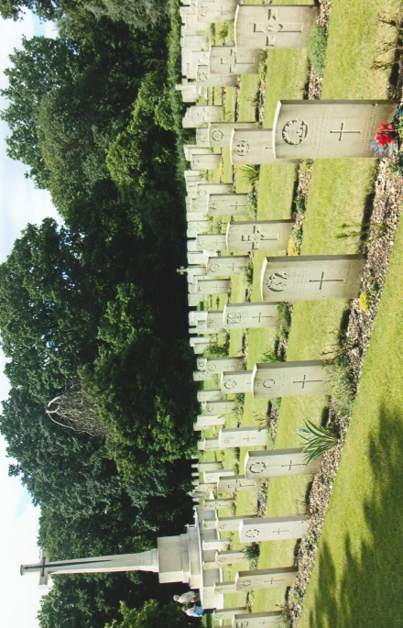
The cemetery is situated within the 200 acres of The Royal Victoria Country Park on which was originally built The Royal Victoria Military Hospital. The hospital had its origins in the Crimean War and of the work carried out by Florence Nightingale at Scutari Hospital in Constantinople (now Istanbul). The standard of hygiene there was non-existent and hundreds of soldiers died from disease and lack of medical facilities. Miss Nightingale’s work struck a chord with Queen Victoria who became interested in the welfare of her soldiers. She made a visit to a hospital at Fort Netley Military Cemetery Pitt, Chatham where the wounded soldiers returning from the Crimea, were convalescing in inadequate and unhygienic conditions. Aware of the Queen’s concern, complaints from medical officers and the general public a committee was established by the government to consider ways of caring for military casualties.
To satisfy public opinion, plans for a new hospital were hastily drawn up which led to a controversy over its design, contractors were given four weeks to tender and twelve months to build it! Over a quarter-of-a-mile long it incorporated two three storey blocks for wards, a chapel, plus another block for offices and staff accommodation. Additionally there was a gas works, reservoir, stables, bakery, swimming pool and a prison! It was an enormous and ambitious project, which could not be completed in the unrealistic timescale laid down by the Government. A suitable site was found and purchased for £15,000 in 1856 at Netley by Southampton water. In May of that year Queen Victoria laid the foundation stone beneath which was a copper box containing the building plans of the hospital, coins, a Crimean War Medal with four clasps and a prototype Victoria Cross.
The hospital was completed in 1863 and the first patients were admitted in March of that year. Florence Nightingale was not impressed, considering that the hospital was out of date and lacked many of her recommendations concerning the health and welfare of patients. Troops from across the Empire were brought by ships to Netley and landed at a pier built close to the main frontage of the hospital. In 1900 a branch line was laid from the main railway line at Netley to the hospital. The pier became virtually redundant but was used for convalescence and exercise for the hospital patients. The Army’s Medical School was transferred to Netley when the hospital was opened which created accommodation problems for officers until a suitable mess was built.
The Boer War demonstrated that the Army was unprepared for war. It was apparent that lessons from the Crimean War had not been learnt as more soldiers died in South Africa from disease than were killed in action. Criticism of the Army’s medical services led to the closure of the Medical School. Netley hospital continued to treat and care for its patients in the comparatively peaceful years following the Boer War. With the outbreak of the First World War the hospital and its staff had to meet the challenges brought about by 20th century warfare. Thousands of wounded soldiers were treated in its wards throughout the war and in addition over 30,000 were cared for by the Red Cross in a tented encampment. Throughout the Second World War the hospital was full to capacity and in 1944 it was handed over to the American forces and returned to the British Army in July of the following year.
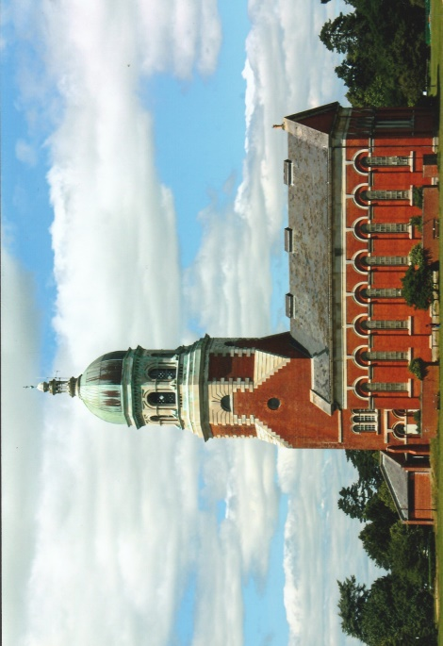
Over the succeeding years Netley Hospital’s primary function gradually declined and wards were closed although many National Servicemen were treated in the hospital. In 1956 the Red Cross used the empty wards for Hungarian refugees. From this period Netley specialised in treating military personnel with psychological problems in Victoria House, a separate unit built within the hospital grounds. In 1963, a fire started by children burnt out the old hospitals central block. Netley Hospital became a financial burden to the Army and was closed and then demolished in 1966. The foundation stone was lifted and the copper box and its contents recovered. Prior to its demolition a decision was made to retain the hospital’s chapel, which is now a The Old Hospital Chapel heritage centre currently undergoing refurbishment and due to reopen in the Spring of 2017. Victoria House continued to care for patients from the armed forces suffering from mental problems until 1979 when it was closed.
In May 1980 Hampshire County Council opened the old hospital grounds as a park which has proved to be a success. The park has vast open spaces for walks, children’s play areas, sports fields, a beach, panoramic views and woodlands all to be enjoyed in a peaceful and tranquil atmosphere. The large cemetery was laid out in an area of the grounds well away from the hospital. Interred there are service personnel from 19th century campaigns, the First and Second World War, including members of allied forces and post-war burials as well as civilians who worked in the hospital. For the thousands of patients who passed through the hospital it could be expected that there would be more burials within the cemetery.
However, many of those who died there were claimed by their relatives for internment elsewhere. Netley Military Cemetery contains 671 identified CWGC casualties ~ 636 of them are from the First World War and include German, Belgian and other foreign nationals. Thirty-five casualties are from the Second World War. There is much for visitors to see and do in the Royal Victoria Country Park and the cemetery containing military and civilians graves has an historic and fascinating interest.
+++
[Sources: Commonwealth War Graves Commission Web-Site ~ www.cwgc.org
Hampshire County Council Web-Site ~ www.hants.giv.uk/rcvp
The Story Of A Great Military Hospital & Royal Victoria Country Park ~ Hampshire County Council Publication.
Personal Photographs]
++++++
R.G. Coleman

