VC MEMORIAL STONE ~ MAJOR R.R. WILLIS V.C.
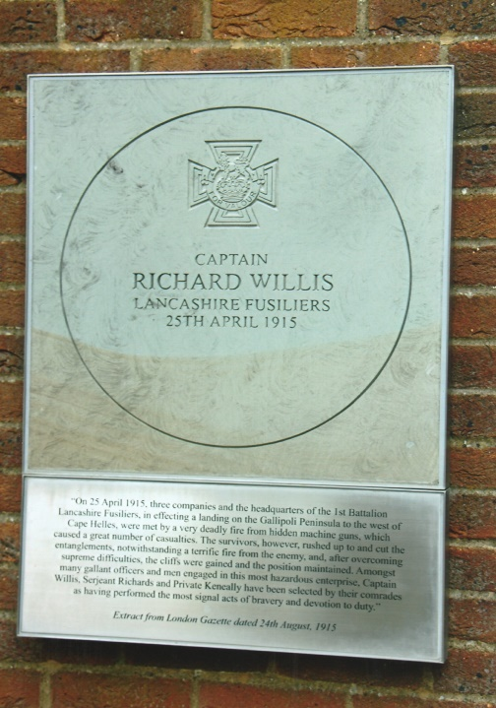
For the centenary of the Gallipoli landings a VC Memorial Stone was erected in Jubilee Square, Woking to Major Richard Raymond Willis VC. He was born in Woking in 1876 and later with his mother, brothers and sisters moved to Devon, whilst his father was in India. Richard was educated at Totnes Grammar School, from where he went to Harrow as a boarder and finally at the Royal Military College, Sandhurst. Commissioned in 1897 he was posted to the 2nd Battalion, Lancashire Fusiliers, who were stationed in India. He became a Lieutenant in 1898 and participated with his Battalion in the Sudan Campaign. On return to India, he was transferred to the 1st Battalion. In 1907 he was promoted to Captain and married his wife Maud, née Temple.
On the 25th April, 1915 Captain Richard Willis leading ‘C’ Company with two platoons attached from ‘D’ Company landed at W Beach, on the Gallipoli peninsula. As they were being rowed towards beach, the enemy opened fire on the boats inflicting heavy casualties. When 100 yards from the shore, those who were able to do so were ordered to jump into the water and wade ashore. Captain Willis waving his walking stick urged his men forward through a hail of machine gun and rifle fire. The Turks had mined areas of the beach and erected barbed wire entanglements which the battalion overcame and eventually gained their objective. For his conspicuous gallantry and leadership Captain Willis was recommended by election of his fellow officers for the Victoria Cross. The award was announced in the London Gazette of the 24th August, 1915: “On the 25th April 1915, three companies and the headquarters of the 1st Battalion Lancashire Fusiliers, in effecting a landing on Gallipoli Peninsula to the west of Cape Helles, were met by a very deadly fire from hidden machine guns, which caused a great number of casualties. The survivors, however, rushed up to and cut the entanglements, notwithstanding a terrific fire from the enemy, and after overcoming supreme difficulties, the cliffs were gained and the position maintained. Amongst the many gallant officers and men engaged in the most hazardous enterprise, Captain Willis, Sergeant Richards and Private Keneally have been selected by their comrades as having performed the most signal acts of bravery and devotion to duty.” Major C. Bromley, Sergeant F.E. Stubbs and Corporal J.E. Grimshaw were also awarded the Victoria Cross and together with Captain R.R. Willis, Sergeant A. Richards and Private W. Keneally they have ever since been known as the ‘Six VCs Before Breakfast’.
On the 4th June, Captain Willis was severely wounded and evacuated to the United Kingdom. He was promoted Major on the 15th September and a few days later on the 21st received his Victoria Cross from King George V. Once fully recovered he served with the 2nd Battalion on the Western Front. At the age of 44 years he retired from the Army in 1920 and joined the education service in the RAF and later taught in private schools to support his wife and three children.
In later life his health seriously declined and he had to appeal for financial help. On the 9th of February, 1966 Major Richard Willis VC died aged 89 in a Cheltenham nursing home and was cremated at Cheltenham Crematorium. His ashes were scattered in the Garden of Remembrance.
After a service of commemoration and remembrance on the 25th April, 2015 at Christ Church, the VC Memorial Stone on the Town Gate Wall was unveiled by Richard Willis’s daughter and the Mayor of Woking. In attendance were other family members, councillors, representatives from the armed forces and members of the general public.
Major Richard Willis’s Victoria Cross Medal group is on display in the Lord Ashcroft gallery at the Imperial War Museum. There is also a memorial plaque at Cheltenham Crematorium.
+++
[Sources: Celebrate Woking Web-Site ~ www.celebratewoking.info
VCs Of The First World War ~ Gallipoli by Stephen Snelling; Published by Alan Sutton 1995
Personal Photograps]
++++++
R.G. Coleman

