WESSEX BRANCH WESTERN FRONT ASSOCIATION BATTLEFIELD TOUR
VERDUN ~ THURSDAY 15th to MONDAY 19th SEPTEMBER 2016.
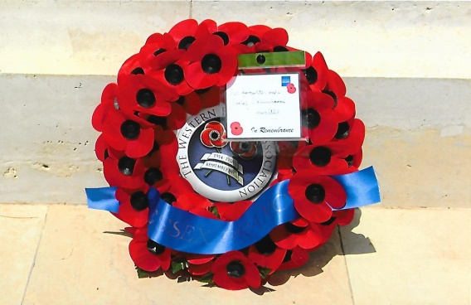
Departing from Pimperne at 0500 hours in a Main Line coach before the ‘cock had crowed’ and under a clear star filled sky we proceeded towards Salisbury, where another member joined us. We made a comfort stop at Fleet Services on the M3, where four more members were waiting and completed our tour party of 31. Our feeder driver was relieved by Derek who was to be our driver for the battlefield tour. Leaving fleet Services at 0715 hours we drove to the ferry terminal at Dover and arrived there without any traffic problems at 0915 hours. We passed through French security and passport controls within fifteen minutes and well ahead of our schedule boarded the P & O Ferry Pride of Burgundy, which left Dover at 1015 hours.
Although misty, the crossing was calm to Calais and by 1235 hours (French time) we were motoring along the A26. At 1435 hours we stopped at the Aire de Urvillers Service Station for a break and refreshments for an hour. Despite the inclement weather it was noticeable as we passed through the countryside how the features of the landscape differed from that of the Somme and Flanders. The traffic on the auto-route was relatively light and we arrived at the Novotel Metz Hotel, Hauconourt by 1835 hours. Allocated to our rooms, which were spacious and comfortable we all enjoyed the first of our four evening meals and drinks before retiring to bed.
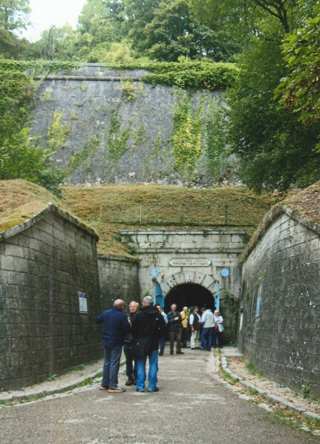
After a good breakfast we left the hotel at 0845 hours travelling towards Verdun. The countryside was shrouded in autumnal mists, occasionally pierced by rays of sunshine by the time we arrived at the 17th century high Citadel of Verdun. The city became part of the French kingdom in 1648 and the military engineer and architect Sébastien Vauban (1633-1707) began a programme of works to strengthen the cities defences, which took over twenty years to complete. In the wake of the French defeat in the Franco-Prussian War of 1870-71, nineteen forts were built around Verdun which became a fortified city. The underground or low citadel was constructed between 1886-1893 to accommodate 2,000 people for use as a command post, supply depot and shelter. Approximately 4-kilometres of tunnels and galleries were dug out the rock and earth. Incorporated into the design underground were barrack accommodation, six powder magazines, seven ammunition stores, a bakery, a mill, communication rooms, kitchens, equipment stores, a cistern and a system for pumping water into Verdun and to other forts. During the First World War the citadel’s tunnels were extended by 3-kilometres to accommodate thousands of soldiers waiting to be sent to the front line.
Citadel Entrance
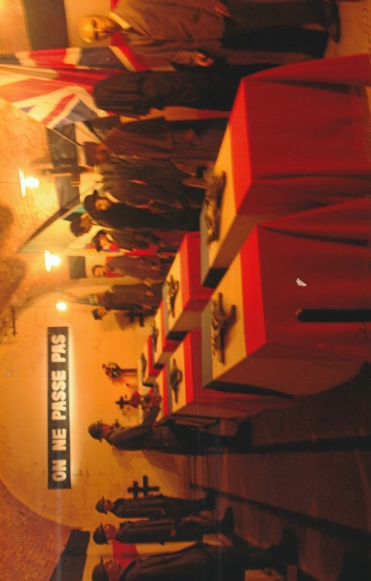
Outside the underground citadel Martin, our chairman gave an interesting talk before we walked a short distance to the entrance tunnel and into the citadel itself. We were divided into groups of nine, the seating capacity of a self-guided tour vehicle. Each vehicle sets off at timed intervals using computer guidance technology to navigate through and around the citadel’s tunnel complex. There are six vehicles and all the technological guidance and safety systems were recently updated.
Choosing the French Unknown Soldier
The vehicle slowly moves off at walking pace through automatic doors into the darkness of a tunnel which is suddenly lit and a commentary, available in six languages begins the fascinating tour. As the vehicle follows its programmed journey it stops at galleries where dioramas create sensory illusions and the dialogue of poilus to demonstrate to the visitor what the living and working conditions were like there during the First World War. The voiced dialogue used by the laser created soldiers has been extracted from personal diaries which help to create a special atmosphere and ambience. At the end of the vehicle tour we stepped off at a gallery where there is displayed a reconstruction of the ceremony for choosing the French Unknown Soldier.
On the 9th November, 1920 coffins containing the remains of eight unknown soldiers from the battlefields of France were brought to the underground Citadel of Verdun. The following day Corporal Auguste Thin of the 132nd Regiment chose the sixth coffin which was taken to Paris and interred in the Arc de Triomphe. The remaining seven coffins were taken to the Nécropole Nationale Faubourg-Pavé French Cemetery and interred in ‘The Square of the Unknown Seven’ burial plot. The last gallery at the citadel contains a collection of battlefield artefacts and military uniforms.
There are not many facilities available at the citadel though this does not detract in any way from the superb underground excursion and was a wonderful beginning to our 2016 battlefield tour. Before re-joining our coach the available beverages at the citadel were eagerly consumed.
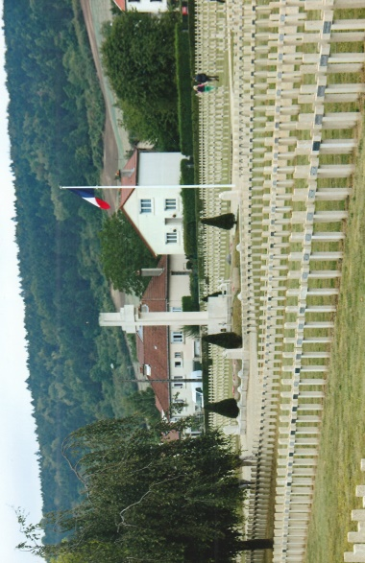
We drove on at 1115 hours to the Nécropole Nationale Faubourg-Pavé French Cemetery, situated in the eastern part of Verdun. The cemetery contains 4,906 French First World burials, 600 from the Second World War and graves of the other nationalities. Beyond the entrance gate are a group of First World field guns. Standing beside a stone statue sculpted by Leon Cuvelle, Rod Arnold gave a brief and informative talk about the cemetery. The statue was originally cast in bronze but was removed and destroyed by the Nazis In 1940. It commemorates French prisoners who were held by the Germans in special camps during the First World War. In the centre of the cemetery is a large cross around which are interred the seven unknown soldiers who were not selected in 1920 as the French Unknown Soldier.
Faubourg Pave Cemetery
At midday we left the cemetery, joining the D964 northwards. Passing along by the River Meuse we gradually ascended up towards the high ground overlooking Verdun. During the Battle of Verdun the Left (West) bank of the Meuse formed the flanks of the German thrust towards Fort Vaux between March and June 1916. A significant part of the German plan was to concentrate their Armies advance along the Right (East) Bank on a front to capture Fort Douamont and Fort Souville. As their advance stalled on the east bank they realised they had to overcome the French forces on the Left (West) bank which was of primary importance if they were to achieve success. Crossing over the Meuse canal, we continued along the D38 in the direction of the Mort Homme Ridge, driving through the villages of Bras-sur-Meuse, Charny-sur-Meuse, Chattancourt and Esnes-en-Argonne. The Nécropole Nationale Petit Bras Cemetery, at Bras-sur-Meuse contains 6,386 French First World War casualties, including 2,000 in an Ossuary and 151 from the Second World War. Esnes-en-Argonne was pounded to rubble and dust in the First World War and was rebuilt retaining its pre-war profile and features as though it had never been destroyed. A kilometre beyond the village is the Esnes-Malancourt Nécropole Nationale Cemetery which has an Ossuary containing 3,000 unknown soldiers and 3,661 burials of the First World War.
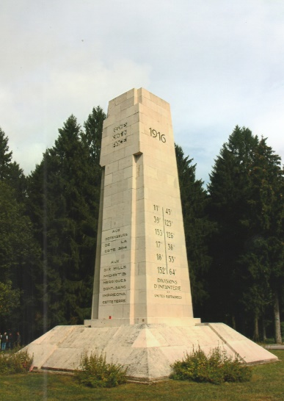
We arrived at the Cote 304 Memorial, where Michael Adams gave an account of the resilient defence by the French to prevent the Germans from penetrating and occupying the position between March 1916 and August 1917. It was during this period that the village of Esne-en-Argonne was obliterated. The survivors from the 2nd French Division erected the memorial in June 1934 to commemorate 10,000 of their comrades who died on Mort Homme. Although overgrown the woodland around the memorial is still littered with shell holes, craters and the debris of war. What appeared to be a ‘sink-hole’ had recently appeared by a pathway, which was an apt reminder to us of what may lie beneath the ground over which we were walking. Just behind the memorial is the grave of Sous Lieutenant Georges Fabre, Legion D’Honneur, Croix de Guerre of the 3rd Regiment Zouave Tirailleurs, who was killed in action on Cote 304 in May 1916 aged 40 years. The inscribed memorial was later erected over his grave by his wife and daughter. Another headstone was inscribed ‘Joseph Girard, Tue le 14 Juin 1940, Recrutement Danger’ would be worthy of further research to find more about him and why he was buried on Cote 304.
Cote 304 Memorial
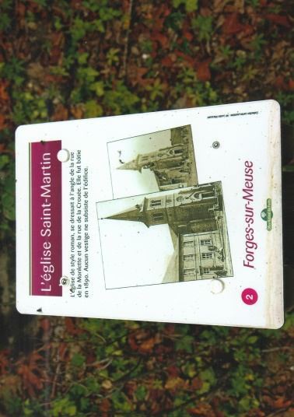
Leaving Cote 304 we drove along the D18/D38b and passed by a cross mounted on the remnants of a pill-box commemorating the 69th Regiment of French Infantry who were virtually annihilated in defending the villages of d’Haucourt and Malancourt. d’Haucourt was not rebuilt and is one of the ‘Village Detruits’ – destroyed villages. A similar fate befell the villages of Bethincourt and Forges-sur-Meuse, where we stopped. Michael outlined to us, standing by the large wooden cross where the village church had once stood, what had happened to Forges-sur-Meuse and about the ‘Zone Rouge’ or Red Zone. The widespread destruction of villages and battle damaged areas across north-eastern France was isolated after the war by the French Government as ‘Zone Rouge’. It covered and area of 1,200 square kilometres (460 square miles) and such was the environmental contamination that it was uninhabitable. ‘Zone Rouge’ was defined as ‘completely devastated with damage to property and agriculture 100%, impossible to clean and human life impossible’. Forestry, farming and housing were either temporarily or permanently forbidden in the ‘Zone Rouge’ and some of the villages, were never rebuilt. These restrictions have been reduced over the passing of the years but still apply today in designated controlled areas. The land on which these destroyed villages stood has been preserved as a testament to their memory. The villages that ‘Died for France’ in the Meuse region were Beaumont-en-Verdunois, Bezonvaux, Cumières-le-Mort-Homme, Douamont (partially rebuilt), Fleury-devant-Douamont (location of the Verdun Memorial and Museum), Haummont-prés-Samogneux, Louvemont-Côte-du-Poivre, Ornes (partially rebuilt) and Vaux-devant-Damloup (rebuilt).
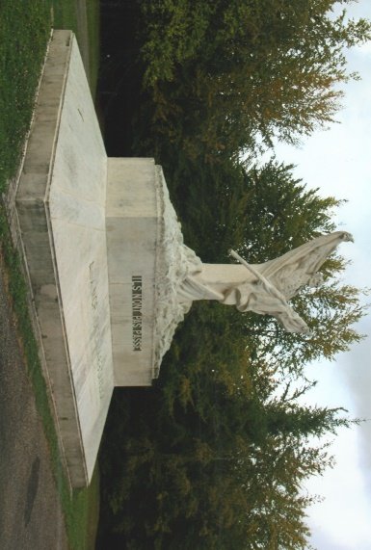
Members spent some time walking around Forges-sur-Meuse and the marshy areas by the river. Where there was once a building or house a marker post records the former owners name and/or the purpose for which it had been used. The remnants of this silent and shattered village, is gradually being reclaimed by nature with trees, shrubbery and lichens.
Returning to the coach we drove up to the Mort Homme Memorial, a few kilometres east of Cote 304. This imposing memorial commemorating the officers and men of the 69th Infantry Division who died on Mort Homme during April and May 1916, has the figure of death, draped in a shroud with one arm outstretched and the other clutching a flag. Carved into the plinth on which it stands are the famous words of General Nivelle, ‘Ils n’ont pas passé – They did not pass. The battle that unfolded along the Mort Homme ridge was horrific for both sides and was vividly described by Michael in his graphic talk. Continuous artillery bombardments, attacks and counter-attacks claimed the lives of thousands of French and German soldiers eventually exhausting both sides. On the grassed verge leading up to the Mort Homme Memorial are two stone crosses, one dedicated to German soldiers and the other to Franco-German reconciliation, erected in 1984. There is also a memorial to the French 40th Division who fought on Mort Homme in April and June 1916.
Mort Homme Memorial
Having completed our itinerary for the day it was decided at 1450 hours to return to the hotel. In so doing we drove along part of the 57-kilometre Bar-le-Duc to Verdun road, the Voie Sacrée, (the Sacred Road) marked at one kilometre intervals by red-capped stones with a French poilus helmet on top. Originally in the bronze the helmets were pilfered by souvenir hunters and are now made of fibre glass. The sacred road was the only highway into Verdun from February to December 1916 and part of it was also used in much the same way by the Allies in the Second World War which is similarly remembered by memorial stones along the route. We alighted from the coach at the hyper-market opposite the hotel to purchase snacks for the weekend and members were free to pursue their own interests until meeting for dinner after a superb and absorbing day.
Our battlefield itinerary for Saturday was to be a busy one and we left the hotel at 0830 hours. Travelling along the auto-routes and cross country roads we passed by several pill-boxes, clearly visible from the coach as the crops had been harvested. The light drizzle which had been falling stopped by the time we arrived at the Verdun Memorial and Museum at Fleury-devant-Douamont. Before leaving the coach Michal gave a vivid account of the fighting here during the Battle of Verdun in 1916. Fleury-devant-Douamont was captured and re-captured sixteen times and completely demolished and within the boundaries of ‘Zone Rouge’ was uninhabitable and not rebuilt. The aftermath of the battle left the land contaminated with the remains of the dead, explosives, chemicals and detritus of war.
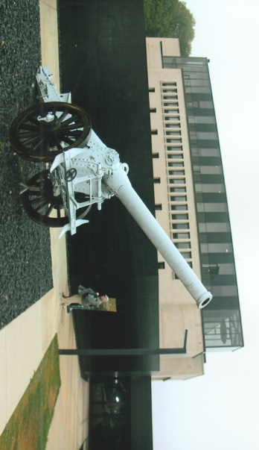
The Verdun Memorial and Museum was built to commemorate French and German combatants as well as civilians who died during the Battle of Verdun. Built on the site of the former railway station it was opened in 1967. After recent extensive refurbishment the museum re-opened in 2016. It has an excellent collection of French and German militaria, thoughtfully displayed with information in three languages. Today the museum’s main focus is on education to appraise the younger generation of the sacrifices during the war and cultural awareness. The French have a flair for museum design and this one ticks all the boxes. Sadly our itinerary did not allow us to spend more time there as members wanted to explore the old village, which prior to the war had a population of 422 whose main employment was agriculture and forestry. On display outside the museum are field guns and motor vehicles. There is also a grave containing an artillery officer, two sappers and a padre who were killed by a shell on the 25th October, 1916. By the side of the pathway leading down to the old village is a memorial unveiled in November 2009 to Lieutenants Henry Herduin and Pierre Millant who were executed without trial on the 11th June, 1916. They had withdrawn their men to save further loss of lives disobeying General Nivelle’s orders of the 4th June that, ‘… we should not take so much as one step back … we die where we stand’. On the 10th Nivelle ordered that the act of retreating, ‘… would be a crime’. Walking down the pathway through the village information signs advise the visitor of the street names, houses and where the shops used to be – today their memorial is a grass covered shell crater. There is a small chapel dedicated to Our Lady of Europe which was closed. A ‘Dove of Peace’ sculpture by Robert Schuman is a silhouette symbolically representing the original village layout, embedded with stones marking the location of the houses.
Verdun Memorial and Museum
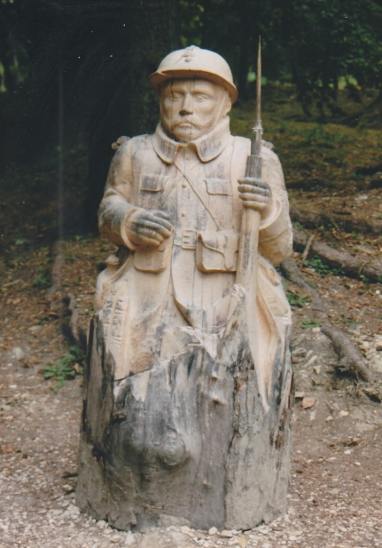
In 2013 a group of German visitors discovered human remains in a crater a few hundred metres from the chapel. A farm had once stood there and was used as a dressing station by the French. Subsequently the skeletons of 26 French soldiers were recovered from the site. They had died from their wounds and were placed in the basement of the farmhouse, which was struck by a German shell. Seven were identified but only three descendants were traced. They were contacted and two took their grandfathers back to their home towns for burial. The other descendant requested to have their relative interred at Douamont. On the 5th December, 2013 a service of remembrance took place at the Douamont Ossuary to commemorate the 26 soldiers and 24 were interred in the cemetery. In the crater there now stands a French poilu carved from a tree trunk guarding the sacred site. It is fair to say that walking through these destroyed villages there is a muffled silence perhaps cast by the departed souls in respect of the thousands who perished in the Battle of Verdun and for the villages that died for France.
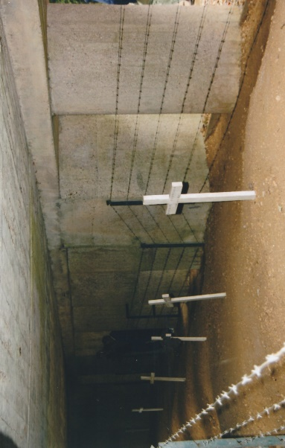
Returning to the coach we drove on to the Tranchée des Bayonettes with its monumental entrance gateway. Michael explained to us the history and the circumstances surrounding the Tranchée des Bayonettes. At the top of a slight inclined pathway is a concrete structure erected over the Tranchée des Bayonettes The construction work was financed by an American who donated 500,000 francs and was officially opened in December 1920. In June of that year the trench had been thoroughly searched and the remains of 47 French soldiers were discovered, only 14 of whom could be identified. A section of the trench was found with rifles and bayonets fixed, protruding through the earth at regular intervals. Beneath each rifle was the skeleton of a soldier. It was concluded that these soldiers of the 137th Infantry Regiment, who had been standing in the trench were buried alive by the earth thrown up during a bombardment on the 11th June, 1916. When this became public knowledge the Tranchée des Bayonettes and the heroes buried in it assumed a legendary significance. Veterans later suggested a more plausible explanation. They had placed their dead comrades in a mass grave and then inserted rifles with bayonets fixed into the ground to indicate that corpses were buried beneath. Today there are no bayonets to be seen. Seventeen soldiers who are known only to God still lie in the trench and are commemorated by seven wooden crosses.
Tranchee des Bayonettes
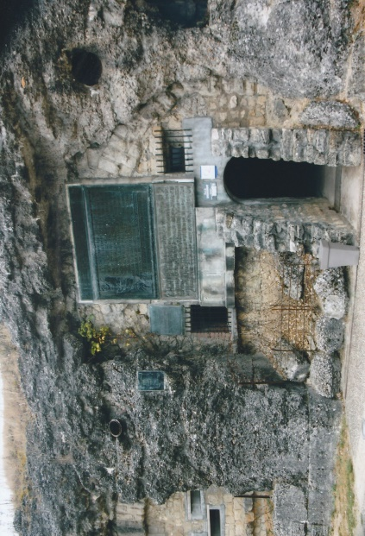
Driving on from the Tranchée des Bayonettes, Michael gave an interesting talk about Fort Douamont before we arrived there at 1150 hours. By the pathway leading up to the fort there is an information panel and memorial to Algerian, Tunisian and Moroccans who fought for France in the Regiments de Tirailleurs. Paying an entrance fee of 3 Euros, members spent time walking through the underground tunnels and galleries. Fort Douamont was the largest of the nineteen forts protecting Verdun. There are two underground levels protected by 12-metres of sand, reinforced concrete and earth. The two main tunnels run east-west above each other with side galleries. In 1915 the garrison was reduced and all except one 150mm rotating retractable gun and one 75mm gun were removed for use elsewhere.
Fort Douamont
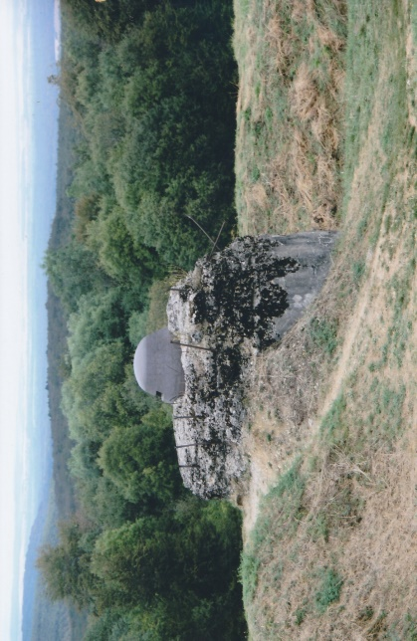
On the 21st February, 1916 the Germans launched the offensive against Verdun and four days later Fort Douamont fell to the 24th Brandenburg Regiment virtually without a fight. The French 2nd Army made an attempt to recapture the fort in May 1916 and managed to regain briefly the western end of the fort but were force to withdraw. The Germans were determined to hold the fort which was subjected to intense artillery bombardments – the earthworks covering the fort are still scarred by it. On the 8th May, 1916 an improvised cooking fire ignited flame-thrower fuel. The eruption of flames and smoke caused chaos and confusion. Some of the German soldiers, blackened by the smoke were mistakenly shot down as French colonial troops. Grenades were also thrown which detonated at stack of stored ammunition. The ensuing explosion and fire killed 679 Germans and injured 1,800. The bodies and remains of the dead were recovered and placed in a side gallery which was walled off and is now an official German War Grave. A cross, commemorative plaque and floral tributes can be seen in front of the sealed wall.
Observation Post - Fort Douamont
The offensive launched by the French against the fort in October 1916 was preceded by an unprecedented bombardment by heavy guns including two 400mm railway howitzers. In addition millions of lighter shells rained down on the fort. Fear of internal explosions forced the Germans to evacuate the fort leaving behind a very small garrison as a rear-guard. Within a few hours the French had captured the enemy rear-guard and Fort Douamont. There is much to see underground and visitors are directed by arrows to all the relevant places of interest including the well preserved 150mm gun turret. Access to the earthworks covering the fort is by a stone stairway. Walking across the cratered and tortured uneven ground gives the visitor an inkling of the maelstrom of shells inflicted upon it which those in the bowels of the fort endured in 1916. The cupola of the 155mm gun, a machine-gun turret and their associated bell-shaped observation posts are well preserved and in good condition. With much to think about we left Fort Douamont for the Douamont Ossuary and the French National Cemetery.
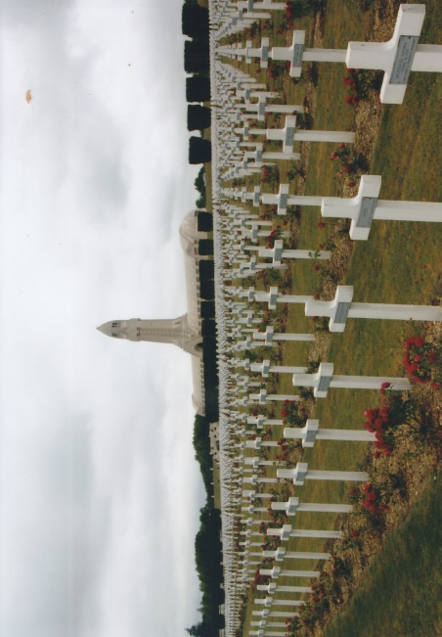
On the initiative of the Bishop of Verdun, Charles Ginisty, work on the building the Ossuary began in August 1920. It was erected within the battlefield area and has been designated as a “Nécropolis Nationale.” Designed in the form of an ambulatory by Léon Azéma, Max Edrie and Jacques Hardy the Ossuary is 137-metres long, with a 46-metre high central tower. The latter known as the ‘Lantern of the Dead Tower’ has panoramic views of the battlefield and within the tower is a 2-ton bronze death bell, donated by Anne Thorburn van Buren, an American citizen in 1927. The bell is only rung at official ceremonies. Situated on the top of the tower is a rotating red and white lantern which shines a beam of light out across the battlefield at night. Within the interior space or cloister are forty-six alcoves, with an apse at each end, a chapel beneath the Lantern Tower and stained glass windows designed by George Desvalliéres. Eighteen of the alcoves along the north wall each contain two tombs and in each apse are five tombs. These represent forty-six of the main battle sectors of the Battle of Verdun. Below the tombs are vaults in which were placed bones of unknown soldiers recovered from each of the battle sectors. The walls and vaulted ceiling stones are engraved with the names of those who died during the Battle of Verdun. Some of the engraved stones bear the names of those who were killed in Second World War, in Indo-China and Algeria. The Battle of Verdun (21st February-19th December 1916) claimed the lives of over 200,000, many of whom were never found and still lie in the earth of the battlefield. Below the Ossuary floor are the skeletal remains of 130,000 unidentified French and German soldiers placed in alcoves. They can be viewed from the outside through small windows at ground level. On the 7th August, 1932 the Ossuary was inaugurated by the French President Albert Lebrun.
Douamont Ossuary and Cemetery
A ceremony of reconciliation was held at the Ossuary on September 1984 attended by President Francois Mitterand and Chancellor Helmut Kohl. President Nicolas Sarkozy attended the first Armistice ceremony to be held there on the 11th November, 2008. On the 9th February, 2014 the name of Peter Freundl, a German soldier who was killed in action on the 28th May, 1916 had his name engraved on a stone in the vaulted ceiling. A programme to refurbish the Ossuary began in 2011 as part of the preparations for the centenary of the Battle of Verdun. There is an intense, quiet and reverential atmosphere within the Ossuary which was clearly felt by members as they walked through and around this magnificent memorial to the dead of France and Germany.
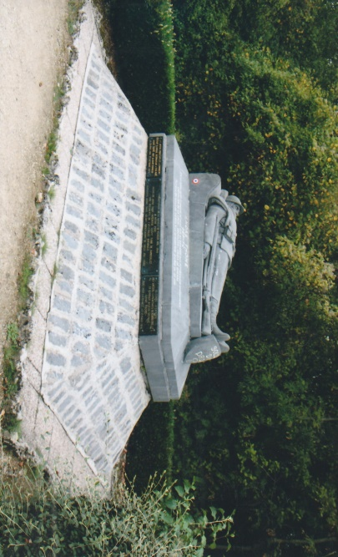
Sloping down and away from the front façade of the Ossuary is the largest First World War French Cemetery containing the graves of 16,142 soldiers who died during the Battle of Verdun. One section, orientated towards Mecca contains the graves of Muslim soldiers of the French Colonial Forces. Nearby is the Wall of the Israelites dedicated to Jewish soldiers who died for France. The cemetery was inaugurated in June 1929 and attended by President Gaston Dourmergue. Across the road from the cemetery is a memorial to Muslim soldiers designed as an open air mosque which was officially opened by President Chirac in 2006. At the junction of the D913/D913d also opposite the cemetery is a large tomb with the recumbent figure of André Thome, Chevalier de la Legion D’Honneur, Croix de Guerre, a French politician who as a Second Lieutenant in the 6th Dragoons was killed in action on the 10th March, 1916. A memorial by the roadside of the D913 commemorates the 44th Regiment d’Infanterie Territorial. At the conclusion of our visit to the Ossuary and the French National Cemetery, members gathered in a café situated by Douamont village war memorial for refreshments.
Tomb of Andre Thome
A short ten minute drive took us to Fort Souville and the Pamart Casemates. From the roadside one of the three casemate pillboxes can be seen and members followed the pathway to it and beyond into the forest woodland. Designed by Commandant Pamart, three pillboxes of this type were built on the slopes of Fort Souville to provide close defence. The pillbox is fixed, but its size and weight made it easier to build and took twenty workers forty-five days to install. They were more reliable than the disappearing turret which was often jammed by stones caused by the explosions of shells.
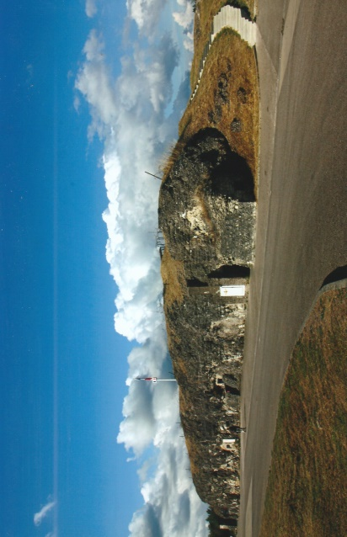
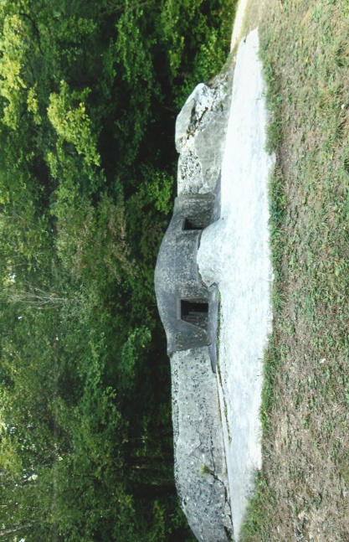
The Pamart pillbox has two crenellations’ almost at ground level which could be closed off by metal plates. Inside two Hotchkiss machine guns, one above the other, fired alternatively. One of them was set in one of the two crenellations when firing while the other waited underneath. The gunner rotated them firing one after the other. Although the morning had been overcast members enjoyed walking around the location in the afternoon sunshine and found there was much to occupy their interest.
Fort Vaux
Pamart Casemate
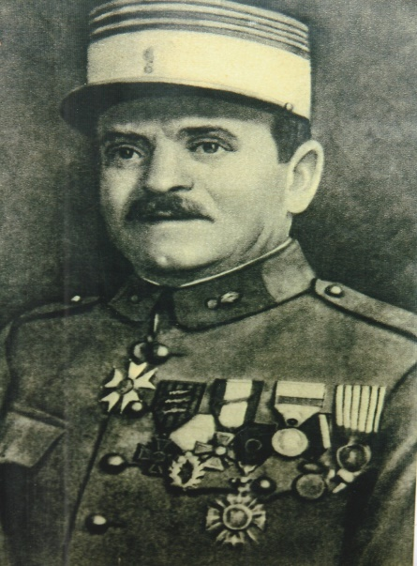
We continued along the D913 passing recently reconstructed trenches and shortly afterwards paused for a few minutes at a memorial dedicated to those executed by the Nazis in the Second World War. At Fort Vaux Michael gave another splendid talk to members who gathered on the ramparts of the fort. Fort Vaux, situated to the north-east of Verdun was built during the 1880’s and later reinforced and strengthened with concrete. Stripped of most of its weaponry prior to the war, the Germans attacked the fort on the 1st June, 1916. Major Sylvain Eugéne Raynal, who had been wounded on three previous occasions had been classed as not fit for duty, was recalled and given command of Fort Vaux. He, with his men heroically endured the artillery bombardment, poison gas, flame-throwers and fought with grim determination in the chaos of the underground passageways.
Major Raynal
With his telephone and visual means of communication out of action, Raynal had to rely on homing pigeons. He sent his final message to HQ using a pigeon named Vaillant, not knowing if the bird would survive the hailstorm of enemy fire across the battlefield. Vaillant reached the HQ but died on arrival. A memorial plaque to the pigeon was later erected on the outside wall of the fort. There is also a defender’s plaque close by listing the units that defended the fort. Raynal’s exhausted garrison lacking rations, water, ammunition and with no prospect of relief, surrendered to the Germans on the 7th June. In recognition of his courage Crown Prince Wilhelm presented Raynal with a French officer’s sword before he and his men were taken as prisoners of war to Germany. The French recaptured Fort Vaux on the 2nd November, 1918. Inside Fort Vaux there is a small museum containing a collection of artefacts and memorabilia. Following passageways through the fort the visitor passes by galleries, some of which are furnished to demonstrate how they had been used during the war. Other underground features include two gun casemates, a chapel, pigeon loft, telephone exchange, latrines and showers.
With time running out and after a very full and superlative day we left Fort Vaux at 1645 hours. As we drove along the D603 in the pleasant early evening sunshine we passed by Hautecourt German Cemetery which contains 7,885 burials. After stopping for fuel and a quick comfort break we were back at our hotel by 1830 hours. Once refreshed, members gathered for an atmospheric and convivial evening.
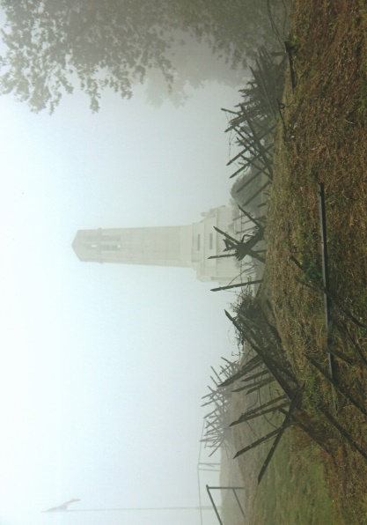
It was another early breakfast to enable us to leave the hotel at 0730 hours on the Sunday morning for an outstanding day’s tour. A brother of one of our members who lives in France, had joined us at the hotel left, to return to his home. It was a wet and misty morning but the old adage ‘rain before seven fine after eleven’ proved to be true. Martin gave a short preparatory talk on the coach before we arrived at our destination the Butte de Vauquois at 0845 hours. There we were greeted by members of the ‘Friends of the Vauquois and its Area Association’ who protect, to pass on the memory and to promote the heritage – which they do without question. We assembled in the car park and introduced to our guide who afterwards gave us an informative presentation. Issued with a safety helmet and torch we were led up a steep pathway to the top of the mist shrouded Butte de Vauquois. On the 24th September, 1914 the Germans occupied the village on the top of the hill after the French 82nd Regiment of Infantry had withdrawn. The occupying enemy forces fortified the hill and were supported on the flanks by artillery. Costly attacks by the French between October 1914 and mid-February 1915 failed to regain the hill. Subsequently attacks by the 10th Division in late February and early March led to a stabilisation of the opposing trench lines. The French held the southern part of the village towards the bottom of the hill overlooked by the Germans. Before the war Vauquois had 168 inhabitants who were evacuated, never to return as their village became a cratered and uninhabitable moonscape.
Les Combattants de Vauquois Memorial
There was little chance of any significant advances by the French or Germans above ground, despite further futile attacks so combat engineers – pioneers and sappers – began to excavate tunnels and galleries underground turning the Butte in the words of Friends Association ‘one huge termite nest’. Eventually 17-kilometres of tunnels and galleries were dug out of the Argonne rock, to depths of 10 to 50 metres. Inevitably an underground war began, using mines, the Germans exploding 199 and the French 320. In May 1916 the Germans detonated 60-tons of explosive which formed a huge deep ditch which separated the opposing trench front lines. The old village landscape then and now is hollowed out and scarred with mine craters. American forces ended the nightmare which engulfed the Butte de Vauquois on the 26th September, 1918.
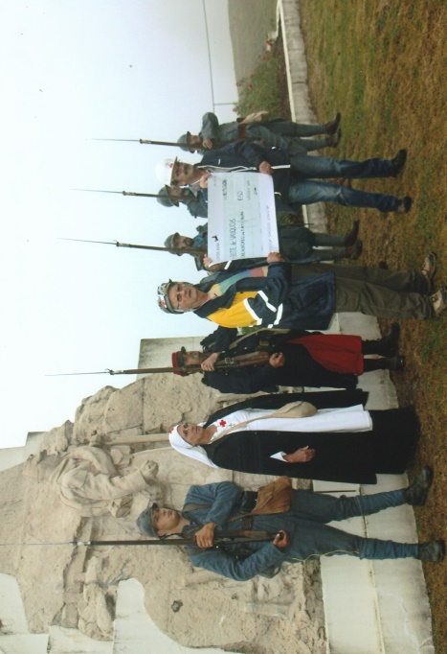
On reaching the summit of the hill our guide led us to the ‘Les Combattants de Vauquois’ memorial, commemorating the French soldiers who died in the Battle of Vauquois. During his engaging talk a group of French First World War re-enactment volunteers dressed as poilu’s and a nurse emerged through the mist and marched past the memorial. Shortly after their arrival, Martin presented a cheque donation from the Wessex Branch WFA to the ‘Friends Association’ in front the memorial to a round of applause and cheers. We followed the guide over hillocks and the uneven ground before entering the maze of underground tunnels. They were damp, very cramped in places, dark and not particularly easy to traverse without the use of a torch and safety helmet. Stopping at intervals our guide explained in great detail how the French and German troops lived this gloomy subterranean world. The underground tour lasted some two-and-a-half hours and was a fantastic and privileged experience for us. To be able walk through an unspoilt complex of passageways where soldiers of the First World War had trod 100 years ago is something very special indeed. Emerging into the daylight and fresh air we continued our walk above ground viewing the clearly visible old trench lines. A minenwerfer recently recovered from a collapsed section of tunnel is on display near to where it was found. The remains of eight German soldiers were also discovered. Two were later identified and their descendants made a pilgrimage to the Butte de Vauquois to lay floral tributes. There is also a poignant memorial to six ‘Sapeurs-Pompiers du Regiment de Paris’ (Paris firemen) who died on the 6th June, 1915 in a horrific incident when fuel from flamethrowers, was ignited by grenades. The ‘French Brigade des Sapeurs-Pompiers de Paris, is an engineering unit of the French Army and serves as the primary fire service in Paris. Our tour of the Butte de Vauquois ended at the car park where we enthusiastically thanked our French guide and hosts. Before leaving we visited the small museum which has a large collection of battlefield artefacts and other militaria. With no facilities at the Butte we drove the short distance to the rebuilt village at the foot of the hill for a comfort stop.
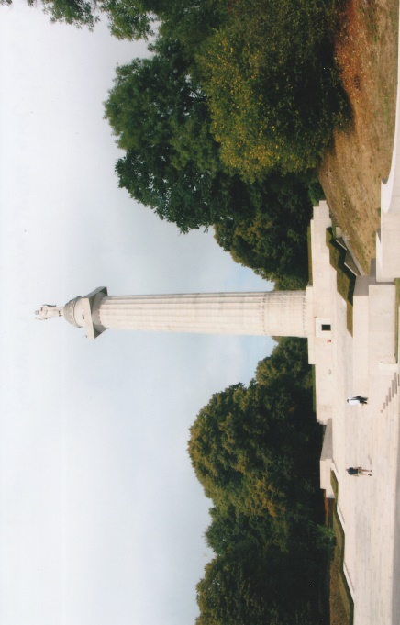
Leaving there at 1230 hours we stopped at Avocourt for welcome refreshments at the La Terrasse Café-Restaurant. Continuing our Sunday tour we drove along the D18, passing Malancourt and arrived at the Montfaucon American Memorial, where Michael gave an account of the American offensive in 1918. The memorial commemorates the American victory in the Meuse-Argonne Offensive of the 26th September-11th November, 1918. The large Doric-style granite column was erected on the high dominating ground close to the destroyed village. Panels inserted into the walls of the entrance foyer give an account of the battle. Two hundred and thirty-four steps lead up to an observation balcony which gives superb views of the battlefield. The monument was inaugurated on the 1st August, 1937 in the presence of the French President Albert Lebrun. President Franklin D. Roosevelt spoke at the ceremony via a radio broadcast from Washington. An enjoyable hour was spent by members walking around the old village and ruined monastery. The Germans had fortified the area in 1914 and remnants of concrete bunkers and strongpoints are still visible for the interested visitor.
Montfaucon American Memorial
From the Montfaucon Memorial we drove to the Meuse-Argonne American Cemetery near Romagne-sous-Montfaucon. Rod gave a short introduction to members about the cemetery and its history. The 130-acre cemetery contains the largest number of American casualties in Europe, 14,246 (486 of whom are unknown) who died during the Meuse-Argonne Offensive fought by General Pershing’s AEF. In front of the steps which lead the visitor up to the grassed central avenue is a large reflection pond. At the top end of this avenue is a chapel decorated with stained glass windows depicting American military insignias. Behind the altar are arrayed flags of the Allied nations. The walls of the chapel loggias are inscribed with the names of the missing, including those who fought in North Russia in 1918-19 and have no known grave. Bodies since recovered and identified are marked by rosettes.
The first burials in the cemetery, laid out in eight sections began in October 1918. Casualties from temporary graves in France and Germany were re-interred here in 1922. Originally the cemetery contained over 27,000 burials but 60% of them were repatriated to America. There are nine recipients of America’s highest military decoration, the Medal of Honour buried in the cemetery: Lieutenant-Colonel F.E. Smith, Major O.F. Miller, Captain M.H. Chiles, 2nd Lieutenant E.R. Bleckley, 2nd Lieutenant F. Luke Jr., Sergeant M. Kocak, Sergeant W. Sawelson, Corporal H.W. Roberts and Corporal F. Stowers. The first American pilot to be killed in the First World War, Sergeant V. Chapman is also buried here.
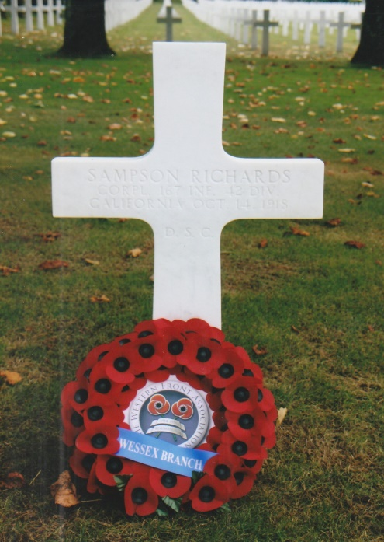
The Branch held a short service of remembrance at the grave of Corporal Sampson Richards D.S.C., of the 167th Infantry, 43rd Division who died on the 14th October, 1918. Rod read out a short personal history of the ‘Cornish Dough Boy’ – (See Issue 7, June 2011 and Issue 10, April 2012 of the Dugout). With members gathered around the grave Rod laid a wreath on behalf of the Wessex Branch WFA. Nigel Plumb gave the exhortation followed by a two minutes silence. Members were then free to walk around this impressive cemetery and the chapel which was a fitting culmination to our excellent 2016 Battlefield Tour. Departing from the cemetery at 1545 hours, we drove through the French countryside taking the scenic route. We paused briefly near the village of Cunel by a memorial to the American 5th Division. It was one of 28 identical memorials erected by the Division at places where they fought or stayed on the Western Front. A ten minute break was made at a service station on the A4/A15 and we arrived at our hotel at 1745 hours.
Grave of Corporal Sampson Richards
Our Monday morning schedule demanded another early breakfast and after loading our luggage we left the hotel at 0800 hours. Travelling via the A4/E50 we made good progress and stopped for twenty minutes at the Aire de Reims Champagne-Nord service station. During the journey, Nigel our Inquisitor General announced the winner of the tour quiz which was based on questions in the Battlefield Tour Guide. The winner Chris and runner-up Pippa each received a book. Traffic on the auto-route was light and being ahead of our timetable it was decided to stop for an hour at Arras. For many of our members it rekindled memories of previous battlefield tours. In the lovely autumn sunshine we were able to enjoy a pleasant stroll around the squares and partake of suitable refreshments. We left Arras at 1330 hours and drove straight to the Calais ferry terminal, arriving there at 1445 hours. Efficiently passing through security and passport controls we boarded the P & O Ferry Spirit of France, which sailed at 1520 hours. At 1625 hours (UK time) we disembarked at Dover greeted by a heavy shower which later turned to almost continuous rain. Stopping at Fleet Services, Derek was relieved by a colleague from Main Line. Thanks must be extended to Main Line Coaches and to Derek who coped exceedingly well with our itinerary. Always friendly, cheerful and amenable we also enjoyed his convivial conversation at dinner. He had been our driver on previous battlefield tours and would be most welcome to drive us again in the future. Four members left us at Fleet and one at Salisbury. Despite the awful weather we arrived in Pimperne at 2100 hours from where members dispersed to their homes.
Of all the Wessex Branch Battlefield Tours the 2016 tour was arguably the best. It was refreshing to visit a Western Front battlefield area where the topography is so different from that further north. There was no question that the highlight of this tour was the Butte de Vauquois with its subterranean world of tunnels and will remain in the memory for not having been sanitised for visitors. This was a remarkable tour and most probably members would like to return there not only to revisit some of the venues but to see new ones both French and German in and around the battlefield areas of Verdun.
Grateful thanks must be extended to Nigel for the production of the Battlefield Tour Guide and to Michael for his knowledgeable and instructive talks. Also thanks to Rod for his invaluable contribution and as our ‘casualty’ bore his injury with stoicism and good humour. All members must be aware that our successful tours emanate from the determination and enthusiasm of our chairman and secretary, Martin and Judy Willoughby to ensure they are unique and always have a surprise element in them for us. Hence our battlefield tours are second to none. Their patience must be worn thin at times in organising these annual events but the outcome is an excellent tour appreciated by all who support them. Thanks Martin for the briefings as well and skilful navigation of the French countryside. As ever Martin and Judy, thank you for your time, energy and for a tour “MAGNIFIQUE”.
R.G. Coleman
[Sources: Wikipedia Web-Site ~ www.wikipedia.co.uk
Battleground Books Series ~ Fort Vaux (2011); Fort Douamont (2014), Verdun – Left Bank (2016) by Christina Holstein. Published by Pen & Swords Books]

