ALBANIA ~ ROYAL ORDER OF THE BLACK EAGLE (BRONZE) – 1914
The large circular bronze medal has a loop for ribbon suspension. On the obverse is a double-headed Albanian eagle, with lightning bolts in its claws, a five-pointed star above and circumscribed ‘BESE E BASHKIM’ (Fidelity and Unity). The reverse has the princely crown topped by a five-pointed star above the monogram ‘W’, and circumscribed with the date ‘ME 26 TE MARSIT 1914’ (26 March 1914).
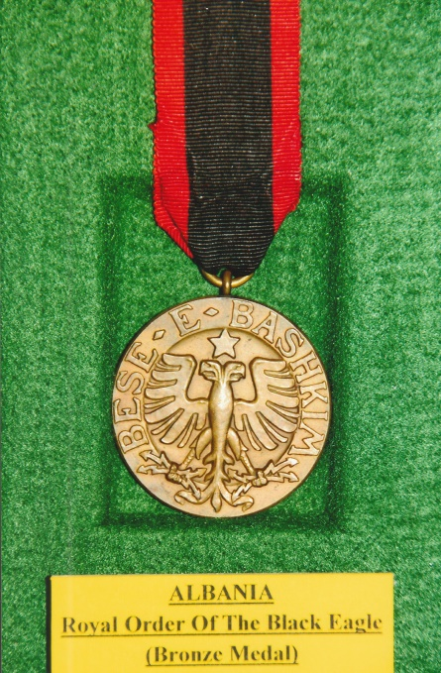
The order was founded by William, Prince of Wied on the 26th March, 1914, soon after his ascent of the throne of Albania, in five classes and three medals, to reward meritorious service, both military and civil, to Albania. After just five months the Order became obsolete as a consequence of civil unrest and the outbreak of the First World War.
Albania came into existence as an independent country on the 28th November, 1912 freeing itself from the Ottoman Empire. In the aftermath of the Balkan Wars, Serbia, Montenegro and Greece all occupied and claimed regions of Albania. The Great European Powers, Austro-Hungary, Great Britain, France, Imperial Germany, Russia and Italy held the view that the governance of the country required a firm and preferably aristocratic ruler. At the suggestion of Queen Elisabeth of Romania her prime minister persuaded the Great Powers that her nephew Prince William of Wied would be a suitable candidate. The Great Powers agreed, but initially Prince William rejected the proposal. Pressure exerted by Austro-Hungary urged him to reconsider. With his agreement and that of the provisional Albanian government, it was officially announced in February 1914 that Prince William of Wied would become King of Albania. Curiously he was still called Prince William outside of Albania.
Wilhelm Friedrich Heinrich Prinz zu Wied was born on the 26th March, 1876 in Neuwied Castle near Koblenz in Germany, the third son of the fifth Prince of Wied (brother of the Queen Elisabeth of Romania) and his wife Princess Marie of the Netherlands. Later, as a young man he became an officer in the Prussian cavalry, and served on the German General Staff in 1911. On the 30th November, 1906 he married Princess Sophie of Schönburg-Waldenburg at Waldenburg, Saxony. Subsequently they had two children, a son and daughter.
King William wasted no time in appointing Turhan Pasha Përmeti to form the first Albanian cabinet which was dominated by princely aristocrats. These appointments caused friction amongst the various Albanian ethnic groups. A Muslim uprising in central Albania erupted over foreigners in the cabinet who were not Turkish. The Greeks backed a separatist government for the north of the country and also occupied parts of the southern Albania. Prince Essad Pasha Toptani, who as defence and foreign affairs minister, was bribed by the Italians to foment a revolt against new King of Albania. Essad was arrested for treason and sentenced to death. An appeal by the Italian government saved his life and he was exiled to Italy.
The outbreak of the First World War plunged Albania in into anarchy as the ethnic minorities rose up against the government. Seizing the opportunity to protect the small Greek communities, Greece took over control of areas in the north and south of Albania. As a response Italy sent troops and Serbia and Montenegro also intervened. Facing a deteriorating situation King William announced that, “… he deemed it necessary to absent himself temporarily” and left Albania for Italy on the 3rd September, 1914.
He returned to Germany and re-joined the German army under the alias of “Count of Kruja.” Any hope that he could return faded when the Austro-Hungarians invaded Serbia and occupied most of Albania. At the Paris Peace Conference having fought against them the Great Powers were not minded to restore William as monarch of Albania. Some of the ethnic groups were in favour of his return. Although progress was difficult and slow central control of the country was established in 1924 and at the end of January 1925 Albania became a Republic, ending King William’s reign. However, monarchy did reassert itself when President Ahmet Zog became king. William always contended that since September 1914 he was the Albanian head of state claimed it for himself and his heirs. Prince William of Wied died on the 18th April, 1945 his wife having predeceased him in 1936. They were buried in the Lutheran Church in Bucharest.
R.G. Coleman
+++
[Sources: Wikipedia Web-Site ~ www.wikipedia.co.uk]
Medal-Medaille Web-Site ~ www.medal-medaille.co.uk
++++++

