GREAT WAR MEDALS
Yser Medal & Yser Cross ~ Belgium
On the 18th October, 1914 German troops of the III Reserve Corps under the command of General von Beseler attacked Belgian positions along the eastern side of the River Yser. Facing a determined and fierce Belgian resistance in defending the opposite side of the river further enemy reserve units were deployed. By the end of October the Belgians had effectively halted the German advance. The bitter struggle between the Germans and Belgian forces in this part of Belgium later became known as the Battle of the Yser. In their stoic defence along the River Yser the Belgians sustained over 60,000 casualties.
Yser Medal
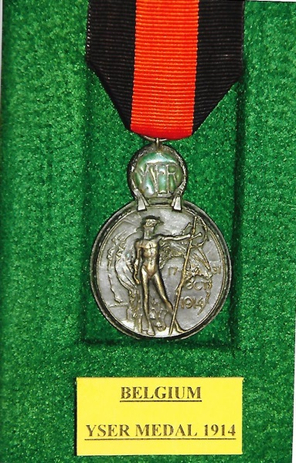
Four years later on the 18th October, 1918 a Royal Decree instituted the Medaille d l’Yser – the Yser Medal – to commemorate the courage and sacrifice displayed by the Belgian troops who fought in the Battle of the Yser. The 35mm diameter, patinated bronze medal is surmounted by a smaller enamelled medallion.
On the obverse is a naked helmeted man holding a lance – indicating the halting of the German advance. To the man’s right a relief inscription in three lines reads: “17-31/OCT/1914” and to the left is the signature of the Belgian artist and engraver Emile Vloors.
The enamelled medallion is inscribed “YSER”. The reverse has an image of a roaring lion sitting on the bank of the River Yser with an arrow in its left shoulder and below in the exergue is the word “YSER”. Above in the centre of the green enamelled medallion is the Belgian royal crown over the letter “A”, the monogram of King Albert.
Suspension is by means of a ring through a loop and the 37mm wide ribbon is black with a 15mm red centre stripe – the red representing spilled blood and the black mourning.
The medal could be awarded to foreign nationals, members of allied military forces who participated in the Battle of the Yser and also awarded posthumously.

Yser Cross
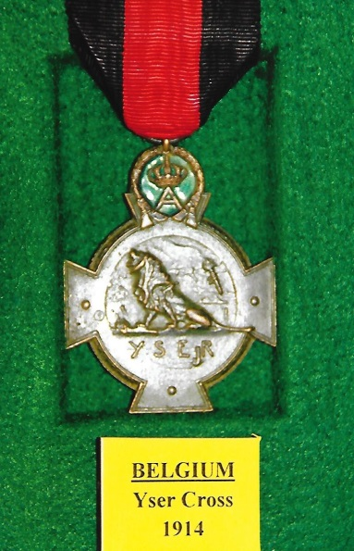
A Royal Decree of the 5th February, 1934 changed the title of the Yser Medal to the Yser Cross, with no change in its design. However, on the 22nd August an additional Decree instituted a new cross 42·5mm wide, in patinated bronze, with the 35mm Yser Medal superimposed upon it. The short ends of the arms of the cross patée are visible, the upper medallion obscures most of the top arm of the cross. The ribbon remained unchanged but many Flemish recipients chose an unofficial black and yellow ribbon denoting them as Dutch speaking Belgians.
The Yser Cross was issued as a replacement for the Yser Medal. Veterans could apply for the cross, with the appropriate payment but very few chose to exchange their Yser Medal. The regulations did not allow the wearing of the Yser Medal and Yser Cross together.
+++
[Source: The Medals Decorations & Orders of The Great War 1914-18 by Alex C. Purves. Second & Revised Edition published in 1989 by J.B. Hayward & Son. ISBN 0 903754 38 X
Medal-Medaille Web-Site ~ www.medal-medaille.com.uk
Wikipedia Web-Site ~ www.wikipedia.org]
R.G. Coleman

