BOOK REVIEW
Betrayed Ally – China In The Great War by Frances Wood & Christopher Arnander. Published in 2016 by Pen & Sword Military. ISBN 978 147387 5012. Price: £19-99.
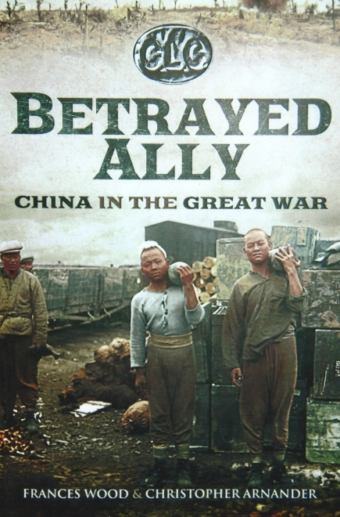
The authors have produced a fascinating book about China, before and during the First World War. It also highlights the attitudes of Western governments towards their Far Eastern ally. There was an undercurrent of fear amongst the Allied nations that by allowing China to contribute militarily in the war it would seriously disrupt the balance of power in the Far East and encourage the growth of nationalism in the region.
China had been under Imperial rule for two millennia and had been reluctantly forced to open its doors to the Portuguese, Dutch and British seeking to exploit opportunities in trade and commerce during the 18th century. The Opium wars of the mid-19th century and its outcome displeased the Chinese and made them wary of the motives of foreigners. Inter-governmental negotiations were made difficult by the intermittent outbreaks of rebellion and internal crises in parts of China. Chinese relations deteriorated further after the Boxer Rebellion of 1900 when China was forced to pay large indemnities to foreign governments. However, along with other European countries including Russia, Great Britain recognised the formation of the Republic of China on the 6th October 1913. America and some Central American countries had already done so.
In August 1914 China declared herself neutral when the First World War broke out with the exception that she wanted to recover the German held colony of Tsingtao in Shandong province. Japan had declared war on Germany on the 23rd August 1914. A few days later on the 2nd September they landed over 20,000 troops, north of Tsingtao to drive out the Germans and claim the Chinese territory for themselves. Although Britain had an Alliance with Japan she arbitrarily took the decision to take Tsingtao without informing the British government. A battalion of the South Wales Borderers (later supplemented by the 36th Sikhs) landed on the 23rd September to support the Japanese. The Germans surrendered on the 7th November but the Japanese had no intention of giving Tsingtao back to China. Japan did not want any British presence there either.
As the battlefield casualties of the western allies mounted in Europe, China proposed in 1915 to send over 300,000 military labourers, one-third of them armed, as a gesture of friendship to the allies and that China would be prepared to fight. Russia accepted 200,000 Chinese labourers, France wanted more time for consideration and Great Britain initially rejected the offer. The term ‘military labour’ implied troops whose first duty was to fight and not work as labourers. A compromise term ‘Labour Corps’ was adopted. Lloyd George had proposed to call them ‘the Auxiliary Corps’ rather than ‘Labour Corps’. By using the term ‘Labour Corps’ it was hoped that it would not provoke the German military leadership and would clearly demonstrate to them that they were civilian workers and not soldiers. France accepted 35,000 Chinese labourers in November 1916 and drew up better terms of employment in their written contracts for them than Great Britain did. The journey from China to Europe was long, tedious and not hazard free. When the transport ship Athos was torpedoed in the Mediterranean carrying labourers to France in February 1917 over 500 Chinese were drowned and forgotten for many years. The Germans seized the opportunity to spread inflammatory propaganda in China about the exploitation of labourers on the Western Front by France and Great Britain and that those who died would never be buried in their ancestral homeland, which was of cultural importance to the Chinese.
Britain had initiated secret negotiations with the Chinese authorities for the recruitment of labour in November 1916. Between January 1917 and March 1918 approximately 100,000 Chinese labourers were recruited by Great Britain. In August 1917 China declared war on Germany and the Austro-Hungarians. A month later she offered to the Allied governments warships for deployment in Far Eastern waters, the Mediterranean and the Baltic. Vacillation between France and Great Britain resulted in a blunt refusal for the warships. The Chinese were only really good for labouring!
China had expected to be treated fairly as any of the other Allied nations by the ‘Big Four’, America, France, Great Britain and Italy at the Versailles peace conference. The ‘Big Four’ however, had taken the view that China had not fought with the Allies to defeat the Central Powers and therefore did not warrant the same status as those who had. China was unaware that in 1917 a secret treaty between Great Britain and Japan gave assurances that the latter would be supported over any territorial claims presented at the peace conference after the war. Other countries had similar agreements which were to the detriment of China. Some of these secret agreements were probably unknown to President Wilson when he drew up his ‘14 Points’ for the basis of peace. Each of the ‘Big Four’ had their own agendas which not only side-lined China but undermined negotiations at Versailles. Two delegations representing northern and southern China attended the peace conference. They returned to China bitterly disillusioned and firmly convinced never to trust the west.
This is an excellent book about China and brings into sharp focus the political intriguing of the allies as the war was being fought. Amongst the many personalities mentioned are those who would lead China to become a dominant world power by the end of the 20th century. Brief biographies about these personalities are given in the books appendices. The author’s research is very rewarding for the reader to further expand their knowledge and understanding about this little known aspect of the First World War.
R.G. Coleman

