Bulgaria ~ Silver Royal Medal for Merit – Boris III (In Fitted Case Of Issue)
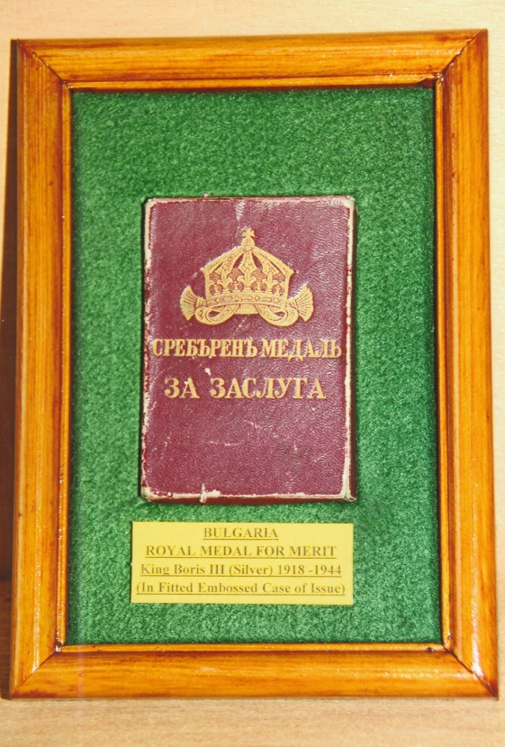
Instituted in December 1881 the Medal for Merit was issued in three classes for service to the ‘Crown or Fatherland’; in gold very rarely; in silver to middle-ranking officials and officers; in bronze to non-commissioned officers and lower ranking officials. The circular silver medal is suspended via a loop from a trifold ribbon. On the obverse is the head of Tsar Boris III, facing left and surrounded by his name and title БOPИСБ III ЦAPБ НА БЪЛГРИΤҌ. The reverse is inscribed ‘ЗА ЗАСЛУГА’ (for Merit) beneath which is a five-pointed star with a wreath of oak and laurel. The example shown dating from 1918-1944 has an original ribbon and is contained in its original fitted and embossed box of issue.
Tsar Boris III of Bulgaria was born in Sofia on the 30th January 1894, son of Prince Ferdinand and his wife Princess Marie Louisa. For thirty years Bulgaria had been a tributary principality to the Sultan of Turkey and the title ‘Prince’ was used by the head of the Bulgarian royal court. After gaining independence in 1908, his father Ferdinand I assumed the title of ‘Tsar’. Boris was initially educated at the Palace Secondary School founded by his father for the purpose of educating his offspring. He later entered the Military School in Sofia and upon graduating participated in the Balkan Wars of 1912 and 1913. During the First World War he was a liaison officer on the General Staff of the Bulgarian Army on the Macedonian Front. Promoted to colonel in 1916 he continued his role as liaison officer to Army Group Mackensen and the Third Bulgarian Army in operations against Romania. Boris was well-respected not only by the troops but also by the Bulgarian and German commanders and Ludendorff considered that he was, ‘excellently trained, a thoroughly soldierly person and mature beyond his years’. In 1918 Boris became a major-general. With the defeat of Bulgaria his father abdicated on the 3rd October 1918 and his eldest son acceded to the throne as Tsar Boris III.
The early years of his reign were marked by political unrest, anarchy and assassination attempts on his life. In April 1925 a bomb killed 150 politicians and senior military personnel who were attending a funeral of a murdered general in Sofia. Later that year, a border war with Greece erupted which was settled by the League of Nations. A coup in May 1934 resulted in a dictatorship and all political parties in Bulgaria were banned. Boris although reduced in status backed a counter-coup and assumed power. Political parties were not re-established although a rudimentary form of a parliamentary government was introduced. For the next five years Bulgaria went through a period of economic growth and prosperity.
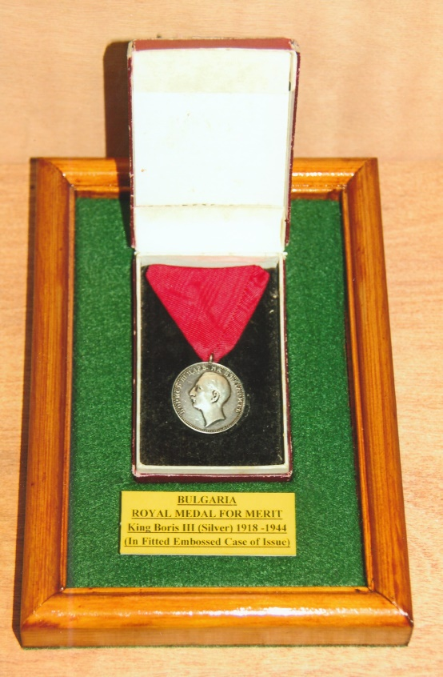
In 1930 Boris married 23-year-old Giovanna, daughter of Victor Emmanuel III of Italy in a Roman Catholic ceremony in Assisi followed by an Orthodox ceremony in Sofia. They later had two children, a daughter Maria Louisa and a son and heir Simeon.
During the Second World War, Boris allied Bulgaria to Germany, to protect his country from being overrun by the German army and regained the disputed areas in Macedonia and Thrace. Bulgaria did not fully co-operate with Germany and refused to send Bulgarian troops to Russia. They introduced anti-Jewish laws in 1940 in accordance with the Nuremburg laws for other European countries under German occupation. Boris risked confrontation with the Nazi regime when he prohibited the deportation of Bulgarian Jews to the death camps. Hitler was annoyed by Boris blatant refusal to declare war on Russia and send troops to the Eastern front. The two leaders met at Rastenburg in East Prussia in August 1943. Boris did not back down and infuriated Hitler. Shortly after returning to Sofia, Boris died in mysterious circumstances on the 28th August 1943. A post mortem revealed the cause of death was a slow acting poison.
After a state funeral held at the Alexander Nevsky Cathedral, Sofia, Tsar Boris III was interred in the Rila Monastery. During the communist years his body was exhumed and reburied in the courtyard of Vrana Palace, near Sofia. After the restoration of democracy in 1990 the courtyard at Vrana was excavated and Boris’s heart was found in a glass cylinder which had been originally placed outside of his coffin when he was buried in 1943. In 1993 his wife took the cylinder back to the Rila Monastery for re-internment. She died seven years later in February 2000.

Postscript ~
In 1998 Bulgarian Jews in the United States and other Jewish agencies organised the erection of a memorial in Israel’s ‘Bulgarian Forest’ near Jerusalem as a tribute to Boris for saving the lives of 50,000 Bulgarian Jews from Nazi persecution. Five years later the memorial was removed by the Israeli authorities as Bulgaria had consented to the delivery of Jews from the occupied territories of Macedonia and Thrace to the Germans. Transported to Bulgaria the memorial was re-erected near Sofia’s civic offices.

Sources: Wikipedia Web-Site ~ www.wikipedia.co.uk
Medal-Medaille Web-Site ~ www.medal-medaille
R.G. Coleman

