BOOK REVIEW
Fighting The Kaiser’s War – The Saxons In Flanders 1914-1918 by Andrew Lucas & Jürgen Schmieschek. Published by Pen & Sword 2015; 256 Pages; Price £25. ISBN 9781783463008.
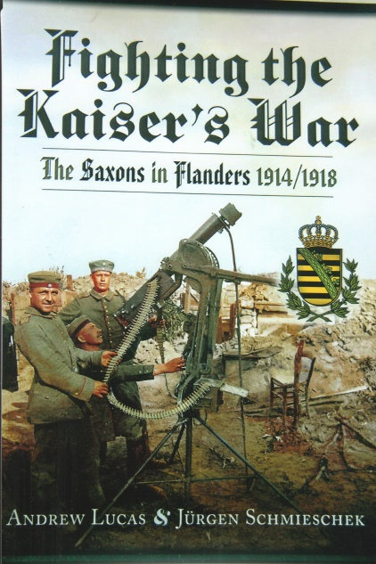
Saxony was one of four states of Imperial Germany who had their own armed forces. Prior to the outbreak of the First World War there were 25 Imperial German Army Corps of which two were Saxon. The structure of their Army conformed to regulations and administrative requirements issued from Berlin, but the Saxons retained the right to approve them and make any necessary changes. These rules and regulations were then ratified by the Army Headquarters in Dresden, capital of Saxony. Aspiring officers were initially trained at Dresden and later at the Prussian War Academy in Berlin. Soldiers swore an oath of loyalty to the King of Saxony and obedience to the Kaiser. The King, Commander-in-Chief of the Royal Saxon Army appointed all his officers although the Kaiser could veto appointments of senior officers.
The authors of this book outline a comprehensive account of Saxony’s social and cultural history prior to 1914. After the sacrifices made by its soldiers on the battlefield and having with its civilian’s endured hardships, the Kingdom of Saxony was dissolved at the end of the First World War. Five chapters are devoted to each year of the war from January to December and contain detailed information about the operational deployments of the Saxon XIX and XII Armeekorps as well as their Reserve Korps, Kavallerie-Divisions and Landwehr units. The use of private diaries, letters, memoirs and previously unpublished primary material of the Royal Saxon Army give a fascinating insight to their experience of the war. Individual accounts for example describe the Christmas Truce of 1914 when the Saxons were deployed in the Ploegsteert sector. The penultimate chapter is devoted to ‘Saxon Lives & Death In Flanders’ ~ personal accounts of ten soldiers. Using letters written by them in the trenches and shell holes to their families were for some their final communication with home. The last chapter, albeit brief is about the day-to-day work on the home front. The text of this book is accompanied by numerous photographs, many of which have never been published. The authors of this book should be congratulated on their excellent research of the Royal Saxon Army during the First World War which expands our knowledge of the German campaign in Flanders.
R.G. Coleman

