Imperial Germany – Kingdom of Saxony ~ Honour Cross for Voluntary & Humanitarian Service in Wartime 1914-1915
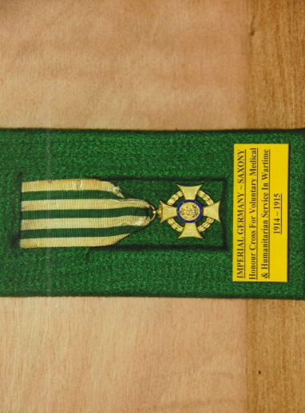
The gilt bronze cross pattée has concaved ends to the arms co-joined with a wreath of oak and laurel. The obverse has a central stippled medallion, with the crowned cypher ‘FAR’ (Friedrich Augustus Rex) of King Friedrich August III encircled by an enamelled deep blue ring with six, six-pointed stars. On the reverse are the dates ‘1914’ and ‘1915’ above and below a horizontal line. The cross is suspended through a ring and pierced loop and in the example shown is on an original ribbon. Established in March 1916, the Honour Cross was awarded to volunteers working in the medical and welfare services supporting Germany’s military forces during the First World War.
Friedrich Augustus was born on the 25th May 1865, the first son of King George and his wife Maria Anna of Portugal. At the age of 12 years Friedrich joined the Royal Saxon Army in 1877, serving as a Second Lieutenant in the Grenadier Regiment Nr 100. Promoted to Lieutenant in 1883, Captain in 1887, Major in 1889 and Lieutenant-Colonel two years later he commanded the 1st Battalion Fusilier Regiment Nr 108. On the 21st November, 1891 Friedrich married Louise Princess and Archduchess of Austria and Princess of Tuscany, Hungary and Bohemia, in Vienna. Subsequently they had seven children. They were divorced in 1903 by a Royal Decree of King George.
She had offended the strictly catholic Dresden Royal Court with her argumentative attitude towards King George. Her popularity with the people was also frowned upon by the royal household and they made her life uncomfortable with alleged intrigues and suspicions. Rumours of an affair with a dentist caused a scandal and outrage within royal family. In December 1902, with the help of her personal staff, sisters and brother she fled from Dresden, pregnant with her seventh child. She feared the threats of her father-in-law to have her committed to a mental asylum for life. In 1907 Louise married an Italian musician and they subsequently had one son. As the news of her second marriage reached the royal court in Dresden she was formally stripped of her Imperial titles and Hapsburg heritage. She died in 1947 virtually penniless as a flower seller in London at the age of 76 years.
Friedrich was promoted to Colonel on the 22nd September 1892 and given command of the Fusilier Regiment Nr 108 on the same day. At the age of 29 years he became a Generalmajor and commanded the 1st Royal Saxon Infantry Brigade Nr 45. Promoted in May 1898 to Generalleutnant he commanded the XII (1st Royal Saxon) Corps. A month later as a General der Infanterie he remained in command of the Corps until October 1904 when he became King of Saxony. His military career was effectively ended on his accession though he was promoted to Generaloberst and finally Generalfeldmarschall in September 1912. On visit to Kiel in July 1902 with his father King George, Emperor Wilhelm II gave Friedrich an honorary appointment in the German Marine Infantry.
Following the defeat of Imperial Germany and the signing of the Armistice on the 11th November, 1918 Friedrich Augustus III voluntary abdicated three days later. He was the last King of Saxony. He died aged 66 years in February 1932 and was buried in the Katholische Hofkirche, Dresden.

Sources: Wikipedia Web-Site ~ www.wikipedia.co.uk
Medal-Medaille Web-Site ~ www.medaille-medal.co.uk
R.G. Coleman

