GREAT WAR MEDALS
Canadian Memorial Cross
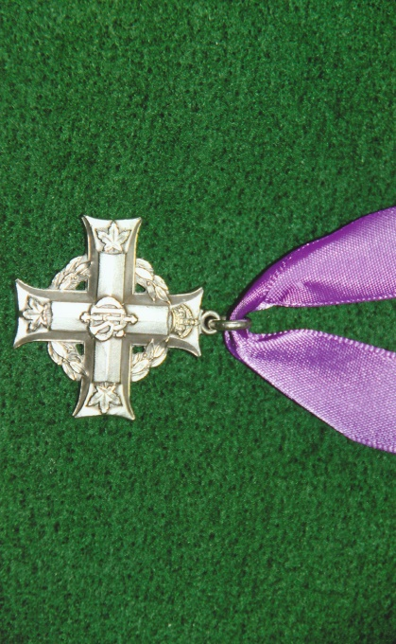
The Memorial Cross was established on the 1st December, 1919 by King George V on the recommendation on the Canadian Government. It was awarded to mothers and widows of Canadian military personnel who had lost their lives during the First World War. Manufactured in dull silver, the 32mm cross has at the top of the vertical arm a St Edward’s crown and in the centre the royal cypher of the reigning monarch. At the foot of the lower arm and on either end of the other two horizontal arms is a maple leaf. Incorporated into the top of the vertical arm is a ring through which is attached another ring for suspension from an 11mm violet ribbon. Between each arm and surrounding the centre of the cross is laurel wreath.
The reverse is plain and inscribed with the name, initials, service number and rank of the deceased person. Towards the end of the lower arm is a sterling silver mark. The Memorial Cross was issued in a presentation case.
Criteria for the award were amended during the Second World War to include merchant seaman and civilian fireman. The Memorial Cross since January 1945 has been issued with a straight silver bar brooch replacing the violet ribbon. From April 1949 service personnel from Newfoundland became eligible and further changes were made during the Korean War and for those deployed on peace-keeping duties.
In May 2006 the Memorial Cross was for the first time awarded to a widower. Subsequent changes in January 2009 to the regulations allow members of Canadian Forces to nominate up to three recipients for the award of the Memorial Cross in the event of their death. Each year a Silver Cross Mother is chosen from those who have received the Memorial Cross.
The above Memorial Cross was awarded the Mrs Mary Mowat of Penzance, Cornwall in remembrance of her son 19093 Private Malcolm Mowat, 2nd Battalion, Canadian Infantry, CEF. He died on the 22nd April, 1915 and has no known grave. He is commemorated on the Ypres (Menin Gate) Memorial.
[Sources: Wikipedia Web-Site ~ www.wilipedia.org
Veterans Affairs of Canada Web-Site ~ www.veterans.gc.ca
Medal Yearbook 2015 ~ Published by Token Publishing Limited
Commonwealth War Graves Commission Web-Site ~ www.cwgc.org ]
R.G. Coleman

