WESSEX BRANCH WFA

Italy – Asiago 17th – 23rd May 2017
BATTLEFIELD TOUR REPORT
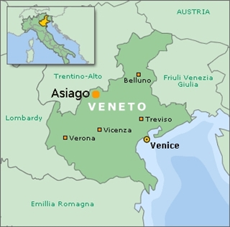
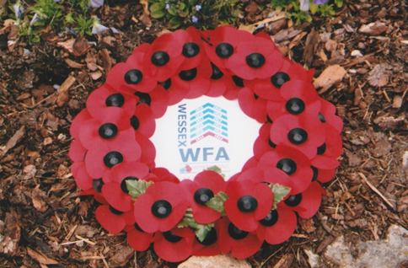
Our tour began on the 16th May at Wareham where Martin, Judy, Steve and Roger boarded a Homeward Bound 16-seater taxi, firstly stopping at Salisbury where Viv, Marc and Ian joined and then on to Medstead for Richard. A brief stop was made at Cobham Services on the M25 before continuing our journey to the Premier Inn at Gatwick (South) where we arrived at 1830 hours. After being allocated to our rooms we all enjoyed an evening meal together and Martin gave each of us his excellent Asiago Battlefield tour guide.
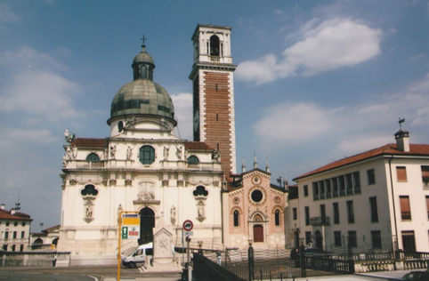
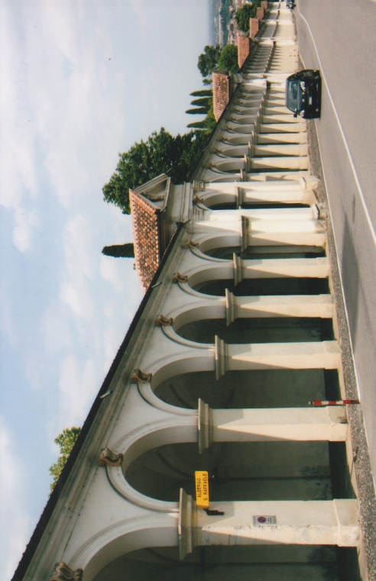
Early on a damp Wednesday morning we assembled in reception at 0445 hours and left by taxi for the Gatwick South Terminal, arriving there twenty minutes later. We made our way to the baggage drop-off area and proceeded through passport and security controls. The opportunity was taken for an early breakfast and then we made our way to the departure area and boarded an A320 aircraft for our flight to Venice. We took off at 0730 hours in murky weather conditions and arrived one hour fifty minutes later at Marco Polo airport Venice in bright sun and a blue sky. Passing through automatic passport controls we collected our baggage and assembled in the airport entrance foyer. There we were greeted by Fabio Perselli who was to be our Italian translator. He guided us to the coach park area where we met our driver, Matteo, loaded our bags and boarded a 24-seater coach. Leaving the airport at 1100 hours (Italian time) we drove along the A4 Autostrada towards Vicenza, our base for the tour, and the drive through the Italian countryside was a pleasurable one. Fabio gave us a brief talk about the Asiago area its history as we motored onward. On arriving at Vicenza we were taken to the Piazzale Della Vittoria, the square in front of the church of St. Mary, a minor basilica at top of Monte Berico to observe the magnificent panoramic views of the city with the Alps as a backdrop in the far distance. The present 17th century basilica was built alongside the original 15th century church. In the 16th century, a covered walkway of stairs was constructed in honour of the Virgin Mary from bottom of Monte Berico to the church by the architect Francesco Muttoni. The walkway is over 700-metres in length and consists of 150 arches, grouped in tens, symbolising the fifteen mysteries and one-hundred and fifty Hail Marys in the rosary. In the square is a large monument commemorating those from Vicenza who died in the 1848 Italian revolution. The Alpini of Vicenza, are also commemorated by two 20th century tablets decorated with the black feather of the Corps.
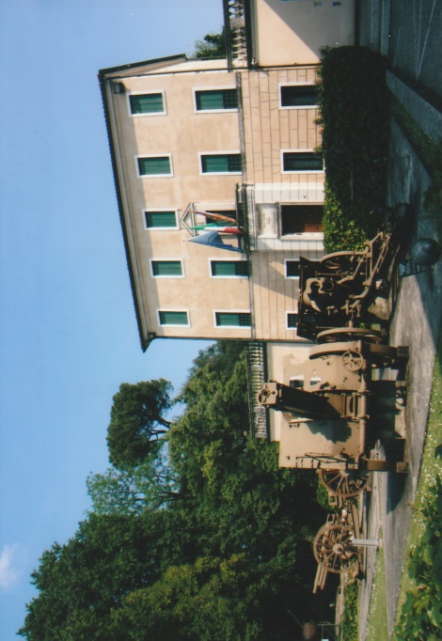
Our hotel was situated just below the crest of Monte Berico. We checked in at 1215 hours and were greeted by Lucia Barban the hotel manager. Used by pilgrims the hotel has a lovely quiet and peaceful contemplative atmosphere and fully met the requirements of our tour party. Assigned to our rooms, time was taken to freshen up and relax before we met in reception at 1400 hours for our afternoon adventures.
We had a light afternoon lunch at a nearby restaurant sitting outside on the wide veranda overlooking the city. We all remarked on the Italian ingredients of our lunch which were local, fresh and stimulated the palette aided of course by Moretti beer and coffee! Lunch over, and a ten minute walk took us up the Ambellicopoli hill to the Museo Del Risorgimento e Della Resistenza in the Villa Guiccioli. The unification of Italy and its associated political aspirations or ‘Risorgimento’ led to the establishment of the Kingdom of Italy in the 19th century. The Italian resistance movement or ‘Resistenza’ was an overall term used by the resistance groups opposed to the occupation by the Germans and the Italian Fascists. Entrance to the museum is free, it is well organised, airy and spacious. All the artefacts, militaria, documents and photographs are clearly displayed for the visitor. Progression through the museum begins with the era of the Venetian Republic, followed by the Napoleonic period, occupation by the Austrians, influence of the Ottomans, the First World War, Mussolini and the Second World War. Included amongst the many fascinating items are numerous British artefacts. Although all the labelling of the displayed material is written in Italian, common sense and the visual imagination helped us to understand what we were observing. In the forecourt of the museum are several guns and equipment of the First World War. We all enjoyed the visit and meandered back to the hotel admiring the views across the city. The group ate together at a nearby restaurant, a short walk from the hotel. Many of the tables are laid out on a large open air veranda and the restaurant offers a wide selection of Italian food and drink. With our batteries fully recharged we returned to the hotel for a good night’s sleep.
After an early breakfast on the Thursday morning we left the hotel in our coach with another driver also called Mateo. From Vicenza we drove via the A31 Autostrada from where we turned on to the S349 towards the town of Asiago and began to ascend the Asiago Plateau. A series of ten hair pin bends on the S349 quickly took us above the valley plain below enabling us to admire the stunning landscape views of small towns and villages.
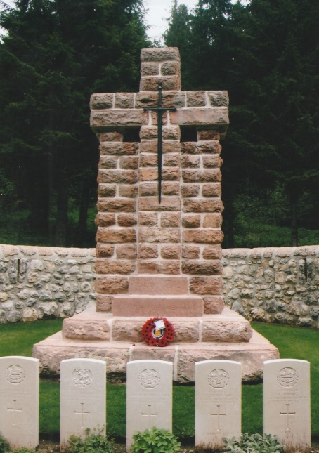
Just before the small town of Canove we turned off the S349 and entered a pine forest for a visit to Boscon British Cemetery. The cemetery contains 166 First World War casualties some of which were concentrated here from other smaller cemeteries after the end of the war. Parking off road we left the coach and had a twenty-five minute walk through the beautiful and aromatic pine forest with trees 100-foot tall. On reaching the cemetery a party of school children and their teachers were gathered outside the cemetery. Fabio introduced himself and informed them that we were from Great Britain and members of the Wessex Branch WFA. With Fabio translating Martin explained to the children about why the British had fought on the Italian front, the cemetery, the significance of the headstones with regimental crests and of those inscribed ‘Known Only to God’. We had previously decided to lay a wreath on behalf of the Branch and invited the school children and their teachers to join us in a short service of commemoration. Viv laid the wreath at the Cross of Sacrifice and Martin recited the exultation – Fabio translated for the children who remained quiet and respectful. After a two minute silence Roger recited the Kohima Epitaph. The children took several photographs in the cemetery and we were then thanked by them and their teachers, two of whom Claudia Ballarin and Oriana Darü warmly shook our hands and exchanged e-mail addresses as they would like to have a copy of this tour report and photographs.
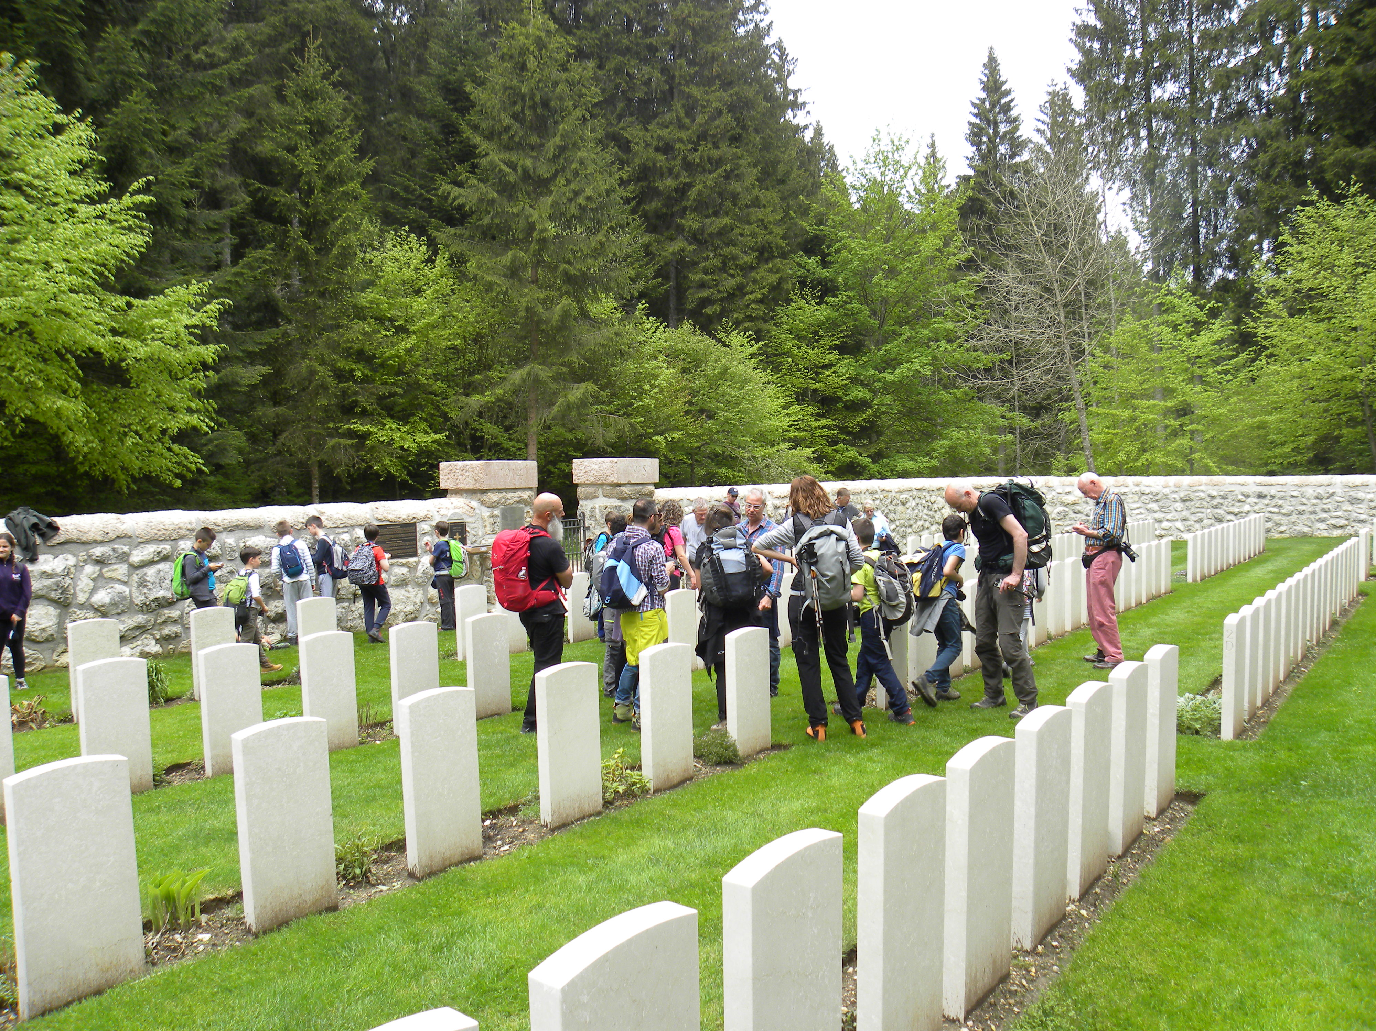
We were all very impressed by the conduct of these children who had come from St Francis of Assisi School, Casier, in Treviso. We all got a lot from the event and it was appreciated by all. The children and their teachers continued their walk to view other nearby battlefield sites. Close by the cemetery was a private memorial to a young 17-year-old Italian man who was shot by the Fascists in 1944. We had all enjoyed our visit to Boscon Cemetery and it was an excellent start to our day.
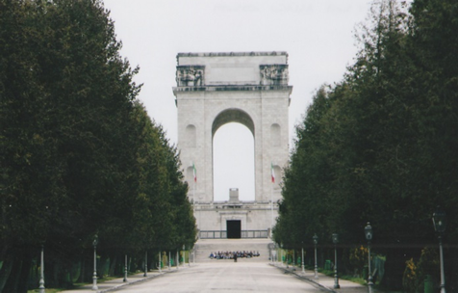
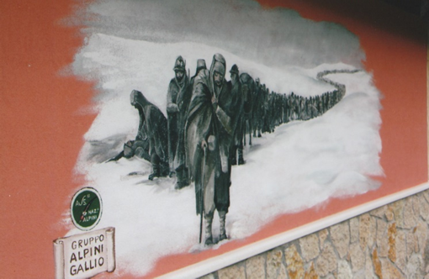
We then drove on into Asiago and parked at the bottom of the Via degli Eroi (Road of Heroes), lined with cypress trees which guide the visitor up to the Asiago War Memorial, one of the largest Italian memorials commemorating the First World War. Situated on the top of Leiten Hill and within walking distance of Asiago town centre it dominates the landscape of the Asiago Plateau. The Sacrario di Asiago or Sacrari Militaire Del Leiten was designed by the architect Orfeo Rossato. An enormous block of locally-mined white marble, 80-metres square was used for the base. Erected on the base is a Roman quadrifrons arch – four faced with four arches – 47-metres in height. A wide stone staircase leads up to a terrace and the entrance. The decorative exterior wall sculpture was created by Roberto Montini and Giuseppe Zanetti. Completed in 1938 the inauguration ceremony was held on the 17th July, attended by Benito Mussolini and King Victor Emanuel III. Within the interior of the memorial is a crypt, an octagonal chapel and altar. The chapel houses the remains of twelve recipients of the Italian Gold Medal of Valour. Behind the interior walls are burial niches containing the remains of 33,086 Italian soldiers whose bodies were exhumed from cemeteries on the Asiago Plateau between 1935 and 1938. The identified were placed in individual niches in alphabetical order and the unidentified in two communal tombs. 12,795 Italians are identified and 20,291 unidentified and the remains of 18,505 Austro-Hungarian soldiers of which 12,355 are unknown were brought in at a later date. There is also a small museum near the crypt which has on display artefacts retrieved from the Asiago battlefields, documents and photographs. Arranged around the exterior of the memorial are several original restored cannons. We enjoyed the views of the landscape surrounding the memorial and Asiago, occupied by the Austro-Hungarians in May 1916 and virtually destroyed during the war. It was an apt moment for us to have an early lunch in the town at a nearby pizzeria used by the local inhabitants and where we too enjoyed an excellent meal and good service. Asiago was preparing for the arrival on the 27th May of the Giro d’Italia, the famous Italian cycle race. Shops windows were dressed in pink material and bunting of similar colour hung across the streets – pink is the colour of the race leader’s shirt. Leaving at 1415 hours we drove through and out of the town observing the houses and buildings with their low sloping roofs, a feature of Alpine regions. We continued to climb steadily through the Val di Campomulo towards Monte Ortigara. Having covered about one-third of the distance on the southern part of the Asiago Plateau we stopped at a small roadside memorial chapel, recently refurbished. Although we were unable to gain access into the chapel, on the external side wall facing the road there is a mural of Italian soldiers returning from the Russia. In January 1943, 45,000 Italian soldiers broke out of the Russian front after the Battle of Nikolajewka, many were frostbitten, ill and demoralized. When the survivors reached Italy the Fascist regime tried to keep them away from the general public because of their skeletal condition. A memorial tablet within the chapel was dedicated to a member of the Alpini Corps, Antonio Finco Scampit (1910-1997) and presumably he was a remarkable survivor from the retreat from Russia.
Continuing our drive through the Val di Campomulo we passed several isolated private memorials. There was clear visible evidence that war had scarred this landscape with jagged holes blasted out of the rock face for shelter from artillery bombardments. The narrow made-up road eventually petered out and the last 10-kilometres to the car park, was an uneven surface which tested the skill of our driver. We stopped to look at a trench line cut into the rock by the Italians. After 100 years the trenches were covered by lichen and lined with pine needles and care had to be taken walking through them. Fissures and holes were numerous waiting to trap an unsuspecting visitor. Rough, burrow-like holes had been cut into the trench walls, presumably for shelter or sleeping and the wider sections could have been used as dressing stations or strongpoints.
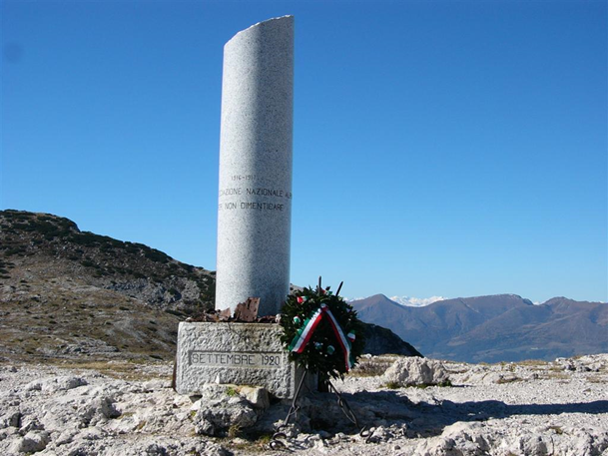
We reached the car parking area below the Monte Ortigara at 1500 hours. It was too late for us to walk to the summit, an overall three hour journey there and back. Information display boards gave details about the First World War combatants. The Battle of Monte Ortigara was fought by the 6th Italian Army Corps between the 10th and 25th June, 1917 and has been described as the “Italian Verdun”. The attack was launched against the Austrians who had been able to reinforce their defensive positions during their Strafexpedition – (Punitive Expedition) – in 1916. Although the Italians had a three to one superiority in men and guns they failed to dislodge the Austrians. The Italians sustained 23,000 casualties and the Austrians 9,000. The commanding general of the Italian 6th Army, Ettore Mambretti was held responsible for the defeat and was removed from his command. In 1920, the Alpini survivors from the battle erected a memorial column – the Colonna Mozza – on the mountain peak.
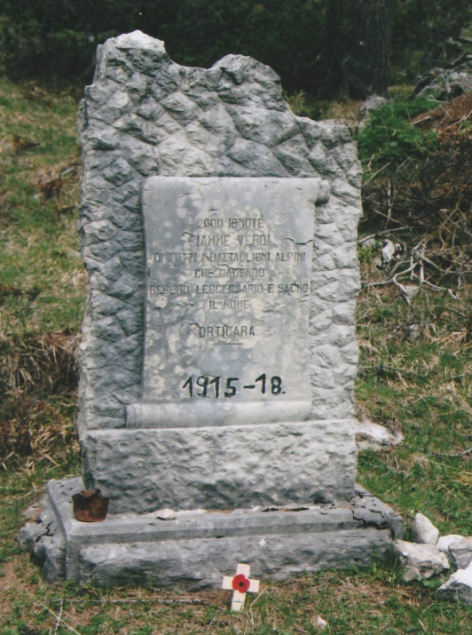
Monte Ortigara is of special significance to the Alpini who had the column inscribed with the words “In Order Not to Forget”. In 1960 the Austrians erected a memorial on a nearby peak, in remembrance of their soldiers who fought on the mountain. There were two small memorials, a short distance from the car park erected by the pathway leading up towards the summit. One was to 2,000 unknown Alpini soldiers who fought on the mountain and have no known grave. A Wessex Branch poppy cross was placed in front of this memorial.
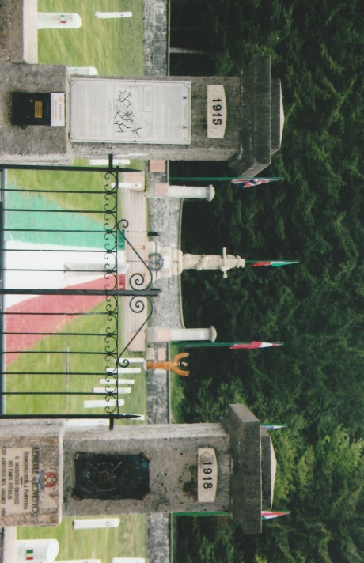
Our journey back to Asiago took nearly one-and-a-half hours and after passing through Canove and towards the village of Cesuna we stopped at Magnaboschi Military Cemetery. One of the five CWGC cemeteries on the Asiago Plateau, it contains 183 burials of the First World War most of whom had participated in the Battle of Vittorio Veneto fought between the 24th October and 4th November 1918. Opposite the British cemetery is the Italo-Austrian Magnaboschi Military Cemetery. During the 1930s significant numbers of identified soldiers from both sides were removed and taken to the Asiago Ossuary. The graves of those who still lie there both identified and unidentified – 1,739 Italian and 596 Austro-Hungarian – have broken pine tree stumps, approximately one-and-a-half metres in height, painted white, with the top edge chamfered, to which is attached a small inscribed plaque. On each of the tree stumps, below the chamfered edge is another small plaque in the colours of either the Italian or Austrian national flag which helps to identify from which country the casualty originated. There is a three metre high Cross of Sacrifice on the far side of the cemetery incorporating both a cross and bayonet. The wide pathway from the entrance gate to the Cross of Sacrifice is lined with gravel in the colours of the Italian national flag.
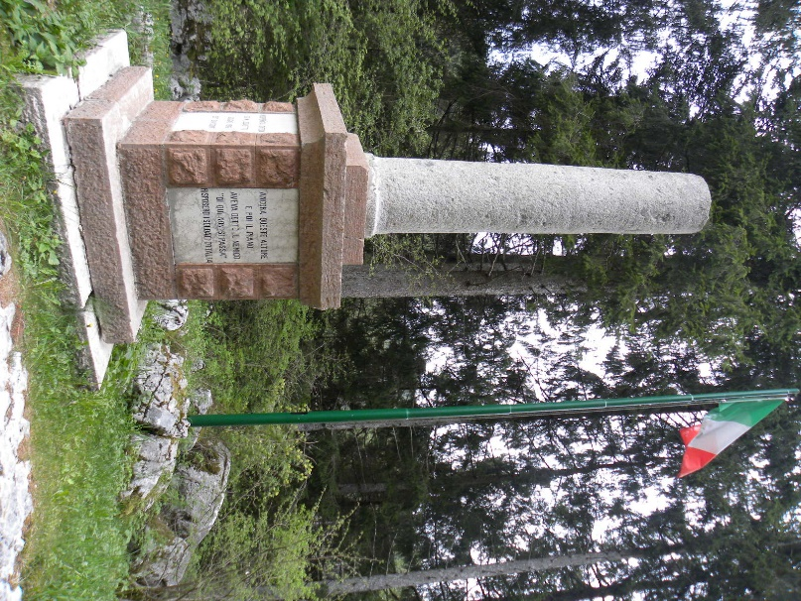
A short distance away to the right of the cemetery is the Colonna Romana, a marble column, donated by the city of Rome. It marks the position where the Italian 33rd Division brought to a halt the Austro-Hungarian advance in 1916.
We left this fascinating area of the Asiago Plateau at 1900 hours and drove back to Vicenza, arriving one hour later at our hotel. We expressed our thanks to the coach driver for his sterling work in driving up to Monte Ortigara, having never done so before. After a quick comfort stop at the hotel it was out again to enjoy another splendid Italian evening meal.
Friday was another early start as before us lay a two hour drive to Trento for a visit to the Alpini Museum. The drive along the S46 and S12 was very pleasant and relaxing as we passed through the green fertile Val Lagarina valley with terraced fields beneath the high rugged mountains. The Alpini Corps were formed in 1872, eleven years after the unification of Italy to guard and protect Italy’s mountain borders with France and Austria. Members of the Alpini Corps wear a distinctive feathered grey felt cap – the Cappello Alpini – which is adorned by a feather or ‘penna’ indicating the rank of the wearer as follows: a black raven’s feather for the lower ranks, a brown eagle’s feather for NCO’s and junior officers and a white goose feather for senior officers and generals. The badge worn on the front of the cappello has a ‘fregio’ or eagle beneath which is the coat of arms of each regiment. The Alpini are an elite corps of the Italian army and is the oldest mountain infantry in the world.
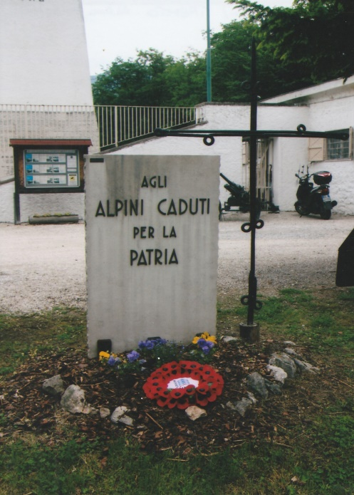
Access to the museum is via a steep winding hill – the Doss Trento – on the right bank of the Adige River. The road follows the contours of a rock outcrop and through a tunnel cut by the Alpini. Within the tunnel and set into the rock face is a memorial, with discreet low lighting and decorated with flowers. It commemorates the construction of the road and tunnel, begun in 1940 and completed two years later by 200 Alpini from five Alpini Divisions. On arrival we were warmly greeted by Brigadier-General Stephano Bassett and the President of the Associazione Nazionale Alpini (ANA) – the Alpini Association. The association was formed in July 1919 by the war veterans and today has over 300,000 members. After introductions we were given coffee by the Alpini Museum staff. A short but poignant service was held at the Memorial in the museum’s forecourt, where Martin accompanied by the Brigadier-General laid a wreath on behalf of the Wessex Branch WFA. This was followed by the exultation, a two minutes silence and the sounding of the Italian Last Post. Before entering the museum Brigadier-General Bassett and his staff were presented with Wessex Branch lapel badges which they promptly pinned to their uniforms. Brigadier-General Bassett gave us a personal tour, explaining the history and traditions of the Alpini Corps in peace and war. He spoke about Cesare Battisti, an important and revered figure in Italian political and social history. They have a life-size photograph of Cesare Battisti in the museum and interesting memorabilia associated with him. The museum has a fascinating collection of artefacts, documents, medals, militaria, photographs, maps and other material of the First World War and other conflicts. Opened in 1958 the museum is compact and all the artefacts and militaria are well displayed, many of them given by former members of the corps. A short stairway at the far end of the museum leads into the – Sacrarium of the Alpine Troops, the branch was again honoured by the placement of our wreath in this hallowed spot after our short commemorative service. In the centre of this revered place is a large rock brought down from Monte Grappa where so many Alpini Troops lost their lives and engraved on large white panels mounted on the walls, are the names of recipients decorated for valour in conflicts from 1848 to 1945. There are also paintings, gold medals and a triptych “Falchi e Prede” – “Hawks and Prey” – painted in the trenches by Mario Urbani. In an adjacent but separate building – the Uniform Hall – is a collection of military skis, uniforms and equipment of the Alpini. There is also small stable unit which contains a blacksmiths workshop and accoutrements for mules, a valuable asset for transporting supplies and equipment in the mountains. Arranged around the pathway outside the museum are large rectangular memorial stone pillars, each dedicated to an Alpini battalion.

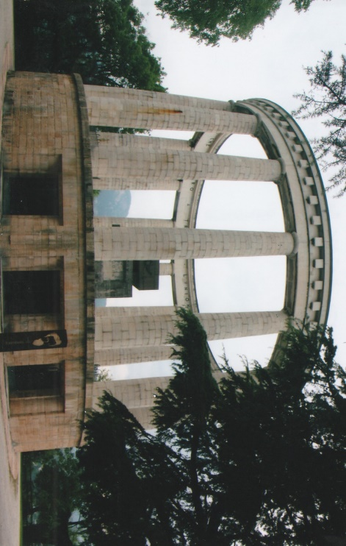
We then walked through the museum grounds to the 10-metre high Mausoleum of Cesare Battisti. The mausoleum, a classical circular building overlooks the city of Trento. Around the top of the entablature are the words: TO CESARE BATTISTI-WHO PREPARED IN TRENTO-THE UNION TO THE MOTHER COUNTRY- AND THE FUTURE DESTINIES. In the centre of the raised exterior first floor is an altar supporting a large commemorative tombstone inscribed with the date “12th JULY 1916 and the name “CESARE BATTISTI”. At ground level three doors open to the interior of the mausoleum where the hypogeum contains the elliptical cell that protects the cask containing Battisti’s remains. Positioned in a semi-circular niche is a marble bust of Battisti sculpted by Eraldo Fozzo. The mausoleum was dedicated on the 26th May 1935 in the presence of King Vittorio Emanuel III.
Cesare Battisti was born in Trento on the 4th February, 1875 and after attending local schools he studied at Graz, Vienna and Florence where he was awarded his degree in 1897. He married Florence Ernesta Bittani in 1899 and subsequently they had three children. Cesare founded and edited weekly newspapers and magazines espousing his socialist and political views. He also published several scientific papers and a history of Trentino and its culture. In 1902 he was elected to Trento’s city council and to the Parliament in Vienna nine years later. In 1914 he was elected a member of the Innsbruck Diet. When Italy entered the First World War in 1915 he volunteered to join the Alpini Corps. At the beginning of July 1916 he was captured by the Austrians during an attack on Monte Corno in the Vallarsa valley. Charged with high treason due to his Austrian citizenship he was court martialled, found guilty, and sentenced to death. He was hanged on the 12th July 1916 in the moat of Castello Buonconsglio, Trento.

At the conclusion of our visit, Martin was presented with an illuminated scroll and a circular Alpini Crest by Brigadier General Bassett. We were the first WFA Branch and English party to visit the museum.
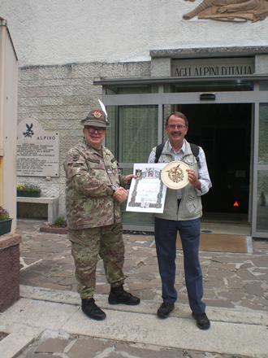
We drove from the mausoleum into Trento for lunch with the Brigadier-General at the Alpini Association Club. There, Martin was presented with a Trento Alpini flag pennant on behalf of the President of the Alpini Association. We had a splendid ‘Alpini’ lunch during which the Brigadier-General related to us snapshots of his career and some amusing stories. In the congenial atmosphere toasts were drunk and thanks expressed to Brigadier-General Bassett and his staff for the privilege of being able to visit the splendid Alpini Museum. Appropriately we concluded the lunch with a final toast of grappa and recorded music and songs of the Alpini. On leaving the club we were greeted by lightning heralding a thunderstorm and heavy rain. Sheltering for about twenty minutes we made a dash for our coach and returned Vicenza.
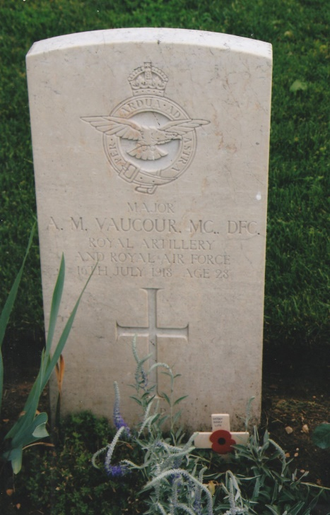
Saturday’s tour of the Asiago Plateau began at Montecchio Precalcino Communal Cemetery Extension, located 18-kilometres, north of Vicenza. We left the A31 near Dueville and followed CWGC directions to the cemetery, which contains 439 burials of the First World War. Between April 1918 and November 1919 those who died in the 9th, 24th and 39th Casualty Clearing Stations were buried in this cemetery or at Dueville. Some of the casualties were concentrated in the cemetery from other burials sites. At the grave of Major Awdry Morris Vaucour MC & Bar, DFC, Richard gave a short talk about his career and sad death. The aircraft he was flying was mistakenly identified as an enemy machine and shot down. We also visited the adjacent civilian cemetery where Fabio informed us about Italian burial customs. Before leaving the village we stopped at their war memorial to pay our respects.
From Montecchio Precalcino we re-joined S349 and ascended the Asiago Plateau, stopping at Campiello railway station, no longer in use.
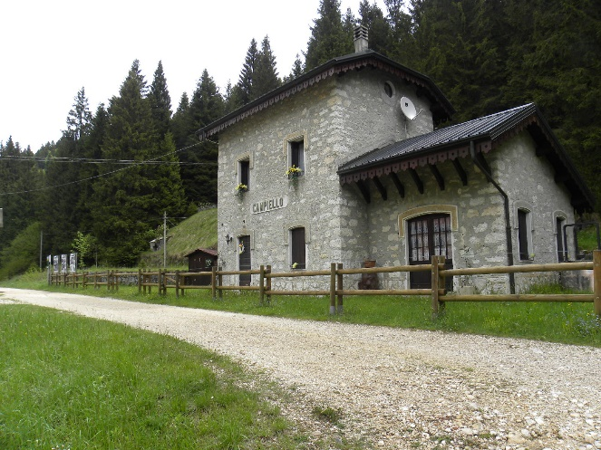
During the First World War it was an essential part of the logistic chain from where stores and equipment were taken up to the front line areas. The railway line was removed some years ago and is now a pathway for walkers and hikers. Information display boards give details about Campiello and the railway during the war. Moving on and passing through the Ghelpac Valley we arrived at Canove, stopping in the disused railway station yard.
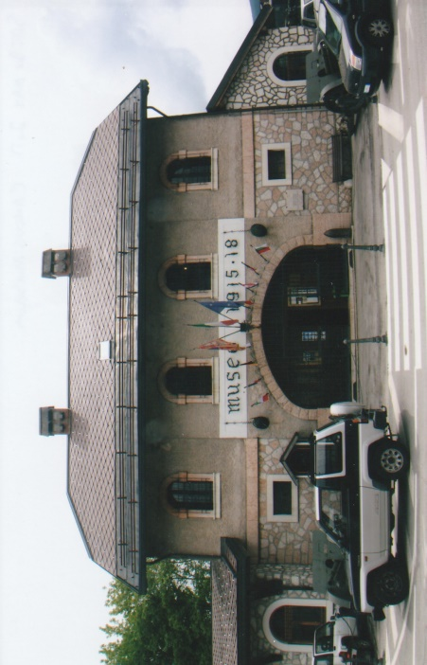
The railway station building is now a museum – Museo della Grande Guerra 1915-18 – and has a comprehensive collection of First War Memorabilia. Among them is an electrical contraption which was used to treat wounded and infectious casualties with ultra-violet radiation. Arrayed outside the museum are field guns and a well preserved railway steam engine. Leaving the museum at 1215 hours we drove into Asiago where there was, a street festival celebrating children, their games and activities. After lunch at the Stella D’Oro Pizzeria we drove from the town along the SP72, from where we turned into a pine forest and on to the Barenthal Road. A stop was made to view some disused and ruined concrete structures. These buildings were once part of an underground hospital complex used by the Italians and British units.
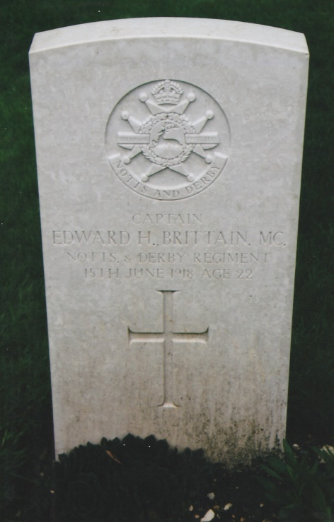
We then moved on to Barenthal Military Cemetery which contains 125 First World War burials. The 48th Division which was part of the Italian Sixth Army remained in the mountains and most of the burials relate to the fighting during the Battle of Vittorio Veneto – 24th October to 4th November 1918 – the final defeat of the Austrians. Our next visit was to Granezza British Cemetery where 142 casualties of the First World War lie. On the 15th-16th June 1918 the Austrians launched an attack and penetrated the Allied line but were forced back and ground they gained was lost. Many of the graves have the aforementioned dates and among them is that of Captain Edward Brittain MC, brother of Vera Brittain author of Testament of Youth.
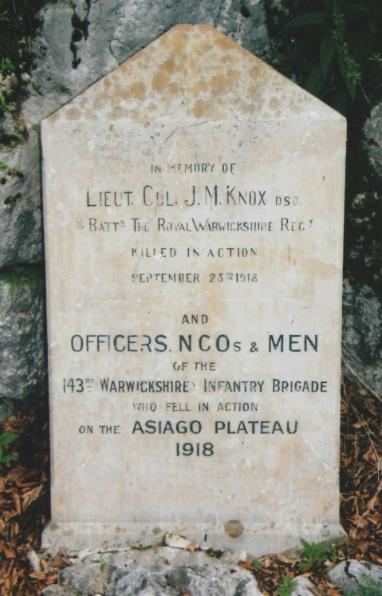
Also buried in this cemetery is Lieutenant-Colonel J.M Knox DSO, 1st/7th Battalion, Royal Warwickshire Regiment who was killed in September 1918. A short distance from the cemetery, by the road side is a memorial to Lieutenant-Colonel Knox and to all ranks of the 143rd Warwickshire Infantry Brigade who died on the Asiago Plateau in 1918, erected by his family.
Although it had begun to rain it did not stop us paying our respects in these cemeteries including Cavalletto British Cemetery. Although quiet remote, it is beautifully situated at the foot of an escarpment on the valley floor. One of our members remarked that if the families of these 100 deceased men knew where they lay they could not have wished for a better resting place.
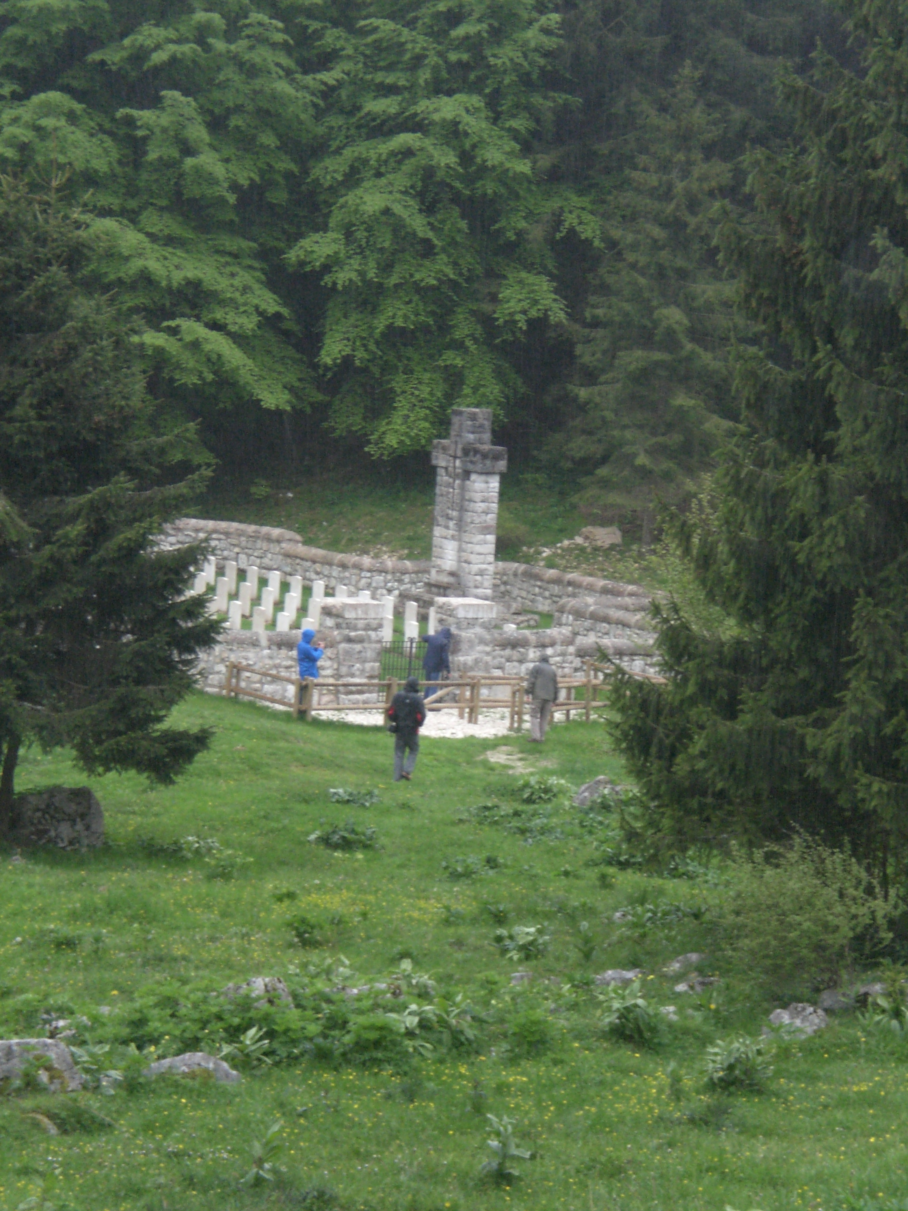
Having visited the five CWGC cemeteries on the Asiago Plateau we drove on in heavy rain and a blustery wind. A brief stop was made at a Restaurant on the 1240-metre summit of Monte Corno for take away hot drinks. Descending the mountain our driver negotiated 16 hair-pin bends to the valley floor passing through the lovely villages and hamlets of Lusiana, Velo, Salcedo, San Giorgio, and Breganze and into Vicenza. As we drove through the suburbs we passed by the 13th century fortified city wall arriving at the hotel soon after.

Arrangements had been made for us to visit Gianni Periz, President of the 3rd November 1918 Association after our evening meal. We were welcomed by Gianni, his wife, family and their dog on the doorstep of their beautiful house. Taken up to the first floor in two separate groups, with Fabio translating for us we entered his study which was overflowing with militaria, books, photographs and albums, maps, documents and other memorabilia. It was difficult to decide where Gianni’s collection began and ended not being confined to the First and Second World Wars but to other conflicts as well. Gianni has an extensive knowledge of the fighting on the Asiago Plateau and in the surrounding mountains and was enthusiastic and enjoyed sharing his information with us. This was an outstanding private archive which would form a basis of a museum collection and we suggested to him that he should endeavour to record and catalogue it. Taken back downstairs it was clear from other visible memorabilia that Gianni was an avid and passionate collector. We spent some time talking to his son who had been educated in Italy and Canada. As well as sharing a glass of wine with our host, it had been a privilege to see this private collection and handle some of the artefacts and material. We left after two hours of Italian hospitality and expressed our grateful thanks to Gianni. Some members then meandered to the nearby streets of Vicenza and others walked back to the hotel. It had been another outstanding and absorbing day for all of us.
Sunday morning dawned bright and sunny and with our driver for the day Franco, we set out for Monte Pasubio. Straddling the border between the provinces of Vicenza and Trento, Pasubio is an Alpine limestone massif rising to over 2,200-metres above sea level. At 1,250-metres is the Ossuary of Pasubio erected on Bellavista Hill with commanding views of the Val Leogra and the surrounding mountains. Construction began in 1920 and was completed six years later. The project was initiated by the ‘Foundation November 3rd 1918’and inaugurated on the 29th August 1926. Designed by Ferruccio Chemello with adornments by Tito Chini and Umberto Bellotto the tower is 35-metres in height with a lantern at the top. Within the tower a vault contains the remains of the dead and there is a shrine to their memory. The vault at the base of the tower has a central crypt and two concentric galleries. Within the crypt are the remains of seventy casualties decorated for their valour and that of General Galeazzo who commanded the First Army from May 1916 to November 1918. It was his wish to lie there and in 1953, twelve years after his death he was interred in the crypt. The Ossuary is dedicated to the memory of those who died in the First World War and contains the remains of 5,146 Italian soldiers and forty Austrians who died on Monte Pasubio. On the last Sunday of June a service is held to commemorate the anniversary of the battle fought on the nearby mountains on the 2nd July 1916.
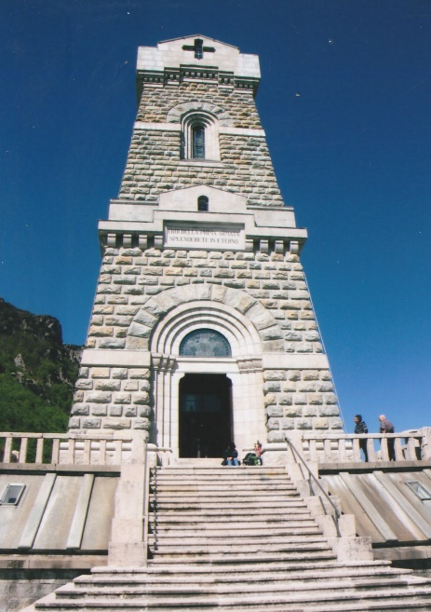
Leaving the A31 Autostrada we drove via Thine, Schio, Torrebelvicino, Valli Del Pasubio, San Antonio and then began the drive up to the Ossuary, Franco taking 14 hair-pin bends before arriving at the car park did exceedingly well in negotiating the climb and avoiding the cyclists and hikers on the narrow mountain road. However, the views from the car park across to the surrounding mountains and valleys below were magnificent as the morning air was relatively clear – a photographic heaven. Gianni arrived shortly after with another member of the 3rd November 1918 Association, Giuseppe Alessandro. Martin presented them with a Wessex Branch lapel badge which they wore with pride. Giuseppe in tracing his family history thought that his grandfather’s name had been omitted from those recorded on the memorial tablets in the ossuary. He discovered that his grandfather’s name was inscribed on one of the memorial tablets, but had been incorrectly spelt.

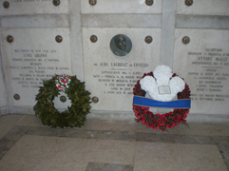
Gianni gave an excellent account of the fighting which took place on Pasubio between the Italians and Austro-Hungarians during the war and the exceptional engineering undertaken by the Italians to carve out roads and pathways that enabled them to occupy, defend and fight on the mountain. Before the engineering work had started over two hundred Italian soldiers were killed in an avalanche close to where the memorial now stands. The front line was a few metres over the mountain peak where the opposing forces faced each other across a saucer-shaped depression on the plateau. (Pasubio – which means a high meadow where shepherds grazed their animals). On completion of his talk we entered the crypt with Gianni and Giuseppe where walls of the galleries are covered with marble tablets inscribed with the names of those interred within. In the very centre of the crypt directly below the centre of the tower are interred the remains of those decorated for valour. Two beautiful wreaths had been laid here, one placed by HRH Prince Charles who had made a visit in commemoration of the 100th Anniversary of the battle in 1917. The other wreath was laid by the 3rd November Foundation. Returning outside we walked round to the front of the monument and ascended the steps into the memorial chapel. Facing us was an altar surrounded by stained glass windows. The internal wall space is decorated with murals of saints and soldiers. A narrow interior stone stairway skirting around the walls of the tower leads up to the top floor gallery. To gain access into the lantern it was necessary to climb carefully up a long steel ladder. Through the windows the visitor is able to get good all round panoramic views of the alpine scenery.
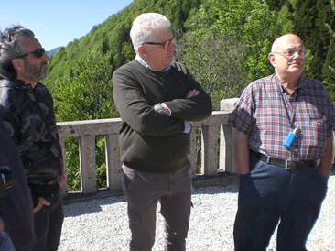
We had a brief coffee break and then visited the 3rd November 1918 Association Museum, situated a short distance away from the memorial tower. The museum is housed in the former summer residence of Bishop of Vicenza. Gianni gave as a guided tour of the museum explaining about the exhibits, dioramas and orientating us to where the Italians fought on Pasubio. The museum is spacious, with good lighting and all the artefacts are well displayed for easy viewing. Bidding farewell to Giuseppe, Gianni and some of his family who had also made the journey to the Ossuary and museum, we thanked them for their time spent with us and imparting their knowledge about the First World War and fighting on Monte Pasubio.
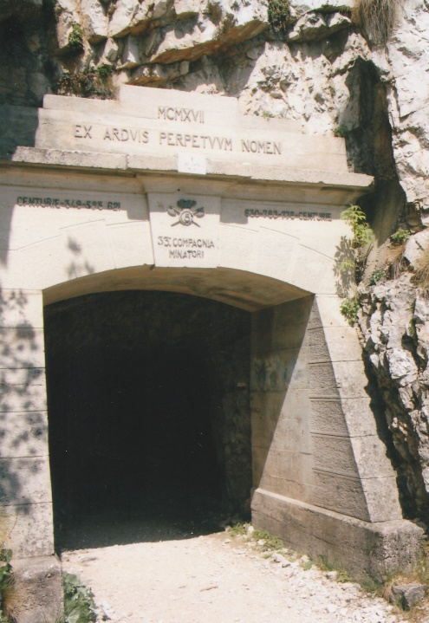
Returning to the coach we drove a short distance to a restaurant for lunch. Leaving there at 1400 hours we descended the steep and twisting road until we reached a turning onto a narrow road, barely wide enough for two cars to pass each other and began another ascent up to the Strad delle 52 Gallerie – Road of 52 Tunnels. The road also known as the Strada Della Prima Armata – Road of the First Army was built on Monte Pasubio during the First World War. Begun in February 1917 between Bocchetta Campiglia at 1,216-metres and Porte del Pasubio at 1,934-metres across the southern slopes of the mountain, with its deep ravines and sheer rock faces, was beyond range of the Austrian artillery. The pathway from the car park to the summit is approximately 6‧5-kilometres in length of which 2‧3-kilometres are divided into 52 tunnels excavated through the rock structure. Each tunnel is numbered and named. The longest is 300-metres but the average length is between 40 and 90-metres and a minimum width of 2‧2-metres, which allowed two mules to pass through with their baggage. This extraordinary undertaking by the 33rd Company of the Italian Army with six hundred workers was completed November 1917. It was of strategic importance as it allowed the transportation of military equipment from the base areas to the summit of Monte Pasubio throughout the year and in relative safety.
Gianni Periz our guide at Pasubio presented a recently published book ‘La Strada Della Gallerie HA 100 Ani’ by Claudio Rigon and edited by the Club Alpine for our Branch library. The publication coincided with the 100th Anniversary of the construction of the tunnels begun in March 1917 by the Italians on Monte Pasubio. The book in English and Italian has maps and photographs of the tunnels on Monte Pasubio and is ‘full of the history and memories for the people in Schio and neighbouring towns’.
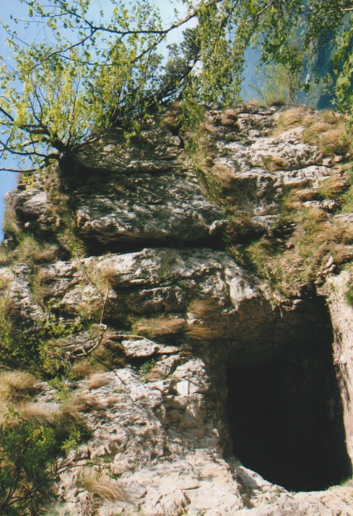
Our driver Franco, skilfully drove up the narrow mountain road and after 5-kilometres stopped at the Rifugio Col Del Xomo, to check how much further it was to the car park for the galleries. After another 1‧5-kilometres of very tight turns overlooking sheer drops and rock strewn slopes we arrive at the car park. Information display boards at the entrance to the pathway leading to the tunnels give details about the 52 Galleries. To get to first gallery it is necessary to walk up a rough pathway strewn with broken rocks and scree and extreme care has to be taken as on one side of the pathway is a precipitous drop. Not only has care to be taken on the pathway, an awareness of the altitude has to be taken into consideration. It was a relief after traversing two particularly steep inclines to arrive at the first tunnel and to walk through it. The tunnels are dark and the underfoot surfaces are uneven and slippery. Members walked as far as they wanted to in the time available and took extreme care in walking back down to the car park.
The Strada delle 52 Gallerie are a fine legacy to the memory of the tough and resourceful Italian engineers. There was no ready-made pathway for them. They had to cut their way through thousands of tons of rock with equipment they had to bring up with them to do it. This area around Pasubio, is known as the “Sacred Area of Italy” in remembrance of the thousands of soldiers who fought and died there. We began our descent back to the main road a 1545 hours. On the way down, we briefly halted by a hairpin bend to observe shepherds grazing a flock of sheep, goats and donkeys. One of the latter had just given birth and the young foal was struggling to stand upright whilst its mother lay exhausted on the grassy bank.
That evening we were able to meet an 89-year-old World War II Italian Partisan, Eugenio Magri in the hotel lounge. He was accompanied by Danilo Androlla, President of the Associazione Nationale Partigiano d’Italia (ANDI). Eugenio was a spritely and communicative man. With Fabio translating, he told us about his early life and of joining the Partisans at the age of 15. After the fall of Mussolini in the late summer of 1943 a political crises gripped Italy. The Germans, supported by the Fascists made everyday life for ordinary Italians very difficult and divided family loyalties. The Germans transported thousands of Italians to concentration camps in Germany. Two women were shot at Vicenza railway station for giving water to the deportees. The majority of the populace of Vicenza did not support Fascism and subtly aided the resistance movement. Vicenza was uniquely awarded two gold medals for their ‘Risorgimento’ and ‘Resistenza’ by the Italian state. Eugenio related his wartime experiences clearly and concisely and still has a fierce pride for what he and his comrades did for Vicenza and Italy. He regularly visits schools and talks to children about the horrors of war and what the Italians had to endure. Eugenio’s father was killed in an Allied bombing raid, but he bears no grudges and is grateful for what Great Britain did during the war and after for Italy. Danilo presented Martin with two calendars, signed by him and Eugenio, and information about the Partisans for our Branch which is due course will be translated for members. Martin presented the two guests with Wessex Branch lapel badges. Eugenio asked if we had any information about the London Blitz as he wanted to tell the school children about the bombing of London during the Second World War. A suitable book will be forwarded to him. He talked for about ninety minutes and told us what he tells the children that ‘History awakens to the present the errors of the past’. Thanking us for visiting Italy and the battlefields of the First World War we shook hands and he bid us ‘arrivederci.’ It was fascinating to listen to him and we had much to think about and consider during our evening meal.
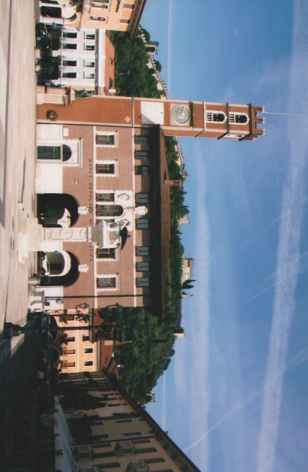
Monday morning was again sunny and warm as we drove out along the SP248 and SP119 to the medieval town of Marostica. There, we had free time to walk around the town square and where Fabio gave us a brief talk about its cultural history, the being famous for its bi-annual human chess game with living chess pieces in the town square. A large keep tower dominates the entrance into the town square. On one internal wall is a memorial tablet to four partisans who were executed there in 1944. Above the town there is a ruined medieval castle and its defensive walls descend to encircle the hillside and the town centre.
Leaving there, mid-morning we continued our excursion towards the 1,750-metre summit of Monte Grappa. After passing through the small town of Romano d’Ezzelino we began the ascent negotiating 14 hair-pin bends. We stopped at hair-pin 7 to view a FWW observation post and memorial which overlooked the plain below. Near to the summit of Monte Grappa is a large bronze statue, commemorating the partisans who fought in the mountains during the Second World War. It took our driver fifty minutes of intense concentration before reaching the car park at mid-day. The mountain air was cool and the views wherever one looked were overwhelming almost defying description.
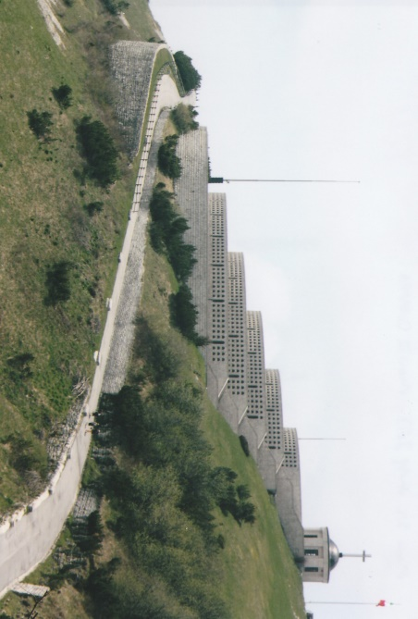
During the First World War three battles were fought for control of Monte Grappa as its left flank covered the Italian Piave front. After the Italian defeat at Caporetto in the late autumn of 1917 they strengthened their defensive positions on Monte Grappa which became an impregnable fortress. The first battle was fought from the 11th November to the 23rd December 1917, when the Austrians supported by the German Alpine Corps, failed to capture the mountain. Their failure enabled the Italians to stabilize their front along the Piave. It was not until the summer of 1918 that the Austro-Hungarians launched their last offensive – Second Battle of the Piave – on a wide front but were unable to dislodge the Italians on Monte Grappa. On the 24th October 1918 the Italians began their final offensive of the war against the Austro-Hungarian units on Monte Grappa with nine divisions. The Austro-Hungarians responded by committing all their reserves without success and their exhausted army began a general retreat on the 28th October. The Italians sustained 55,000 casualties in these three battles and the Austrians 29,000.
The Sacrario Militare del Monte Grappa on the summit was designed by Giovanni Greppi with the co-operation of the Sculptor Giannino Castiglioni. “Art Deco” in style this monumental ossuary is the largest in Italy and was inaugurated on the 22nd September 1935. Basically the monument is composed of three connected parts stretching across the mountain top. The Italian ossuary at the southern end is constructed in five layered concentric circles to form a low pyramid and contains the remains of 12,615 soldiers of which 2,283 have been identified. The Austrian ossuary at the opposite northern end contains 10,295 remains of whom, 295 are identified. The ossuary’s are connected by the Strada Eroica (Heroic Way). On either side of the Heroic Way are seven pairs of cippi – large rectangular boundary stone blocks – on which carved in relief are the names of the places where the Battles of Monte Grappa were fought. Situated above the Italian ossuary is the small chapel sanctuary of the Madonnina del Grappa. Inset into the layered walls are bronze tablets. Behind each individual bronze tablet, inscribed with the name of the identified soldier is a niche into which the body of the casualty was placed. Along the Heroic Way and on the hill side leading up the monument are several small memorials commemorating individuals or units that fought on Monte Grappa. We spent nearly two hours slowly walking around this mountain top monument which has a peaceful resonance. As a point of interest a number of the towns and villages added the words del Grappa, for example Paderno del Grappa after the First World War in memory of the sacrifices made on Monte Grappa range.
It was convenient to have lunch at the restaurant situated a few metres below the summit. On the walls of the restaurant are photographs taken during the war of the soldiers working and fighting on Monte Grappa. We left at 1500 hours and slowly descended admiring the panoramic views.

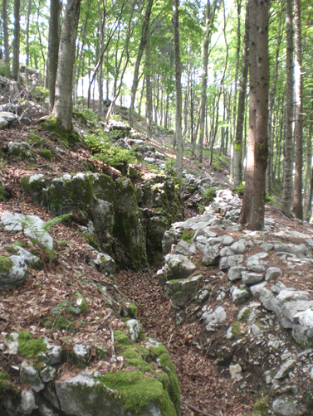
We stopped at an Italian observation position signposted for the 100th anniversary commemorations, ‘Alsito B1’. At a height of about 1,000-metres, the limit of the tree line we descended down a steep pine forest pathway and now part of a hikers trail which was not easy to traverse but we were rewarded as a trench system came in view. The Italians had utilised the natural rugged outcrop of rock, facing northward and fortified it.

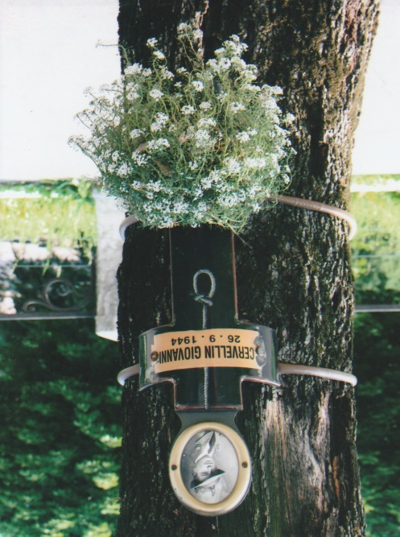
Re-joining the main road we drove on to Bassano del Grappa. There we walked through an old city gate to view a tree lined avenue, the Viale de Martini (Martyrs Avenue) by the River Brenta. The trees had been used by the Fascists to hang 31 partisans on the 20th September, 1944. Around each tree is a stylised memorial cross onto which is painted the outline of a hangman’s noose. Attached to the cross is a named photograph of the partisan with a posy of fresh flowers beneath. On the inner wall of the gateway entrance is a memorial tablet inscribed with the names of these partisans and another 16 who were shot. We then walked on through this beautiful city to a wooden covered bridge the Ponte degli Alpini, spanning the River Brenta. The bridge was originally designed by Andrea Palladio in 1569. Destroyed on several occasions over the succeeding centuries the Ponte Vecchio as it was then known, was severely damaged during the Second World War. It was rebuilt in 1948 by the Alpini, hence it is now known as the Ponte deli Alpini and on the far side of the bridge is a small Alpini museum. Currently the bridge is being refurbished. Since 1779 grappa has been distilled in Bassano and the Poli Grappa Museum is situated in the town. An enjoyable hour spent in Bassano before we returned to Vicenza completing another superb day of our tour.
For our last evening meal in Vicenza we were taken by taxi into the city. After our meal we strolled through the streets into the main square, with its Palladian architecture and enjoyed a night-cap at a café/bar in the square, sitting outside in the warm evening air. Some members then chose to walk back to the hotel others went by taxi.
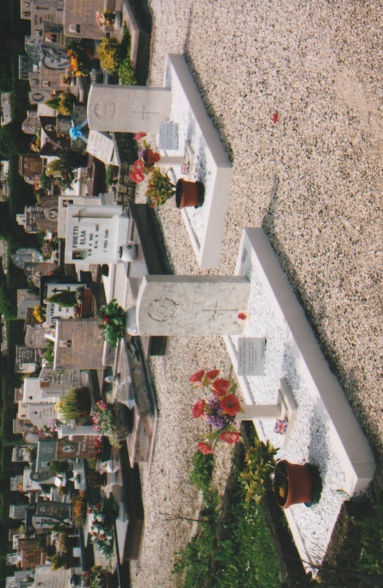
Our Tuesday return flight from Venice to the UK was at 1755 hours. With our luggage loaded we left Vicenza via the SP11 and drove to Montecchio Maggiore – twinned with Alton in Hampshire. We drove up a steep hillside to the Castle Bella Guardia or Juliet’s Castle once a ruin but later reconstructed and now includes a restaurant and bar. From the ramparts there were excellent views of the town and a few hundred metres distance, slightly lower down is the Castle of the Vila or Romeo’s Castle built in the 14th century and partially dismantled in the 16th century. These two mediaeval castles facing each other were once in the possession of two feuding families, the Capuleti and Montecchi. Vicenza born Luigi da Porto (1485-1529) invented a story about two lovers from these rival families. William Shakespeare later used da Porto’s text to create his famous play Romeo and Juliet. A tunnel and cave system below these castles were utilised during the First World War as shelters and a nearby villa was used as a hospital. The town was on the logistic supply route from France to Taranto for the troops based at Salonika.
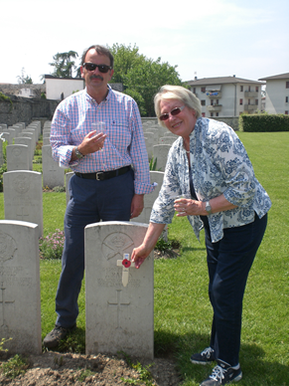
From the castle we drove to the Montecchio Maggiore Communal Cemetery where there are two CWGC graves. Buried here are Private Joseph Styles of the 1st/6th Battalion, Gloucestershire Regiment who died on the 11th April 1918 aged 42 years and immediately in front of his grave is Staff Sergeant Ernest Reason, 25th Field Bakery, Royal Army Service Corps who died on the 14th January 1919 aged 35 years. Both of these two graves are immaculately cared for by the local association of the Alpini who had placed a commemorative plaque on each grave with flowers and potted shrubs. Martin formally placed a cross on each grave. It was then necessary to drive back to Vicenza where Fabio, having other commitments left us. From Vicenza we drove 12-kilometres in a northerly direction to Dueville Communal Cemetery Extension.
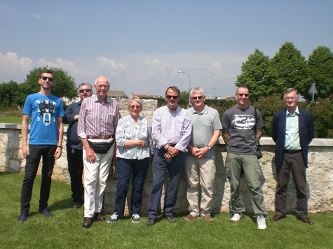
There are 134 commonwealth and two French burials of the First World War in the cemetery. From April 1918 to the first few months of 1919 the 9th, 24th and 39th Casualty Clearing Stations were located in Dueville village school. We toasted with grappa all those who were at rest in the cemetery, with Viv and Marc locating and toasting the memory of two members of the Hampshire regiment and also had a group photograph with our coach driver. On our drivers recommendation we lunched at a restaurant in Dueville square. Emerging into a hot and sunny afternoon after an excellent meal we boarded the coach for the journey to Venice.
By 1600 hours we had passed through passport and security controls at Marco Polo airport and duly boarded an air bus A319 for the flight to Gatwick. Landing at 1910 hours (UK time) we had exited the airport by 1945 hours and rendezvoused with our Homeward Bound taxi driver Neil. Richard was the first to leave us at Medstead, followed later by Viv, Ian and Marc at Salisbury. Martin, Judy, Steve and Roger arrived at Wareham at 2335 hours where the latter two drove themselves by car to Weymouth and Portland respectively.
As with Verdun, this was a ‘gold standard’ battlefield tour. We visited all the CWGC cemeteries on the Asiago Plateau as well as some of the Italian and Austro-Hungarian cemeteries and ossuary’s. It was a different kind of war that these soldiers fought at altitude across the Asiago Plateau and on mountain peaks. Whoever those participants were they deserve to be remembered and commemorated with honour. Our warm thanks are extended to Fabio for his knowledgeable support and to Gianni, Giuseppe, Eugenio, Danilo and Brigadier-General Bassett and his staff for their contributions. Our tour of the Asiago Plateau could not have been achieved without the skill of our Italian coach drivers supplied by Giorgio Muraro. To Lucia Barban and her staff at the hotel we extend our grateful thanks and to Neil the Homeward Bound taxi driver.
Above all without the enthusiasm and determination of Martin and Judy in the planning, organising and liaising with our Italian friends this tour would not have been the great success it was. We tour members extend to both of you our very sincere thanks. The Wessex Branch WFA can take immense pride in this tour to Italy – a first – and for establishing valuable cultural links in Italy concerning the war on the Italian front. Finally, may the light shine eternally on all those soldiers of war who fought and died on the Italian front during the First World War and now rest in peace surrounded by evergreen pine forests and guarded by the Alpine mountains of Italy.
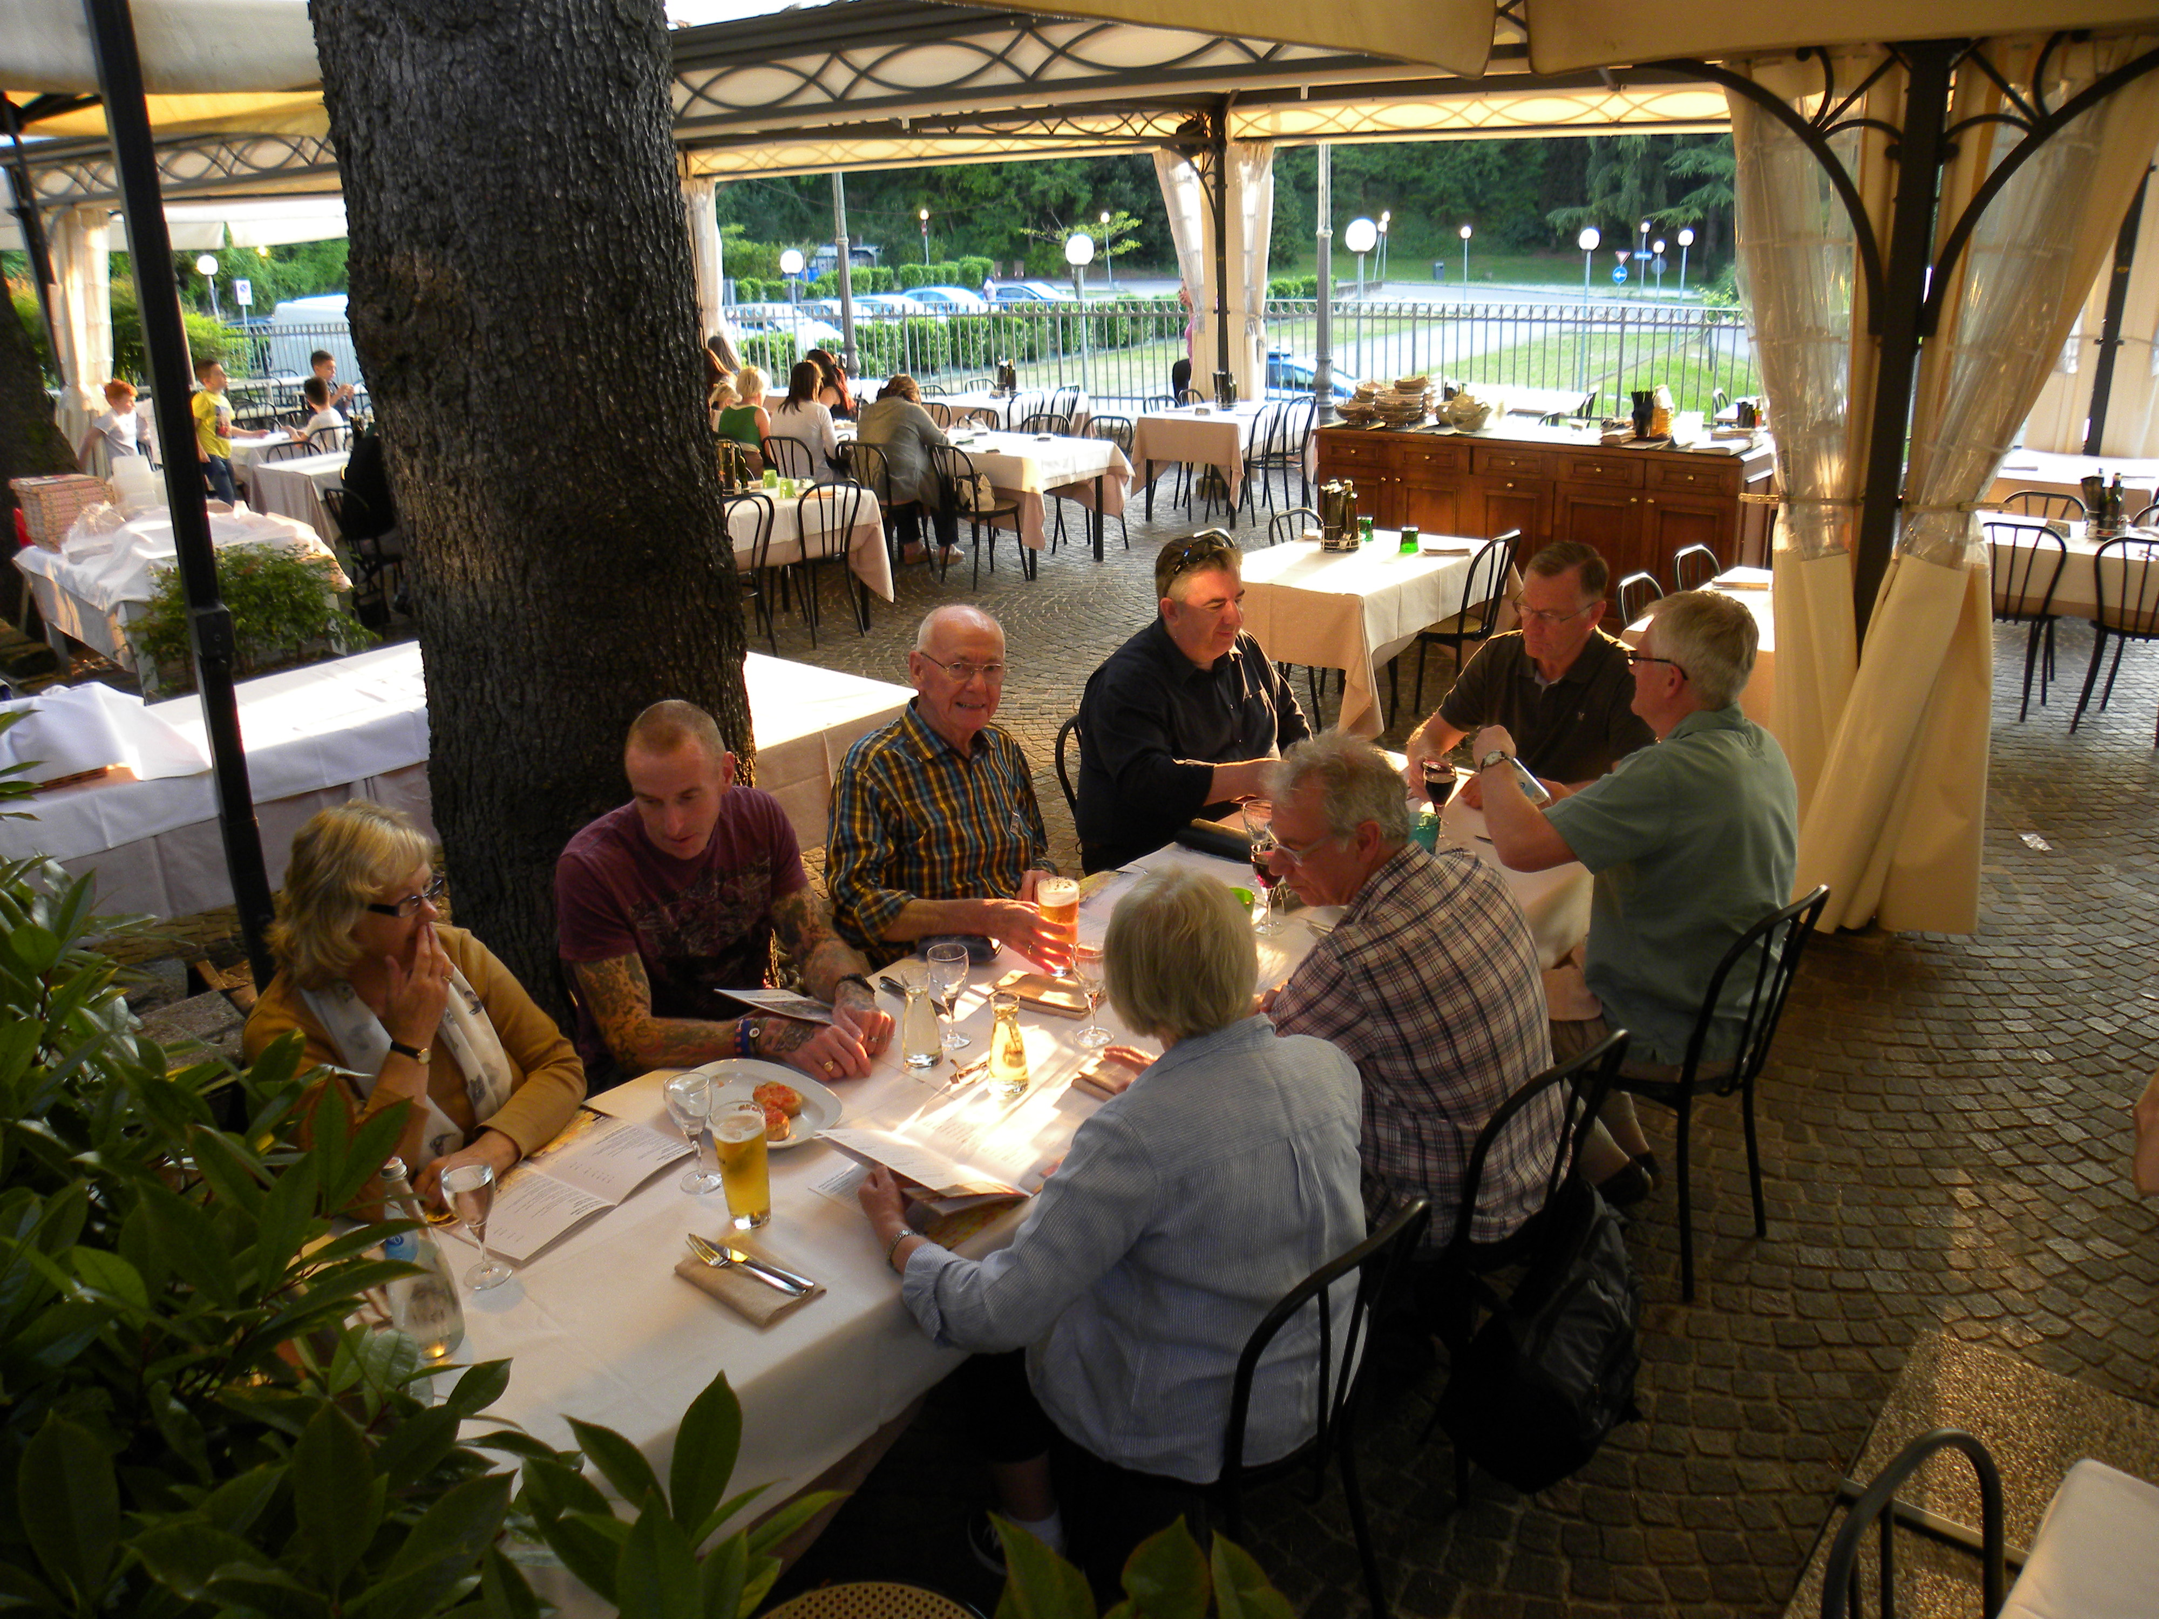
SALUTI!
Sources
Wikipedia Web-Site ~ www.wikipedia.org
Commonwealth War Graves Commission Web-Site ~ www.cwgc.org
Numerous Italian Web-Sites ~ Regarding information on FWW Italian Battlefront, Topographical Subjects, Cities, Towns, Memorials and Ossuary’s.
Italian Map Web-site ~ www.tabacoeditrice.com
Michelin Map 354 ~ Trentino-Alto Adige.
Various Italian Leaflets and Guides.
Asiago – Italy by Francis Mackay ~ Battleground Europe Series Pen & Sword Books Ltd. ISBN 0850527597
Personal Photographs.
R.G. Coleman
©RG COLEMAN & WESSEX BRANCH WFA

