FIRST WORLD WAR BRONZE MEMORIAL PLAQUES
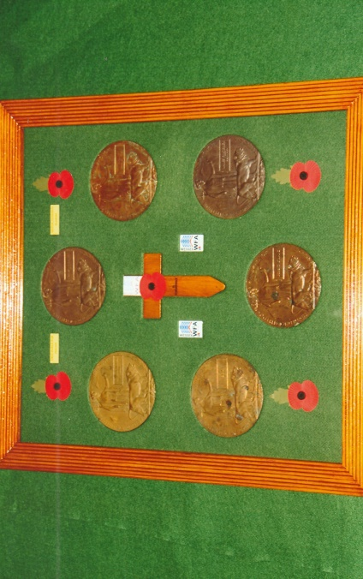
The bronze memorial plaque was issued to the next-of-kin of British and Empire servicemen and women who had died between the 4th August 1914 and 30th April 1919 serving their King and Country during the First World War. In August 1917 a government committee announced that a competition was to be held for members of the public to submit proposals for a memorial bronze plaque incorporating specific competition terms and conditions into the design. Over 800 designs were submitted and the entry by Edward Carter Preston was chosen. A renowned sculptor and medallist, Edward Carter Preston (1885-1965) was born in Liverpool. In 1931, at the invitation of the architect Giles Gilbert Scott (1880-1960) he began a series of sculptures for Liverpool’s Anglican Cathedral – a project which was to last 30 years – producing 50 sculptures, 10 memorials and a number of carved reliefs.
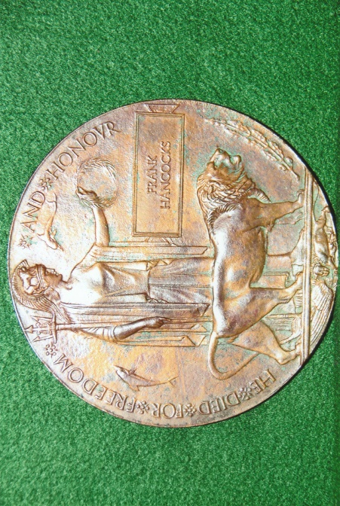
The obverse of the 122mm diameter memorial plaque has the robed and helmeted figure of Britannia standing behind a menacing lion facing left. Clasped between her right arm and body is a trident. In her left hand is a laurel wreath and beneath is a rectangular panel with the name of the deceased in relief lettering. Directly in front of the lion’s head is an oak branch and acorns. Behind and in front are two dolphins representative of Great Britain’s sea power. Around the circumference is the approved inscription “He Died for Freedom and Honour” for servicemen and “She Died for Freedom and Honour” for servicewomen. In the exergue is another lion devouring a German Eagle. The reverse of the memorial plaque is blank.
Production of the plaques began in December 1918 at the Memorial Plaque Factory, 54-56 Church Road, Acton, London.
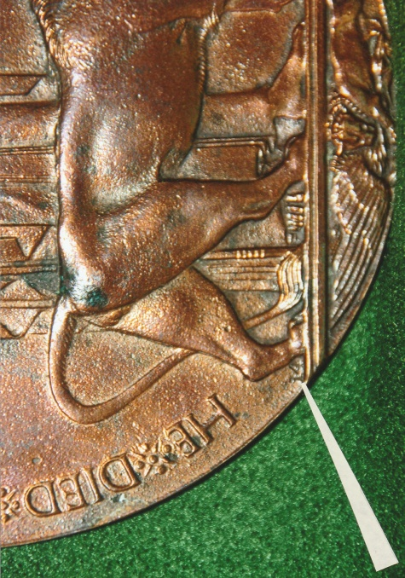
Mass production of the plaques was out of the question as each plaque had to be produced individually and named to a deceased person. In December 1920 the production of the plaques was transferred to the Royal Arsenal Woolwich. Initially the early Action plaques did not have any identifying numbers in front of or behind the lion’s rear leg. Later for reasons of quality control each worker had a specific number which can be found behind the lion’s rear-most leg. Plaques produced at Woolwich have the workers number between the rear leg and tail of the lion and the plain reverse is stamped with “WA” superimposed on each other within a circle. Edward Carter Preston’s initials E.C.P. can be found to the right of the lion’s right foreleg. The final production figures of the memorial plaques amounted to 1,365,000 of which approximately 600 Acton Plaque – Worker Number 14 hundred were named to women.
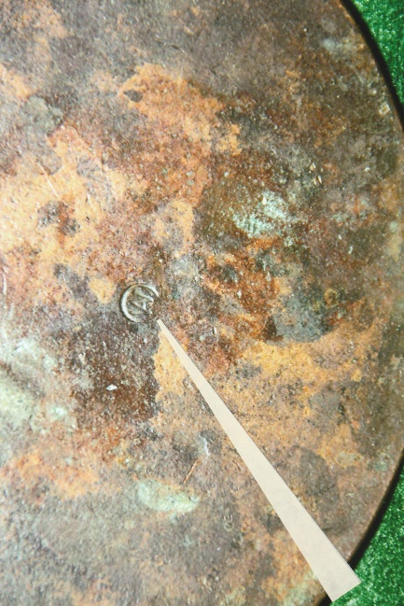
When completed each plaque was placed in a thick waxen cardboard envelope in readiness for despatch to the next-of-kin. A condolence slip and Illuminated Memorial Scroll accompanied the memorial plaque when it was forwarded to the deceased’s relatives.
Woolwich Arsenal Plaque
The government established an order of precedence to determine the relative who was entitled to receive the memorial Plaque and Scroll as follows:-
- Widow
- Eldest surviving son
- Eldest surviving daughter
- Father
- Mother
- Eldest surviving brother
- Eldest surviving sister
- Eldest surviving half-brother
- Eldest surviving half-sister

If there were no surviving close relative of the above then the memorial plaque was forwarded to:-
- Paternal grandfather
- Paternal grandmother
- Maternal grandfather
- Maternal grandmother
- Eldest living nephew
- Eldest living niece
- Eldest living uncle on father’s side
- Eldest living aunt on father’s side
- Eldest living uncle on mother’s side
- Eldest living aunt on mother’s side
In the event of the 14 and 15 above being very young, the memorial plaque could be presented to their guardian for safe keeping until the children were old enough to receive them.
With regard to the Memorial Scrolls, coloured inks were used for the different services, with minor difference to the lettering, whereby:
- Army – Blue H of “HE”; Name and Rank in red and unit in red;
- Royal Flying Corps – As Army;
- Royal Air Force – Black H of “HE”; Name and Rank in “Royal Air Force” blue;
- Navy – Red H of “HE”; Name, Rank and Ship in blue;
Artists from the London County Council Central School of Arts designed the memorial scroll which was printed from a wood block. Production of the memorial scrolls began in January 1919.
The Memorial Plaques were sent to the relatives in an ‘On His Majesty’s Service (OHMS) envelope with a printed ‘Official Paid’ stamp.
Inside the outer envelope was another envelope with an embossed Royal Cypher Crest on the reverse and enclosing a letter of condolence with a copy of King George V’s signature.
The Memorial Scroll was despatched separately in a cardboard tube. Distribution of the plaques and scroll began in 1919 and continued until the 1930’s.

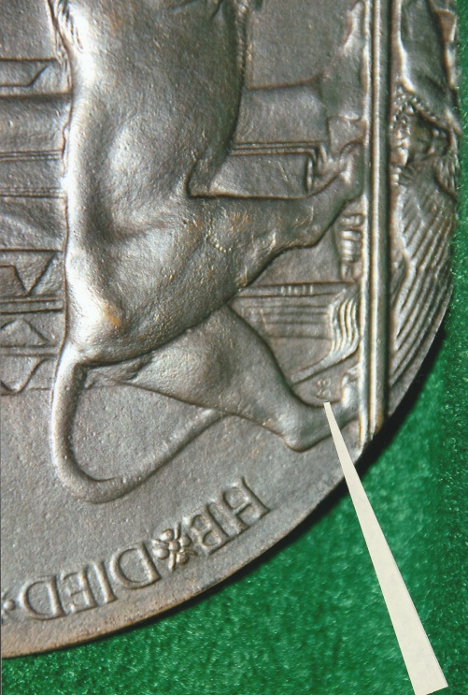

Woolwich Arsenal Plaque
Worker Number 66

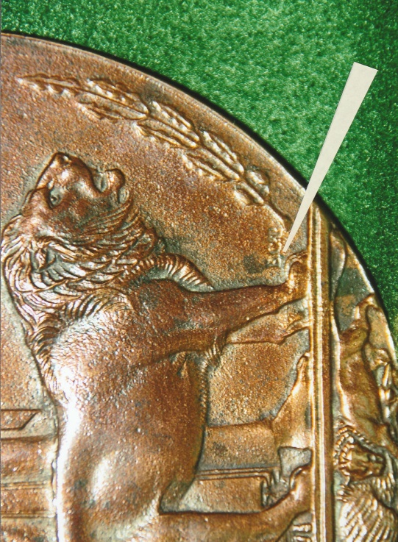

Initials (E.C.P.) Of Memorial Plaque
Designer Edward Carter Preston

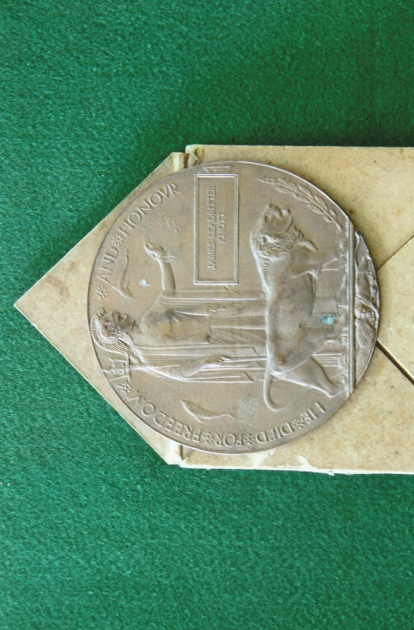

Waxen Envelope & Memorial Plaque

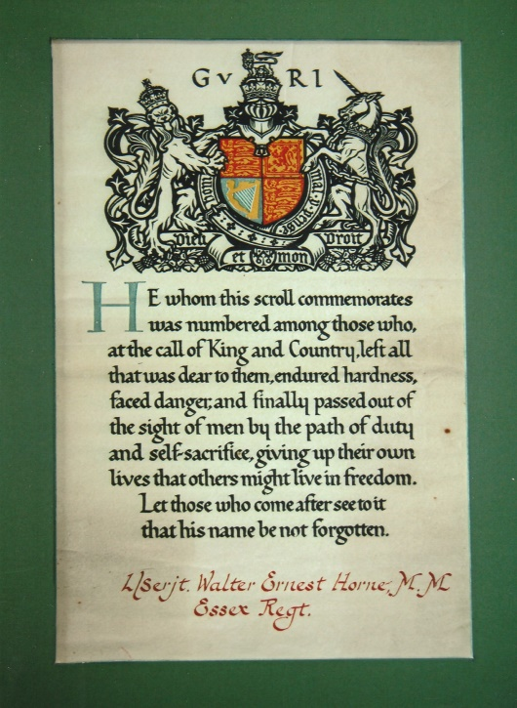

Memorial Scroll ~ Lance-Sergeant Walter Ernest
Horne M.M. Essex Regiment

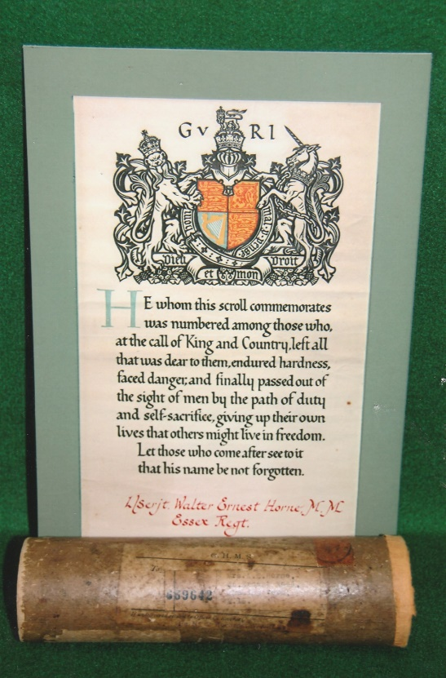

Memorial Scroll & Despatch Cardboard Tube

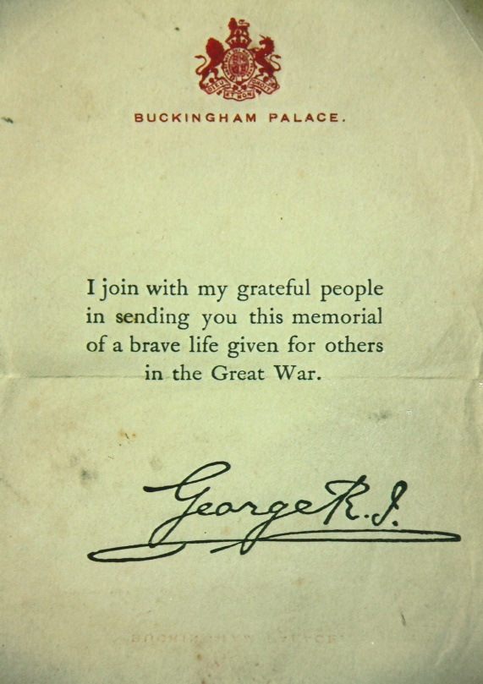

Condolence Slip

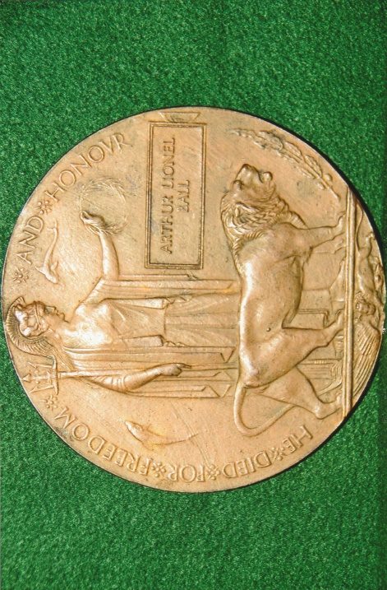
BRONZE MEMORIAL PLAQUE NAMED TO:- ARTHUR LIONEL BALL
Arthur Lionel Ball was born c.1895 at Harlington, Middlesex the son of Arthur and Alice Ball. At the time of the 1901 Census the family were living at 81 Cambridge Street, Coventry, and Alice was recorded as the ‘Head’ of the family as her husband was absent from the family home. She was aged 24 years, her son’s Arthur, Sidney and Alfred were aged 6, 4 and 1 year respectively and a visitor to their household Sarah Odell was aged 30 years. Woolwich Arsenal Plaque – Worker Number 49
Ten years later in 1911, the Census recorded that Arthur (senior) was 38 years old, his wife Alice aged 34, their son’s Arthur, Sydney, Alfred aged 16, 14 and 11 years respectively. Their father was a Storekeeper at a Motor Engineers Company and his eldest son Arthur Lionel was an apprentice motor engineer. The other two sons were still attending school in Walthamstow as the family were living at 24 Cumberland Road, Higham Hill, Walthamstow.
In May 1914 Arthur Lionel Ball attested to serve for a period of four years in the Territorial Force at the age of 19 years and 3 months. He was described as being 5ft 7ins in height, had good eye sight and physical condition, a chest measurement of 35¾inches with an expansion of 3½ inches and no previous military service. Arthur gave his trade as that of a metal turner and was living at 5 Dover Terrace Sandycombe Road, Richmond.
He was medically examined at Fulham by an RAMC doctor who considered him to be ‘Fit’ for service in the Territorial Force. He agreed to serve for four years in either the Royal Artillery or Royal Field Artillery, signed the attestation form for the 25th Battery, 7th London Brigade on the 7th May 1914 and was appointed as a Gunner. He was formerly embodied into the Territorial Force on the 5th August 1914.
By the 1st September 1914, 1482 Gunner Arthur Lionel Ball was stationed at Boxmoor, Hertfordshire, where he signed the following document:-
‘Agreement to be made by an officer or man of the Territorial Force to subject
himself to liability to serve in any place outside the United Kingdom in the
event of a National Emergency.
1482 Gunner Lionel Arthur Ball, 20th Battery, 7th London Brigade do hereby
agree, subject to the conditions stated overleaf, to accept liability in the event
of National Emergency, to serve in any place outside the United Kingdom,
in accordance with the previous Section XIII(2) of the Territorial and Reserve
Forces Act, 1907.
Signed – A.L. Ball Signature of Commanding Officer ~ Major Peel
Station Boxmoor 1st September 1914.
Arthur remained in the United Kingdom for just over ten months on Home Service duties until the middle of March 1915 and was then sent to France on the 17th. In June 1916 he was posted to the 7th London Brigade Line Depot, 47th (2nd London) Division. The Brigade was later renamed CCXXXVII Brigade (237). He returned to the United Kingdom on the 14th July 1916, possibly because he had been diagnosed in France with a ‘Systolic Infunction’ [sic Systaltic Infarction]. He was admitted to the Connaught Hospital, Frenshaw Hill, Aldershot for a week. His symptoms included dizziness, headaches and dyspepsia. Examined by doctors who found that his heart was not enlarged and the systaltic murmur diminished on lying down. His condition improved sufficiently and he was discharged on sick furlough on the 16th August 1916.
On the 1st January, 1917 re-numbering for personnel of the Royal Horse Artillery, Royal Field Artillery and Royal Garrison Artillery Territorial Force came into force. Gunner Arthur Lionel Ball’s new service number was 960626. In March 1917 he was posted to the 6th Reserve Brigade and in September was examined by a Travelling Medical board and categorised medically as ‘B (ii)’. At a follow up medical examination on the 25th October 1917 he was considered to be ‘Fit’ and upgraded to Category ‘A’. A week later he returned to France and posted to ‘A’ Battery, 46th Brigade, which served as Divisional Artillery with the 14th (Light) Division. He remained in France until early March 1918 when the Brigade was sent to the Italian Front to support the Italian Army. In the autumn his health broke down and he was sent to No.9 Rest Camp at Taranto and subsequently admitted to the 79th General Hospital. Sadly on the 6th October 1918 Arthur died from influenza and bronco-pneumonia. He was 23 years of age. His parents were informed of their son’s death by telegram from the hospital. Gunner Arthur Lionel Ball lies buried in Taranto Town Cemetery Extension ~ Grave Location: Plot III, Row K, Grave No.6. The inscription on the headstone reads – “His Duty Nobly Done He Gave His Life To Save His Home His Country.”
The Royal Navy was based at Taranto after Italy entered the First World War. Its importance grew in 1917 when lines of communication were established from France to Taranto. The facility included a rest camp, two hospitals and units of the British West Indies Regiment were based there. Initially the Town Cemetery was used for burials from June 1915 to April 1919. With limited capacity it became necessary to create a military extension and after the Armistice 102 burials in the Town Cemetery were removed and re-interred in the extension which now contains 449 burials of the First World War. There is also one Non World War burial and a sailor from Trani Communal Cemetery was re-interred in the extension in 1958.
Arthur Ball’s possessions were forwarded via Woolwich Arsenal to Mr and Mrs Ball who were living in the Sudbury-on-Thames area. They also received the residue of their son’s army pay and his war gratuity which totalled £13 7s 6d. Subsequently they took delivery of their son’s 1914-15 Star, British War Medal 1914-1920, Allied Victory Medal 1914-1919, Territorial Force War Medal 1914-1918, Bronze Memorial Plaque and Scroll.

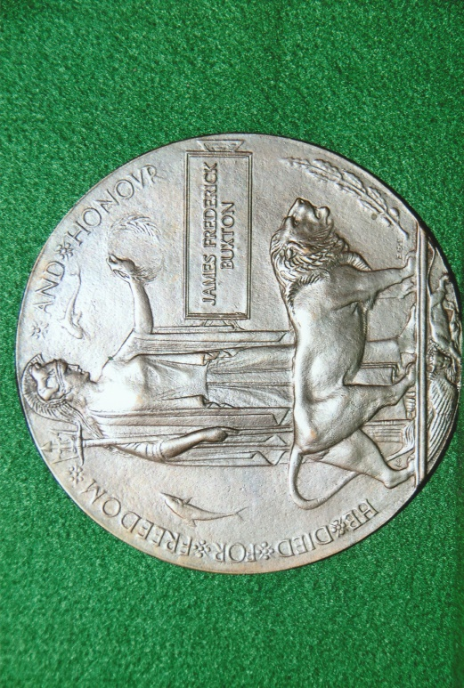
BRONZE MEMORIAL PLAQUE NAMED TO:- JAMES FREDERICK BUXTON
James Frederick Buxton was born at Bristol the son of James Buxton and his wife Annie. He was christened on the 6th February, 1890. The 1891 Census recorded that James (senior), the father was aged 40 years and worked as a warehouse porter in Bristol and Annie, aged 34 years was a tailoress. They were living at 8 Dyas Buildings, Bedminster with their six children, Edward aged 14 years, a printers machine boy, William, Thomas and Hubert aged 10, 6 and Woolwich Arsenal Plaque – Worker Number 66 4 years respectively were schoolchildren, daughter Lily aged 3 years and 1 year-old James Frederick.
James (senior) was not recorded on the 1901 Census and was absent from the family home, which was at 11 Dyas Buildings. Annie was still listed as a tailoress, Thomas aged 16 years was a bottle washer, Hubert aged 14 years was a delivery boy, James Frederick was 11 years old, daughters Harriett and Victoria aged 8 and 4 respectively and their youngest son Arthur, was aged 3 months.
By the time of the 1911 Census James Frederick Buxton had left the family home and was residing in the house of Sidney and Rose Price at 34 Somerset Street, Cathay, Bristol, probably as a boarder along with Charlie Cook. Both of these two young men were employed as Railway Porters with the Great Western Railway.
At the age of 23, James married Florence Jay, aged 24 at Bristol during the Spring of 1913. Florence was the eldest daughter of Tom Jay a coach builder and his wife Elizabeth. Florence had been baptised at the church of St Philip and St Jacob, Bristol on the 14th April 1889. Her occupation was a printing machine feeder and prior to her marriage lived at 11 Beaufort Avenue, Barton Hill, Bristol. After the outbreak of the First World War, James remained working for the Great Western Railway and continued to do so until September 1917 when he joined the Royal Navy at Devonport as a ‘Hostilities’ only entrant.
He was described as being 5ft 4ins in height, with light coloured hair, blue eyes, a fresh complexion and had a chest measurement of 36-inches. His date of birth on his naval service record is given as the 22nd November 1888.
His record of service was as follows:-
Period of Service
Ship Rating From To Remarks
Vivid I Ordinary Seaman 20 Sept 1917 31 Dec 1917
St George* Ordinary Seaman 1 Jan 1918 31 Mar 1918
Latona* Ordinary Seaman 1 Apr 1918
Latona* Able Seaman 16 Aug 1918 30 Nov 1918
Egmont* Able Seaman 1 Dec 1918 31 Dec 1918 Discharged Dead
*Flotilla Depot Ships ~ From which J/78202 Frederick James Buxton served on HMS Torpedo Boat Destroyer TB 18. James’ character and ability during his service in the Royal Navy was recorded as being ‘Very Good’ and ‘Satisfactory’.
HMS Vivid, a shore establishment and naval barracks was established at Devonport c.1890. New entrants joining the Royal Navy received their initial and basic training there. Other establishments within Devonport and in other parts of the country were also designated either HMS Vivid I, II. III, IV and V. HMS Vivid I was the seamanship, signalling and telegraphy school at Devonport.
*HMS St George was an ‘Edgar’ class cruiser launched in 1890. In 1900 she was converted into a destroyer depot ship. During the early months of the First World War she was attached to the Humber Patrol and after a refit became a submarine support ship and was sent to the Aegean in 1918 as a depot ship for the 2nd Submarine Flotilla at Salonika.
*HMS Latona an ‘Opollo’ class cruiser was also launched in 1890 and was converted in 1907 to a minelayer. Based at Sheerness and Dover at the beginning of the First World War she was extensively refitted and became a depot ship in 1915 and sent to the Mediterranean.
*HMS Egmont – Originally HMS Achilles, a first class armoured cruiser was built at Chatham in 1863 and was later specially fitted out for service at Malta. Renamed HMS Egmont in 1904 she returned to the United Kingdom in 1912. Fort St Anglo, a medieval castle situated at the end of the Birgu Peninsula, Malta and dominates the Grand Harbour. Later used as a British garrison it became a shore base for the Royal Navy and named HMS Egmont in 1912. Subsequently it became the principle naval base for the Royal Navy in Mediterranean. HMS Torpedo Boat TB 18 was an ex-‘Cricket’ class destroyer and re-classed as a Torpedo Boat Destroyer. These boats were designated 1st, 2nd and 3rd Class, the latter two were given numbers. TB 18 was a 2nd class boat. She was built by William Denny & Brothers of Dumbarton and launched in 1908. Her technical details were as follows:
Dimensions ~ Length OA 180-ft; Breadth 18-ft; Draft 6-ft;
Machinery ~ 2 x Yarrow Boilers Oil Fired; Parsons Turbines; 3 Propeller Shafts; 3750 SHP; 26-knots;
Armament ~ 2 x 12-pounders; 3 x 18-inch Torpedoes;
Crew ~ 35 Officers and Ratings;
At the outbreak of the First World War there were 106 Torpedo Boats; 11 were sunk and at the end of the war most were paid off and sold.
The seagoing qualities of the ‘Cricket’ class were poor, mainly due to their shallow draft and made them unfit for destroyer duties.
Able Seaman James Buxton served on Torpedo Boats which operated and were deployed from the particular depot ship to which they were attached. His service in the Royal Navy amounted to fifteen months. It would appear that his health deteriorated and he was sent to a hospital at Brindisi where he died of double pneumonia at the age of 29 years. He was buried in Brindisi Cimitero Communal Cemetery, in Italy. His widow Florence who was living at 68 Lincoln Street, Barton Hill, Bristol was duly informed about the circumstances of his death and place of burial. Her husband’s war gratuity payment was sent to her and would also have later received his British War Medal 1914-1920, Allied Victory Medal 1914-1919, Bronze Memorial Plaque and Scroll. In 1981 the Commonwealth War Graves Commission removed 85 First World War casualties from Brindisi Communal Cemetery and re-interred them in Bari War Cemetery. There are 2,128 Commonwealth casualties of the Second World War and a number of casualties of other nations buried in the cemetery. Able Seaman James Frederick Buxton now lies in Bari War Cemetery ~ Section 16, Row G, Grave No.4. The inscription on his headstone reads: ‘To Good In Life/To Be Forgotten/ In Death Rest In Peace’

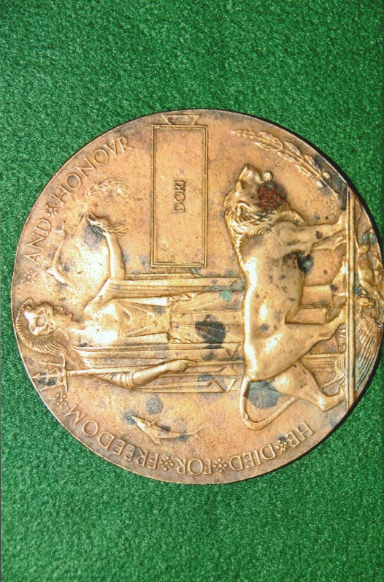
BRONZE MEMORIAL PLAQUE NAMED TO: DORI
The Commonwealth War Graves Commission list four casualties named to Dori.
- 7438 Bearer Dori, 19th British Field Ambulance, Indian Medical Corps. He died on the 27th May 1915 and was the son of Isri of Akha, Aoula Bareilly, United Provinces. Bearer Dori lies buried in Indian Grave A8, in St Vaast Post Military Cemetery, Richebourg-L’Avoe.
Woolwich Arsenal Plaque – Worker Number 81
- 116653 Gangman Dori, 127th Railway Construction Company, Indian Labour Corps, died on the 31st December 1916. He is commemorated on the Delhi Memorial (Indian Gate) Face 9-11-15-16-18-20.

- 7112 Bearer Dori, Army Hospital Corps. He died on the 1st April 1915 and was the son of Ishri of Akha, Ainia, Bereilly, United Provinces. He is commemorated on the Neuve Chapelle Memorial, Panel 42.

- 509 Labourer Dori, Indian Labour Corps. He died on the 14th December 1917 and was the son of Gobind of Pipra, Dataganj, Budaun, United Provinces. He lies buried in Mazargues War Cemetery, Marseilles, and is remembered by a Special Memorial in the southwest corner of the cemetery.

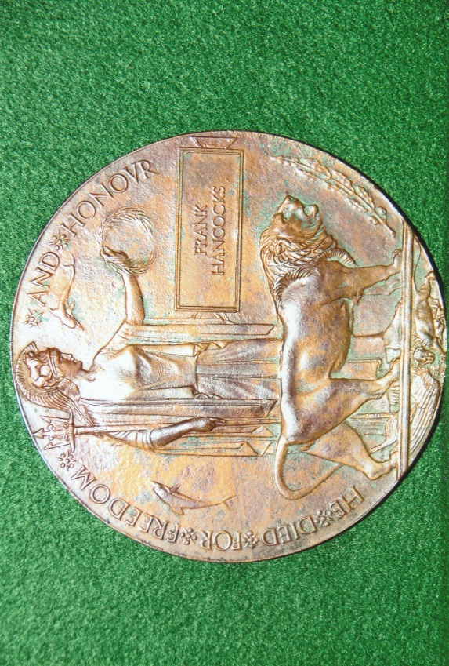
BRONZE MEMORIAL PLAQUE NAMED TO: FRANK HANCOCKS
Frank Hancocks was born in Birmingham on the 2nd April 1887, the son of William and Maria Hancocks. The 1891 Census recorded that William, was born in Yorkshire, aged 34 years and employed as a ship’s carter. His wife Maria was born in Birmingham in 1861 and at the time of the Census they had seven children, Alice aged, 12, Arthur aged 10, Harry aged 9, Lilian aged 6, Ellen aged 4, Frank aged 3 and Frederick aged 1 year. The family Woolwich Arsenal Plaque – Worker Number Smudged were living at 99 Cooksey Road, Bordesley, Birmingham. William who had become a Publican of the ‘Lord Clifden’ died on the 18th August, 1899 aged 43 years. He left his estate which was valued at £602 10d 9d to Maria.
By 1901, Maria had become the head of the family and was recorded on the Census as a ‘Publican’ of the ‘Lord Clifden’ residing at 34 Great Hampton Street. Maria was 42 years old and before William died they had had two more children. Alice aged 22 was a barmaid, Arthur aged 20 a railway porter, Harry aged 19 a tool maker, Lilian aged 16 a ‘pen slitter,’ Ellen aged 14 a jewel case maker and Emily Watson aged 38, a boarder was also a barmaid. Frederick was now aged 11 years and the additional two children, May and Emily, were 7 and 2 years of age respectively. Frank aged 14 years was living with Thomas and Emma Hancocks, his uncle and aunt at 6 Ivy Place Birmingham. Thomas was recorded as a bricklayers labourer and Frank an errand boy.
In 1906 Maria married Alfred Harbige who was a widower, born in 1859 and a jeweller by trade. By the time of the 1911 Census he was recorded as being a beer retailer. He died in 1923 aged 64 years. Maria died on the 9th April 1940 aged 79 years in Birmingham and when probate was granted the net value of her estate was £875 1s 4d.
Frank, most probably in his late teenage years left the United Kingdom and emigrated to Canada. With no precise information about when he arrived in Canada or what trade he pursued, by 1911 however he had joined the 15th (Alberta) Light Horse. The South Alberta Light Horse was raised in 1885 as an irregular light cavalry unit from which the 15th Light Horse came into existence at Calgary in 1905. On the outbreak of the First World War, Canadian militia units were not mobilised but volunteers from the militia and newly recruited men were drafted to form new units. The existing militia were used and organised to recruit and initially train men for the Canadian Expeditionary Force.
On the 18th December, 1914 at the age of 25 year and 9 months, Frank Hancocks Attested For The Canadian Overseas Expeditionary Force at Port Arthur, Ontario. [If his given age on the attestation form is correct it would put his birth year c.1888 or 1889 and not 1887 as recorded on the 1891 Census]. Port Arthur, amalgamated with Fort William and other townships to form the city of Thunder Bay, in 1970. Frank was described as being 5ft 9¼ins in height, had a fair complexion, brown eyes, light brown hair, a chest measurement of 38-inches with a 3-inch expansion, gave his religious denomination as Church of England and occupation as a lineman. He had two distinguishing marks recorded on his service record one was a small scar on his right foot and a blemish on his right forearm from an abscess. His mother Maria Harbige was nominated as next-of-kin and was living at Waterloo House, Alcester Road, Bideford-on-Avon, Warwickshire. Medically examined Frank was pronounced ‘Fit’ for the Canadian Overseas Expeditionary Force. He signed the declaration section on the attestation form which read:-
I, F. Hancocks, do solemnly declare that the above answers made by me to
the questions are true and that I am willing to fulfil the engagements by me
now made, and I hereby engage and agree to serve in the Canadian Overseas
Expeditionary Force, and to be attached to any arm of the service therein, for
the term of one year, or during the war now existing between Great Britain
and Germany should that war last longer than one year, and for six months
after the termination of that war provided His Majesty should so long require
my services, or until legally discharged.
Signed Frank Hancocks and witnessed M.G. Kelly 18th December 1914.
Frank also signed the oath to be faithful and bear true allegiance to His Majesty King George V. [On the attestation form and other documents relating to Frank his surname it is spelt either Hancock or Hancocks – a clerical error] There are also some inconsistencies on his record of service, with sections missing and other information not fully written up.
Given Army Number A38018 – later renumbered 438018 – Private Frank Hancocks embarked from Canada for the United Kingdom. There is no precise date on his service record, but he probably came over in February 1915 having been drafted to the 32nd Battalion, which in April became a Reserve Battalion to reinforce depleted units in France and Belgium. By the summer of 1915 he was stationed at Shorncliffe Barracks situated on the outskirts of Folkestone in Kent. The barracks were originally built in the late 18th century for the British Army. They were used by the Canadian Expeditionary Force from April 1915 for the formation of a Canadian Training Division. On the 23rd July 1915 Frank again attested for the Overseas Canadian Expeditionary Force. There were minor changes to his personal details on this attestation form and he was pronounced medically ‘Fit’ on the 2nd August for service with the CEF. Written across the front page of the attestation form in red ink are, the words ‘52nd Batt Rein Draft’. The latter battalion did not arrive in the United Kingdom until November 1915.
On the 3rd August 1915, Frank proceeded on draft to the 8th Battalion (Winnipeg Rifles) from the 1st Canadian Corps Training Battalion (CCTB) and arrived in France two days later. The 8th Battalion had embarked from Canada in October 1914 and were sent to France in February 1915 as part of the 2nd Infantry Brigade, 1st Canadian Division. They fought in the Second Battle of Ypres in 1915 when the Germans used gas and were isolated at the head of a salient for four days enduring artillery shell fire from the front, flank and rear. Having been diagnosed with haemorrhoids Frank was initially admitted to No.3 Casualty Field Ambulance on the 10th October and then sent to No.2 Field Ambulance. After treatment he was returned to his unit on the 21st.
At the end of April 1916, much troubled with his haemorrhoids and conjunctivitis in his right eye he was admitted to No.24 General Hospital at Amiens. His condition was considered to be serious and he was evacuated and sent to the Canadian Casualty Assembly Centre (CCAC) at Folkestone on the 9th May. A week later he was transferred to the Canadian Convalescent Hospital at Woodcote Park, Epsom. Discharged on the 29th May he was sent to the 1st Canadian Corps Depot at Folkestone for four weeks. At a subsequent medical examination at the beginning of July 1916 his haemorrhoids were causing concern and the doctors recommended an operation and also advised circumcision due to a very long foreskin. He was admitted to the Moore Barracks Hospital at Shorncliffe and underwent an operation on the 10th July. Fourteen days later he was transferred to the Canadian Convalescence Hospital at Bearwood, Wokingham. From the latter hospital he was returned to the Canadian Convalescence Hospital at Woodcote Park and remained there until the middle of August. On his discharge from the hospital he returned to the 1st Canadian Corps Training Battalion at Shoreham. Frank attended a Canadian medical board at the Shoreham depot on the 15th November and was passed ‘Fit For Duty’.
Frank embarked at Hastings on the 9th January, 1917 having been drafted back to the 8th Battalion. The battalion served in France and Flanders throughout the duration of the war. In February 1917 Frank made a will which read:
‘In the event of my death I give the whole of my property and effects to my
mother, Mrs Maria Harbige, Waterloo Cottage, Alcetser Road, Bideford-on-Avon,
Warwickshire.
Signed Frank Hancocks Pte. 8/Can. Inf. Feb 15 1917’.
Frank participated in the Battle of Vimy Ridge between the 9th–12th April, one of several battles fought in the wider Allied offensive during the Battle of Arras 9th April–16th May, 1917. Private Frank Hancocks was recorded as ‘missing in action’ on the 12th May 1917 which was later amended to him being ‘killed in action’ on the 28th April 1917. The Battle of Arleux part of the overarching Battle of Arras was fought on the 28th – 29th April. The objective of the battle was to engage German reserve units to help the French in their offensive north of the Aisne. On the 28th April at 0425 hours the British and Canadian troops attacked on an 8-mile front north of Monchy-le-Preux. The Germans stubbornly defended their positions with grim determination and mounted several major counter-attacks. Both sides sustained heavy losses. At Gavrelle the 63rd Division fought off seven German attacks at a great cost in lives. The 1st Canadian Division captured the village of Arleux-en-Gohelle and the 2nd Canadian Division made significant advances around Oppy and between Monchy-le-Preux and the Scarpe. The 8th Battalion was part of the 2nd Canadian Division and although there is no reference to where Frank Hancocks was killed it may be reasonably assumed he was killed in the Division’s advance on the 28th. Private Frank Hancocks body was not recovered and his name is commemorated on the Vimy Memorial. His name is also commemorated in the Canadian First World War Book of Remembrance on Page 250. There are seven Books of Remembrance held in the Memorial Chamber in the Peace Tower on Parliament Hill, Ottawa. The Books of Remembrance commemorate over 118,000 Canadians who died in the service of their country – 63,332 of them in the First World War.
In 1921, Maria received her sons British War Medal 1914-1920, Allied Victory Medal 1914-1919, Bronze Memorial Plaque and Scroll and the silver Canadian Memorial Cross.
BRONZE MEMORIAL PLAQUE NAMED TO: JAMES LEADBITTER KNOTT
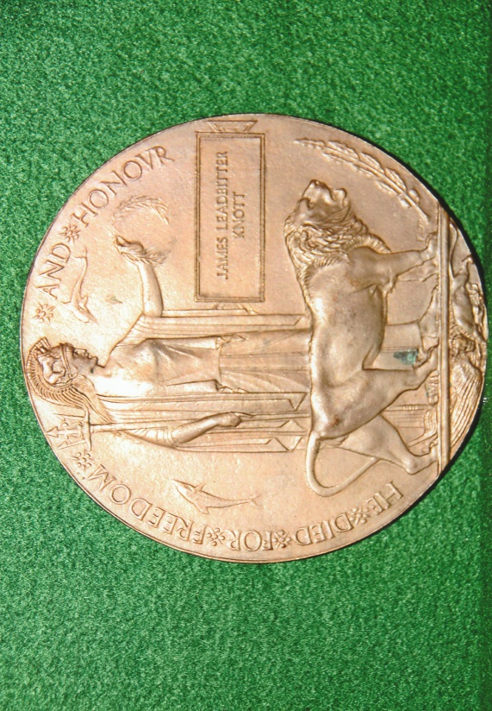
James Leadbitter Knott was born in North Shields, Northumberland on the 2nd December 1882 the son of James and Margaret Knott. Their second son Henry Basil was born in 1891 and the Census of that year recorded that the family and their servants were living at the Manor House, Jesmond, Newcastle. There were thirteen people listed at this address in the Census and they were as follows: James, the head of the household was 36 years old, whose occupation was given as ship-owner, shipbroker and barrister-at-law, his wife Margart was the same age as her husband, their son James aged 8, and their second son Henry aged 3 months, Emile Malfart, a Frenchman aged 28 was a tutor, Woolwich Arsenal Plaque – Worker Number 52 Anne Hendmarch aged 47 housekeeper, James Pearson aged 20 butler, Mary Tomlinson aged 47 a certified nurse, Hannah Canfield aged 45 cook, Isabella Armstrong aged 24 a nurse, Margaret J. Mangham aged 23 housemaid, Sarah J. Stoker aged 29 upper housemaid and Mary J.M. Barter aged 23 the downstairs maid. The eldest son Thomas Garbutt Knott was not recorded on the 1891 Census. He was born in 1879 and is recorded on the 1881 Census with his parents, aged 1 year and does not appear on the 1901 Census.
James, senior their father was born at Howden-on-Tyne in January 1855, one of ten children born to Matthew and Margaret Knott. Educated in North Shields he left school at the age of 14 and found employment with a shipbroker in Newcastle. Five years later, he himself became a shipbroker and bought a small sailing collier the Pearl for £186. At the age of 23 in 1878, he married Margaret Garbutt and a year their first child, Thomas was born. By 1886, James owned a small fleet of sailing and steamships. He continued to expand his shipping business and in 1895 he established the Prince Line which in later years, with over forty ships became one of the largest fleets in the world. During this period he studied law and was called to the Bar in 1899 and practiced for four years. Apart from his shipping business he had investments in coal mining. James purchased the Togston Colliery in 1899 and established the Acklington Coal Company Limited. He also invested in the South Wales Primrose Coal Company who mined anthracite.
The 1901 Census recorded that the family were living a 4 Sydenham Terrace in the parish of St Andrews in Newcastle. James senior and his wife were ten years older, James their son was 18, Henry was absent as he was a boarder at Eton College. The family employed different servants to those recorded in 1901. Carline J. Cowing aged 27, a companion and housekeeper, Janet Roy aged 31, lady’s maid, William T. French aged 26, butler, Mary McAtominey aged 37 cook, Sarah A. Coulson aged 37 and Lizzie Coulson aged 31, housemaids and Margaret A. Nesbit aged 22, kitchen maid.
As the family’s wealth increased over the succeeding years they moved into Close House, Wylam-on-Tyne. James senior was recorded in the 1911 Census as a ship-owner, he and his wife were aged 56 and had been married for 31 years. James Leadbitter Knott aged 28 was single and a ship-owner, his brother Henry aged 20 was a ship-owner’s clerk, Norton B.N. Good a visitor at the time of the census was aged 24 and a naval architect, William Graham aged 42, butler, Mary Graham aged 45 cook, Arthur Sanderson aged 21 footman, Evelyn Tweddle aged 20 housemaid, Margaret Bowman aged 18 kitchen maid, Mable Morrow aged 18 house maid, Elizabeth Sharp, aged 17 scullery maid, Caroline Jane Cowing aged 37 lady’s housekeeper, Isabella Sandieson aged 29 house maid, Sidney Robinson Postlethwaite aged 28 chauffeur and Mary Annie Heslop aged 32 lady’s maid.
James, senior was a Justice of the Peace and in 1906 he was selected as the Conservative candidate for the Tyneside Division of Northumberland, but failed to get elected. He was more successful in 1910 when he became Member of Parliament for Sunderland but after serving for a few months he stood down at the end of the year. His heart was in shipping. In 1909 James and his household were living at Close House, situated within a large estate, on a five year lease which he extended for a further 15 years in 1914. During the First World War the Prince Line lost 21 ships with the loss of 86 lives. James held a commission in the Royal Naval Reserve, but did not serve during the war as the authorities deemed that his duty was to continue operating his mercantile fleet as the cargoes they carried were of vital importance to the war economy.
James Leadbitter Knott was educated privately and at Eton College. He left there in 1900 at the age of 18 and went to America to learn and gain commercial and business experience. On his return to Newcastle he became the Deputy Managing Director of the Prince Line. Like his father he had an interest in politics and was selected as a prospective Conservative parliamentary candidate for the constituency of Hyde. He was also a member of the Natural History Society of Northumbria, which he joined in December 1906.
On the outbreak of the First World War, James applied for an appointment to a commission in the 4th Battalion Northumberland Fusiliers as a Second Lieutenant on the 8th August 1914. He was described as being 5ft 9½-inches in height, had no previous military experience other than 4 years as a private in the Eton College Volunteers and gave his occupation as ship-owner. The medical officer passed him ‘Fit’ for duties as an Officer of the Territorial Force on the 2nd September and the Lieutenant Colonel commanding the battalion certified that James was of ‘good moral character’. The 4th Battalion (TF) Northumberland Fusiliers were raised after the 1908 Army reforms when volunteers and yeomanry battalions were organised into the new Territorial Force. Their battalion headquarters was at Hexham. Mobilised on the 4th August 1914, 17 officers and 660 men reported for training. Sent to France as part of the Northumbrian (TF) Division in April 1915 they fought in the Second Battle of Ypres sustaining heavy losses in attacking German positions at St Julien.
A number of reference sources about James make no mention of the 4th Battalion (TF) Northumberland Fusiliers. After being accepted for a commission with the Territorial Force he was posted to the 9th Battalion. Formed at Newcastle in September 1914, part of the 52nd Brigade in the 17th (Northern) Division they went to France in July 1915 and had their first experiences of the war at Ypres. Having been promoted to Captain in November 1914, and later to Temporary Major, James arrived in France with the 9th Battalion and transferred to the 10th Battalion, West Yorkshire Regiment (Prince of Wales’s Own). The battalion was raised at York in September 1914 and joined the 50th Brigade, 17th (Northern) Division. Following intensive training locally the battalion moved to Wareham and then to Winchester. James’s brother Henry also underwent training at Bovington with the 9th Battalion, Northumberland Fusiliers. The Division proceeded to France in July 1915 and were encamped at St Omer, prior to moving to the Ypres sector. They were given instruction and familiarisation about trench-life in the Ypres Salient and took over a section of the front line at the beginning of August between Vierstraat and Verbrandenmolen. A few days later they supported an attack at Hooge. Periods of rest, followed by training and return to front line duties in the Hooge sector became their routine until January 1916. The battalion in early February marched to Ruminghem for further training and were present at The Bluff when the Germans exploded a large mine there. A severe and intense bombardment followed and in the close quarter fighting the battalion sustained 120 casualties on the 1st March. They left Flanders and moved towards Armentières in mid-March and remained there until the first week of May when they transported by rail southward for more training in preparation for the Somme offensive.
The London Gazette of the 13th June 1916, Supplement 29623, page 5936 announced that Major James Leadbitter Knott of the West Yorkshire Regiment had been awarded the Distinguished Service Order (D.S.O.). There is no mention of the reasons for the award, but it may be reasonably assumed it was for ‘distinguished service in the field’.
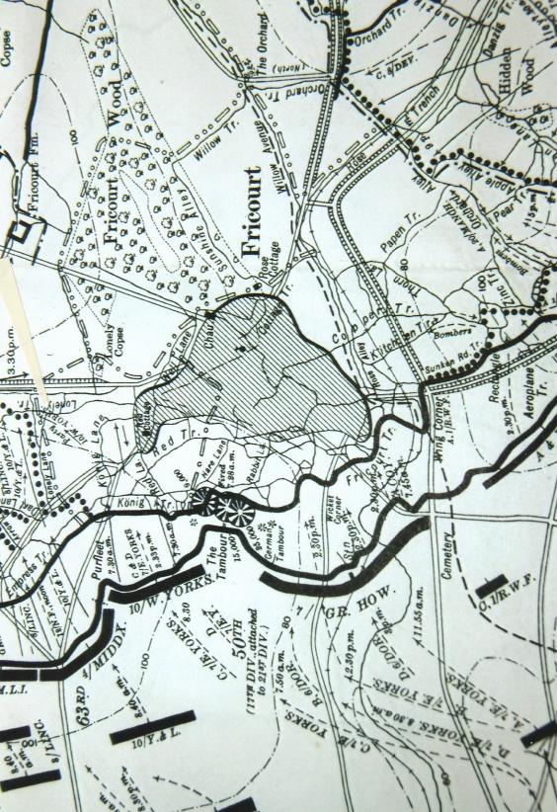
With reference to the Official History France & Belgium 1916: ‘On the 1st July the 21st Division were to advance towards the sunken road and form up with three of its four brigades, The 50th (attached from the 17th Division for the attack), with the 63rd and 64th Divisions in the front line and the 62nd Brigade in reserve. The majority of the 50th Brigade commanded by Brigadier-General W.J.T. Glasgow were to stay in the front trenches in readiness for the assault on Fricourt at a later stage in the battle, if the village had not been ‘pinched out’ by advances on its flanks. The left battalion the 10th Battalion, West Yorkshire Regiment were to form a defensive flank towards Fricourt. The 63rd and 64th Brigades were to capture the German first intermediate line, Crucifix Trench, as first objective and Bottom Wood and part of the Quadrangle Trench, the second intermediate line, as the second objective, joining up at the Wood with the 7th Division. No Man’s Land was approximately 200 yards wide and in a few places stretched to over 300 yards. The assault by the 10th Battalion, West Yorkshire Regiment was on a frontage of six hundred yards. The lines of the two leading companies crossed into the enemy front trench with little loss and moved on towards “Red Cottage” at the northern end of Fricourt. The Germans in the area of the village and nearby trenches did not emerge from their deep dugouts quickly enough to stop them. However when the third and fourth companies moved forward, the machine-guns in Fricourt and the German Tambour brought up out of the dugouts which had not been blown in by the mine explosions were in position – there had been little damage inflicted on Fricourt by the bombardment of 9‧2-inch shells which failed to explode as their fuses fell out during flight! As the barrage moved forward there was no fire to keep the enemy in their shelters and enemy machines guns from the northern edge of the Tambour caused severe losses. Although Brigade headquarters were informed of the location of these machine guns they were not silenced. When the 3rd and 4th Companies moved forward they were shot down. Lieutenant-Colonel A. Dickinson commanding officer of the battalion and all regimental staff were killed and only a few troops reached the German front trenches. The leading companies, passed along communication trenches and reached the “Red Cottage” but being isolated were overpowered later in the morning with the exception of a few small parties who gained a junction with the right of the 63rd Brigade further north. Owing to the intense machine gun fire opened from Fricourt on any sign of movement in the open it was not possible to reinforce the survivors of the 3rd and 4th Companies in the German front trench where they remained until darkness. Casualties sustained by the battalion were 22 officers and 688 other ranks during the fighting on the opening day of the offensive.’
The War Diary of the 10th Battalion, West Yorkshire Regiment recorded:- ‘1st July. At 0730 a.m. the Battn took part in the grand assault the objective being as in the attached orders. On the right were the 7th Divn & on the left the 21st Divn. The Battn assaulted in 4 lines. 2nd line got through the German position to the 4th line & were cut off, the attack on our left failed. Casualties were very heavy chiefly caused by machine guns which enfaladed [sic enfiladed] our left flanks & were so deadly that the 3rd and 4th lines failed to get across “No Man’s Land”. 22 officers casualties including Lt.Col Dixon [sic Dickinson] and Major Knott 2nd in Command (Both killed & approximately 750 OR. The Battn were then withdrawn to Ville.
‘2nd July. The Battn. marched to Heilly Lt.Col. H.A Ross was appointed to command and assumed duty this day’.
Major Knot was 33 years of age when he was killed. His father was informed via the Secretary of the War Office by telegram on the 6th July which read:-
“Deeply regret to inform you Major J.L. Knott DSO 10th West Yorkshire Regt
reported missing believed killed July 1st. The Army Council express their sympathy.”
On the 12th he received another telegram:
“Deeply regret to inform you Major J.L Knott DSO 10th West Yorkshire Regt
reported missing believed killed July 1st now reported killed July1st. The Army
Council express their sympathy.”
This latter information that Major Knott had been killed was confirmed by a statement given by 1411 Private J.N. Pickering ‘D’ Company 10th West Yorkshire Regiment that he had been ‘shot through the head’.
This sad news must have increased the burden of grief that James’s mother and father had to endure. In September 1915 their youngest son Henry, known in the family as Basil was killed at Ypres. Born on the 5th February 1891 at the Manor House, Newcastle he was like his brother educated at Eton. He left there in 1910 and became a Director of the Prince Line. On the outbreak of the First World War he applied for and was granted a commission as a Second Lieutenant in the 9th Battalion, Northumberland Fusiliers in September 1914.
The battalion had been brigaded with the 52nd Brigade, 17th (Northern) Division and on completion of their training they went to France in July 1915 and deployed in the Ypres Salient. Henry was promoted to Captain, prior to the battalion’s departure. In the fighting at Bois Carré, near the village of Vierstraat, Henry was wounded in the head by a rifle bullet. Taken to No.10 Casualty Clearing Station at Poperinghe he died there on the 7th September 1915 aged 24 years. When probate was granted Henry left an estate valued at £20,196 13 8d.
The eldest son Thomas was also believed by his family to have been killed during the war. He is recorded in the 1881 Census aged 1 year. In later years he left the family and went to New Zealand and probably served with the NZEF in Gallipoli. In the ‘fog of war’ precise details about him led to the mistaken belief he had died as initially there was no trace of him. He had been captured and taken prisoner and spent the rest of the war in Prisoner of War camp.
On release he may have returned to New Zealand suffering from complete memory loss as to who he was and eventually returned to the United Kingdom penniless. Fortunately his identity was established and he gradually regained his health in the care of his mother and father. The death of his two sons had a deep emotional effect upon his father.
He decided towards the end of 1916 to sell the Prince Line to Furness, Withy and Company. In the 1917 King’s Birthday Honours List James was made a Baronet and became Sir James Knott, Bart of Close House Northumberland. He chose for his motto ‘Deeds Not Words’ and also became a Knight of Grace of the Order of St John of Jerusalem in England.
The solicitors Wilkinson & Marshall of 1 Mosley Street, Newcastle acted on behalf of the deceased Major J.L. Knott and began the process of assembling information pertaining to his pay allowances, valuation of his kit, personal effects and business interest for the purpose of probate. Major Knott’s father was his sole executor.
On the 24th July, 1916 the solicitors wrote to the Military Secretary with reference to Major James Leadbitter Knott deceased:

‘Dear Sir,
We are instructed to prove the Will of the late Major James Leadbitter Knott
of the 10th Batt. West Yorkshire Regiment, who was killed in action at Fricourt,
France on the 1st inst. We shall thank you to forward us a certificate of his death.
The deceased was a bachelor and has made a Will under which his father,
Mr James Knott, is absolutely entitled to all the deceased’s property and is the
sole Executor. The estate will exceed £5,000. We shall thank you to forward
the necessary recommendation for remission of Death Duties to the Estate
Duty Office.
Yours faithfully, (Sd.) Wilkinson & Marshall’.
The Military Secretary testily replied on the 30th July:
‘Gentlemen,
In reference to you letter of the 24th instant, asking for a certificate of the
death of Temporary Major James Leadbitter Knott, D.S.O., 10th (Service)
Battalion, West Yorkshire Regiment, I am directed to explain that in a list
of casualties received in this Department, it is stated that this Officer was
Killed in Action on the 1st day of July, 1916.
‘It is not the custom of this office to issue certificates of death based upon
these casualty lists, but to await the receipt of a considered, written individual
report which should be rendered by the authorities at the Base when the details
of the casualty are known. This report has not yet been received in the case of
this Officer, but as soon as it is forthcoming you will be informed. A further
communication will be addressed to you on the subject of the Remission of Death
Duties.
‘I am. Gentlemen,
Your obedient servant (Sgd) Percy Taylor for the Secretary’.
On the 24th August 1916 James (senior) was informed by letter that:-
‘The Military Secretary presents his compliments to Mr J. Knott, and begs to
inform him that a report has just been received from Army Headquarters in
the Field which states that the late Major J.L. Knott, D.S.O. 10th Battalion,
West Yorkshire Regiment was buried in Fricourt New Military Cemetery, 3 miles
E. of Albert. Reference Map Sheet 62.d.Square F.3.a.4.5. Row B. Grave 14.
The Military Secretary ventures to send this information now, as Mr Knott may
not have previously received it’.
James replied by letter on the 30th August:
‘Mr James Knott begs to thank the Military Secretary for his note of the 24 inst.
Giving full particulars of the grave in which the late Major J.L. Knott D.S.O.,
10th Batt. West Yorks was buried’.
Probate was granted at Newcastle-upon-Tyne on the 15th September 1916 to James Knott, father and sole Executor as named in Major J.L. Knott D.S.O. Will, the sum of £104,350 2s.
As already stated Major J.L. Knott, D.S.O. was buried in Fricourt Military Cemetery. His brother Henry was buried is a plot close to Lijssenthoek Military Cemetery. When the names of those who had died in the early weeks of the war became known, wealthy families sought to have their deceased sons brought back to the United Kingdom for burial. The authorities in order to be fair to all families especially those of limited financial means took the decision that those who lost their lives on the battlefield would be buried or commemorated near to where they had died. Sir James Knott had become a wealthy man and had influence not only locally but with government officials and those in high office. He tried to have his two sons brought home. Perhaps as a compromise Sir James was able to get both his deceased son’s bodies exhumed and with his agreement they were re-interred in Ypres Reservoir Cemetery. Both brothers lies alongside each other in the cemetery in Section V, Row B – James in Grave No.15 and Henry in Grave No.16. At the request of their family each headstone bears the inscription ‘Devoted In Life/In Death Not Divided’
Sir James Knott had accrued a considerable fortune by the end of the war including land and properties in the north-east. In 1918 Sir James bought several properties and land surrounding the village of Heddon-on-the-Wall and six years later sold several of them in property lots. A year he later created Heddon Memorial Park in memory of James and Henry. He made a significant donation towards the building of the Bell Tower of St George’s Church, Ypres, where a memorial tablet to his son’s was erected. At Fenham on the western outskirts of Newcastle Sir James commissioned a church, St James and St Basil to be built in memory of his two deceased son’s. The church was consecrated in 1931. Sir James retired in 1925 to Jersey, and bought the 12th century Samarès Manor, restoring both the property and gardens. Lady Margaret Knott died on the 8th March 1929, shortly after celebrating 50 years of marriage. Sir James married in 1932 Elizabeth Gauntlett at Monte Carlo, she died in 1998. He died on the 8th June 1934, in Jersey and was buried in the family plot in St Clement Churchyard. The names of James and Henry are inscribed on the grave stone. Sir James left the bulk of his estate, £5 million, to form the Sir James Knott Trust Fund, which still flourishes today and continues to make significant charitable donations particularly in the north-east each year. In 1936 the family erected the Knott Memorial Hall at Heddon-on-the-Wall in memory of Sir James and Lady Margaret Knott. Thomas, the eldest son who also was a Knight of Grace of St John of Jerusalem in England inherited his father’s title and lived at Exmouth, although twice married, there were no children. He died in 1949 and left the majority of his estate to the Trust Fund.
Major James Knott D.S.O. and his brother Henry are commemorated at Eton College, Wylam-on-Tyne, St Andrews Church Heddon-on-the-Wall, Fenham, and Cullercoats. James wrote a letter to his parents which, was to be opened after his death. In the letter he made mention of his medals and requested his mother and father to keep them but on their deaths he would like them to be destroyed. The letter is on display in the Memorial Chapel of the West Yorkshire Regiment in York Minister. His medal entitlement comprised the Distinguished Service Order (KGV), 1914-15 Star, British War Medal 1914-1920 and the Allied Victory Medal 1914-1919. His campaign medals, Bronze Memorial Plaque and Scroll were despatched to his next-of-kin in January 1920.

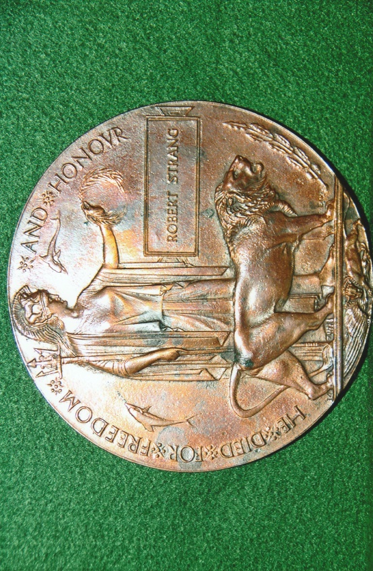
BRONZE MEMORIAL PLAQUE NAMED TO: ROBERT STRANG
The Commonwealth War Graves Commission list three casualties named Robert Strang.
- Captain Robert Strang, ‘D’ Company, 7th Battalion (T), Princess Louise’s, Argyll and Sutherland Highlanders. He was the son of Alex R. Strang CBE and Agnes Strang of Alloa. He was killed in action on the 14th November 1916, aged 27 years and lies buried in Acton Memorial Plaque – Worker Number 14 Mailly Wood Cemetery, Mailly-Maillet. Section I, Row D, Grave No.27.

- S/13478 Private Robert Strang 8th/10th Battalion, Gordon Highlanders. He was born at Barony, Lanarkshire, enlisted at Glasgow and died on the 9th April 1917. His sister, Mrs Mary Nelson resided at 77E Princes Street, Helensburgh. Private Robert Strang is commemorated on the Arras Memorial, Bay 8 and 9.

- 28661 Private Robert Strang, 2nd Battalion, Royal Scots Fusiliers. He was born at Carlton, Glasgow, enlisted there, resided at Parkhead and died on the 18th August 1918. He is commemorated on the Ploegsteert Memorial, Panel 4.

Sources: Janes Fighting Ships Of World War One. Originally published in 1919 by the James Publishing Company; Republished in 1990 by Studio Editions of London. ISDN 1 85170 3780
Commonwealth War Graves Commission Web-Site ~ www.cwgc.org
Wikipedia Web-Site ~ www.wikipedia.org
Ancestry Web-Site ~ www.ancestry.org
Library & Archives Canada ~ www.lac.gc.ca
Veterans Affairs Canada – The Canadian Virtual War Memorial ~ www.vac-acc.gc.ca
Library & Archives Canada ~ Private Frank Hancocks Ref: CEF RG150 Accession 1992-93/166 Box 4006-1
National Archives Able Seaman James Frederick Buxton ~ Ref: ADM.188/803
Nation Archives – Major J.L. Knott DSO ~ Ref: WO339/45395
National Archives – Gunner Arthur Lionel Ball ~ Ref: WO/363 Series – ‘Burnt Documents’
Heddon-on-the-Wall Local History Society
Natural History Society of Northumbria
Sir James Knott Trust
Hellfire Corner – The Knott Brothers
History Of The Great War – Military Operations France & Belgium 1916 Volume I 1916; Compiled by Brigadier-General Sir J.E. Edmonds CB CMG RE – Maps & Sketches by Major A.F. Becke RA; First Published 1932; Published in 1993 by The Imperial War Museum (UK & The Battery Press (USA). ISBN 9 901627 97 6 (UK); ISBN 0 89839 185 7 (USA)
The Great War Medal Companion Volume I by Howard Williamson; Privately Published in 2011
R.G. Coleman (P)

