A STROLL THROUGH A COUNTRY CHURCHYARD
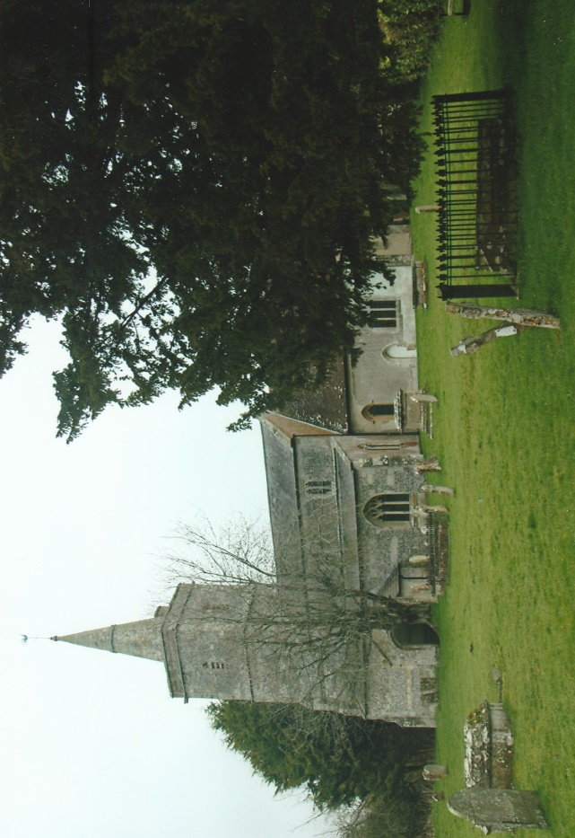
Situated approximately 12 miles north of Salisbury is the village of Fittleton. Several barrows in the area suggest the presence of prehistoric occupation and later Iron Age and Romano-British settlements. The village of Fittleton (Vitelstone) is mentioned in the Domesday Book. There is also a Manor House dating from the late 17th and early 18th century. A village school was also founded in the early 18th century and enlarged during the Victoria period. Years later the school amalgamated with Netheravon School and was closed in 1989 when a new school building was opened at Netheravon. At the end of the 19th century the War Office bought acres of the land in the area for military training and today forms part of the Tidworth ranges within the Salisbury Plain Training Area.
The 13th century church of All Saints, constructed of flint and stone with partial rendering was enlarged during the 15th century and the south porch added in the 16th century. Within the church is a 12th century font and a memorial window dedicated to HMS Fittleton, a minesweeper, manned by members of the Royal Naval Reserve which was sunk during an exercise in the North Sea in 1976 with the loss of 12 men. It was for this reason that I went to visit the church. Afterwards I strolled through the churchyard and noticed two unusual cast iron grave markers. On close examination they were in the form of the ‘Old Contemptibles’ Association Lapel Badge.
The British Expeditionary Force (BEF) was the British army sent to the Western Front during the First World War. The term ‘BEF’ is usually used to make mention of the forces present in France prior to the conclusion of the First Battle of Ypres on the 22nd November 1914. However, the BEF remained as the official name of the British armies that fought in France and Belgium throughout the First World War. It has been alleged that the Kaiser, Wilhelm II of Germany issued an order on the 19th August 1914 to “Exterminate … the treacherous English and walk over General French’s contemptible little army”. No documentary evidence about this order has been discovered, but in later years the British soldiers of the regular army who survived were proud to call themselves “The Old Contemptibles”.
The design of the lapel badge is of voided crossed swords with the inscription ‘OLD CONTEMPTIBLES ASSOCIATION’ and with central scrolls with ‘1914’ on one and ‘AUG.5 TO NOV 22’ on the other. The Association was founded in 1925 to ‘foster the spirit of the Contemptible Little Army of 1914, to strengthen the bonds which held them together through adversity in 1914, to safeguard the interests of its members in relation to pensions and allied matters and to assist those members who may be in need’. Membership was confined to those who had been granted a clasp to the 1914 Star under the terms of an Army Order of October 1919 which covers officers, warrant officers, non-commissioned officers and men who served in France and Belgium between the 5th August 1914 and midnight 22nd-23rd November 1914 and fought in the Battles of Mons, Marne, Aisne and Ypres.
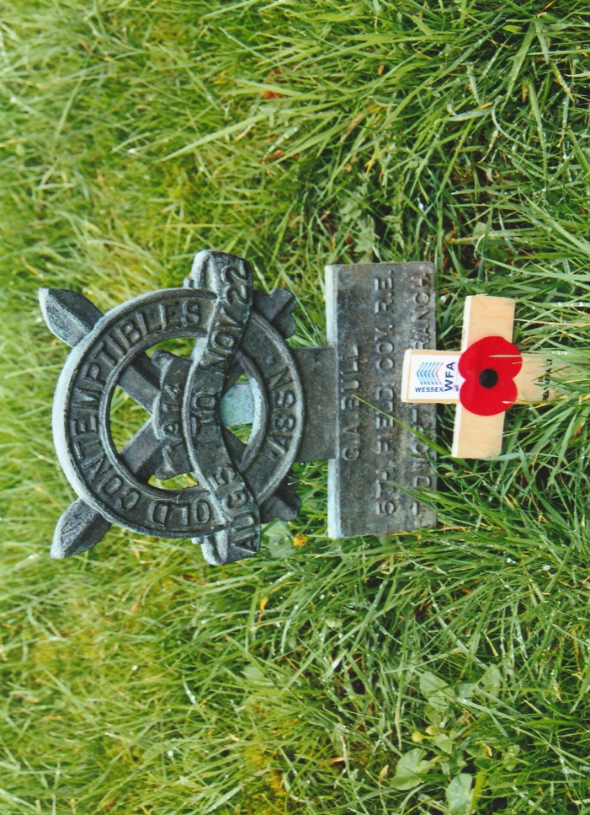
Grave Marker of G.A. Bull – Royal Engineers
The grave marker has a small entablature to record the name of the deceased, his regiment and the branch of the Old Contemptibles Association of which he was a member. They were awarded to members by the local branches to recipients of the 1914 Star with clasp and issued in the 1920’s and 1930’s.
Each of these grave markers has the voided swords and circular ring with the words around the top half inscribed in relief ‘OLD CONTEMPTIBLES’ and the lower half ‘•ASSN•. The top most central scroll is similarly inscribed in relief ‘1914’ and the scroll below ‘AUG 5 TO NOV 22’.
The grave markers entablatures in All Saints churchyard read:
G.A. BULL
5th FIELD COY. R.E.
TIDWORTH BRANCH

H. WISE
ARGYLL SUTHERLAND
HIGHLANDERS
SALISBURY PLAIN BRANCH
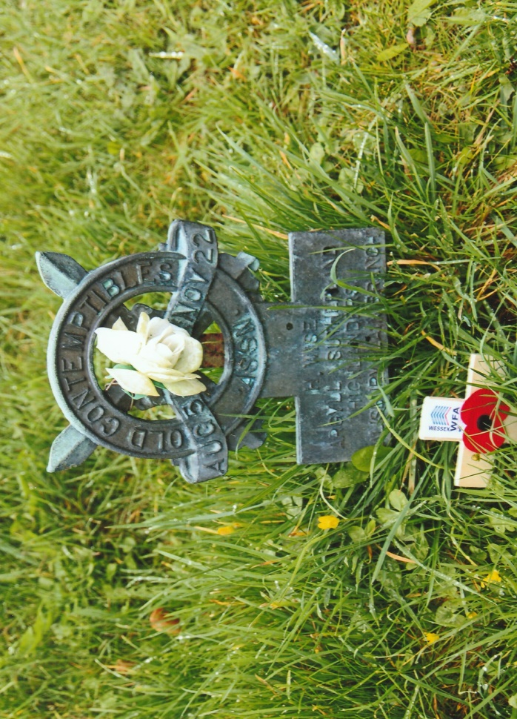
Grave Marker Of H. Wise – Argyll & Sutherland Highlanders
In the west cloister of Westminster Abbey there is a memorial tablet of limestone and Welsh blue slate dedicated to the memory of the “Old Contemptibles”. Designed by Donald Buttress, its shows the badge of the Old Contemptibles Association at the base with the inscription above in gilded letters: “Remember THE OLD CONTEMPTIBLES The British Expeditionary Force which served in Flanders within the range of the enemy mobile artillery between 5 August and 22 November 1914. At the first battle of Ypres their stand against a force of ten times their number prevented the German advance against the Channel ports. Unveiled 5 July 1993 by H.M. Queen Elizabeth The Queen Mother”.
Online Sources
Imperial War Museum Web-Site ~ www.iwm.org.uk
Westminster Abbey Web-Site ~ www.westminster-abbey.org
Wikipedia Web-Site ~ www.wikipedia.com
Photographs ~ R.G. Coleman
R.G. Coleman

