BOOK REVIEW
British Widows Of The First World War ~ The Forgotten Legion
By Andrea Hetherington Published by Pen & Sword (Military) 2018.
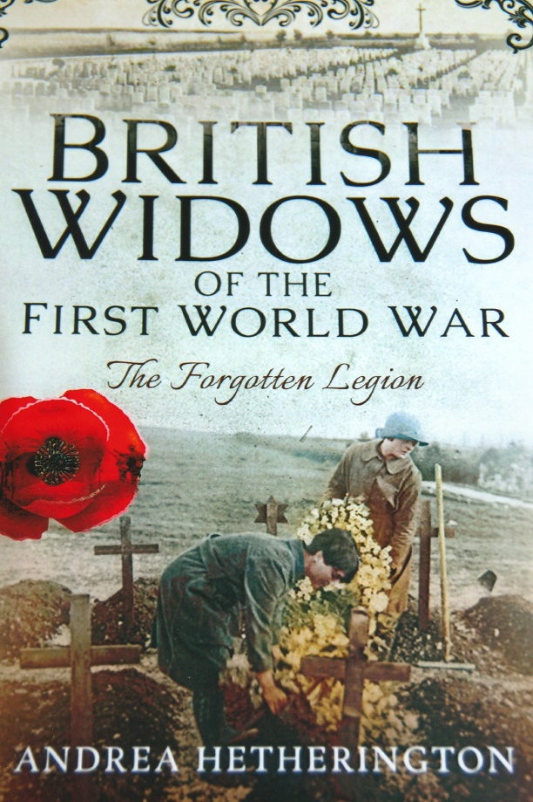
ISBN 978 1 47388 676 6 Price ~ ₤19·99
This is fascinating and very interesting book on an overlooked aspect of the traumatic consequences of war. The author traces the history of the effects of those killed in action from earlier times upon individuals, families and particularly women as an introduction to the First World War. She outlines the system which led to the award of compensation and pensions to women who suddenly had no household income caused by the death of their husbands. It was not considered to be an automatic right that women should have a widow’s pension and there were many bureaucratic hurdles which obstructed or reduced payments. The state was always eager to take away payments to which the widow was entitled. Many of these women probably had had only a basic education and would have found it difficult to know how to make a claim and to fill out the appropriate forms. Today over one hundred years later similar problems still exist, with many not knowing details about their proper entitlements. It was problematic enough for these bereaved widows during the First World War to find out what had happened to their loved ones, let alone how to obtain any compensation which only increased their grief at a particularly emotional time.
One aspect which irritated widows was the ‘Lady Visitor’. A respectable, mostly upper class lady would call on the claimant to ensure that she was running her household efficiently and had no other income. It was not unusual for bereaved women to take in a lodger for extra income to support the family. Lodgers were always suspected of being either a lover or a surrogate husband. Class and background impinged upon the approach adopted by officialdom. Wives of wealthy officers especially in the early months of the war who lost their husbands did not need to seek compensation as they were financially secure. So it was argued by some why should the State then make payments to other women! As the war dragged on the rising cost of compensation paid to widows became an additional heavy burden on the public purse. Existing legislative measures concerning compensation payments were manipulated and the introduction of additional new legislation was often obstructed for the most trivial of reasons.
Andrea Hetherington has thoroughly researched all aspects about widows of the First World War. She relates to the reader about widows who sought a degree of comfort about their missing husbands through spiritualism which was widely practiced during and after the war. The problem’s experienced by wives whose husbands were executed or took their own lives is also considered by the author. Other aspects include widows who broke the law, women and work, relying on charity, seeking a new life abroad, re-marriage, forfeiture of pensions, post-war deaths, emotional accounts and detailed personal experiences of widows, remembrance of those killed, attitudes of government and the military authorities, give a very comprehensive coverage of the problems and difficulties that widows of the First World War had to overcome.
Photograph ~ R.G. Coleman
R.G. Coleman

