WESSEX BRANCH WESTERN FRONT ASSOCIATION
BATTLEFIELD TOUR ITALY 14th-23rd MAY 2018 ~ ASIAGO ~ ANZIO ~ CASSINO
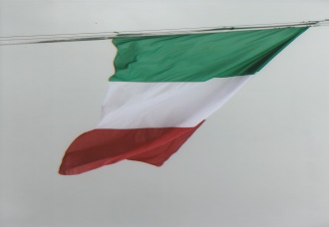
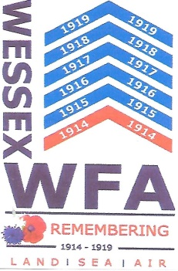
Our Italian battlefield tour 2018 began at Wareham where Martin, Judy, Steve and Roger boarded a Homeward Bound Travel 16-seater mini-bus with driver Keith. Leaving Wareham in the early afternoon we headed for Salisbury where Viv, Sandra and Tom joined us and then we drove onto Stockbridge where Marc was waiting and he completed our tour party of nine. We stopped for a thirty-minute break at Fleet Services and then continued along the motorway system to a Premier Inn at Gatwick for an overnight stay. Martin issued to us there a comprehensive and well written battlefield tour guide for bed-time reading! We all gathered for an enjoyable evening meal and drinks before retiring for an early night and looking forward to the tour.
Arising early on the 15th May we assembled at 0515 hours in the hotel reception for the fifteen minute shuttle bus journey to Gatwick (South) Air Terminal. On arrival there we took our luggage to the Baggage Drop area for loading onto the aircraft and then with reasonable efficiency passed through passport and security controls into the airport shopping mall. An infusion of coffee/tea was eagerly consumed before we took our seats on an Air Bus A319 for the 1¾ hours flight to Venice, which took off at 0735 hours. Ahead of schedule we landed at Marco Polo airport where we quickly passed through passport control, collected our baggage, rendezvoused with Georgio our driver and took our places on a 16-seater mini-bus for the journey to Vicenza. Having put our watches forward one hour we enjoyed the pleasant drive to our Monte Berico hill-top hotel. Warmly greeted by Lucia and the hotel staff we checked into our rooms to unpack and freshen up.
Gathering an hour or so later in reception Martin outlined our tour programme for the following day – Wednesday – and then we walked to a nearby restaurant for a light lunch and drinks. Although the temperature was warm, dark clouds began to gather followed by a light drizzle which did not deflect us to spend free time exploring Monte Berico. We took the opportunity to visit the Santuaro Di Monte Berico – The Basilica of St Mary of Mount Berico which is a Roman Catholic minor basilica and a Marion shrine erected at the top of the hill. Legend has it that on two occasions on the hill the blessed Virgin appeared to a local peasant worker, firstly in March 1426 and again in August 1428. The Virgin promised that if the people of Vicenza built a church on the hill top she would rid the city of the plague. The people’s response to the Virgin was almost immediate and a church was built in three months. It later became a sanctuary. Many alterations and additions, including a convent have transformed the original church into a predominately 18th century Baroque style church. The north façade faces the Piazzale della Vittoria, the square in front of the Basilica which gives a panoramic view of the city of Vicenza.
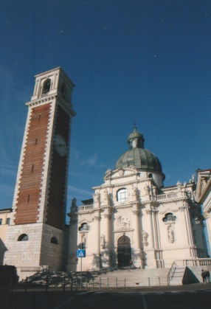
The interior of the church is impressive with classical decorations and artwork. Paintings by Venetian artist such as Alessandro Maganza (1556-1630) and 15th century frescos are resplendent examples. Above the beautiful altar is a 15th century statue of the Madonna by Nicoló de Venezia. The former refectory is dominated by a Paolo Veronese (1528-1588) painting of the Supper of St Gregory (1572). It was his custom to dine with twelve people in recollection of the last supper. On one occasion an unexpected man joined them who later revealed himself as Jesus. This 8-metre x 4-metre painting was cut into thirty-two pieces by the Austrians in 1848 during the First War of Italian Independence. Later it was carefully restored and conserved.
One of the tombs in a small crypt was adorned with floral tributes and contains the remains of Jochim Stevan who was born in 1921. Later he became a baker and was duly called up for military service in 1941, serving with the Alpini in Albania, Montenegro and France. After the war he became a postulant and non-cleric brother of the Order of the Servant of Mary and accepted into the convent of Monte Berico. He began in 1948 his novitiate and took the religious name Gioacchino M. Stevan. However a year later he died of tubercular meningitis. Pope John Paul declared him venerable on the 8th April 1997.
On leaving the church we walked up the Ambellicopoli Hill to the Villa Guiccioli which houses the Risorgimento and Resistance Museum. The museum has a fascinating and interesting collection of artifacts and material reflecting the historical experiences of Italy from the mid-19th century arranged in five rooms. Room 1 charts the fall of the Venetian Republic to the Lombard-Venetian Kingdom; Room 2 the Risorgimento and the 1848 revolt; Room 3 the Wars of Independence and Kingdom of Italy; Room 4 the First World War; Room 5 Fascism and the Second World War Resistance. These visits to the church and museum were a stimulating introduction to the cultural traditions of Italy and heralded the start of a very good battlefield tour. Returning to our hotel we later gathered for an early evening meal.
We were up bright and early on Wednesday and eager for the day’s itinerary’s adventure. By 0900 hours we had left the hotel and travelled along the A31 in bright sunshine. Martin gave us a strategic overview of the British deployment to the Italian front and the political reasoning for the decision to send five divisions to Italy. Georgio brought to our attention the distant snow-capped mountains rising above the clouds as we approach the foothills of the Dolomites. Leaving the autostrada we drove along the S349 to begin the climb up the Asiago Plateau via hairpin bends and twisting roads absorbing the stunning views down and across the valley plain below. There are still traces of the discontinued Vicenza to Asiago railway line on the slopes of the hillside clearly visible, which is now used as walkers trail. The local people had a nick-name for the train calling it the ‘Black Cow’ as it steamed up and along the railway track slower than cattle could be driven. Having passed through the villages of Gogollo dei Céngio and Trechè-Conca – ‘Conca’ was a regional dialect spoken in this area – we turned towards the Cesuna and on its outskirts we made our first stop to visit Magnaboschi British Cemetery. We walked along the old mule track to the cemetery which contains 183 burials of the First World War. At the Cross of Sacrifice we held a short service of remembrance. Steve laid a Wessex Branch WFA wreath, Roger gave the exhortation followed by a minute’s silence.
Opposite the British cemetery is the Italo-Austrian Military Cemetery which contains 1,739 Italian and 596 Austro-Hungarian burials. The graves are marked by broken pine tree stumps approximately 1½-metres in height with a chamfered top. Attached to each stump is an engraved plaque bearing the name or names of the identified buried beneath and another plaque in the national colours from which the casualty originated. On the far side of the cemetery is a 3-metre high Cross of Sacrifice incorporating a cross and bayonet and the pathway leading up to it is lined with gravel in the colours of Italian flag. On a low ridge near the cemetery is a Roman marble column – the Colona Romana – where the Italian 33rd Division stopped the Austro-Hungarian advance in 1916.
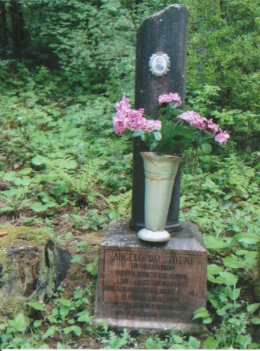
We left these two splendid and well cared for cemeteries and drove a short distance, parking up in a pine tree surrounded layby to visit Boscon British Cemetery. We all enjoyed the 1·5-kilometre walk through the beautiful pine forest and fresh mountain air full of aromatic scent from the trees and flora. The location of this cemetery imposes on the visitor a feeling of contemplation when viewing the graves of the men who died a century ago. On the rising woodland ground behind the cemetery is a lone private grave of Angelo Del Zotto Di Raimondo, well-tended with fresh flowers. Born in 1927 in Canove he was the son of Raimondo and Elvira and lived in Cogollo Del Cengio. On the morning of the 22nd June 1944, he took some cows to pasture and graze. One of them wondered off and when he went looking for it he was shot and killed in the wood behind Boscon cemetery by a burst of machine-gunfire from a group of fascists. Angelo was 17-years-old and had no connection with any partisan group.
Leaving Boscon cemetery in a reflective mood we rejoined our mini-bus and drove back to Cesuna, through Canove, where there is a very good First World War museum in the old railway station building to the town of Asiago. An Austro-Hungarian counter offensive – Battle of Asiago – against the Italian Front was fought here in May and June 1916. As dark clouds began to draw a curtain over the lovely sunny morning it was an appropriate moment to stop for lunch.
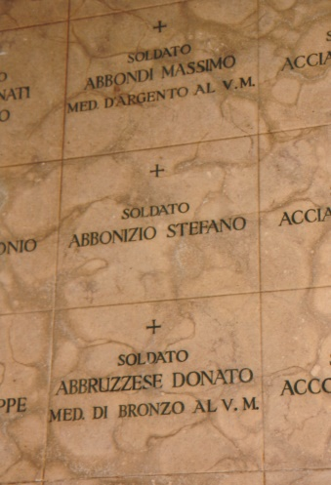
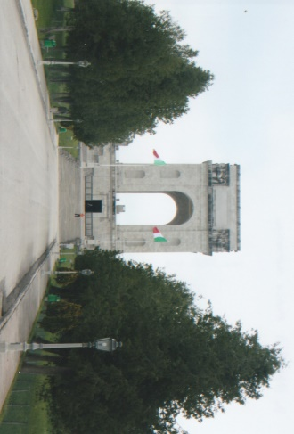
After a delicious lunch we drove to the car park at the foot of the Sacrario di Asiago or Sacrario Militare del Leiten, the latter is the name of the hill on which was erected the Asiago War Memorial. To gain access to the memorial requires a walk up a steep hill – the Via degli Eroi or Road of Heroes lined with cypress trees. The Asiago War memorial was completed in 1938 and inaugurated on the 17th July in the presence of King Victor Emmanuel III and Benito Mussolini. Designed by the Architect Orfeo Rossato (1885-1937) with sculpture by Roberto Montini (1882-1963) and Zanetti it was constructed of locally mined white marble. Two 35-metre staircases lead up to a terrace which encircles the memorial and on which, arranged at intervals are restored original cannons. Within the memorial lie the remains of over 50,000 Italian and Austro-Hungarian soldiers. Inside there is a crypt and an octagonal chapel with an altar at its centre. Interred behind the chapel walls are the remains of twelve Italian recipients of the Gold Medal of Military Valour. Radiating outwards from the centre are corridors with low lighting and veiled natural light. Behind the marble lined walls are the remains of 33,086 Italian soldiers who were exhumed from thirty-five war cemeteries surrounding Asiago between 1935 and 1938. The identified remains were placed in individual niches in alphabetical order and the unidentified remains placed in two communal tombs. Of the Italians, 12,795 are known and 20,291 are unknown. The remains of 18,505 Austro-Hungarians of which, 12,355 are unidentified were brought into the crypt. Near the crypt is a small museum with artifacts, photographs and documents relating to the First World War. There is a letter written prior to the Battle of Mount Ortigara, by Lieutenant Adolfo Ferrero. It was discovered when his remains were found in the 1950’s and he was later interred within the memorial. We were all amazed by the Books of Remembrance which are made from brass and contain the names of the known buried within the Asiago War Memorial. The dedicated and devoted workmanship in producing these Books of Remembrance to honour all those soldiers who gave their lives for the cause of their respective countries is remarkable.
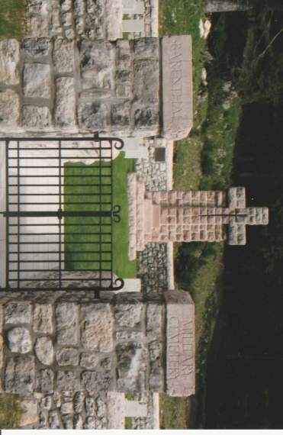
From the Asiago War Memorial we drove to the ‘Barenthal Road’ which traverses the plateau to visit four Commonwealth War Graves Cemeteries. A brief stop was made at the ‘Ospedaletti Inglisi’ Bunker – the English Hospital. Sited by the side of the road its structural form is basically a concrete Nissen hut. The British were deployed in this sector of the front and were attacked during Operation Radetzky by the Austro-Hungarian forces on the 15th June 1918. (See the WFA 2018 Calendar for the month of June for a splendid photograph of the Ospedaletti Inglisi). For the centennial of the First World War new information display boards have been erected near this structure. Driving on along the uneven forest road, approximately 2·5-kilometres from the SP272 main road we arrived at Barenthal Military Cemetery, containing 125 burials of which 9 are unidentified. The Italian meaning of Barenthal is ‘Bear Valley’. All of the Commonwealth War Graves Cemeteries on the Asiago Plateau are peacefully situated and surrounded by forest trees. Our next visit was to Granezza British Cemetery containing 142 burials of which 3 are unidentified. In this cemetery lies Captain Edward Brittain MC, brother of Vera Brittain who wrote Testament of Youth and on her death her ashes were scattered on his grave. Lieutenant-Colonel J.M. Knox DSO, 1st/7th Battalion, Royal Warwickshire Regiment who was killed in September 1918 is also buried here. To the right of the entrance pathway to the cemetery, by the roadside is a memorial to the men of 143rd Warwickshire Infantry Brigade who died on the Asiago Plateau which was erected by Lieutenant-Colonel Knox’s family. To complete our visit to the five Commonwealth War Graves Cemeteries on the Asiago Plateau we stopped at Cavalletto British Cemetery situated on the hillside of the Rifugio Verdefonte. Surrounded by numerous forest trees the cemetery contains 100 burials. It was near to this cemetery that an advanced hospital was located to treat urgent battlefield casualties as the journey to the main hospital on the plateau was long and difficult to traverse. We held another short service of remembrance at the Cross of Sacrifice, where Roger laid a Wessex Branch WFA wreath, Steve recited the exhortation followed a minutes silence. During our visits to these cemeteries Wessex Branch WFA crosses were placed at individually chosen graves.
Proceeding from Cavalletto cemetery we descended Monte Cavalletto following a single track road and soaking up the landscape views displaying nature’s luscious spring growth and rejoined the SP72. We passed through several villages including Lusiano, Fontana Colombrar, Salcedo and San Giorgio towards the town of Breganze. The latter in the province of Vicenza is noted for its fine red and white wines. Georgio asked us if we would like to visit the Beato Bartolomew Bregaze Winery named after a 13th century friar and established in 1797. Accepting his invitation we were guided around the winery by the company’s President. With Georgio translating we visited the automated bottling plant and informed about the production methods of the winery. We descended approximately 16-metres underground to a vast cool basement where hundreds of thousands of litres of wine are kept to ferment and mature. One section contained wooden barrels containing 12,000, 8,000, 4,000 and 220-litres of red wine. Adjacent were gigantic stainless steel vats for holding white wine. In 1950 a co-operative of 121 regional wine growers was formed who bring their grapes to the winery for processing. The company has an excellent reputation and exports its wine into the global market. Returning to the ground floor retail area where wine can be purchased we were fascinated by what appeared to be four half-size petrol pumps which in fact dispensed wine. Local people bring along containers to be filled with wine at very reasonable prices from these pumps and pay at the cash desk. This was another first for our Branch and we all thoroughly enjoyed this privileged visit thanking both the President and Georgio. We then left the winery and made our way back to Vicenza for a pleasurable and relaxing evening.
We had left our hotel by 0830 hours on the Thursday morning with Nico as our driver. Travelling from Vicenza we sped along the SP 46 towards Schio and the distant mountains. As we began to climb up the SP349 via a series of hairpins the precipitous drops to our right hand side were more than compensated for by the views towards our destination Fort Punta de Corbin. From the hamlet of Tresché Conca we turned firstly onto an asphalt road and then followed a 5-kilometre dirt road to the Fort. We were a few minutes early as the staff had not arrived. Most probably surprised to see an English party awaiting them patiently, they quickly opened the entrance gates for us to enter the grass covered sward of Fort Corbin. The latter takes its name from the rocky spur that dominates the Val d’Astico on which its sits.
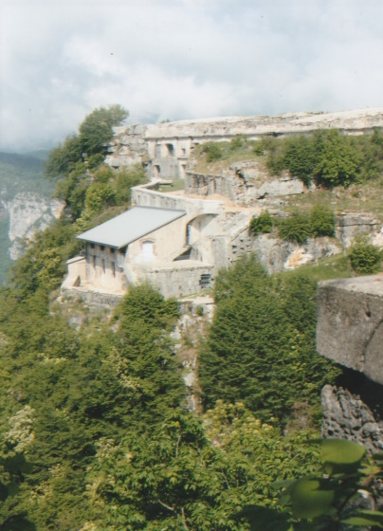
Fort Punta de Corbin at 1,077-metres was one of the fortresses forming the line of defence on the south-western edge of the Asiago plateau to the north of Vicenza and guarding against any incursion by the forces of the Austro-Hungarian Empire. Constructed between1906-1914, a military road had to be specially built to connect Tresché Conca to Fort Corbin for the movement of building materials and equipment. The steel domes for the Fort’s cannons were transported in sections by rail to Campiello, off-loaded onto wagons, hauled up to the fort and then welded together on site. Fort Corbin’s main armament comprised 6 x 149-mm cannons with a range of 7-11-kilometres, mounted in 360-degree rotating steel domes 160-mm in thickness. Massive masonry blocks replaced earthworks surrounding the fort. Light artillery weapons and machine-gun posts were inserted for close proximity defence and a large guard house on the eastern side defended the main structure which also protected the entrance and cableway. An internal road and underground tunnels allowed access to the western part of the fort where the powder magazine, service rooms, machinery for rotation of the domes and accommodation for 134 artillerymen were located.
At the outbreak of the First World War the fort was garrisoned by the 9th Fortress Artillery Regiment. However, higher military authority deemed that the fort’s armament would be more useful near the front line. The six cannons were removed and replaced by tree trunks to deceive the enemy, which they appeared to do as they continually shelled the fort for a year. On the 15th May 1916 a huge 380-mm Austrian shell fired from Fort Campo severely damaged Fort Corbin. At the end of May during the Strafexpedition the fort was occupied by the Austrians of the 28th Division. The Italians made an unsuccessful attempt to recapture the fort in early June when the Austrians were engaged in a bloody battle against Sardinian Grenadiers for the occupation of Mount Cengio. Towards the end of June the Austrians abandoned the area of Monte Cengio to settle on the defensive line of the Val d’Assa. Although the fort was re-occupied by the Italians it was no longer involved in any fighting and its primary role was observation of Mount Cimone which remained in Austrian control until the end of the war.
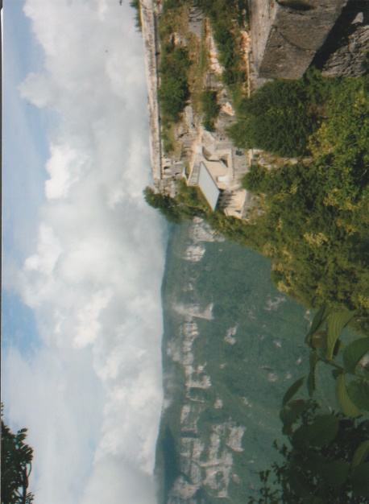
When the conflict ended the fort was used as a depot barracks for military training until the early 1930’s when any material of economic value was removed. Damaged was caused to the structure as explosives were used to extract metal from the masonry. In 1942 the Fort and the surrounding land was transferred by the military to private ownership. Since the 1980’s they have undertaken to clean up the site, secure, stabilize and restore the structure so that the fort could be opened to the general public. The sun shone brightly during our visit and melted away the ever shifting clouds giving breathtaking glimpses of the surrounding mountains and valley below. The fort’s dominating presence and solidarity remains as a permanent memorial to the men who lived and died here. Information display boards guide the visitor around the fort in conjunction with a printed handout. There is also a café and a small museum exhibiting battlefield artifacts, photographs, documents and documentary videos. For the centennial of the First World War new information display boards and finger posts have been erected on the former Italian battlefield sites which are now regarded as ‘open air’ museums in order to preserve them for future generations.
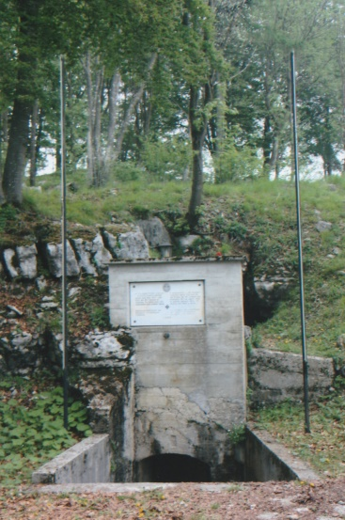
Leaving at midday we drove back down the SP349 passing through the villages of Cogolo del Cengio, Caltrano, Chiuppani and onto the SP350. Having descended one mountain we began the ascent of another mountain on the opposite side of the valley following the SP64 to Velo d’Astico where we had lunch. Remaining on the SP64, which is practically a single track road we continued climbing around tight bends with no room for error past Arsiero and on to the village of Tonezze de Cimone. In an outlying area Nico parked the min-bus in a car park surrounded by forest and from where we began a steep up-hill walk to the 1,226-metre summit of Mount Cimone. The hillside track was rutted, strewn with boulders with clearly visible former defensive lines and structures cut into the natural rock on either side of the rough trail. About half-way up the track is a memorial tablet above an entrance to an underground gallery in commemoration of 133 soldiers of the Austrian Karnter Volunteer Guards who were killed there between December 1917 and July 1918. On reaching the summit, finger posts point to features to the left and right. Taking the former pathway leads to well preserved trench systems which we were able to traverse for some distance to see dugouts, machine-gun positions and tunnel entrances. This ‘open air museum’ is riddled with trenches and strongpoints, some sections of which have been respectfully restored. The remainder virtually, untouched probably due to their remoteness have been left to nature. Caution has to be exercised around the site and should not be traversed alone. Retracing our steps to the fingerposts we followed the right-hand pathway which leads up to the Ossuary of Mount Cimone.
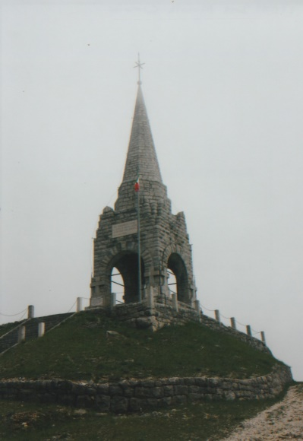
Situated at the southern end of the 1,226-metre high Monte Cimone di Tonezza plateau and connected to it by a narrow strip of land Monte Cimone was an important strategic position during the Austrian Strafexpedition of May-June 1916 and during the following Italian counter-offensive. Possession of the peak ensured effective control of the valleys of the Astico and Posina and the important route from the Trentino to the Veneto plain. The Austrians occupied the position on the 24th May 1916 which was bloodily contested by the Italians in July. In an attempt to dissuade the Italians from penetrating their lines the Austrians excavated a gallery to explode a mine under the top of Monte Cimone. At 0545 hours on the 23rd September, 14,200-kilograms of explosives were detonated and changed the profile of the mountain top and eradicated the Sele Italian infantry brigade. The remains of 1,210 soldiers were recovered after the war and buried in a mass grave. Designed by Thom Cevesse (1886-1947) a four-sided portico was erected over the grave. A series of steps lead up to beneath the archways of the portico where there is a small altar made from stone removed from the crater caused by the explosion. From the top of the portico two octagonal bosses support a tower surmounted by an iron cross. On the pediment of the tower a plaque is inscribed “BURIED BY MINE HERE A THOUSAND SONS OF ITALY SLEEP 23rd SEPTEMBER 1916”. The Ossuary was inaugurated on the 28th September 1929 in the presence of Prince Umberto of Savoy. On the western side of the ossuary are the remains of two gravestones which recall a former military cemetery and along the access path to the summit in the Austrian area of operations another bilingual inscription records the presence of the Carinthian Volunteer Rifle Regiment and their dead. The Sacrum-Ossuary of Monte Cimone together with those of Pasubio, Monte Grappa and Leiten, have become a symbol of the province of Vicenza. We could have spent more time looking around the battlefield strewn landscape but with lightning flashes and thunder it was wise to return to our mini-bus. Descending the steep mountain roads we rejoined the A4/A31 to Vicenza and arrived there in bright sunshine.
Georgio rejoined us on Friday morning accompanied by an Alpini veteran Piero Antonio, who has studied and researched the fighting which took place on Monte Grappa and in the surrounding mountains. His great uncle had fought on the Italian front during the First World War and after the Armistice he took Holy Orders. Piero Antonio has written books and articles about the conflict in the Monte Grappa sector and has for eight years given educational talks to schoolchildren and accompanies them on day-trips into the mountains to explain about the war fought on the Italian front. For his work the Austrians awarded him a gold medal in 2014 and he is a member of the Society of the White War and The Historical Association of the Piave. Proudly he produced from his shoulder bag a bottle of grappa called ‘Spirit of Peace’. Martin gave him a Wessex Branch WFA Lapel Badge which he promptly pinned to his jacket. He then gave Martin a very interesting article, written from the Italian perspective about the fighting on Monte Grappa which Martin read out to us as we motored along the autostrada. Ascending the steep SP141 mountain road, Piero pointed out to us a memorial to 3,000 partisans who were killed on the mountains during the Second World War. With Georgio translating, Piero explained to us the appalling cost in lives and the bravery of the soldiers who fought on Mount Grappa in summer and winter. He said that despite all battle plans drawn up by generals the ‘Mountains Make Their Own Rules’.
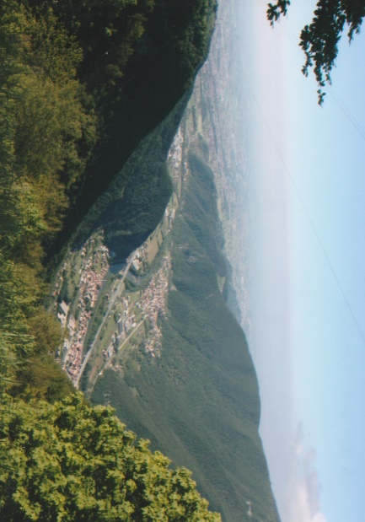
Arriving at Solagna we stopped for a comfort break and coffee. The village is located 27-kilometres from the valley plain and 13-kilometres from the summit of Mount Grappa. The panoramic views from the village are outstanding especially with a backdrop of blue sky, sunshine and fluffy white clouds. Piero mentioned that the hillsides are regarded as a ‘cemetery’ because of the remains of soldiers that still lay in the ground beneath the slopes and in the forests. It is estimated that 450,000 Italian and Austro-Hungarian soldiers are listed as missing in the mountains, many of them on Monte Grappa. It is not unusual for personnel licensed to use metal detectors searching for battlefield artifacts to discover human remains. Nearby the café almost hidden from the road by pine trees is a small modern church which was closed. Continuing we passed by a “Cologna Romana” marking the furthest point reached by the Austro-Hungarian army. We crossed over the San Lorenzo Bridge near to where the Austrians planned to attack the Italians. Believing the latter were exhausted and ill prepared the Austrians allowed themselves half-a-day to overcome this depleted force. However, the Italians launched a counter-attack forcing the Austrians back to their starting line. They had only brought with them rations for half-a-day. Austro-Hungarian resources were stretched and troops were not available to help or relieve them. When reliefs and rations eventually arrived the Austrians were found to be starving.
We arrived shortly before midday in the car park on the 1,750-metre summit of Monte Grappa for a visit to the Sacrario Militare de Monte Grappa. During the First World War three battles were fought between the Italians and Austro-Hungarian armies to gain control of the Monte Grappa massif, which protected the left flank of the Italian Piave front. The first and most important battle fought between 11th November and 23rd December brought a halt to the Austrian summer offensive of 1917. Although the Austrians were supported by German troops the combined force had not been able to capture the summit of Monte Grappa. General Luigi Cardona, Chief of the Italian General Staff then issued orders to construct fortified defences on the summit of Monte Grappa to make the mountain an impregnable fortress. Although the Austrian summer offensive of 1917 inflicted a costly defeat on the Italians, Cardona’s initiative saved Italy from total defeat in 1918. The second battle of Monte Grappa was a part of the larger Austrian summer offensive of 1918 and the last offensive of the Austro-Hungarian Army during the First World War. On the 24th October the third battle of Monte Grappa began as part of the last Italian offensive when nine divisions attacked the Austro-Hungarian positions. The latter had reinforced their positions from nine to fifteen divisions and committed all their reserves. After four days of fierce fighting the resurgent Italians forced the battle weary and exhausted Austrians to begin a general retreat on the 28th October heralding the break-up of the Austrian-Hungarian Empire.
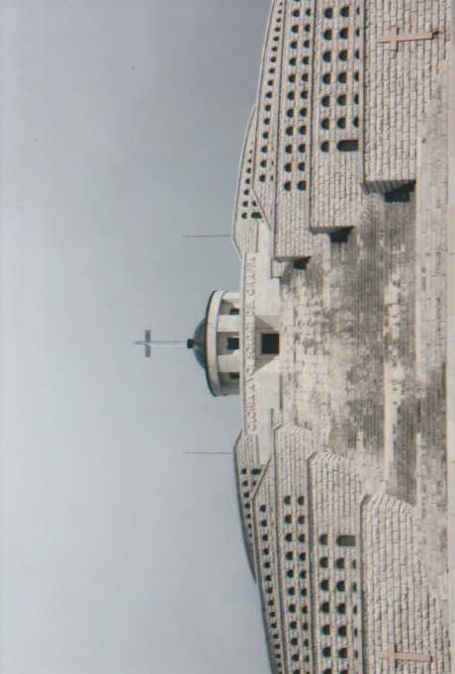
The “Art Deco” style Sacrario Militaire de Monte Grappa erected on the summit of Monte Grappa was designed by Giovanni Greppi (1884-1960) together with the sculptor Giannino Castiglioni (1884-1971). It is the largest monumental ossuary in Italy and was inaugurated on the 22nd September 1935. The monument stretches across the mountain top in three connected sections. At the southern end is the Italian ossuary, constructed in five layered concentric circles to form a low pyramid containing the remains of 12,615 soldiers of which, 2,283 have been identified. At the northern end is the Austrian ossuary containing 10,295 remains of whom, 295 are identified. The two ossuaries are connected by the Strada Eroica (Heroic Way). The latter has on either side seven pairs of cippi – large rectangular boundary stone blocks – on which are carved in relief the names of the locations of where the Battles of Monte Grappa were fought. Inset into the layered walls are niches in which the individual remains were placed and sealed with bronze plaques, each inscribed with the names of the identified soldier.
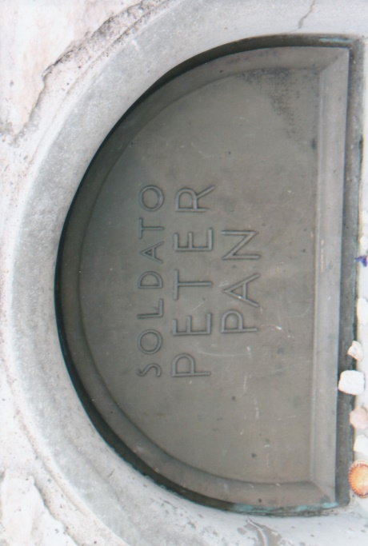
Above the Italian ossuary is a small chapel of the Madonna del Grappa. Originally soldiers who were stationed in the now abandoned military barracks on the Monte Grappa Massive erected the Madonna on the mountain before the First World War. Damaged by Austro-Hungarian shell fire it was restored and placed in the chapel exactly where it had originally stood before the war. There are several memorials by the side of the Heroic Way and on the grassy slopes leading up to the monument commemorating units and individuals who fought on Monte Grappa. From the car park we walked up the fairly steep hillside via steps to the “Strada Eroica”. Piero then led us to the northern section of the ossuary to grave number 107 where the remains of Peter Pan who fought with the Austro-Hungarians forces are interred. He was born on the 21st August 1887 in Ruszkabanya-Krassōzoreny, Hungary and was killed on Col Caprile on the 19th September 1918. His birthplace, now in Romania is called Rusca Montana. The village square there is called Monte Grappa and a road named after Peter Pan leads up to the house where he was born. As a young boy he looked after sheep and it was allegedly foretold that he would die amongst sheep. The hill on which he was killed was known locally as the ‘Hill of Sheep’ where animals grazed before the war. There is not much further biographical information about Peter Pan but he has sparked keen interest amongst those who have undertaken research about him, including Piero. Many who come to visit the resting place of Peter Pan romantically associate him with J.M. Barrie’s fictional character and place tributes of remembrance on the lip of the niche.
From where we were standing at the northern end of the ossuary and directly below is a vast rolling green landscape with isolated groups of trees. It is a sobering thought that beneath these untouched fertile slopes lay the remains of countless numbers of unidentified soldiers. We thanked Piero for relating to us many fascinating details about Monte Grappa and for imparting his detailed knowledge to us. Each of us then had free time to explore the Sacrario Militare de Monte Grappa. The Grappa Massive and its environs are rich in both flora and fauna. Traces of the Italian trench lines are still visible around the summit and the grassy slopes are pock-marked by shell re-entrants. The larger shell holes are utilized by farmers for watering their animals. Numerous underground tunnels constructed beneath the summit allowed the Italian soldiers to move safely to and from the front lines and artillery positions. A few are accessible, but most have been sealed for safety reasons. In a nearby by cave it is locally believed the Nazi-Fascists burnt alive a number of Partisans. In 1974 a statue called Al Partigiano sculpted by Augusto Murer (1922-1985) was placed in the cave as a permanent memorial.
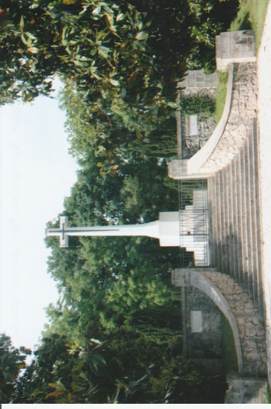
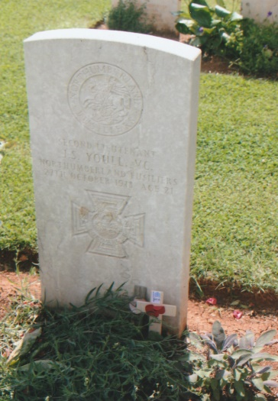
Our visit to the Sacrario completed we had lunch in the Refugio and then drove down from Monte Grappa in heavy rain which gradually ceased as we emerged from the cloud cover. Our drive then took us through the villages of Borso del Grappa, Crespano del Grappa, Paderno del Grappa and Asolo. The latter is known as The Pearl of the Province of Treviso and has a fine castle dating from the 10th century, a 16th century cathedral and was once the home of the poet Robert Browning. Continuing on through and past Montebelluna the road took us past the foothills of the Montello Ridge. As we did so Martin outlined the significance of the ridge during the First World War. The bean shaped hill rise’s 371-metres above the Piave River which runs along the northern and western edges of the hill. During the war Montello was part of the Italian front line sector defended by the Italian 8th Army and was the scene of the “Battaglia del Solstizio” in June 1918. After the war a church and monument was erected on the top of the hill. We arrived at Giavera de Montello for a visit to the Giavera British Cemetery. The town was expecting the Giro d’Italia to pass through its streets during the afternoon and some had been temporarily closed for it. Georgio spoke to a policeman who allowed us to access the road to the cemetery. This beautiful and impeccably maintained cemetery contains 417 burials of the First World War of which two are unidentified. The soldiers commemorated here died defending the Piave from December 1917 to March 1918 and also those who died west of the river during the ‘Passage of the Piave’ between the 23rd October and 4th November 1918 during in final Battle of Vittorio-Veneto. Within the cemetery is the Giavera Memorial commemorating 150 soldiers who died in 1917 and 1918 and who have no known grave. Among those buried here is Second Lieutenant John Scott Youll V.C., 11th Battalion, Northumberland Fusiliers. He was awarded the Victoria Cross for his conspicuous gallantry in the Asiago sector on the 15th June 1918. The announcement of the award appeared in the London Gazette of the 25th July, 1918: “For most conspicuous bravery and devotion to duty during enemy attacks when in command of a patrol which came under hostile barrage. Sending his men back to safety, he remained to observe the situation. Unable to subsequently to rejoin his company Second Lieutenant Youll reported to a neighbouring unit, and when the enemy attacked he maintained his position with several men of different units until the troops on his left had given way and an enemy machine gun had opened fire from behind him. He rushed the gun, and having killed most of the team, opened fire on the enemy with the captured gun, inflicting heavy casualties. Then, finding that the enemy had gained a footing in a portion of the front line, he organized and carried out with a few men three separate counter-attacks. On each occasion he drove back the enemy, but was unable to maintain his position by reason of reverse fire. Throughout the fighting his complete disregard of personal safety and very gallant leading set a magnificent example to all.”
Also awarded the Italian Silver Medal for Valour he was later killed on the 27th October, 1918 during the crossing of the River Piave. He was 21 years of age. His medal group is on display in the Lord Ashcroft Gallery in the Imperial War Museum.
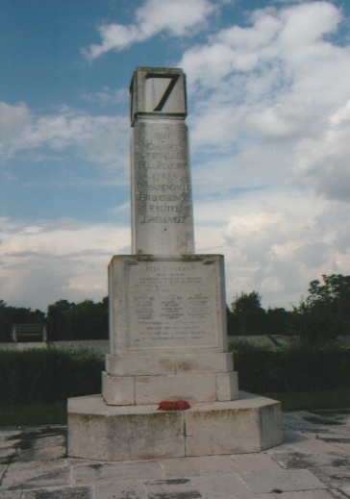
We spent a pleasant time at this cemetery in the warm sunshine and placed several crosses at chosen graves. Moving on from the cemetery we encountered several road closures and Georgio had to negotiate his way around the outskirts of the town to rejoin the SP248. Our last destination of the day was to the Piave River opposite Grave di Papadopoli or Papadopoli Island. We parked near the 7th Division Memorial on the western bank of the river. The 7th Division was transferred from the Western Front to Italy in November 1917. During March they were deployed near Vicenza before taking over the left sub-sector on the Asiago front.
In April and May they participated in actions against enemy entrenchments on the Asiago plateau. By October the division, part of the 10th Italian Army commanded by General Lord Cavan, had moved to the Piave front where they were ordered to occupy the enemy held northern part of Papadopoli Island. The crossing from the western bank began on the 22nd October, and despite bad weather they achieved their objective within twenty-four hours.
Ceasing an opportunity they continued their advance and by the 26th occupied the whole of the island. This enabled British and Italian forces to cross over from the island and attack the enemy held eastern bank of the Piave on the 27th October. The 7th Division maintained their forward momentum crossing over the Monticano and Livenza rivers and gained a foothold on the eastern bank of the Tagliamento River before hostilities ceased. When the Armistice came into effect on the 4th November the division withdrew to Treviso. They remained in Italy until 1919 when the division was demobilized.
The 7th Division Memorial stands a few metres from the western embankment of the Piave River from where on the footpath we were able to look across to Papadopoli Island and the Piave with its many shifting sandbanks, islands and fast current to the eastern side of the river. A modern bridge spans the Piave near to where we were standing. A group photograph was taken at the memorial before we set off on the journey back to Vicenza.
We left the hotel early on a lovely sunny and bright Saturday morning with Georgio and Piero for our day’s tour to Monte Zebio. Piero produced for us information and photographs about the latter and Martin outlined the days programme as we drove towards Asiago. Following the SP 349 into the town of Asiago we passed the old prison now housing an exhibition about Ernest Hemingway. Continuing on past Asiago airfield we turned onto a single track road, very uneven with tight hairpins bends until we reached a finger post at 1,395-metres and pointing up a track towards Monte Zebio.
We alighted from the mini bus by this signpost and prepared ourselves for a climb up the steep track strewn with forest debris and boulders. There were a couple of places where the track became relatively flat and grassed over but then it rose again ever more steeply. It was necessary for all of us to walk at a steady and even pace. Piero came with us pointed out trenches, dug-outs, redoubts and long abandoned troop positions. Snow still lay in the deep gullies and the whole atmosphere on this forested slope was magical. We eventually reached the 1,795-metre summit where we took a break in the peaceful and tranquil surroundings.
Monte Zebio was an important stronghold in the Austrian defensive line between 1916 and the autumn of 1918 from the Val d’Arsa to Ortigara. The whole area has a complex of trenches, tunnels and strong-points and was the scene of bloody and a hard fought battles during the First World War.
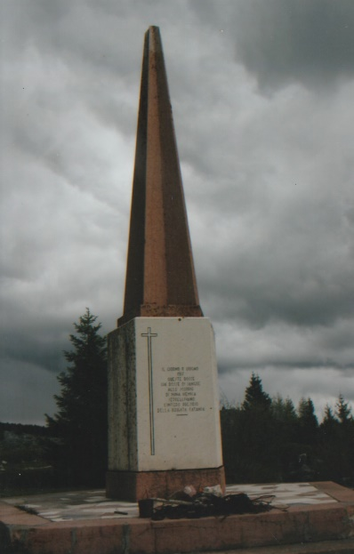
The Italians from the summer of 1916 and especially during the Battle of Ortigara (10th June – 25th June 1917) launched several attacks against the Austrians without success.
They began to excavate a tunnel under Lunetta’s spur in 1916 to place a mine beneath the Austrians positions on Monte Zebio. Unfortunately for reasons which are not clear the mine exploded prematurely on the 8th June 1917 two days before the commencement of the Battle of Ortigara which also exploded an Austrian camouflet killing 120 Italian soldiers, together with more than 40 officers of the Catania Brigade who were observing enemy positions from the Lunetta Spur.
An inscribed memorial obelisk was erected to commemorate those who were killed and translated reads:
The Day 8 June 1917 These Rocks Already Red With Blood At The Outbreak Of The Enemy Mine They Buried The Whole Garrison Of The Catania Brigade
Although care must to be exercised when walking around the area it is full of interest and deserving of exploration. The Asiago communal authorities took the decision in 1997 to create a Peace Trail up Monte Zebio – which we had followed. The Austrian positions, gravestones, dugouts, trenches, mine crater and the cemetery where soldiers of the Sassari Brigade were buried were all restored and carefully preserved. Now well sign posted with information boards the Monte Zebio ‘open air museum’ has been made safe for visitors. We would have stayed longer on the summit but dark clouds had gathered and with the sound of distant thunder we called a halt to our activities. We had a group photograph by the memorial and Piero then led us across the plateau to Malga Zebio where Georgio was waiting for us with a picnic lunch of local produce. The low clouds duly delivered heavy rain and we finished our lunch in the mini bus.
The descent down the single track road from Malga Zebio was negotiated by Georgio with skill. On reaching the bottom end of the single road Georgio was hailed by a friend, Ricardo who was the caretaker of the Missionali Saveriam, a former religious school. Now closed the complex, is on the property market for 1·5-million Euros. When Georgio was a boy he spent four weeks here participating in sporting activities and adventure training in the fields and forests during the summer months. Ricardo offered to show us around the school complex and another gentleman made for us delicious coffee while we did so. The school is still used between June and September, mainly for boys provided their parents and friends help to undertake all the domestic duties. A group photograph was taken outside the building before we left. We spent a very pleasant hour or two with Ricardo and his friend, who were both very pleased to meet us. With farewell handshakes and grateful thanks we left the Missionali Saveriam for a leisurely drive back to our hotel.
It was an early breakfast again on Sunday morning so that we could depart from the hotel and begin a long journey south to Rome. We were joined by Simonetta, who was to be our driver for the remainder of the tour. Driving via the A13 & A1 we had a comfort stop mid-morning at a service station and then continued onward. We passed through several regions of Italy some predominately with flat landscapes others with hills and mountains in the distance, all peppered with a palette of nature’s spring colours. The autostrada passes over several rivers and through a series of road tunnels, some short in length others exceeding 2,500-metres. We stopped for lunch at the fortified hill-top town of Orvieto where Simonetta briefly parked the mini-bus on the square of the former Carabineri Barracks. Parking is strictly controlled and Simonetta had to drive back down to park the mini-bus in the modern town of Orvieto and take the cable car back up to the old town where she joined us for lunch. Orvieto, a small city in the province of Terni in south-west Umbria is situated on the summit of a volcanic tuff which rises almost vertically from the new town below. The city’s defensive walls are built of stone called Tufa. There is a 15th century Romanesque cathedral which has a mosaic façade, a 16th century well shaft with a double spiral staircase and an underground network of tunnels which can be traced back to the city’s Etruscan roots. Our schedule did not allow us time to explore the city with its narrow streets and shops displaying a wealth of tempting goods for tourists.
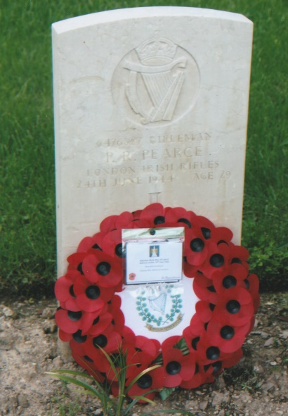
Simonetta had gone ahead to bring the mini-bus back up to the car park whilst we strolled through Oriveto to meet her. She then drove us to the nearby Oriveto War Cemetery which contains 190 Commonwealth burials of the Second World War. The majority of burials in this battlefield cemetery, established by the 78th Division during the fierce fighting that took place north of Rome are from the period 14th June – 4th July 1944. At the grave of Rifleman Philip Rhys Pearce, Marc read out to us detailed biographical information about this soldier who had family connections with Romsey. Afterwards we held a short service of remembrance at the graveside. Steve laid the wreath and Martin gave the exhortation followed by a one minute silence. A thoughtful time was spent here viewing the graves which are laid out on a fairly steep slope, beautifully and faultlessly cared for with the Cross of Sacrifice overlooking the cemetery.
Once back on the mini-bus we had another two hours’ drive to Rome. Rain began to fall in the late afternoon which became torrential for twenty minutes, slowing the traffic as water cascaded across the autostrada inches deep. Simonetta did very well to cope with the conditions and by the time we reached the outskirts of Rome, thankfully the rain had stopped. On arrival at our hotel we checked in to our rooms and gathered together, including Simonetta for a lovely evening meal and drinks in the restaurant.
The breakfast menu and food on display in the hotel was extensive and delicious. Leaving at half-past eight Simonetta drove us via the A31/A1 southwards to the town of Cassino. En route Martin gave a detailed account about the battles fought in the town and for Monte Cassino. On the approach road to Cassino we stopped at a service station for a comfort stop before arriving at Cassino War Cemetery.
In January 1944 the Germans held positions along the Rapido-Gari, Liri and Garigliano valleys including several peaks and ridges at the western end of the Gustav Line. Dominating above the town of Cassino, the Liri and Rapido valleys is the Abbey of Monte Cassino. The Germans also occupied positions on the steep slopes below the abbey walls. Between January and June 1944 the Allies launched four assaults against German held positions to break through the Gustav Line. On the 17th May the Polish II Corps forced the Germans to withdraw from the abbey and soldiers of the 12th Podolian Cavalry Regiment raised a Polish flag over the ruins. Early on the 18th the British 78th Division linked up with the Poles in the Liri valley. With their lines of communication under threat the Germans withdrew to a new defensive position. The bombing of the abbey and the town of Cassino combined with the intense shelling caused widespread devastation killing soldiers, refugees and civilians. The series four battles resulted in 55,000 Allied casualties and approximately 20,000 German.
Cassino War Cemetery contains the burials of 4,271 Commonwealth servicemen of the Second World War of whom 289 are unidentified. Within the cemetery is the Cassino Memorial commemorating 4,045 servicemen. We held a short service of remembrance at the Cross of Sacrifice where three wreaths were laid – by Marc in remembrance the soldiers of the Hampshire Regiment, by Viv, whose father had fought at Cassino, on behalf of the Royal West Kent Regiment and by Ian for the East Kent Regiment (The Buffs) – Martin, recited the exhortation which was then followed by a one minute silence.
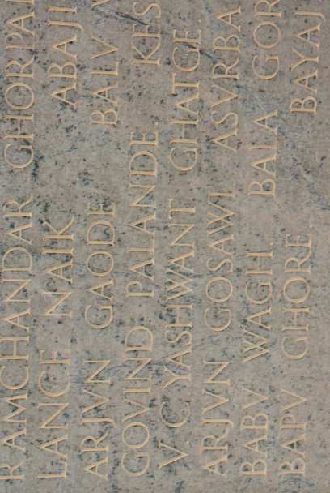
A recipient of the Victoria Cross, Naik Yashwant Ghatge of the 3rd Battalion, 5th Mahratta Light Infantry is commemorated on the Cassino Memorial. His award was announced in the London Gazette of the 2nd November, 1944: “In Italy on the 10th July 1944 a company of the 5th Mahratta Light Infantry attacked a position strongly defended by the enemy. A rifle section commanded by Naik Yashwant Ghatge came under heavy machine-gun fire, which killed or wounded all the section except the commander. Without hesitation, Naik Yashwant Ghatge rushed the machine-gun post, threw a grenade, shot one of the crew and then grasping his gun by the barrel, killed the remaining two men. Finally he was shot by enemy snipers and died in the post he had captured single-handed. The courage, determination and devotion to duty of the Indian N.C.O. in a situation where knew the odds against him gave little hope of survival were outstanding.” He was 23 years of age. His medal group is not publicly held.
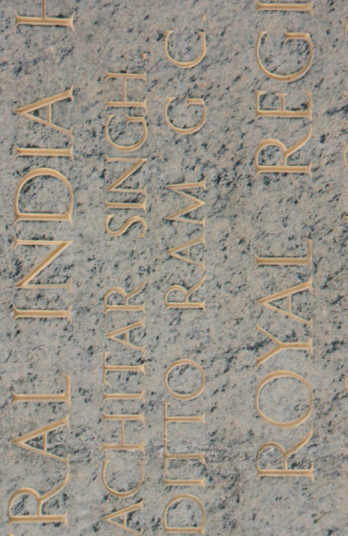
Also commemorated on the Cassino Memorial is Sowar Ditto Ram of the 21st King George V’s Own Horse (Central India Horse), a recipient of the George Cross. His award appeared in the London Gazette of the 12th December, 1945. “In Italy on 23rd July 1944, Sowar Ditto Ram was a member of a patrol which had been ordered to occupy a hill. On reaching the objective the patrol ran on to an enemy minefield and five men were injured. Sowar Ditto Ram was among those wounded, his left leg being blown off below the knee. He applied a field dressing and hearing calls for help from another man, he crawled forward through the minefield, though fully aware of the danger to which he was submitting himself. On reaching the other Sowar whose left leg had been shattered, he applied a field dressing to his comrade’s wound. He was in the greatest pain throughout, which made the operation both difficult and protracted. Having completed his task he lost consciousness and died a few minutes later. Sowar Ditto Ram, besides showing the greatest personal courage and disregard for pain, by crawling through a minefield to help a wounded companion set the finest example of soldierly comradeship and self-sacrifice.” He was 29 years of age. Sowar Ditto Ram’s Commander, Lieutenant St John Graham Young R.A.C. attached 21st King George V’s Own Horse (Central India Horse) I.A.C., was also awarded the George Cross for his part in the same incident. He also died of his wounds aged 23 years and was buried in Arezzo War Cemetery. Both of these George Cross recipients and one of the injured, Sowar Niru Chand who died are commemorated on a memorial tablet in the hill-top town centre of Monterchi.
Cassino War Cemetery and Memorial were designed by Louis de Soissons (1890-1962) an architect who was born in Canada and moved to London as a child with his parents. He lost a son who was killed, aged 17 years on H.M.S. Fiji when it was sunk off Crete on the 22nd May 1941. As the Commonwealth War Graves Commissions Chief Architect for the Second World War, Louis de Soissons designed nearly fifty cemeteries in Italy, Greece and Australia. We left the war cemetery and drove into the town of Cassino to access the S149 for a steep climb with twenty hairpins to the Abbey of Monte Cassino. After parking the mini-bus we had free time to visit the Abbey.
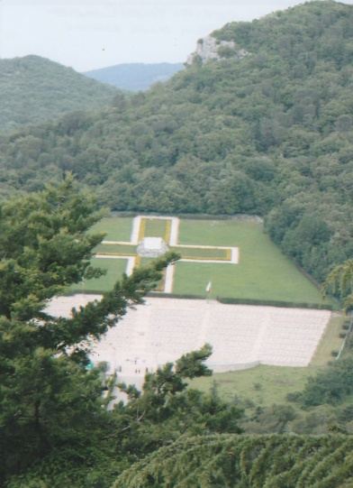
Founder of the Benedictine Order, St Benedict of Nursia established the hill-top monastery c.529. Over the following centuries the abbey was destroyed on three occasions in 577, 883 and in 1349 by an earthquake. Subsequent rebuilding and embellishments created a magnificent and inspiring monastery until the 15th February 1944 when it was bombed into a ruin during the Second World War. From the car park there is an uphill walk to a series of steps to the entrance cloister which leads to a second and larger Renaissance style cloister where in the centre is an octagonal well surrounded by Corinthian columns. A balcony overlooks the Liri valley from where there is a good view of the Polish War Cemetery and high above it on Monte Cairo is a white marble obelisk inscribed with the words: “We Polish Soldiers Have Given Our Body To Italy Our Hearts To Poland And Our Soul To God For Our Own And Other People’s Freedom”. Stairs from this second cloister guide the visitor up to the anti-portico of the upper cloister on the far side of which is the façade of the Basilica Cathedral with three bronze doors. The Basilica was rebuilt and decorated after the Second World War according to 17th and 18th century designs and the interior has wonderful frescos and paintings depicting biblical stories and figures. There are four chapels dedicated to saints and the High Altar, which although damaged by the bombing was restored with original features and decorations. Numerous reliquaries of saints are kept in the richly decorated sacristy. The Crypt, hewn out of the mountain has three 16th century chapels decorated with paintings, frescos, mosaics and walls of Swedish granite with bas-relief decoration in Candoglia marble.
From the crypt the visitor is directed towards the abbey museum where they are examples of medieval flooring, paintings, gold work, sketches, sculptures, wooden statues, book binding, prints, manuscripts, choir books, books of hours, Etruscan and Roman artifacts. Our visit to the Abbey of Monte Cassino, for each of us was an overwhelming and unforgettable experience.
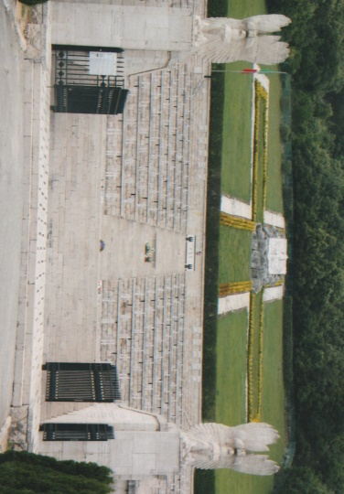
Full of our own thoughts we left the Abbey and drove down a short distance to the Polish War Cemetery at Monte Cassino. Situated on a flat area of what was known as ‘Death Valley’ between the Abbey and Hill 593 the Polish War Cemetery contains 1,072 soldiers who died during the Battle for Monte Cassino. Work on the cemetery began in 1944 by leveling the bomb cratered ground and removal of 20,000 cubic metres of earth. Retaining walls were constructed and thousands of rocks were excavated and dressed. Designed by Waclaw Hryniewicz (1909-1987) and Jerszy Skolinowski (1907-1985) the cemetery was built by soldiers of the 2nd Polish Corps with help and assistance of Italian monumental masons. The graves are arranged on a series of rising terraces. Sculptures by Michal Paszyn (1903-1970) include an eternal flame torch, bronze eagles on the uppers altars, laurel wreaths and the White Eagle bas-relief overlooking the cemetery. An Italian Professor Cambelotti was responsible for the two hussars eagles, symbols of the 2nd Polish Corps mounted on pediments at the entrance into the cemetery. The consecration of the cemetery took place on the 1st September 1945 during a multi-faith celebration conducted according to the rites of the Roman Catholic, Orthodox, Protestant and Jewish faiths. Among those buried in the cemetery are, Chaplain General Jósef Feliks Gawlina (1892-1964), a participant in the Monte Cassino assault who was buried there in April 1965; General Wladyslaw Anders, Commander of the 2nd Polish Corps whose ashes were brought from London where he lived in exile and interred on the 18th May 1970, the ashes of his wife Renata were interred on the 21st May, 2011; Major General Boleslaw Bronislaw Duch (1885-1980) commander of the 3rd Carpathian Infantry Division of the 2nd Polish Corps.
There are two memorial inscriptions the first based on the Epitaph of Simonides reads:
Passer-by, Go Tell Poland That We Have Perished Obedient To Her Service
The other translated from Polish:
For Our Freedom And Yours We Soldiers Of Poland Gave Our Soul To God Our Life To The Soil Of Italy Our Hearts To Poland
Throughout the cemetery and on the graves there were many floral tributes and lighted candles indicative that these soldiers of Poland are not forgotten.
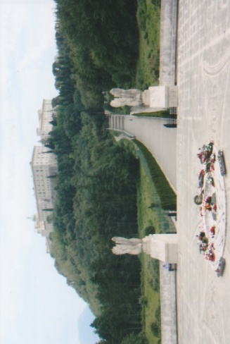
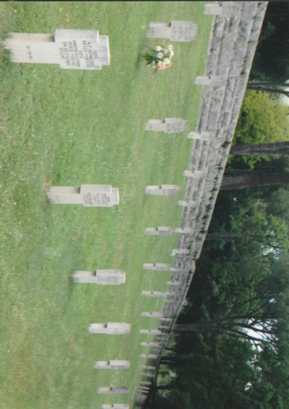
Moving from the Polish War Cemetery we continued the descent towards the town. We stopped briefly in a lay-by to view the Castle on Castle Hill where the father of one of our members was deployed during an assault on Monte Cassino for photographs to be taken. It was then our intention to visit the Cassino History Centre based in the town but despite published information that it would be open it was in fact closed and deserted.
This however, gave us the opportunity to visit the Cassino German War Cemetery 3-kilometres to the north of the town. The cemetery was established on a hill and contains 20,027 burials of soldiers who were killed during the Battle for Monte Cassino and in the surrounding battlefield areas. A wide pathway leads up a slope to a small building in which there is a sculpture symbolizing mourning and comfort. From this building is the entrance into the cemetery laid out in a series of elliptical terraces, each separated by a low wall of limestone. Over each grave is a cross of travertine engraved with up to three names on each side with dates of birth, rank and date of death. Two pathways circumvent around to the top of the hill on which is an 11-metre high cross. Behind it are mass graves covered by large blocks of stone with inscribed tablets recording the names of the unidentified. Towards the rear of the cemetery on a pedestal is a ‘blessed lamp’ donated by to the cemetery by Pope Paul VI.
Having completed our itinerary for the day we drove back into Cassino town where Simonetta suggested we stop at a gelateria. Sitting outside with our gelatos we remarked on the name of the street the Via Nicholas Green. He was a 7-year-old American boy who was shot during an attempted robbery. The car in which he, his sister Eleanor and his parents were travelling on the A3 Salerno-Regio Calabria motorway was mistaken by robbers for the car of a jeweler. Taken to hospital Nicholas died a few days later on the 24th September, 1994. His parents gave permission for their sons’ organs to be donated which benefited seven Italians. Organ donation in Italy at that time was not a common practice and the media coverage of the tragic event promoted an increase in organ donations throughout Italy. Nicholas’s parents are active supporters of organ donations worldwide and Reginald Green, Nicholas’s father has written two books about his family and a 1998 TV film ‘The Gift of Nicholas’ was broadcast in Italy, America and many other countries. Many streets, squares, gardens and some public buildings in Italy are now named after Nicholas Green. The two perpetrators of the robbery and murder were subsequently sent to prison one for life the other to 20 years. Simonetta drove us back to our hotel and later we all met for our evening meal completing a superb day spent at Cassino.
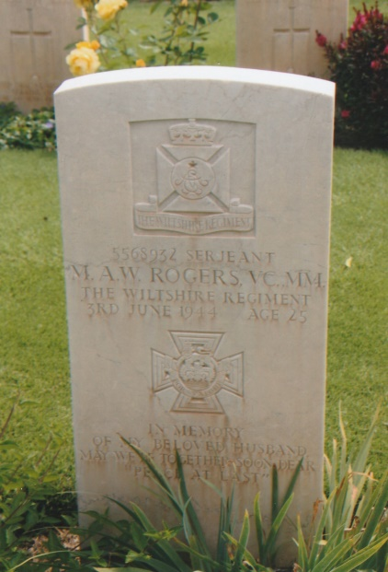
Following another splendid healthy and Mediterranean breakfast we left the hotel on Tuesday morning for another drive south along the SP148 to Anzio. As we passed by the undulating Italian landscape Martin gave a detailed account of the American and British landings – ‘Operation Shingle’ on the 22nd January 1944 – at Anzio and the planned objectives. At Aprilia we turned on to the SP207 which gradually sloped down towards the coast. The road passed through a thickly wooded area for about 2-kilometres and then once again into open farmland. Entering the town of Anzio we drove to the Villa Adele which was the first villa built in Anzio at the beginning of the 17th century by Monsignor Bartolomeo Cesi (1566-1621). In 1911 the villa was bought by the Bank of Italy and in 1937 became a prestigious hotel. It was purchased in 1964 by the Municipality of Anzio to be used as a public park, where over many years archaeological finds were found in the gardens. The villa was restored in 2017 and now houses the municipal library, civic offices and the Beach Head and archaeological museums. We were warmly welcomed at the former museum by the staff who, were preparing to show a documentary film about the Anzio landings. The Beach Head Museum has an eclectic collection of various artifacts, photographs, maps and uniforms divided into American, British, German and Italian sections, providing something of interest for any visitor. Most of the material has been donated by veterans or their families and some which has been recovered from the sea off Anzio. The museum was founded by Signor Patrizio Colantuono, its President to whom we gave a Wessex Branch WFA lapel badge. Inaugurated on the 22nd January 1994, the 50th Anniversary of the Allied Landings, the museum is run by volunteers. In the foyer of the Villa Adele is a marble statue c.230 BC of the Lady of Anzio, discovered in 1878. Erected in grounds of the sea-side Villa Claudia, which later succumbed to coastal erosion it was moved to the museum. It was for the same reason that the memorial to the 2nd Battalion, Sherwood Foresters was moved and erected in the grounds of the Villa Adele for the 50th Anniversary of the Anzio Landings in 1994. Leaving the museum we drove along the coastal road past ‘Peter Beach’ where the 1st British Infantry Division landed to the Beach Head War Cemetery. The cemetery contains 2,316 Commonwealth burials of the Second World War, 295 of whom are unidentified and one First World War grave brought to the cemetery from Chieti Communal Cemetery, near Rome. The location of this cemetery was close to a casualty clearing station and burials were made direct from the battlefield after the landings and later many were brought in for burial from the surrounding area. A beautiful and well cared for cemetery it has an arbour erected over the central pathway adorned with roses and climbing plants. Among the many burials is a recipient of the Victoria Cross, Sergeant Maurice Albert Wyndham Rogers M.M., 2nd Battalion, Wiltshire Regiment. His award was announced in the London Gazette of the 8th August, 1944: “In Italy a battalion of the Wiltshire Regiment was ordered to attack high ground held by the enemy. The carrier platoon of the leading company, dismounted, were ordered to capture the final objective. They advanced under intense fire and sustained a number of casualties. The platoon, checked by the enemy’s wire and intensity of his machine-gun fire, took cover some 70 yards short of their objective. Sergeant Rogers continued to advance alone, and penetrated 30 yards inside the enemy’s defences, drawing their fire and throwing them into confusion. Inspired by his example the platoon began the assault. Sergeant Rogers was blown off his feet by a grenade and wounded in the leg. Nothing daunted he ran on towards the enemy machine-gun post, attempting to silence it. He was shot and killed at point blank range. This N.C.O.’s undaunted determination, fearless devotion to duty and superb courage carried his platoon on to their objective in a strongly defended position. The great gallantry and heroic self-sacrifice of Sergeant Rogers were in the finest traditions of the British Army.” He was 25 years of age and a married man. His medal group is held by The Rifles (Berkshire and Wiltshire) Museum, Salisbury.
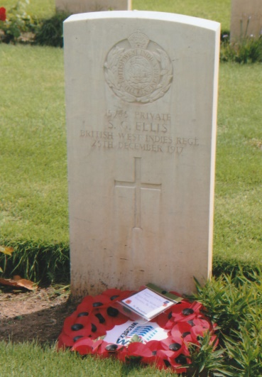
We held a short service of remembrance at the grave of the only First World War soldier buried in Beach Head Cemetery, Private Silbert George Ellis of the British West Indies Regiment. He was killed on Christmas Day 1917. Steve laid the wreath, Martin gave the exhortation, followed by a one minute silence. We spent some time in this lovely cemetery and afterwards had a coffee break at a local café. We then moved on to Anzio War Cemetery, 1-kilometre north of the town. On our arrival the gardeners were busy and we greeted and thanked them in our best Italian for the work they undertake. The cemetery was chosen shortly after the landings at Anzio and dates from January 1944 and contains 1,056 burials. Thoughtful and contented with our visit we left the cemetery and drove on past X-Ray Beach where the 3rd US Infantry Division landed to the Sicily-Rome American Cemetery and Memorial at Nettuno.
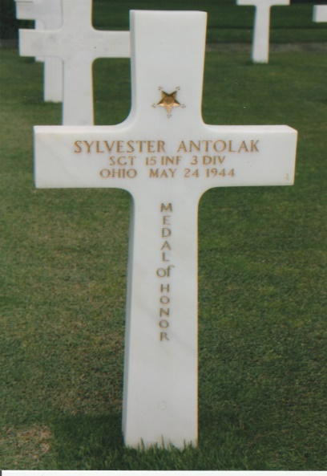
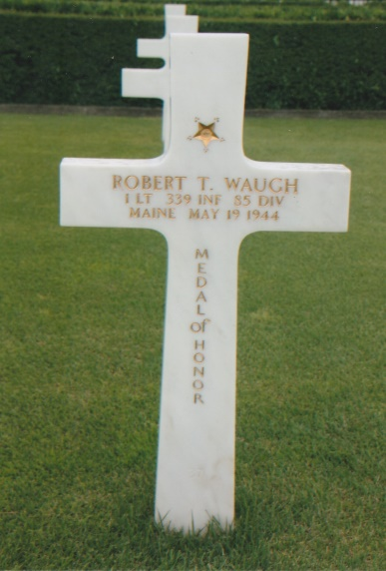
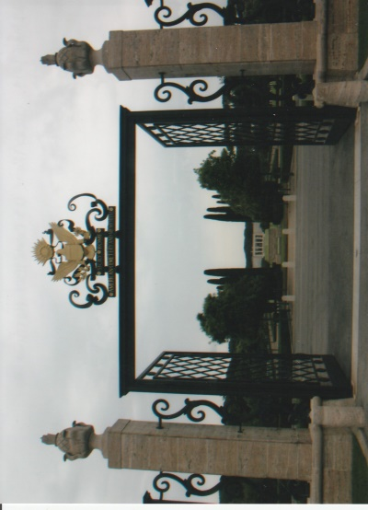
The Sicily-Rome American Cemetery was established two days after the landings at Anzio on the 24th January 1944. It was initially used as a temporary cemetery by an American CCS it now comprises 77 acres of green lawns, trees and gardens. Directly ahead of the elaborate ornamental entrance gate is a flowering lily pool and a small island and cenotaph flanked by tall cypress trees. There are 7,861 American military casualties buried in the cemetery who were killed during the Second World War. The ten plots of green lawn surrounded by clusters of Roman pine trees contain the graves each marked by a marble cross, arranged in arcs. Those who are buried here died liberating Sicily in July-August 1943, at Salerno in September 1943, during ‘Operation Shingle’ and the expanding of the beach-head at Anzio and Nettuno from mid-January to May 1944. The memorial, overlooking the slightly rising ground at the far end of the cemetery has a chapel, peristyle and map room with a bronze relief map and four fresco maps detailing the American operations in Sicily and Italy. Inscribed on white marble walls are 3,095 personnel listed as missing. Rosettes mark the names of those who have since been recovered and identified. At each end of the memorial are ornamental Italian gardens. Buried in the cemetery are two holders of the Congressional Medal of Honour, First Lieutenant Robert T. Waugh who died on the 19th May 1944 and Sergeant Sylvester Antolak who died on the 24th May 1944. In Plot B are members of Audi Murphy’s platoon. Twenty-three sets of brothers are buried in the cemetery, a complete bomber crew and a number of nurses who were killed by a shell where the cemetery entrance is now situated. There is a modern visitor’s centre to the right of the entrance which contains artifacts, films, interactive displays and photographs which help to explain the Allied operations in Italy during the Second World War. It was unfortunate that as we started to walk through the cemetery a light rain began to fall which rapidly became heavier and curtailed our time spent there.
From the cemetery we passed around the outskirts of Nettuno and rejoined the SP148 for the drive back to Rome. Nettuno is a town approximately 60-kilometres south of Rome and is a seaside tourist resort and agricultural area. The town is noted for its medieval streets, an early 16th century castle and a marble sculpture, the Borghese Gladiator, c.100 BC, which was discovered in Nettuno in 1611. The rain gradually abated which gave us the opportunity to visit Pomezia German War Cemetery, 26-kilometres south-east of Rome. In 1947, 2,740 German war casualties who had been buried near Nettuno were moved to this cemetery and 3,751 were brought in from battlefield areas around Anzio. 10,704 German casualties buried in municipal cemeteries and from other Italian provinces were moved to Pomezia under a German-Italio agreement of the 22nd December 1955. Pomezia German War Cemetery now contains 27,500 casualties from the Second World War. From the entrance a central paved pathway leads up to a monument built over a tomb ‘Kameraden Grabe’ containing 3,770 casualties who could not be identified. Four columns support a canopy, the bottom of which is covered with mosaics. The central column is in the form of a sculpture of four soldiers and family members. The cemetery surrounded by pine trees was opened to the public on the 6th May 1960. Our visit to Pomezia German War Cemetery completed our excellent 2018 Italian battlefield tour itinerary and from there we returned to our hotel in Rome.
Wednesday morning and early afternoon was given over to free time and allowed us to have a leisurely breakfast, prior to packing our cases for return to the UK. We left the hotel at 1500 hours and Simonetta drove us to Rome Fiumicino airport. There we extended our grateful thanks, said good-bye and wished her, a safe return journey to Vicenza. Having passed through passport and security we had time for a light bite before boarding our aircraft which took off at 1845 hours (UK time). Landing at 2030 hours we proceeded through Heathrow airport without incident, retrieved our luggage, rendezvoused with driver Colin, the 16-seater mini-bus and set off for Dorset. At Winchester Marc was the first to leave our tour group followed by Ian, Sandra, Tom and Viv at Salisbury, finally arriving at Wareham just before mid-night. With a farewell to Martin and Judy, Steve and Roger left for their drive homeward to Weymouth and Portland.
Our 2018 Italian Battlefield Tour was another outstanding success for the Wessex Branch WFA. We were privileged to meet a number of Italians who were always most helpful and friendly, maintaining our cultural links with them. Thanks must be extended to Lucia and her staff at Vicenza, Piero Antonio, Nico, Simonetta and especially Georgio for all their enthusiasm and hospitality extended to us. This tour took a considerable amount of planning and time spent in communications with our Italian principals in Vicenza all of which resulted in a splendid tour. To Martin a thank you for the detailed tour guide with its well-researched comprehensive content. Without Martin and Judy’s enthusiasm this Wessex Branch Tour to Italy would never have come to fruition and we all extend a heartfelt thank you. This tour was another first for the Wessex Branch WFA as we commemorated and remembered the sacrifice of those who died in two World War conflicts, many of whom now lie far from their homelands, ensuring they are not forgotten. Quoting from the words of General John Pershing: “Time Will Not Dim The Glory Of Their Deeds”
Sources
Monte Cassino ~ Matthew Parker – Published by Headline 2003
Anzio ~ Lloyd Clark – Published by Headline 2007
The British Army in Italy 1917-1918 ~ John Wilks & Eileen Wilks – Published by Pen & Sword 2013
The White War – Life & Death on the Italian Front 1915-1919 ~ Mark Thompson – Published by Faber & Faber 2008
Various English & Italian Guide Books & Leaflets
Iain Stewarts Victoria Cross Web-site ~ www.victoriacross.org
Wikipedia Web-Sites ~ www.wikipedia.org
Commonwealth War Graves Commission Web-Site ~ www.cwgc.org
The Times ~ 23rd July 2003
Battlefield Italian Tour Photographs 2018
Note ~ Combining This 2018 Battlefield Tour Report with the 2017 Report Will Give Reader A Good Overview Of The War On The Italian Front During The FWW.
R.G. Coleman

