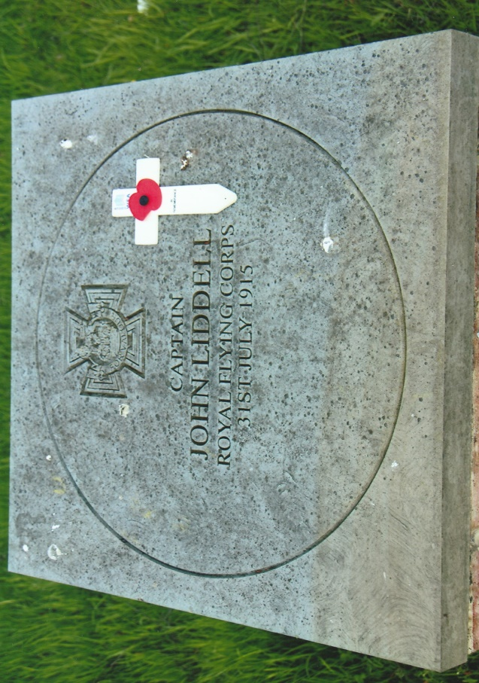
CAPTAIN JOHN AIDAN LIDDELL V.C., M.C.
John Aidan Liddell was born on the 3rd August, 1888 at Benwell Hall, Newcastle-upon-Tyne, the eldest son of John and Emily Liddell. By the turn of the century a further five children had been born, two sons and three daughters. John Liddell (senior) was a wealthy businessman, Justice of the Peace and philanthropist. The 1891 Census recorded that he was ‘living on his own means.’ The family moved into a number of different properties in the north of England before moving south in 1904 to Newbury and a few year later to Sherfield-on-Lodden and into Sherfield Manor, which was to be the family home for the next nineteen years.
To mark the 100th anniversary of the award of the Victoria Cross to Captain Liddell a commemorative memorial paving stone was unveiled on Sherfield-on-Lodden village green opposite the four horseshoes public house in July 2015.
Aidan was initially educated at a preparatory school in Hampstead and Ushaw College, Durham prior to becoming a pupil at Stoneyhurst College aged 12 years in September 1900. On leaving there he went to Balliol College, Oxford in 1908 and graduated four years later with an honours degree in Zoology. Aidan was not particularly inspired by sporting activities but was keenly interested in science, astronomy, photography, technology and had a passion for motor cycles and cars. In 1905 he went to Spain to record and photograph, the total eclipse of the sun and on his return was elected a Member of the British Astronomical Society.
In June 1912 he joined the Special Reserve of Officers and obtained a commission in the 3rd Volunteer Battalion, Argyll and Sutherland Highlanders, whose depot was based at Stirling Castle. He was attached to the 2nd Battalion and spent Christmas 1912 with them at Fort George. As a wealthy young man Aidan was able to enjoy hunting, fishing and managing the Sherfield Manor estate. Prior to the outbreak of the First World War the lure of the new phenomenon of flying became and attraction for the wealthy, including Aidan. On the 14th May, 1914 he gained his Royal Aero Club Certificate No.781 flying a Vickers Biplane at the Vickers School, Brooklands.
Mobilised, Aidan reported for duty at Stirling Castle on the 5th August 1914 after a long railway journey from Basingstoke. Second Lieutenant J.A. Liddell was placed in charge of two Maxim machine guns and one hundred men. He organized all the necessary supporting equipment and ammunition by himself as his machine gunners were employed elsewhere with the battalion. They left Scotland on the 8th August by train for Woolwich Arsenal and on arrival were deployed on Plumstead Marshes with the task of guarding the Thames river bank, Royal Arsenal and training recruits! By the end of August the 3rd Reserve Battalion was composed of over 1,000 men and the first draft left on the 26th to join the 2nd Battalion in France. Aidan with 100 men were drafted two days later and embarked the following day on the S.S. Lake Michigan for St Nazaire, France.
The 2nd Battalion, Argyll & Sutherland Highlanders, together with the 1st Battalion, Middlesex Regiment, 2nd Battalion, Royal Welch Fusiliers and 1st Battalion, Cameronians formed the 19th Brigade. The latter were not allocated to a Division and were an independent command at this time. In October 1914 they were transferred to the 6th Division and in May 1915 to the 27th Division. The 19th Brigade were deployed along the Mons-Conde Canal on the 23rd August where they engaged the advancing German Army until forced to withdraw and begin the retreat from Mons as the French on their right had already withdrawn. The Germans were temporarily held at Le Cateau before the retreat resumed until the 5th September when indecisive action by the Germans gave the opportunity for the Allies to advance. It was into this cauldron of war that Aidan arrived on the 7th September to join the 2nd Battalion, Argyll & Sutherland Highlanders at La Haute Maison.
He participated in a number of actions on the Marne and at the Aisne. In mid-October 1914 the brigade was ordered to hold the line at Le Maisnil for as long as possible. Aidan and his machine gun section were deployed, inflicting heavy casualties on the Germans. Having sustained casualties and running out of ammunition as the Germans were reinforced Aidan and his machine-gunners withdrew during the afternoon of the 21st. Later with the loss of 200 casualties the battalion moved to Le Boutillerie and ordered to entrench.
The 2nd Battalion moved to the Ploegsteert leaving Aidan and his machine gun section with the 1st Battalion, Middlesex Regiment at La Boutillerie. Although the Middlesex battalion was relieved by the Border Regiment, Aidan was again ordered to remain in the trenches enduring the cold, rain and snow. However, on the 16th November he and his section rejoined their battalion who had been deployed in trenches near Houplines. The conditions were appalling with mud and water at times waist deep and apart from enemy shelling, small arms fire the very cold weather added to their misery. Unable to wash and without dry clothing the men’s health began to deteriorate and any opportunity to gain relief for a few hours in the nearby village was eagerly taken. The rigours of trench warfare continued until the end of the month when the battalion was relieved. Aidan had spent over forty continuous days in the trenches.
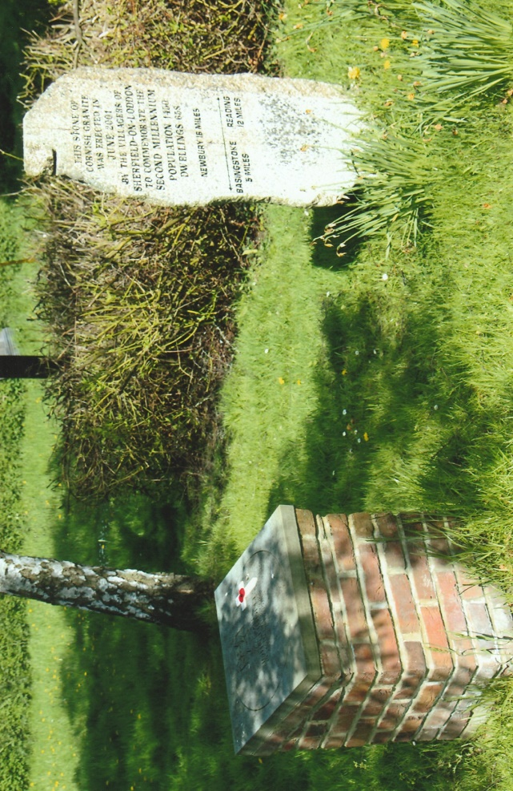
Christmas was spent in Armentieres where the battalion was billeted in a former lunatic asylum. Both friend and foe participated in observance of the ‘Christmas Truce.’ The New Year brought more heavy rain and continuing deplorable conditions for both sides. For Aidan personal relief came in the form of a week’s leave from the 11th to 15th January. Back at Sherfield Manor he enjoyed all of its luxuries and spent his time ordering new kit and fishing. He returned to France where the introduction of time spent in the trenches and in reserve was rotated every five days. The inclement weather inevitably affected Aidan’s health which the medical officer was unable to cure in the trenches. Aidan was taken to a Field Ambulance at Erqinghem and then to No.7 Stationary Hospital at Boulogne. From there he was evacuated to the United Kingdom on the Hospital Ship St Edward on the 28th January and taken by Hospital Train to Woolwich and diagnosed with influenza. With rest, clean surroundings and good food he began to improve and was granted three weeks leave having been adjudged unfit for General or Home Service. It was while he was on sick leave that he learnt that he had been Mentioned in Dispatches – London Gazette 17th February 1915 – and two days later the Military Cross for his ‘courage and initiative’ at Le Maisnil. He attended another medical board and was still considered unfit and given another three week’s leave. At his next appearance before the medical board he was pronounced fit to resume his duties and returned to Woolwich.
During the period of convalescence Aidan who had been promoted to Lieutenant, gave thoughtful consideration to his future military career in the Army. Having decided that flying might be the better option he applied in the spring of 1915 to transfer to the Royal Flying Corps. His application was approved and he was posted on the 4th May to No.3 Reserve Aeroplane Squadron based at Shoreham. A transfer to No.15 Squadron soon followed where he underwent pilot training. He was awarded his ‘RFC Wings’ and gazetted an RFC Officer with the rank of Captain on the 20th July 1915. Instructed to report to Farnborough from where he expected to fly to St Omer. However, the weather conditions were unsuitable and via train and troopship he arrived in France on the 24th.
He joined No.7 Squadron at St Omer and was initially given the opportunity to fly a BE2c and also an RE5 aircraft. On the 29th July he flew an RE5 with his observer on a ‘long reconnaissance’ mission over the coastal sector of Belgium, including Bruges and Ghent. The flight lasted nearly four hours during which they encountered an enemy aircraft and anti-aircraft fire which peppered the fabric of the RE5. His next mission was on the 31st July, with his observer 2nd Lieutenant Roland Peck on another ‘long reconnaissance’ mission in an RE5 No.2457. They took off from St Omer and headed in the direction Furnes and then towards Bruges. Flying at 5,000-ft and nearing Bruges they were attacked from above by an enemy two-seater aircraft firing directly at the RE5. 2nd Lieutenant Peck operating the Lewis gun returned fire, emptied one drum of ammunition, reloaded another drum and fired again. The enemy aircraft had seriously damaged the RE5 particularly on the left-hand side. 2nd Lieutenant Peck was in the process of again reloading the Lewis gun when suddenly the RE5 nose-dived and turned over. Aidan had been severely wounded in the right thigh and leg and lost consciousness. All loose equipment fell out of the aircraft and Peck was desperately hanging on as he was unstrapped in order to fire the Lewis gun. Aidan miraculously regained consciousness and managed to stabilize the aircraft at 3,000-ft. With no control over the engine, rudder damage and broken control wheel Aidan with skillful ingenuity continued to fly the RE 5 although they were losing height. Not wishing to land in enemy territory he communicated to Peck about his intention to land on the sandy shore to the west of Nieuport. Peck suggested they land at La Panne airfield where they would get assistance and medical aid from the Belgians. As he approached the airfield Aidan cut the engine’s fuel supply and successfully landed the aircraft. Having applied a tourniquet and a rudimentary splint Aidan insisted on remaining in his pilot’s seat until a doctor arrived. After the doctor arrived Aidan was lifted out of the aircraft and taken by ambulance to the Red Cross Hospital at La Panne. A photographer who was at the airfield took a number of remarkable photographs of Aidan in the RE5 and his removal by the medical staff which recorded the events for posterity. One shows Aidan lying on a stretcher, smiling and waving to the onlookers.
John and Emily Liddell received a telegram that their son had been seriously wounded and Aidan from his hospital bed managed to write a more comforting letter about his condition. He was hailed as a hero and the Daily Mirror of August 14th 1915 had the front page headline “British Airman with Fifty Wounds in His Leg: Unconscious When His Machine Turned Turtle” and accompanied by several photographs taken by the Belgian photographer. This newspaper coverage thrust Aidan’s name into the public’s consciousness. A number of senior military officers and the President of France visited Aidan in hospital and 2nd Lieutenant Peck was sent by the Squadron’s commanding officer to visit John and Emily to give them a first-hand account of the aerial action. The Belgian officer who made all the arrangements for Aidan at La Panne sent official reports and personal letter to them. On the 17th August Aidan wrote to his parents that he had been awarded the Victoria Cross which would be announced officially in the London Gazette.
London Gazette 23rd August 1915: “John Aidan Liddell, Captain, 3rd Battalion Argyll & Sutherland Highlanders and Royal Flying Corps. For most conspicuous bravery and devotion to duty on 31st July 1915. When on a flying reconnaissance over Ostend-Bruges-Ghent he was severely wounded (his right thigh being broken) which caused momentary unconsciousness, but by great effort he recovered partial control after his machine had dropped nearly 3,000-ft and, notwithstanding his collapsed state succeeded although continuously fired at, in completing his course and brought the aeroplane into our lines half-an-hour after he had been wounded. The difficulties experienced by this officer in saving his machine and the life of his observer cannot be readily expressed, but as the control wheel and throttle control were smashed, and also one of the under-carriage struts, it would seem incredible that he could have accomplished his task.”
Aidan’s medical condition gave cause for concern and the doctors reluctantly decided to amputate the right leg. The operation was carried out on the 18th August and Aidan’s mother arrived at the hospital on the 23rd to find her son in good spirits. This masked the reality of the situation as Aidan was slowly deteriorating with fits of shivering and high body temperatures due to blood poisoning. On the 31st August, 1915 Captain John Aidan Liddell died peacefully in his hospital bed with his mother by the bedside. He was 27 years of age. Aidan had been given the last rites according to his Roman Catholic faith. After a short service in the hospital chapel his body was returned to the United Kingdom on the 2nd September. He was taken to the Church of the Immaculate Conception in Farm Street London where a Requiem Mass was celebrated the following day. His body was then conveyed to Basingstoke for interment in South View Cemetery with full military honours in the presence of his family, friends and large crowds. Five Pipers from the 3rd Battalion, Argyll & Sutherland Highlanders led the funeral procession through the town crowded with respectful onlookers as the cortege passed by.
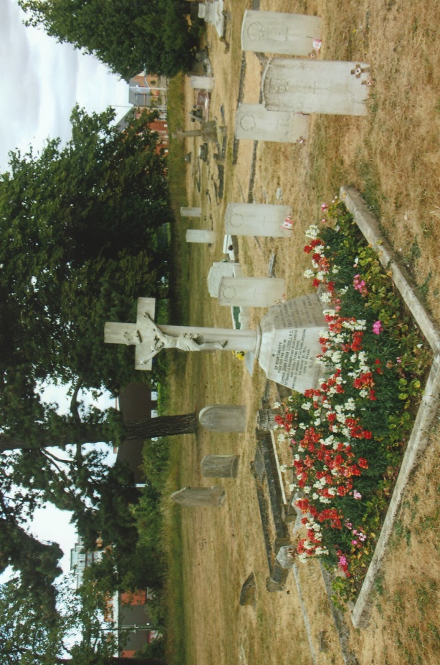
John Liddell, Aidan’s father received his son’s Victoria Cross from King George V at an investiture held at Buckingham Palace on the 17th November, 1916. The family commissioned William Carter to paint Aidan’s portrait in full dress uniform of the Argyll & Sutherland Highlanders with the Victoria Cross and Military Cross pinned on the red sash – Aidan never wore his medals. Completed in 1917 a second portrait was presented to Stoneyhurst College in 1918.
Liddell Family Grave
Aidan’s father died in 1930, his mother in 1934 and Dorothy his sister in 1938. All are buried in Aidan’s grave plot. His two brothers survived the First World War and Roland Peck was killed whilst serving with 30 Squadron in Mesopotamia on the 5th March 1916.
On Friday 31st July 2015 a centennial commemorative Victoria Cross paving stone was unveiled on Sherfield-on-Lodden’s village green. Although Aidan had not been born there the stone was presented to the village as the Liddell family had lived there for a number of years at Sherfield Manor – now Sherfield School. The Lord Lieutenant of Hampshire Nigel Atkinson unveiled the memorial in the presence of the Mayor of Basingstoke and Deane, Councillor Anne Court. Among the distinguished guests was Ranil Jayawardene MP, representatives from the Arygll & Sutherland Highlanders, Squadron standards and personnel from No.7 Squadron RAF Odiham, military representatives, school children and villagers.
Aidan is commemorated on a number of other memorials including, Sherfield-on-Lodden War Memorial, St Lawrence Church Sherfield-on-Lodden, Victoria Cross Memorial in St Clement Danes Church London, Church of the Holy Rood Stirling, Stoneyhurst College War Memorial, St Tarcisus Roman Catholic Church Camberley, Balliol College Oxford, Imperial War Museum and St Omer. More recently on 31st August 2017 plaques commemorating three Newcastle Victoria Cross recipients – Edward Lawson, Adam Wakenshaw, John Aidan Liddell – were unveiled outside Newcastle’s Discovery Centre. Captain John Aidan Liddell’s Victoria Cross medal group is on display in the Lord Ashcroft Gallery in the Imperial War Museum.
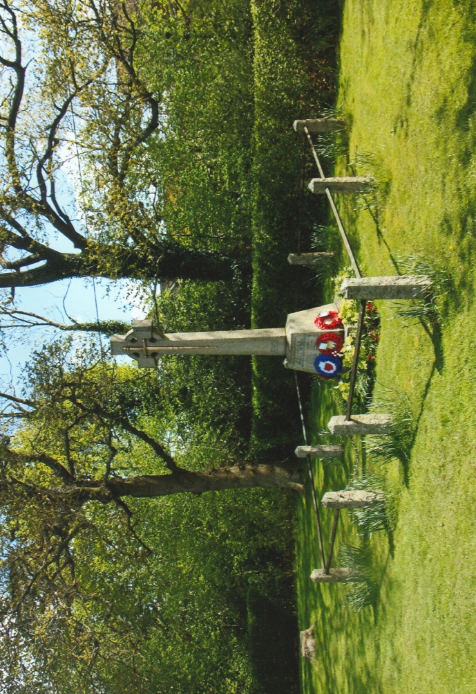
Sherfield-on-Lodden War Memorial
+++
Sources: VC’s of the First World War – Arras & Messines 1917 by Gerald Gliddon ~ A Sutton Publication 1998
The Victoria Cross 1856-1920 by Sir O’Moore Creagh VC GCB GCSI & E.M. Humphris ~ Originally published in 1920. Republished by J.B. Hayward & Son 1985
History of the Great War – Military Operations France & Belgium 1914 Compiled by Brigadier-General J.E. Edmonds CB CMG RE. Published by IWM (UK) & The Battery Press (USA) 1996
Online Sources: Wikipedia Web-Site ~ www.wikipedia.org
Ancestry Web-Site ~ www.ancestry.com
Photographs ~ R.G. Coleman
R.G. Coleman

