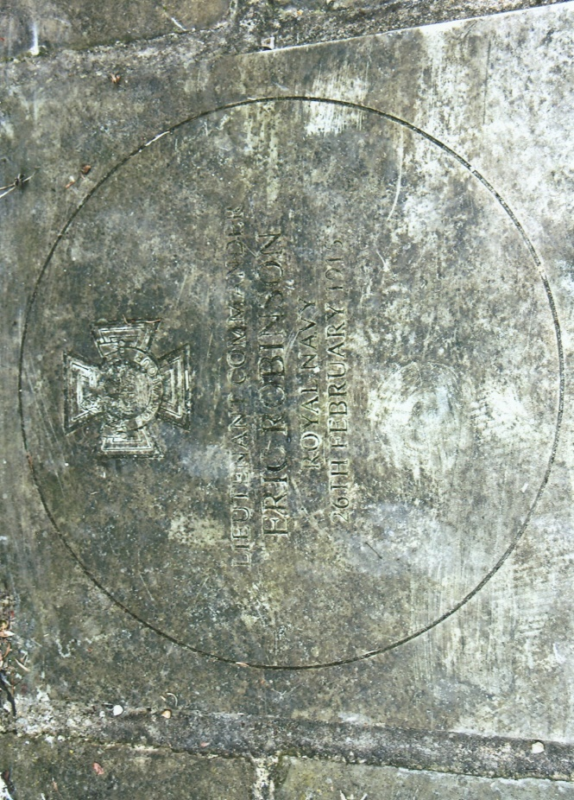
REAR-ADMIRAL ERIC GASCOIGNE ROBINSON V.C.
During the Wessex Branch WFA Field Trip to the National Maritime Museum on the 14th April, 2018, I took the opportunity to walk to 1 Diamond Terrace, Greenwich. There on the 16th May 1882, Eric Gascoigne Robinson was born the son of John, Chaplain of the Royal Naval College and his wife Louisa Robinson. The 1891 Census reveals that there were two older children Mary aged 15, Ernest aged 11, plus a cook who doubled as a servant and a housemaid.
Eric attended St John’s School and the Limes at Leatherhead, prior to entering at 14½ years of age HMS Britannia, a wooden hulk moored in the River Dart, as a naval cadet on the 15th January 1897. (The foundation stone of the Royal Naval College was laid in March 1902) A year later Eric joined HMS Victory as a midshipman followed by appointments to HMS Majestic and HMS Endymion in June 1899. He served in the Naval Brigade of Admiral Seymour’s expedition to relieve the besieged legation in Peking and was wounded in June 1900. For his services he was Mentioned in Dispatches and received the China Medal 1900. In 1901 he was promoted to Sub-Lieutenant and to Lieutenant two years later. He remained on the China Station until returning to the United Kingdom where he qualified as a Torpedo Officer in 1907 at HMS Vernon. Three years later, as a Lieutenant-Commander he served on HMS Thames, a submarine depot ship and later on other warships.
During the summer of 1913 he married Edith Cordeaux, who was born in Doncaster in 1892. The couple later had three children, two sons, one of whom was killed in the Second World War and a daughter. At the outbreak of the First World War, Eric was serving in HMS Amethyst. On the 2nd September, 1914 he was appointed to HMS Vengeance, a pre-dreadnought battleship as Torpedo Officer and two months later the ship was transferred from United Kingdom waters to the Eastern Mediterranean and based at Alexandria. The warship was ordered in January 1915 to join Admiral Sackville Carden’s Eastern Mediterranean Squadron as the 2nd Flagship of the Dardanelles Squadron under the command of Rear-Admiral Sir John de Robeck, and arrived there in February. Admiral Carden had produced a plan for the naval forces under his command to pass through the Dardanelles by initially destroying the Turkish outer forts guarding the entrance and coastal defence batteries. His minesweepers would then be able to clear the entrance of mines. If Carden’s plan was successful it would allow his warships to sail through the Dardanelles, enter the Sea of Marmara and capture the Turkish capital Constantinople (modern Istanbul).
On the 18th February HMS Vengeance was present at the bombardment of the Turkish forts, although Rear-Admiral de Robeck’s flagship task was to act as the observer for other warships. The following day she bombarded the Orkanie fortress on the Asiatic side of the straights and in the afternoon engaged the battery at Kum Kale with the main armament while her secondary shelled Orkanie. Orders were passed to cease fire to allow for a passing seaward inspection of the damage inflicted on the forts. As HMS Vengeance steamed past the forts, the Orkanie battery and one at Cape Helles commenced firing at the ship, causing minor damage to the masts and rigging. Admiral Carden then ordered his ships to withdraw. Another attack on the forts was launched on the 25th February by a combined force of French and Royal Naval warships. By mid-afternoon the enemy guns had been silenced which gave the opportunity for the minesweepers to begin clearing the enemy minefields whilst the main body of the fleet withdrew. HMS Vengeance and two other ships remained on station to cover the minesweepers. Once the mines had been cleared the Allied warships could then enter the Dardanelles and attack and destroy the additional fortifications allowing the fleet to proceed on through the straights and into the Sea of Marmara – a naval ambition which was never achieved.
The following day, 26th February Rear-Admiral Sir John de Robeck issued orders for the complete the destruction of Orkanie Battery situated between Kum Kale and Yeni Shehr. Lieutenant-Commander Eric Robinson was selected to lead a demolition team of fifty seaman supported by fifty Royal Marines. The assaulting party landed ashore unopposed and followed the course of the River Menderes, past a cemetery and into to a ground depression where they were subjected to intense sniper fire. In the distance a large Turkish force could be seen advancing from the direction of Yeni Shehr. This enemy force was observed from the warships waiting offshore and a salvo caused them to pause and seek cover. However, the enemy snipers remained in their hidden positions targeting Robinson’s detachment. Robinson continued his forward movement, towards a hillock known as Achilles Mound, beyond which was the main enemy battery. While the seaman and Royal Marines sort cover to engage the enemy Robinson dashed onwards, and over into another depression. After placing a gun-cotton charge, he re-emerged followed by a loud explosion which destroyed two guns. The warships off shore maintained their steady bombardment and Robinson seized the opportunity to lead a small group of seaman towards the main battery and destroyed a 9·4-inch enemy gun. Having sustained relatively few casualties Robinson was able to withdraw the demolition party and Royal Marines back to the safety of HMS Vengeance.
The raid was considered to have been a notable success by Robinson’s superiors and for his brave leadership and determination under fire he was awarded the Victoria Cross which was announced in the London Gazette of the 16th August 1915. “Eric Gascoigne Robinson, Lieutenant-Commander, Royal Navy. Date of Act of Bravery 26th February 1915. Lieutenant-Commander Robinson on the 26th February advanced alone, under heavy fire into an enemy’s gun position which might well have been occupied and destroying a four-inch gun, returned to his party for another charge with which the second gun was destroyed. Lieutenant-Commander Robinson would not allow members of his demolition party to accompany him, as their white uniforms rendered them very conspicuous. Lieutenant-Commander Robinson took part in four attacks on mine-fields always under fire heavy fire”.
Robinson performed a number of acts of gallantry at the Dardanelles. He commanded a trawler on mine clearing duties on four occasions always under intense artillery fire from Turkish shore batteries. During April the submarine E15 ran ashore off Kephez Point. In order to prevent the submarine falling into enemy hands Robinson was tasked by Rear-Admiral de Robeck to lead two steam pinnaces, manned by volunteer crews from HMS Majestic and HMS Triumph to destroy the E15. The pinnaces were adapted to carry a torpedo. Setting off after dark and approaching the submarine they were ‘lit up’ by powerful Turkish searchlights and came under heavy artillery fire. Robinson in HMS Triumph’s pinnace got to within 300 yards of the submarine and fired their torpedo which missed the target. HMS Majestic’s pinnace followed and when the E15 was caught in a searchlight beam fired the torpedo which struck the submarine which then began to sink. The steam pinnace however received a direct hit from an enemy battery. Despite the artillery fire aimed at Robinson’s pinnace he brought it alongside the sinking pinnace and rescued all the crew. Although heavily laden and buffeted by heavy seas they returned to the safety of HMS Triumph. All those who participated in this action received decorations except Robinson who was promoted to Commander on the 20th April 1915.
The Royal Navy’s plan to force the Dardanelles alone having failed they acknowledged the necessity of a land campaign and the Mediterranean Expeditionary Force were given the unenviable task of capturing and occupying the Gallipoli Peninsula. Robinson was appointed Naval Transport Officer at ANZAC and later at Suvla where he was wounded and evacuated to Alexandria.
Having recuperated he received his Victoria Cross from King George V at an investiture held at Buckingham Palace on the 5th October 1915. After a period of leave he was given command on the 22nd December 1915 of HMS M21 a monitor, based at Port Said. Their duties were mainly confined to assisting the army in land operations along the coast of Egypt and the Eastern Mediterranean. For his services Robinson received the Egyptian Order of the Nile 4th Class and was Mentioned in Dispatches.
Returning to the United Kingdom he was sent to Osea Island for Coastal Motor Boat training in the summer of 1918. His training with the Coastal Motor Boats was put to good use during the following year when he was sent to the Caspian Sea during the Russian Revolution. The Bolsheviks had seized control of the Caspian Sea in October 1919. Intelligence reports indicated that the Bolsheviks intended to carry out an attack on Petrovsk or Baku with the object of obtaining oil. The Bolsheviks were in occupation of Fort Alexandrovsk from where the attack to seize the oil would be launched. A flotilla of Royal Naval vessels commanded by Commodore D.T. Norris had clashed with the Bolsheviks sinking several of their ships in Alexandrovsk harbour. In a second raid a cruiser was damaged and a destroyer sunk. A few days later Robinson led his flotilla of Coastal Motor Boats into the harbour of Fort Alexandrovsk sinking a barge which resulted in the occupants in the fort raising a white flag and surrendering to Robinson. For his leadership he received the OBE (Military) in November 1919 and the Russian Order of St Anne with Swords 2nd Class in July 1920.
He served in HMS Iron Duke as Fleet Torpedo Officer from the 22nd July 1919. A year later on the 31st December 1920 he was promoted to Captain and attended a senior officer’s war course. In the succeeding years he held both sea-going and shore-based appointments including command of HMS Berwick on the China station and received the Japanese Order of the Sacred Treasure 3rd Class in February 1929. His last appointment was as Captain of Devonport Dockyard in 1932 and promoted to Rear-Admiral the following year he was placed on the retired list.
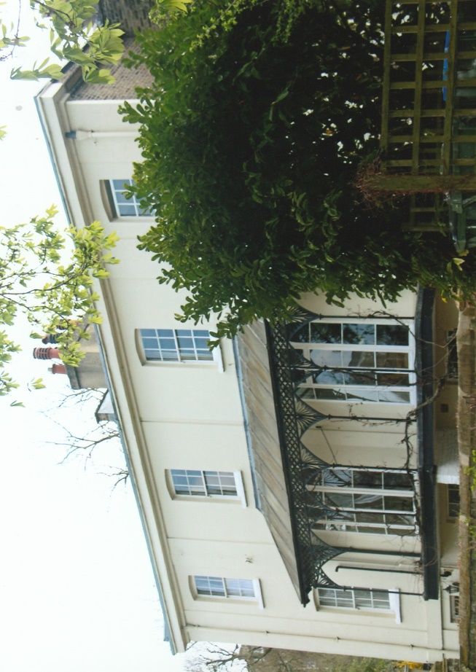
His wife, Edith died on the 23rd March 1938 aged 54 years. Rear-Admiral Robinson was recalled for service at the beginning of the Second World War and became a convoy commodore. In February 1941 he came ashore from the HMT Duchess of Atholl at Cape Town and was admitted to the naval hospital at Simonstown where a medical examination revealed prostate and abdominal symptoms. He was placed temporarily on the retired list until fit for duty. After a satisfactory recovery he resumed his naval duties until the 25th December 1944 when he was finally placed on the retired list aged 53. For his valuable services in convoy duties he had received on the 2nd August 1941, the Norwegian King Haakon VII’s Freedom Cross. He spent his retirement residing at Langrish, Hampshire participating in village activities and represented them on the Rural District Council as well as being a member of parochial church council and churchwarden. Rear-Admiral Eric Robinson V.C., died on the 20th August 1965 in Haslar Naval Hospital aged 82 years and was buried in St John’s Churchyard, Langrish. For over thirty years his grave remained unmarked until August 1998 when a headstone was erected and unveiled after a memorial service.
My reason for going to 1 Diamond Terrace was to photograph the centennial commemorative Victoria Cross memorial stone. It had been unveiled with due naval ceremony on 26th February 2015, one hundred years to the day of Eric Robinson’s bravery in the Dardanelles. Among those present were family descendants, Royal Naval personnel led by Rear-Admiral Matt Parr, Leader of Greenwich Council, Councillor Denise Hyland, civic dignatories and members of the public. I have photographed other memorial stones to Victoria Cross recipients and they have been 1 Diamond Terrace Greenwich placed on plinths, fixed to walls, laid beside war memorials and other appropriate locations. Having arrived outside 1 Diamond Terrace, I was not sure where the memorial had been placed. I looked on the front and side walls of the house, surrounding enclosure walls, the pavement and even across the other side of the road, but was unable to see it. Although disappointed, I thought perhaps that after the ceremony it had been taken to another location.
So I left with a nagging doubt but then decided to go back and look again. Whatever it was that caused me to look at a pile of rotting leaves and debris on the pavement I am not sure but I scraped them and revealed the memorial stone. I could not believe that after just three years how neglected and dirty the memorial had become. I am of the opinion that this memorial stone had been placed in an inappropriate location on this pathway and simply left uncared for. Hardly fitting for a ‘hero’ of the Victoria Cross!
Sources: The Victoria Cross 1856-1920 Edited by Sir O’Moore Creagh V.C., G.C.B., G.C.S.I, & E.M. Humphris. Originally published in 1920; Republished by J.B. Hayward & Son 1985.
The Naval VCs by Stephen Snelling. Published in 2002 by Sutton Publishing.
On-Line Sources: National Archives ~ www.nationalarchives.gov.uk – Service Record Eric Gascoigne Robinson: ADM 196/125/389; ADM 196/142/626; ADM 196/91/88; ADM 196/47/77;
Ancestry Web-Site ~ www.ancestry.com
Photographs ~ R.G. Coleman
R.G. Coleman (P)

