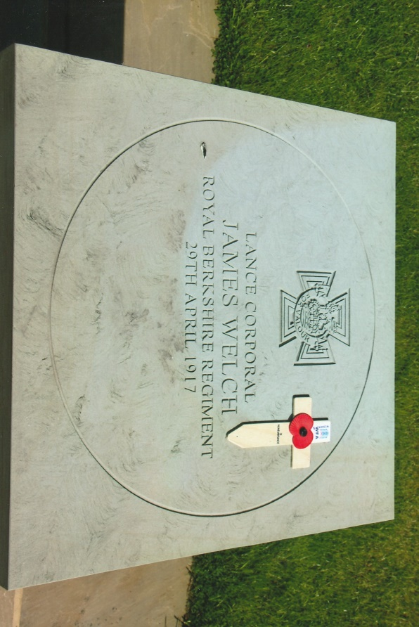
SERGEANT JAMES WELCH V.C
Stratfield Saye is a village situated within the Borough of Basingstoke and Dean, Hampshire. Probably more widely known than the village itself is Stratfield Saye House, built in the early17th century and has been the home of the Dukes of Wellington for 200 years. It came into the possession of the 1st Duke of Wellington – the ‘Iron Duke’ – victor of the Battle of Waterloo in 1818. More recently on the 29th April, 2017 a commemorative memorial stone was unveiled in the village to commemorate the conspicuous gallantry of Lance Corporal James Welch V.C.
James was born on the 7th July, 1889 the son of Daniel an agricultural labourer and his wife Martha who resided at 66 Fair Oak, Stratfield Saye. James, one of eight children was educated locally. In 1908, at the age of 18 he joined the army as a private and was posted to the 2nd Battalion, Royal Berkshire Regiment and served with them in India. Although small in stature he excelled as an athlete and represented his battalion, particularly in running.
On his return to the United Kingdom he was transferred to the 1st Battalion. At the outbreak of the First World War they were stationed at Aldershot, part of the 6th Brigade, 2nd Division. After mobilisation they embarked at Southampton for France on the S.S. Ardmore on the 12th August 1914. During the Battle of Neuve Chapelle, James was wounded and evacuated to the United Kingdom for treatment and recuperation. On returning to his unit he was again wounded during the Battle of Somme.
By April 1917 the 1st Battalion, Royal Berkshire Regiment, were part of 99th Brigade in the 2nd Division and had been deployed on the left of the 63rd (Royal Naval) Division on a line running from Gavrelle to Arleux. The battalion received orders on the 28th April, 1917 to make the necessary preparations for an attack on Oppy Wood the following day at 0400 hours. The Battalion War Diary recorded:
29 April 1917 – France – Front line E of Bailleul. 4 a.m. Battn – less ‘D’ Company – with troops on either flank attacked and captured the Oppy Line from B.18.d.57 to B.18.b.28. The troops on our right failed to get in and the right flank was consequently exposed. At about 5 a.m. the enemy commenced to bomb the right flank and fighting continued until about 10 a.m. when owing to lack of bombs and SAA we were forced to give way and withdrew to the “jumping off” trench via Sunken Road in B.18.b. ‘C’ Company on the left withdrew northwards along the Oppy Line and placed themselves under the orders of the 17th RF, establishing a block at about B.12.d.14 taking with them 3 captured machine guns. The enemy shelled our front line heavily throughout the remainder of the day and there was a great deal of MG and rifle fire. Patrols were sent out at dusk and found Oppy Line still held by the enemy.
11 p.m. The Battn was relieved by the 13/E Yorks and returned to the trenches E of Roclincourt through a barrage of gas shells without sustaining any casualties. About 70 prisoners and 3 machine guns were captured by the Battn. During the day and severe casualties were inflicted on the enemy.
Casualties: Officers – Killed 2/Lt. M.A. Simon; Wounded and Missing: 2/Lt. H.A. Gibbs, 2/Lt. E. Ready; Wounded: Capt. V.G. Stokes, Capt. E.L. Jerwood, 2/Lt. A.P. Aveline, 2/Lt. G.M. Archadale.
Other Ranks: Killed 15, Wounded 89, Missing 47. Total 151 casualties out of the 250 who actually attacked.
It was during the attack that Lance-Corporal James Welch of ‘B’ Company, in charge of a Lewis Gun section was awarded the Victoria Cross for his conspicuous gallantry. The announcement of the award appeared in the London Gazette of the 27th June, 1917: “James Welch, 8763 Lance-Corporal 1st Battalion, Royal Berkshire Regiment. For most conspicuous bravery. On entering the enemy trench he killed one man after a severe hand-to-hand struggle. Armed only with an empty revolver, Lance-Corporal Welch then chased four of the enemy across the open and captured them single-handed. He handled his machine gun with the utmost fearlessness and more than once went into the open fully exposed to heavy fire at short range to search for and collect ammunition and spare parts in order to keep his guns in action, which he succeeded in doing for over five hours till wounded by a shell. He showed throughout the utmost valour and initiative”. The War Diary of the 29th June briefly recorded: LCpl J. Welch was awarded VC for his work during the attack near Oppy on April 29th.
Promoted Corporal, James received his Victoria Cross from King George V at an investiture held at Buckingham Palace on the 21st July, 1917. A few weeks later he was promoted to Sergeant. He survived the war and was discharged on the 24th April, 1919 as being medically unfit for further service. James had served in the Army for 11 years and 4 months.
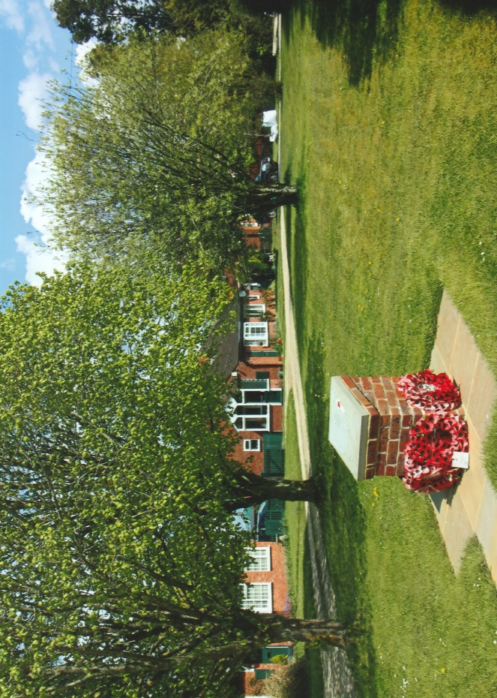
After his discharge from the Army, James was employed by C.H. Lea Ltd. a Sheffield cardboard box company. James had married in 1915 Daisy Barnes. She had been born in Sheffield on the 11th March 1886. Later James and Daisy had five children, only three of whom survived. He attended the centenary of Victoria Cross celebrations in 1956 held in Hyde Park and many other Victoria Cross related functions.
The family moved to Bournemouth where Daisy died in 1968 aged 82 years. James died aged 88 years on the 28th June, 1978 and his ashes were interred with his wife in a grave in Bournemouth’s North Cemetery. In 1979 James Welch’s Victoria Cross medal group were purchased for nine thousand pounds and are on display in the Rifles (Berkshire & Wiltshire) Museum, Salisbury.
The centennial commemorative Victoria Cross memorial stone was unveiled by the Lord Lieutenant of Hampshire Nigel Atkinson. Also present was the Basingstoke and Dean Mayor Councilor Jane Frankum, the local MP Ranil Jayewardene, Stratfield Saye Parish Councilors, the Commanding Officer of the Rifles, who provided the honour guard, Major Philip Welch (retired), grandson of James Welch was also present, representatives of the Royal British Legion and members of the public.
The Commemorative Victoria Cross Memorial Stone is mounted on a brick plinth and was surrounded by floral tributes laid by those attending the ceremony in 2017.

Sources; War Diary of the 1st Battalion, Royal Berkshire Regiment – August 1914-19 ~ Published the Museum in 2006.
VC’s of the First World War – Arras & Messines 1917 by Gerald Gliddon ~ A Sutton Publication 1998
The Victoria Cross 1856-1920 by Sir O’Moore Creagh VC GCB GCSI & E.M. Humphris ~ originally published in 1920. Republished by J.B. Hayward & Son 1985
Online Sources: Wikipedia Web-Site ~ www.wikipedia.org
Ancestry Web-Site ~ www.ancestry.com
Photographs ~ R.G. Coleman
R.G. Coleman (P)

