WESSEX BRANCH WESTERN FRONT ASSOCIATION 15th BATTLEFIELD TOUR ~ LES EPARGES, ST. MIHIEL, HARTMANSWILLERKOPF/VIEIL ARMAND ~ 13th-17th SEPTEMBER 2018
We departed from Pimperne on a chilly but fine morning at 0500 hours and drove towards Salisbury. There we were joined by members of the branch who completed our battlefield tour group. At Fleet Services the Sea View Coach feeder driver was relieved by Annie, who was to be our coach driver for the tour. As dawn broke the early sunshine and clear skies heralded a fine day ahead. We arrived at Dover without incident and passed through the port controls and embarked on the P & O Ferry, Pride of Kent for the 1110 hours sailing to Calais. Having put our watches forward one hour, we docked at Calais at 1345 hours and fifteen minutes later we were travelling along the French motorway system for our journey to Hauconcourt near Metz. Passing along through the flat and rolling landscape we glimpsed the Double Crassier, Notre Dame de Lorette and passed over the Canal du Nord busy with barge traffic. We stopped for a break at the Mont de Nizzy service station and continued onward along the A4/A17 to Metz. The flat landscape began to rise with hills and woodland forests as we entered the Argonne/Meuse Valley/Verdun region. The green leaves of the forest trees were turning into their beautiful autumnal colours reminding us that summer has passed and winter not far off. From the coach we had a view of the Woüvre Valley and had our first sighting of the Les Eparges ridge in the far distance. As we motored along Martin issued us with his excellent battlefield tour guide for our bedtime reading! Dusk was descending as we arrived at our hotel and after checking in and allocated to our rooms, there was time to freshen up before enjoying drinks and an evening meal.
After a good breakfast we left our hotel on a fine but slightly overcast morning to begin the second day of our tour. Via the A31 we joined the D120 at Atton, and drove over the bridge spanning the Moselle River at Pont-a-Mousson, and onto the D958. At St-Pierre we turned onto the D3 passed by the village of Fey-on-Haye surrounded by the Forêt de Front de Haye. The ancient village was situated in 1914-1915 between the French and German lines and was totally destroyed. A new village was rebuilt after the war few hundred metres from the original one. The forest is now listed as an ecological zone. Continuing on through the village of Thiaucourt-Regniéville, where there is a German military cemetery we arrived shortly after at the St. Mihiel American Cemetery and Memorial situated on the western edge of Thiaucourt.
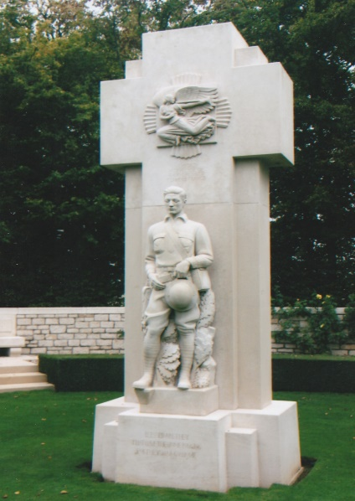
We were greeted at the cemetery by the American Superintendent and after introductions he gave us an excellent guided tour of the cemetery. The cemetery contains the graves of 4,153 American casualties, the majority of whom died during the American Expeditionary Force’s (AEF) attack to pinch out the St. Mihiel Salient. From initial designs in the 1920s by the architect Thomas Harlan Ellett (1880-1951) who served in the First World War with the 302nd Engineers, 77th Division and sculpture by Paul Manship (1885-1966), the cemetery covering over 40-acres was begun in 1930 and completed four years later. We were informed by the superintendent about the history and origins of the cemetery, which is divided into four equal plots. The crosses marking the graves were all originally carved from Carrera marble. Over the passing of years some were replaced using a cheaper stone which is noticeably of a different colour from the white marble ones. Both type of stones age and weather over the years and a long term programme to replace all the crosses with Carrera marble has begun. Approximately twenty crosses are being replaced each year. General John Pershing, Commander of the AEF had considerable influence concerning the layout and sculpture erected in the cemetery. There is a unique statue of an American soldier situated on the western side of the cemetery. It was privately paid for by the mother, whose son First Lieutenant Walker Blaine Beale was killed during the war and is buried in Plot D. She wanted the statue sculpted in a likeness of her son but Pershing overruled this and at first would not allow it to be erected. However, her husband was a US Senator and a friend of Pershing. Common sense prevailed and the General relented. The statue is not modeled on a known individual but stands as a memorial to all American troops who lost their lives. Although privately funded the statue in order to remain in the cemetery had to be formally assigned into the care of the American Battle Monuments Commission by the deceased son’s family.
The superintendent drew our attention to some of the marble crosses and gave us biographical details about the person buried in the grave. There is one recipient of the Medal of Honour buried in the cemetery, 2nd Lieutenant John Hunter Wickersham who served with the 353rd Infantry, 89th Division, A.E.F. He was awarded the medal for his bravery near Limey on the 12th September, 1918. The citation reads: “Advancing with his platoon during the St. Mihiel offensive, he was severely wounded in four places by the bursting of a high-explosive shell. Before receiving any aid for himself he dressed the wounds of his orderly, who was wounded at the same time. He then ordered and accompanied the further advance of his platoon, although weakened by the loss of blood. His right hand and arm being disabled by wounds, he continued to fire his revolver with his left hand until exhausted by loss of blood, he fell and died from his wounds before aid could be administered.” His posthumous medal was presented to his family in 1919.
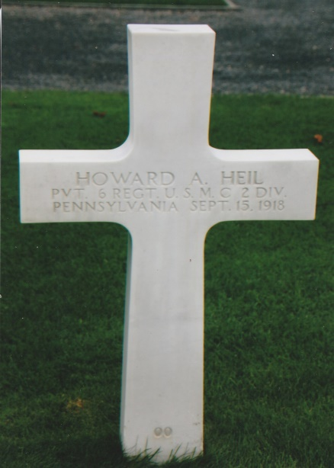
On the eastern side of the cemetery is a semi-circular structure dominated by a sculpture representing a Victory Vase. Separated from the burial area on the southern side is the Memorial with a chapel, a colonnade with the large rose-granite funeral urn in the centre and a hall of remembrance. The chapel floor is inlaid with green marble and the ceiling with gilt Napoleonic bees. Above the ivory-tinted altar is a mosaic portraying St Michael the Archangel, sheathing his sword and flanked by a pair of doves of peace holding olive twigs. The national colours of the USA and France are incorporated on decorated mosaic shields. Inside the hall of remembrance opposite the chapel is a large inlaid map of the St Mihiel offensive designed by the mosaic artist Barry Faulkner. The adjacent walls are inscribed with the names of 284 missing soldiers. Those marked by rosettes have since had their mortal remains recovered and identified. In 1991 the remains of an American serviceman, Private Howard A. Heil, 6th Regiment U.S.M.C. killed on the 15th September, 1918 was recovered from nearby farmland. Interred in the cemetery, his grave numbered ‘00’ is set slightly aside of the other graves in Plot D.
Beneath the colonnaded memorial is a large underground chamber. During the Second World War the Germans for some as yet unexplained reason bombed the village of Thiaucourt on five successive nights. During these raids the villagers sought shelter in this underground space. When the Germans occupied the area a number of the Jewish markers in the cemetery were kicked over. After remonstrations from the then superintendent the cemetery was not further defiled and the gardeners continued working there for the remainder of the war. The space beneath the memorial was also used by American and British airmen who were shot down during the Second World War and were temporarily hidden there whilst following an escape route to neutral countries. At the end of our tour the superintendent was heartily thanked by all members for his informative and enlightening guided tour. Members were then free to walk around the cemetery in quiet contemplation and reflection.
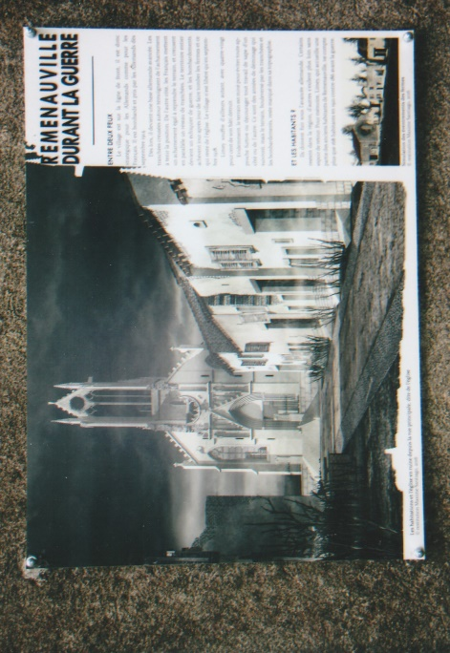
On leaving the cemetery we returned in our coach back along the D3 until we reached the turning for the D75 for a visit to the ‘detruit’ village of Remenauville. The village is in the department of Merthe-et-Moselle and had a population before the First World War of 138. During September 1914 the Germans occupied Remenauville and throughout the war the village was part of the front line and was razed to the ground during the devastating onslaught of battle. Only a few traces remain of the destroyed village. A small display board with a photograph attached to a wooden stake placed in front of the destroyed property informs the visitor of its former purpose. A small memorial chapel was later built on part of the site of the original 19th century church. Information display boards have been erected on the exterior walls of the chapel in commemoration of the 1914-1918 centenary. Remenauville was never rebuilt and is one of the many villages that “Died for France”. The Germans were driven out of the area in 1918 during the French and American St. Mihiel offensive. Members were able to walk along what was originally the old village street now covered with grass. The disturbed ground and rubble of destroyed buildings are relentlessly being reclaimed by flourishing undergrowth and trees. Although the village was not rebuilt the former inhabitants agreed in 1942 to attach the name to a nearby village which henceforth has been known as the town of Limey-Remenauville.
From Remenauville we drove along the D958/D904 past a French marker indicating the limit of the German advance, to Bouillonville German Cemetery. The village lies on the left bank of the Rupt de Mad, a thirty-three kilometre long river which flows through Bouillonville on the border of the Meurthe-Moselle and Meuse regions. The cemetery contains 1,368 German soldiers who died during the First World War. It is laid out in a series of rising terraces on the steep southern hillside of the village. There are some unusual aspects to this particular German cemetery. The lowest terrace contains graves from 1914 and there are a number of original stone grave markers. A circle of graves are arranged equally spaced around a large tree, perhaps laid to rest in this way by their comrades in 1914. A considerable number of the stone markers are inscribed with only one name instead of the usual multiple inscriptions found in other cemeteries. At the far end of this terrace beyond fenced hedging is a collapsed structure of a strongpoint. The graves laid out on the upper terraces reflect the year of the combatant’s death as the war progressed. This cemetery’s has an enlightened and thoughtful approach to its layout.
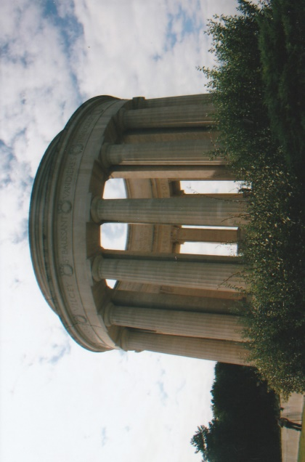
Leaving Bouillonville we drove back to Essey-et-Maizerais across the D904 and onto the D28 to the junction at St-Baussant, along the D33, through Lahayville and at Richecourt joined the D119. Then driving up the D12 we arrived at the Butte de Montsec American Monument designed by Egerton Swartwout (1870-1943) which dominates the landscape. From the monument there are wonderful views to be observed from all points of the compass. Built during the 1930’s, in the style of a classical circular colonnade with a broad paved steep stairway leading up to the monument. Within the open interior space there is a large stone orientation table on the top of which is a large bronze relief map of the St Mihiel salient illustrating the military operations undertaken by the French and American First and Second Armies. The monument commemorates the American soldiers who fought in the St Mihiel sector in 1917 and 1918. During the Second World War the monument was damaged by American artillery as their forces advanced against the Germans. It was later restored. We all gathered around the orientation table where Michael gave us a vivid account of the American and French attack on the Salient on the 12th September 1918. The weather was sunny and warm and we spent time absorbing the panoramic views of the plain below.
Rejoining our coach we drove along the D12 through Loupmont to Apremont-la-Forêt, then onto the D907 and into the Bois d’Apremont/Bois Brule. We turned off the main road and drove along a forest track to the Tranchée des Bavarois et de Roffignac – Trench of the Bavarians and Roffignac. [Tranchée is a French term for the frontline trench] The Germans were determined to occupy the ground they had gained and built their trenches with concrete, sheet metal plating, steel joints and cement bags. They also dug deep underground shelters, where the troops could rest, eat and sleep. The German line here emanated from the Meuse to the Bois d’Ailly through an open field to the southern-western edge of Bois d’Ailly to Apremont. Ferocious battles were fought in this area from August 1914 and throughout 1915. French losses in the first three months amounted to 15,000. The Tranchée Bavarois bears witness to their efforts and although the artillery barrages scarred the woodland landscape, this trench system is still very impressive after 100 years. More time could have been spent here as there is much to see. Making our way back along the forest track we crossed directly over the D907 and past a French Second World War Memorial, to the L’Hopital Allemand – the German hospital a few hundred metres into the forest from the main road. This hospital was situated relatively close to the front line and is a remarkable survivor. We were able to enter the concrete structure and walk through it with care. A protecting deep trench curves round and behind the hospital and continues on into the forest.
We rejoined the D907 and drove towards the village of Rambucourt and via the D958/D904 stopped near Flirey to visit the German trenches in the Forêt des Hauts de Mad/Bois de Mort Mare. These trenches are an absolutely magnificent and a tribute to those who constructed them. We were able to walk through them and peer into the entrances with stairways descending down to former living quarters deep below the ground level. More time could also have been spent here exploring this amazing network of trenches Once all our members were back on the coach we drove along the D958 past Montauville where in Le Pétant French Cemetery laid out on the hillside, lie 13,516 casualties of the First and Second World Wars and via Pont-a-Mousson arrived back at our hotel during the early evening having enjoyed a memorable day’s tour.
On the Saturday morning we left our hotel early, travelling via the A31/A330/E23/N66 to the Vosges Mountains of France for a visit to Hartmannswillerkopf/Vieil Armand. As we reached the Vosges the low cloud and the early morning mist shrouded the hills and mountain tops. It was a very pleasant and interesting drive as we passed through villages reminiscent of those to be found in Switzerland. Bunting was strung out across the long winding street at Le Thillot and a Saturday market was very busy. From there we entered the Thur Valley and passed through the lovely village of Fellering. At the village of Willers-Thur we turned on to the D13B to begin the ascent to Hartmannswillerkopf (HWK). A series of hair pins quickly took us up to 500-metres and shortly after reached the village of Goldbach-Altenbach. From there we turned onto the D431 and by the side of a hairpin bend, near the summit is a memorial to the crew of a Halifax Bomber, MZ807 of 433 Squadron RCAF which crashed on the mountain in December 1944. The D431 still has a short section of original cobbled road which has been left uncovered by modern road surfacing material.
Hartmannswillerkopf literally means the Head (geographical summit) of Hartmannswiller, a village located at the foot of the mountain. Popularised as early as April 1915 by “I’lllustration” newspaper under the name of “Vieil Armand” French soldiers preferred to call it Hartmann “HWK” or “the Man Eater” and German soldiers “HK”, the “Mountain of Death” or the “Sacred Mountain”. The Hartmannswillerkopf plateau, is a pyramidal rocky spur with a high point of 956-metres, located on the ridge line of the Vosges Mountains and occupies a strategic position. From the lookout position on the “Aussichtsfelsen” rock it offers a panoramic view out over the Alsace Plain. After war was declared on the 3rd August 1914, the French wanted to retake Alsace and Moselle which had been German since 1871. This meant the ridge line became a strategic site and a challenge. It became a place of death and extreme violence throughout the war as both sides attempted to capture and recapture HWK. The year 1915 and 1916 were the most terrible, marked by battles in which the best French and German troops fought with outstanding courage in the extreme physical, climatic and military conditions which the mountains subjected them to.
HWK is a characteristic battlefield of static mountain warfare and comprises one of the largest networks of trenches, communication trenches, tunnels, strongpoints, dugouts, saps and shelters in the Vosges Mountains. It still bears the battle scars caused by the death of 30,000 French and German soldiers. Approximately another 30,000 men were wounded or taken prisoner. These costly operations continued until the early months of 1916 when both sides accepted a virtual stalemate and withdrew troops to reinforce their armies farther north. Until 1918 the front line remained relatively stable.
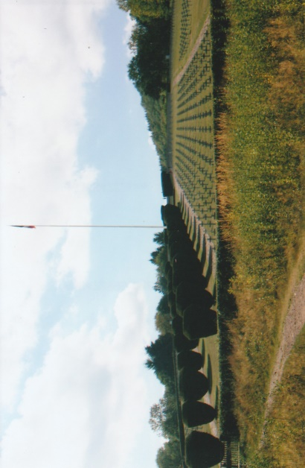
The visitors centre at HWK has a very good museum with artifacts, photographs, maps, audio-visual displays, information and details about mountain warfare, the daily lives of soldiers, a film theatre all conceived in the spirit of reconciliation between France and Germany. The highly original design of the building merges with the woodland setting and was opened in 2017. It is well laid out, spacious with a welcoming atmosphere reflected by the friendly staff. After a splendid lunch we had a guided tour of HWK. The La Nécropole Nationale du Silberloch Cemetery lies on the site of positions held by the 28th Chasseurs battalion in December 1914. There are 1,640 soldiers buried here including 384 unidentified bodies buried in six ossuaries. In front of the cemetery is the National Monument containing the remains of approximately 20,000 unknown French and German soldiers in an ossuary and built into a crypt together with three chapels – Catholic, Protestant and Jewish. Above the monument is the Altar of La Patrie, bearing on the sides the names of the cities who donated money to build the memorial. The latter is overlooked by the summit of HWK where many reminders of the battles that took place here in 1915 are conserved and which today remains a cemetery, open to the sky. At the lower end of the cemetery from where pathway’s lead upwards and crisscross around HWK, Mark our guide outlined the history about the French and German forces who, fought on HWK before we began our tour of this very large site. The ground is fairly steep, uneven and strewn with stones and woodland debris and good walking boots are a must. Walking this site requires visitors to be fairly fit and have a degree of stamina.
Mark explained that the French trenches were built only for temporary occupation and they lined the side walls with small rocks and stones using the dry-stone wall method. These were easily collapsed when struck by artillery shells and had to be rebuilt, which was time consuming for exhausted battle weary troops. The French High Command did not want their troops to get too ‘comfortable’ as their philosophy espoused the fighting spirit Attack! Attack! Attack! The Germans on the other hand constructed their trench systems for permanence as it was their intention to hold and occupy ground gained. On the summit, the primary objective of both sides, there is a 20-metre high illuminated cross which was inaugurated on the 10th November 1936. Nearby is a memorial, erected in October 1975 to commemorate the 28th Mountain Infantry Battalion, who defended an advanced combat post. The last survivors of the position, first occupied on the 25th December 1914, were captured on the 23rd January 1915 after a month of intense fighting. Just below the summit and looking out over the Alsace plain is a monument dedicated to the 152nd Regiment known as the “Diables Rouges” – “Red Devils”. The monument depicts five larger-than-life-size soldiers all advancing to attack sculpted by Victor-Charles Antoine (1881-1959). Originally in bronze it was destroyed by the Germans in the Second World War as they wanted to eradicate memorials in Alsace commemorating the French of the First World War. They also wanted to blow up the cemetery but after tough negotiations with the French regional prefect the Germans did not carry out their threat.
As we continued to make our way around HWK we were introduced to Jean Klinkett, president of the HWK Visitors centre. HWK is maintained by volunteers who have helped to uncover and maintain the pathways for visitors to explore the site. After the war ended it was declared by the authorities as a ‘Red Zone’ but having been cleared over the succeeding years of battlefield detritus and debris it has been downgraded and made safe for visitors. However, it is not unusual for the volunteers to still find human remains and materials of war on HWK. It was listed in 1921 as an historic monument and since 1932 has become an important place of remembrance and a symbol of peace and reconciliation. Our two-an-half-hour guided tour ended back at the visitor centre where we thanked Mark, our very knowledgeable guide. As with all these battlefield sites more time could have been spent here and perhaps a future tour could include another visit. Having stayed at HWK longer than anticipated we left at 1800 hours and via the D83/E35/N83/A4, arrived back at our hotel in darkness after a challenging and pleasurable day.
We emerged from our hotel, into a fresh and sunny Sunday morning and via the A31/A4/D908 drove to Les Eparges. Martin had read out first class information prepared by Rod, who was unable to come on this tour. The Les Eparges ridge marked the north-west boundary of the St. Mihiel Salient, and was the scene of several ferocious battles, originally fought above and later below ground. On the 17th February 1915 the French launched an attack on the ridge to reduce the size of the Salient. German counter-attacks regained ground taken by the French in severe and bloody fighting. A battalion of the 8th Infantry Regiment captured the eastern spur of Les Eparges (Point C) on the 9th-10th April. The Germans retaliated by attacking the Les Eparges from the Calonne trench, but the French managed to hold their position on the western side of the battlefield. The battles continued over the following months devastating the ridge which became scarred by the detonation of mines. In September 1918, the American armies drove the Germans from Les Eparges.
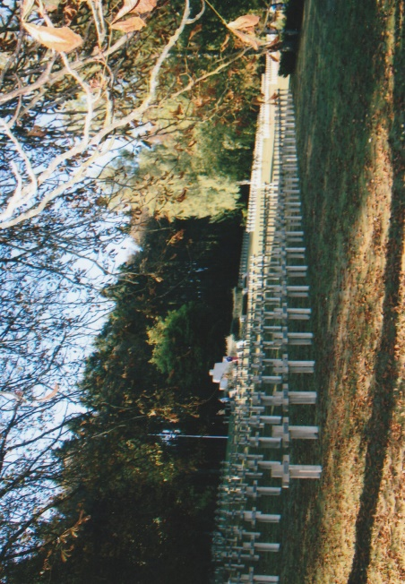
We stopped at the Nécropole Nationale “Le Trottoir” cemetery, which contains the remains of French soldiers who died during the battles on the Hauts-de-Meuse between 1914 and 1918. Established in 1915, the cemetery was redesigned in 1922, 1924, 1933 and 1934 to accommodate the bodies of soldiers killed in the sector and exhumed from the nearby cemeteries. There are 2,960 French soldiers buried in the cemetery including 852 in an ossuary. In the first row, on the right as you enter the cemetery lies Robert Porchon, friend and comrade of Maurice Genevoix. At the beginning of the war, this man, born in 1894, was made Second Lieutenant in the 106th Infantry Regiment, where he met up with his old school friend Maurice Genevoix. Robert was killed in February 1915 after being hit by shrapnel. Immortalised by Maurice Genevoix in his book ‘Ceux de 14’ – (The Men of 1914), using letters and diaries of Robert Porchon he gives a fascinating insight on the war. The French and Germans incurred similar losses of 10,000 killed, wounded or missing prefiguring those in the offensives at Verdun and on the Somme in 1916. Genevoix, who after the war became a novelist, wrote in Ceux de 14: “What we did, it was more than should ever be asked of any man, and yet we did it.”
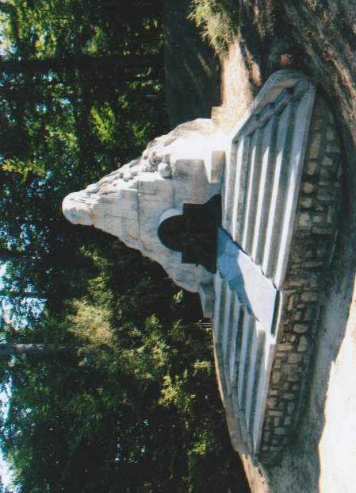
We drove on a few hundred metres from the cemetery and stopped at ‘Les Revenants du 106e R.I.’ – Monument to 106th French Regiment of Infantry. The French and Germans fought for control of this position and within a few days the 106th Infantry had lost half of its men. The monument, erected in 1935 is situated on the top of a hill and set against a background of trees. It was sculpted by Maxine Real Del Sarte (1888-1954) who lost part of his left arm at Les Eparges in January 1916, and takes the form of an irregular pyramid topped with a human head. Severed hands, skulls and crosses evoke the suffering of those who fought on the ridge. Del Sarte creates a gruesome suggestion of a copse trying to escape from an enforced and unwanted tomb – many of those who died would have been buried alive in the shelling and mine explosions. A bronze bas-relief on the front of the monument is a metaphor portraying the descent of the Cross. The woman wearing a helmet represents Mary as France and Christ a soldier who sacrificed his life for the motherland. The next memorial we stopped at was the Genie (Engineers) Memorial commemorating the military engineers who suffered and endured the battles and mine warfare. In front of a double semi-circular wall are seven concrete sheet piles each bearing a plaque and inscribed: ‘Pontonniers’, ‘Telegraphistes’, ‘Electro Mecanicians’, ‘Sapeurs Minuers’, ‘Chemin de Fer’, ‘Aeroshers’, & ‘Artificiers’. On the left-hand side of the memorial is a dedication to the Engineers and on the right the symbol of engineering.
Annie then parked the coach in the car park a short distance away from the Monument at Point X. The French were determined to capture Point X because of its strategic position on the eastern edge of the ridge. The reason was that the position gave a remarkable observation of the Woëvre valley and the slopes to the crests of the Meuse River (Côtes de Meuse). Point X was held by the Germans until September 1918. The monument was erected to the memory of 10,000 French and German soldiers who have no known grave. It was sculpted by Mlle Fischer as a tribute to her beloved fiancé reported missing in 1915. It takes the form of sharply sloping walled surfaces, topped with a triangular pediment. A cross above an altar is inscribed on one face and on the other is a bas-relief in which a bare-headed officer leads his men into battle. Several plaques attached to the monument are inscribed to regiments and individuals. Close by is another monument in the form of a small wall and situated on the cusp of a crater. It bears a plaque adorned with the Croix de Guerre and inscribed: ‘302nd Infantry Regiment 20 September 1914, 20 March 1915 Veterans of the 302nd and 102nd Infantry Regiment’.
At Point C (Gunners Landmark) is the Monument du Coq, an obelisk erected on a raised low pyramidal stone-work structure and crowned with a rooster – looking towards Germany – is dedicated to ‘The 12th Division to his dead and their brothers-in-arms fallen in the Eparges’. It was sculpted by Lefebvre Klein, a veteran of the 132nd Infantry Regiment and stands near to the edge of a very large and deep mine crater. Attached to the monument are two marble engraved plaques including the Orde du Corps d’Armee No.66 from General Herr and from General Roques, Army Order No.147 to the 12th Division. General Roques (1856-1920) commanded the 1st French Army and General Herr, (1855-1932) the 6th Corps.
Members had free time to walk around Les Eparges in at least a paired group, with a mobile phone in case of accident or getting lost on the site. The sign-posted pathways allow the visitor to walk with care around the whole area where there is still evidence of war clearly visible – trenches, dugouts, strongpoints, observations posts and mine craters some small and others very large, evidence of the 300 mines which were blown from 1915 to 1918. After our exploration we drove back to the cemetery where we had a picnic lunch in the lovely warm afternoon sunshine. We then drove to St Remy-la-Calonne and along the narrow D331 road of the Tranchée de Calonne. The latter a forest road, not crossing any village is 25-kilometres long connecting Hattonchâtel to Verdun. It dates back to 1786 when Charles Alexandre de Calonne, a minister of Louis XVI had the road constructed to a château which came into his possession in 1770 at Hannoville-sous-les-Côtes. [Note that the word ‘trench’ a pre-war term, commonly used in the Hauts-de-Meuse and is a forest term similar to the word road – taken from the Latin rupta: broken or cut through]
During the First World War the Tranchée de Calonne witnessed many battles fought between the French and Germans. It was a strategic artery that was bitterly contested from September 1914 onwards with neither side making significant gains until the American offensive of 1918. Maurice Genevoix who fought there in 1915 wrote of being in a trench being deluged with artillery shells: “The shells are heavier, the earthquake, the clouds evaporate in fine brown and black and tawny fumes, whistles and air slaps our eardrums. All clods, all the shapeless debris goes back to the buzzing of shards.” Ernest Jünger was wounded in the fighting here in April 1915.
Driving along the forest road of the Tranchée de Calonne, on either side of which we could see disturbed ground and passed by a number of memorials, including a large monumental cross dedicated to Alain Fournier. For many years after the end of the First World War it was not known where he had been buried and on the 11th October 1964 the cross designed by Dante Donzelli (1909-1999) was erected at the cross-roads of the Tranchée de Calonne and the Saint-Remy road. Annie parked our coach by a finger post pointing to Alain Fournier & Comrades. The woodland track, originally the route of a German 60-centimetre railway was built to supply troops with rations, equipment, ammunition and the evacuation of wounded. Walking along the woodland track we stopped to view a stairway leading down to a German underground barrack building which was linked to the artillery headquarters by a trench. Some of the rooms in this underground structure were carved into the rock but for safety reasons are now inaccessible. Nearby is the underground German Artillery Headquarters which has three rooms, including a telephone exchange from which artillery battery fire was organised. When St Remy-la-Calonne woods were captured by the 26th American Division, the 103rd Field Artillery Regiment lived in this underground shelter. After walking for about 400-metres into the forest we arrived at the memorial to the twenty-one combatants. On the 2nd May, 1991 the burial location of these soldiers killed on the 22nd September 1914 was located. They had been buried in a shallow pit by the Germans. Their remains were exhumed and with the exception of two, nineteen were identified, including Alain Fournier. He was born Henri-Alban Fournier in 1886 and later wrote a literary French classic novel “Le Grand Meaulnes” (The Lost Domain) in 1913. It is a story about a boy’s coming of age inspired by the author’s unrequited love for a woman he hardly knew.
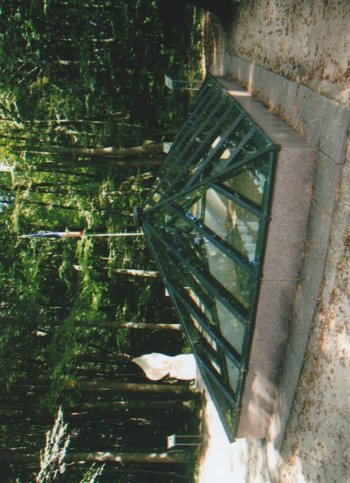
On the 10th November, 1992 the exhumed bodies of the twenty-one soldiers were interred in Saint-Remy-la-Calonne Military Cemetery in alphabetical order. The burial site where the remains were found, now a memorial, is covered by a glass pyramid. Stone markers with the name of the deceased soldier attached have been placed where his remains were found. Next to the pyramid is a Euville stone monument, the work of Henri-Patrick Stein, representing a massive stone flame. Carved at the base of the flame is a volume of “Grand Meaulnes” and Alain Fournier’s kepi bearing the number of his unit. Below is the following inscription: ‘In Memory of the 21 Soldiers of the 288th RI Killed in Action in this Clearing September 22 1914’. Arranged around the memorial, which was unveiled in 1993, are information display boards in French.
We walked back to the forest road and a short distance from the finger post directing visitors to the 21 Comrades, are the remnants of a roadside German cemetery. The German Campaign Cemetery 1914-1918 – JR19 Von Courbiere contained more the 500 Germans soldiers from Infantry Regiments 19, 47, 154 and the Grenadier Regiment No.7 killed in the area and buried in this cemetery. It was the largest cemetery in the Tranchée de Calonne. The exhumation of the bodies took place in the 1920s and they were transferred to Troyon and Viéville-sous-les-Côtes. A large wooden cross placed roughly in the centre dominates this former cemetery surrounded by undergrowth and forest debris. There are a few original gravestones guarding empty graves, their inscriptions eroded but one or two can still be read.
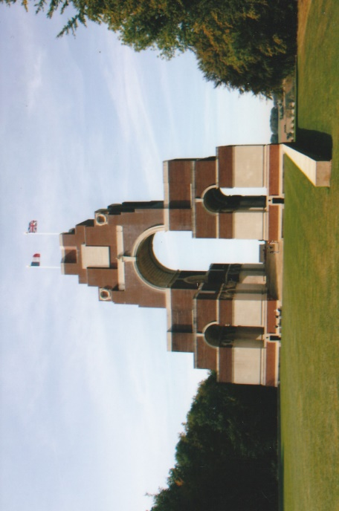
In the woodland on the opposite side of the road, the track of the former light railway leads the visitor after about 250-metres to the positions of German heavy gun batteries most probably controlled from the artillery headquarters already mentioned above. This last stand completed our programmed battlefield tour itinerary and we drove back to our hotel in the late afternoon sunshine. Thanks were extended and applause followed for Martin our tour leader for his guidance and extremely knowledgeable input throughout our tour. Rested and refreshed we all went out to a restaurant and enjoyed an evening meal and drinks completing our excellent tour and visits to some of the less well-known battlefields of the First World War.
We left our hotel the following day for the return journey to Calais. The morning was sunny and bright as we drove along the motorways. A comfort stop was made mid-morning and then we resumed our journey. Annie, our driver’s grandfather was killed during the First World War and she did not know where he was commemorated. We were able to establish that his name is inscribed on the Thiepval Memorial and we took the opportunity to stop there, where Martin took Annie to the appropriate panel. We all enjoyed the short break and the opportunity to have look around the visitors centre and the memorial ourselves.
We set off again and Annie stopped for fuel before reaching the Calais ferry terminal. Initially it seemed likely that due to unforeseen circumstances our ferry departure would be delayed. Fortune however, smiled on the Wessex Branch WFA and we embarked on the P & O Ferry Pride of Britain more or less on schedule. Arriving at Dover at 1745 hours (UK time) we disembarked and set off for Fleet Services where our lovely driver, Annie was relieved by a feeder driver. We heartily thanked Annie for her patience and careful driving and continued on to Salisbury arriving there at 2140 hours where several of our members alighted. Continuing on without incident the coach arrived at Pimperne at 2215 hours and from where all the remaining members of our tour group dispersed to their homes.
Our fifteenth battlefield tour to the Vosges region of France was a superlative one. Thanks must be extended to Annie our driver who joined with us in all our visits and explorations of the battlefield sites with enthusiasm, friendship and it has stimulated her interest in the First World War. To Michael, who delivered with authority and knowledge his talk about the American and French offensive in the St Mihiel Salient and to Rod for his information about Les Eparges. This tour could not have come into fruition without the patience, determination, enthusiasm of Martin and Judy. It takes hours of their time, willingly given to make all the arrangements, liaising and communicating with travel operatives both in the UK and France. All their hard work, flowers into a well organised and professional tour for our members. The purpose of our enjoyable tours is not only to expand our knowledge about the First World War. Bloodily and bitterly fought we also remember the sacrifice so readily given over 100 years ago by so many, who having passed into history, continue to be honoured and remembered with pride.
Sources
Wikipedia Web-Site ~ www.wikipedia.com – Battle of St Mihiel; Alain Fournier; Remenauville; St Mihiel American Cemetery & Memorial; Trench of Calonne; Hartmannswillerkopf
American Battle Monuments Commission Sites Booklet
Find A Grave Memorial Web-Site ~ www.findagrave.com – Alain Fournier
Traces of War Web-Site ~ www.tracesofwar.com – Le Trottoir French War Cemetery
Chemins de Mémoire Web-Site ~ www.cheminsdememoire.fr - Les Esparges
Maurice Genevoix ~ ‘Ceux de 14’
Michelin Road Map ~ Alsace-Lorraine No.516
Photos R.G. Coleman ©2018
R.G. Coleman

