MUSLIM BURIAL GROUND ~ WOKING
THE PEACE GARDEN
During the First World War over one million soldiers of the British Indian Army fought for Great Britain and her Empire. They participated in campaigns on the Western Front in France and Belgium. Of the one million approximately 40% were Muslims. Soldiers wounded on the Western Front were evacuated to hospitals in southern England. Probably the best known was The Royal Pavilion at Brighton utilised during the war as a hospital for Indian soldiers.
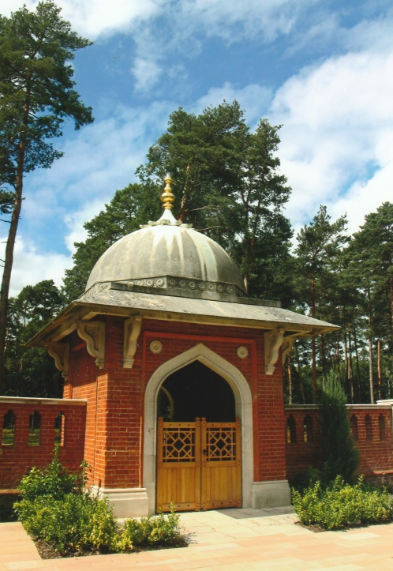
For those who died it was necessary that funeral arrangements were carried out in accordance with their religion. Hindu and Sikh soldiers were cremated and those of the Muslim faith buried. The Germans used propaganda targeted at Indian Army soldiers to agitate unrest amongst them that the British authorities were ignoring their religious customs. However, arrangements had been established to ensure that Hindu’s and Sikhs were cremated at specially designated crematoria in Sussex and Hampshire.
A number of appropriate locations had been identified for the burial of Muslim casualties. After careful consideration the War Office took the decision in 1915, to purchase land owned by the Earl of Onslow in the pine woods of Horsell Common, at Woking. The burial ground was completed in 1917 and its location is not far from the Shah Jahan Mosque, the first mosque built in the United Kingdom in 1889. During the First World War 18 Muslim soldiers were interred in the burial ground and another 8 casualties were subsequently buried there. One in 1920 and seven during the Second World War, the last in the Spring of 1947. In 1921 the Imperial War Graves Commission (later the Commonwealth War Graves Commission) had undertaken the care and maintenance of the burial ground.
A policy was adopted that the majority of later interments of Muslim casualties would be buried at Brookwood Military Cemetery and burials at Woking ceased. In the 1960’s, neglect and vandalism necessitated the removal of the bodies by the CWGC in 1968 to Brookwood where they were re-interred in Section 2a of the Military Cemetery. The Horsell Preservation Society took over ownership of the abandoned burial ground in 1969, despite a lack of adequate funds. English Heritage (now Historic England) listed the site as a Grade II structure in 1984. A programme of work by the preservation society to clear the undergrowth and stabilise the red brick walls was completed by them but their attempts to raise funds for restoration were unsuccessful.
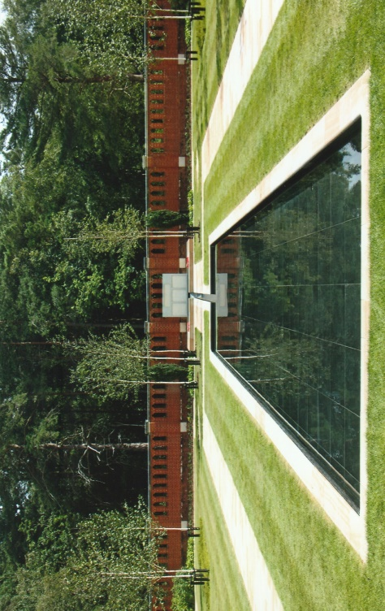
In 2011 Woking Borough Council and the Horsell Preservation Society launched a new initiative to seek funds for a restoration project and to create a peace garden in the Islamic style. Their determination and tenacity was rewarded in 2013 when work on a detailed plan for the restoration began. A number of organisations helped to make this possible through financial help and support including Woking Borough Council, Historic England, Armed Forces Covenant Scheme, Department for Communities and Local Government, Shah Jahan Mosque, Surrey County Council and the Sultanate of the Government of Oman. This enabled the architectural structures to be restored and the associated brickwork renewed where necessary. Damaged or missing Portland capping stones on the top of the red brick walls were replaced. The interior groundwork was landscaped by Terra Firma Limited with the help of the Horsell Common Preservation Society and serving members of the armed forces to create a garden for remembrance, commemoration and contemplation. Planted within the Peace Garden are shrubs and 27 Himalayan birch trees representing the number of Muslim military personnel who, were once buried there. Running water circulates and flows beneath the memorial stone on which their names are inscribed. The Islamic features are orientated towards Mecca.
On the 12th November, 2015 HRH The Earl of Wessex K.G., G.C.V.O., officially opened the Peace Garden. The garden is a hundred yards or so from the road side of the A320 in Monument Road, Woking and is open seven days a week. There is also a car park, a short walking distance away from the Peace Garden.
[Sources:- Woking Borough Council Web-Site www.woking.gov.uk/woking/heritage/peacegarden
Horsell Common Preservation Society Web-Site ~ www.info@horsellcommon.org.uk]

R.G. Coleman

