GREAT WAR MEDALS
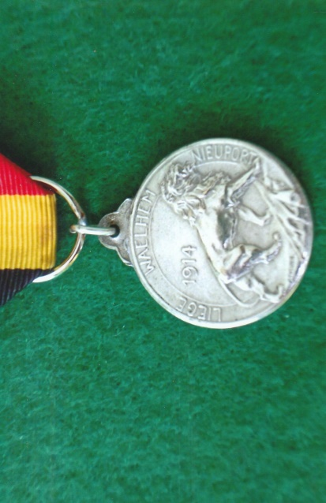
Belgium ~ Medal For The Resistance Of Liege, Waelhem & Nieuport 1914
The circular silvered bronze medal has on the obverse a standing lion facing right with its right paw on a fallen standard and above to the left the date ‘1914’. ‘LIEGE WAELHEM NIEUPORT’ is inscribed around the circumference and below the lion’s rear feet is the signature of P. Theunis – a Belgian sculptor, 1883-1950. On the reverse is a classical portrait of the head of a Roman soldier facing left and encircled with the words ‘DE TOUS LES GALOIS LES PLUS BRAVES SONT LES BELGES JULES CESAR’ – Bravest of all Gauls are the Belgians, Julius Cesar. To the right of the soldier’s neck are the initials ‘ED’ – most probably for the artist E.J. Bremaecker, 1879-1963. The medal is suspended by an eyelet and ring with a ribbon in the colours of the Belgian national flag.
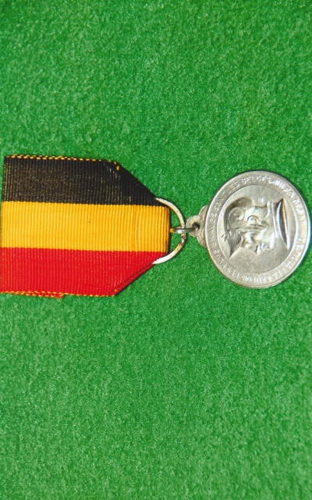
The common link of the three Belgian towns on the medal is their heroic and stubborn resistance against the invading German 2nd army at the beginning of the First World War. It was the planned intention of the Germans to quickly occupy Liege. Around the town was a chain of forts, garrisoned by Belgian troops who before being forced to surrender held up the German onslaught for eleven days. Antwerp had an inner and outer ring of forts, from which the Belgians at the end of August and beginning of September 1914 launched attacks against the Germans. On the 28th September the Germans began a bombardment of the forts and villages around Antwerp, including Waelhem. Fort Waelhem and many others became untenable and by the 9th October the Belgian army withdrew to the Yser. In their defence of the Yser canal the Belgians fought a defensive battle until the enemy were on the verge of breaking through. It was then that Belgians took the decision to open the canal locks at Nieuport on the 25th October and flood the low lying ground forcing the Germans to retreat four days later. Nieuport remained in Belgian hands throughout the war.
Precise details about how and why this medal was instituted remains unclear. There was no doubt about bravery of the Belgians during the First World War and they proved Julius Cesar’s remarks were still relevant.
[Sources: Medal-Medaille Web-Site ~ www.medal-medaille.co.uk
Personal Photographs]
R.G. Coleman

