Bulgaria ~ Royal Order For Civil Merit V Class With Crown Tsar Ferdinand I (Tsar Issue 1908-1918)
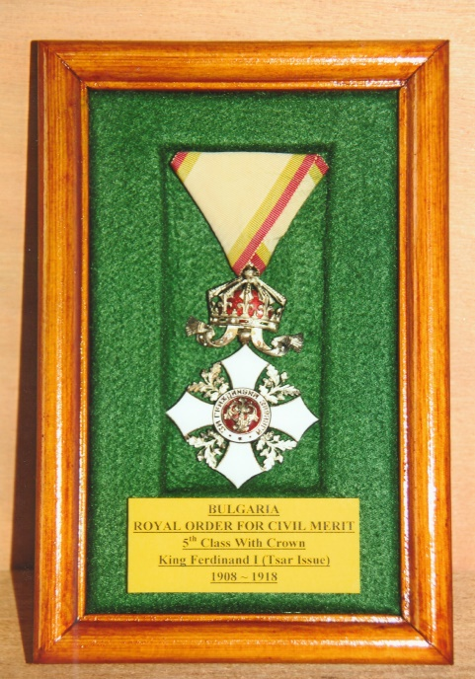
The white enamelled Urdy cross (A heraldic term for a pointed or sharpened cross representing the three nails of the crucifixion and the spear that pierced Jesus’s side) has silver edges with silver acorns and leaves between the arms and is suspended by an enamelled crown with red enamelled lining and flying pendent. The obverse of the cross has a red enamelled medallion inscribed ‘ФI’ for Ferdinand I, within an enamelled white ring bearing the letters in silver ‘ЗA ГPAЖДAHCKA ЗACЛУГA’ (for Civil Merit). On the reverse is a central red enamelled medallion with the Bulgarian lion rampant and a shield with the Saxon coat of arms on its breast within an enamelled white ring with silver letters bearing the date ‘2 ABГУСTЪ 1891’ (2 August 1891). In the example shown the crown and cross are suspended on an original trifold ribbon.
The Order was established on the 2nd August 1891 to reward civilians for exemplary meritorious service to their country. The example is from the reign of Ferdinand I after the creation of the Kingdom of Bulgaria when the crown suspension changed from the ‘Princely’ to the ‘Tsar’ form and dates from 1908-1918. For three decades Bulgaria had been a tributary principality to the Sultan of Turkey and the title ‘Prince’ was used by the head of the Bulgarian royal court. Although the country in reality had been independent since 1878, Ferdinand declared the country to be free of Ottoman influence in 1908. He then pronounced that Bulgaria was to be a Kingdom and assumed the title of Tsar.
Ferdinand I was born on the 26th February 1861in Vienna, son of Prince August of Saxe-Coburg and his wife Clémentine of Orleans daughter of King Philippe of the French, and a Prince of the House of Saxe-Coburg and Gotha-Koháry. The Emperor Maximilian of Mexico and his Empress Carlota of Mexico were his godparents. Ferdinand was brought up with the wealthy and high nobility of the Austro-Hungarian Empire. He served as an officer in the Austro-Hungarian army and was elected Prince of self-governing Bulgaria by its Grand Assembly in July 1887. His election was not popular with the other Royal Houses of Europe and prompted Queen Victoria, to record, “… he is totally unfit … delicate, eccentric and effeminate … should be stopped at once.” Despite such deprecating views the next two decades were very successful for him and Bulgaria.
Ferdinand had married Princess Marie Louise of Bourbon-Parma on the 23rd April 1893. They had four children but sadly she died after the birth of her fourth child in January 1899. Nine years after his first wife’s death, Ferdinand married Eleonore Reuss of Kösbitz. The marriage was one of convenience as Ferdinand wanted a wife to look after his children. Her status was relegated to simply being a member of his household. Suffering from poor health she died in September 1917. Although Ferdinand was bi-sexual he fathered a number of illegitimate children, who he supported financially.
In concert with other Balkan states Bulgaria declared war in 1912 on the Ottoman Empire to free occupied areas of their countries. There was however, an undercurrent of mutual distrust between these Balkan countries, each having their own agendas. Bulgaria wanted most of Macedonia when it was freed from Ottoman rule, but Serbia and Greece demurred and wanted to keep possession of their particular spheres of influence in the Balkans. Bulgaria invaded her allies Serbia and Greece to occupy Macedonia before being attacked herself by Romania and the Ottomans. Bulgaria was defeated in the second Balkan War of the following year. The subsequent 1913 Treaty of Bucharest granted Bulgaria small territorial gains.
On the 11th October 1915 Bulgarian military forces attacked Serbia after signing a treaty with the Austro-Hungarians and Imperial Germany. Her motive was to reclaim those areas of Macedonia she craved at Serbia’s expense. Bulgaria initially achieved a number of victories during the First World War and in the hope accumulating more territory she formed an alliance with the Ottomans. In 1916 Bulgaria found itself defending Allied advances from Greece and participated in a campaign against Romania. When Ferdinand realised that the defeat of the Central Powers was imminent he abdicated in favour of his son Boris, who became Tsar Boris III on the 3rd October 1918. Following the surrender Bulgaria forfeited most of the disputed territory her troops had fought for during the war.
Ferdinand was able to enjoy a wealthy and comfortable life between the two world wars. He was devastated when he learned that his eldest son Tsar Boris III had died in suspicious circumstances on his return from Germany in 1943 after a meeting with Adolph Hitler. Boris’s heir Simeon II was deposed in 1946 and was the last of the Bulgarian monarchs. The latter was replaced by the People’s Republic of Bulgaria under whose regime Ferdinand’s other son Kyril was executed. Ferdinand died heartbroken at the Burglaß-Schlöschen, Coburg, Germany on the 10th September, 1948 aged 87 years. Although he wanted to be buried in Bulgaria he was placed in the crypt of St Augustine’s Church, Coburg alongside his parents.

Sources: Wikipedia Web-Site ~ www.wikipedia.co.uk
Medal-Medaille Web-Site ~ www.medal-medaille.co.uk
R.G. Coleman

