BOOK REVIEW
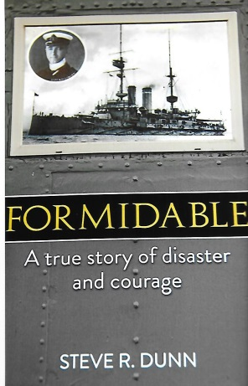
Formidable ~ A True Story Of Disaster & Courage by Steve R. Dunn. Paperback £12-99p. Published in 2015 by The Book Guild Limited, The Werks, 45 Church Road, Hove BN3 2BE. ISBN 978 1 910508 15 2
Steve Dunn has written an interesting account of this tragic incident in maritime naval history. He has not confined himself to the loss of HMS Formidable exclusively but has explored the wider consequences of its affects upon the wider community in time of war. The circumstances surrounding the torpedoing of the 1897 battleship HMS Formidable on New Year’s Day 1915 has provoked comments both official and unofficial that the incident should never have happened. The chronology and facts of this affair are carefully set out for the reader in which 583 men lost their lives. 197 were very fortunate to have survived the sinking in the gale force weather conditions.
The author’s describes the Royal Navy at the outbreak of the First World War as ‘Vicwardian.’ It is a navy which belonged to the age of Nelson whose characteristic’s spilled over into the Edwardian period. For naval officers it was essentially an exclusive club whose members were from the upper classes. In the ‘Vicwardian’ navy promotion for officers was not necessarily based on ability but very dependent upon the sponsorship of a senior officer under which the aspiring officer had served. A technological revolution had catapulted the Royal Navy into the 20th century and very few officers, especially those of flag rank understood or had come to terms with it consequences. Their hidebound attitude was based on discipline, a smart ship – was an efficient ship – and if it did not move ‘paint it.’ Lack of initiative and innovation made them unfit for modern industrial warfare. Admiral’s orders were followed by their sub-ordinates to the letter and never questioned. Many dismissed the emergence of submarines and were unable to comprehend the destruction they were to unleash on warships and merchant vessels during the First World War and in later conflicts.
The opening months of the war were not auspicious for the Royal Navy. A significant number of ships were lost and questions were raised inside and outside of the navy about the competence of the Admiralty under the First Lord, Winston Churchill and his seagoing commanders. Vice-Admiral Lewis Bayley commanded the Fifth Battle Squadron which included HMS Formidable and he was severely reprimanded for its loss. Bayley had a good relationship with the First Lord although he fell out of favour for a short period after the Formidable incident. Bayley angered by his reprimand, demanded a court-martial. The Admiralty demurred fearing adverse publicity. They had prosecuted Rear-Admiral Troubridge for his actions in the Goeben affair and he was found not guilty although his career was curtailed.
The author examines the consequences of death on active service for those families affected and the financial implications on the upper, middle and working classes. Limitations on pension and compensation payments made to the bereaved and to service personal are brought to the reader’s attention. In coming to terms with the horrendous death toll incurred during the war the author explores the wide spread need for remembrance in the form of public and private memorials. Two dogs feature in the loss of HMS Formidable. Bruce, an Airedale terrier was drowned with his master the captain of the Formidable and Lassie, a Collie, revived John Cowan in the Pilot Boat Inn at Lyme Regis. Steve Dunn devotes a section of his book on the role of dogs and their training for carrying messages on the battlefield in the First World War. The high demand made upon the male population during the war gave an opportunity for women and ignited a change in social attitude towards them which is still on-going today.
Those who fought during the war had hoped that they would return to a ‘land fit for heroes’ – many were to be disappointed. Unemployment, health issues arising from the war shortened many lives. Numerous aspects appertaining to the First World War are highlighted in Steve Dunn’s book. He has forthright views about the ‘Vicwardian’ Royal Navy, and the sinking of HMS Formidable. He also gives his opinion as to who was ultimately to blame for this naval disaster.
R.G. Coleman

