BOOK REVIEW
Glory ~ A Story of Gallipoli by Rachel Billington. Published in 2015 by Orion Books. ISBN 978 14091 46230. £19-99 (Hardback); (530 Pages).
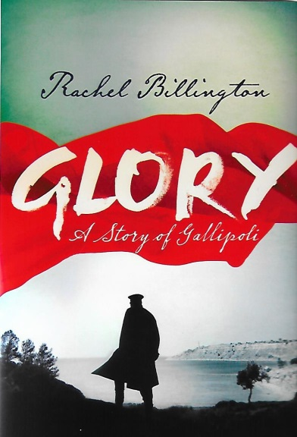
This well written, interesting and absorbing novel about the First World War blends the facts about the Gallipoli campaign and its consequences upon the fictional characters and their families. The author’s grandfather was Brigadier-General Sir Thomas Pakenham, Lord Longford who commanded the 2nd South Midland Mounted Brigade of the 2nd Mounted Division at Gallipoli. He was killed on the 21st August, 1915 on Scimitar Hill, Suvla aged 50 years, leaving a widow and six children.
His body was not recovered and he is commemorated by a Special Memorial in Green Hill Cemetery. Rachel undertook a battlefield tour of the Gallipoli Peninsula in 2012 with the historian Peter Hart who has spoken at our Branch Meetings. She visited Green Hill Cemetery and laid flowers on her grandfather’s grave. The tour motivated her to write a story about Gallipoli.
The main characters in the book, Captain Rupert Prideaux, Lieutenant Arthur Lamb, Private Fred Chaffey and Sylvia Fitzpaine, Arthur’s fiancée are brought vividly to life. Their fictional experiences reflect the real lives of those who lived and fought through the First World War. These characters from the landed gentry to the humble labouring classes go to war for King and Country and adventure.
The sequence of the political and military decisions which lead to Gallipoli are clearly described. As are the landings, battles, evacuation and the reality of the human aspects the conflict has upon each of the characters. Sylvia’s mother is devastated at the loss of her husband, the more so that his body is not found and clings to the possibility that he may have be taken prisoner by the Turks.
To alleviate her distress Sylvia travels to Egypt, Malta and eventually to the peninsula to try and find out what happened to her fictional father – mirroring the life Lord Longford. To further her search for the truth she volunteers to become a VAD nurse.
Rachel Billington has written many books both fiction and non-fiction. Her research about Gallipoli and its topography for this book will give those readers who are not familiar with the campaign a good starting point from which to learn more about the history of this controversial campaign of the First World War as well as enjoying a very good read.
R.G. Coleman

