BOOK REVIEW
BOY SOLDIERS OF THE GREAT WAR ~ FULLY REVISED EDITION BY RICHARD VAN EMDEN PUBLISHED BY PEN & SWORD MILITARY ~ ISBN 978 1 39901 163 1
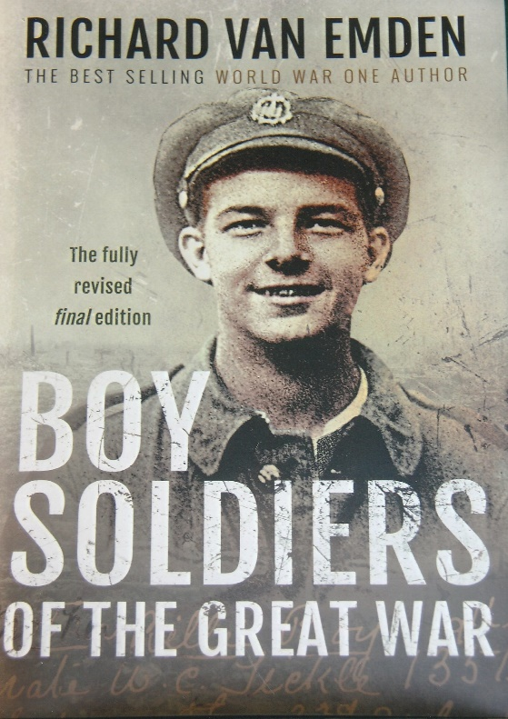
The time spent, research and dedication by the author concerning boy soldiers of the First World War has reaped a magnificent and enjoyable book. Over one hundred years has passed since the conflagration which drew millions of people into a World War. It is difficult to imagine the social conditions and lifestyles of people prior to and during the early years of the 20th century. The working class faced many hardships in their day-to-day lives but on the announcement that Great Britain was at war with Germany an explosion of patriotic fervour burst out to defend King and Country.
It was a relatively normal occurrence for children pre-war to be employed to augment the family income. Some, not all became physically strong and robust as they grew into their teenage years. An opportunity for further adventure and deeds of ‘daring do’ could be achieved by joining the army. Officially the age at which a person could join the army was 18 and 19 for overseas service. In their enthusiasm to fulfil the appeal made by Lord Kitchener for 100,000 volunteers, underage boys wanting to join the army had to adjust their ages upwards. Reporting to a recruiting venue and in answer to their age they added three or maybe four years to their true age. Although questioned by recruiting sergeants a blind eye was adopted despite them being aware that basically a grown-up child was in front of them. Possibly they may have thought they would be rejected by medical officers due to their physicality. A few were weeded out, but many were accepted to meet army quotas. Boys could opt to join the Territorials and remain serving at home unless they agreed to serve overseas.
Parents were often unaware that their underage sons had joined the army and wrote to the military authorities forwarding birth certificate as proof of the sons age. Official attitudes wavered. If a young boy was already serving with his unit abroad and wanted to stay the commanding officers acquiesced as he needed them for fighting. Underage boys were recalled and discharged or sent to bases behind the front lines. Evidence and recollections from oral sources and letters of these early recruits reveals the eagerness of the boys, not just from Great Britain but also from the Empire. Fraudulent enlistment incurred the possibility of prosecution but was not strictly enforced.
Whatever young boys thought of or dreamed about army life prior to joining was quickly brought into sharp focus when their training began under experienced NCO’s. Parents were under the impression that their sons would not be given frontline duties and their fears and worries are documented in the narrative. After arrival in France with their battalions, the underage boys on being deployed in the frontline, brought into sharp focus the horrors of war and of trench life they had to endure. Their initiation into the cauldron of war, are described from letters and other sources. The heavy losses, particularly of officers in the opening months of the war were replaced by temporary officers aged between 18 and 30 from a variety of backgrounds. Young underage boys were also given commission’s during the passage of the war to replace officer casualties.
The army suffered setbacks, which culminated in the ‘Shell Scandal’ of 1915. Dissatisfaction of the army command spread, and pertinent questions were raised in Parliament over the conduct of the war. Sir Arthur Markham MP criticised and questioned ministers and later campaigned against enlistment of underage boys into the army.
Preparations for the Battle of Loos – 25th September – 8th October 1915 – its initial success, ultimate failure and consequences for the young boys is conveyed in stark reality. Brief, sympathetic letters written on behalf of the wounded to their families illustrate the human cost of war. The reverses on the battlefield had a negative effect on voluntary recruitment. It became inevitable that if Great Britain was to maintain an army in sufficient strength to continue the war, then conscription would have to be introduced. A National Registration scheme was established by the Government in July 1915 as a legal requirement of both sexes aged between 15 and 65. This ironed out some of the anomalies concerning the age and status of young males who were then able to produce on enlistment their registration card to confirm their age. However, the scheme did not apply to those who had already enlisted. The scheme was also reliant on the honesty of the person filling out the registration form. The government gave assurances that youths under 17 years of age would be discharged and those over 17 but under 19 would be placed in reserve. A War Office instruction No.1186 published in June 1916 made this policy clear.
‘The Big Push’, the Battle of the Somme in 1916 involving soldiers of Kitchener’s New Volunteer Army is comprehensively described with contemporary extracts from underage boys. Examples of letters sent before they went into action to their families and anguished replies, some of which were returned stamped ‘Killed in Action’ are included in the text.
Parents armed with instruction No.1186 to remove underage sons from the front line came too late for those who were to participate in the opening of the Somme offensive on the 1st July. Some boys who fought continued to maintain they were old enough to fight until confronted by their commanding officer when they admitted their true age. But in time of war officialdom worked slowly against the Army reluctant to comply with the War Office instruction. If a discharged boy was deemed to have made a ‘mis-statement’ as to his age the cost of the fare home was his responsibility. Those unable to pay were held back until their army pay could fund their fare home or parents could bear the cost on behalf of their sons. Ironically, the army paid for those who were discharged for ‘misconduct’.
Some discharged boys were sent home whilst others were retained in France for future service in camps where ill disciplined soon rained. The YMCA organisation stabilized the situation to the relief of the army by establishing routines to keep the boys occupied. In April 1917, the underage soldiers in France were placed under the command of Major H. Cardinal-Harford adjutant of the 33rd Infantry Base Depot at Étaples. He established a disciplined training programme to prepare them for front line duties.
The pressures of war on Great Britain prompted the government on two occasions to reduce the age for front line duty in 1918. In March of that year the German launched their Spring Offensive. For the Germans it was their last opportunity to win the war, as they made the deepest advances on the Western Front since 1914 and hundreds of young men from Great Britain were drafted into France with the aim of halting their offensive. This phase in the war is eloquently and sympathetically explained in detail accompanied by accounts of the young participants. The German offensive gradually weakened and the British stabilised and held their line but the cost in lives was high. Great Britain and her Allies launched a 100 day’s counter offensive on the 8th August. The British broke through the Hindenburg Line and continued their victorious advance until the Armistice on the 11th November 1918.
The ending of the war was greeted by the soldiers with feelings of exhaustion, relief and the prospect of a welcome return to civilian life, though the latter for many proved to be a difficult adjustment. The underage boys who had gone to war returned home as men. Their trade had been war and seeking suitable civilian employment without qualifications created problems. Those maimed and the mentally tortured found little sympathy from the army who granted inadequate compensation to them for service to King and Country.
This is an outstanding book on Boy Soldiers and is a culmination of Richard van Emden’s passionate research into the many thousands who fought in the war. It becomes very clear that previous estimates fall well short of the actual numbers involved. The author gives his considered opinion and explains how through months of research he was able to produce valuable statistics which he himself admits have been offset to take in account of any errors. He tabulates year by year the age groups and deaths of the underaged boys in the war years using CWGC figures and cross referencing them with medal index cards. He frequently questions the figures and lists caveats seeking to answer the question of how many underage soldiers served in the war. He reveals the fascinating story of the youngest known British soldier Private Sidney Lewis. The courage, bravery and gallantry of the young is beyond question. Some of the stories tug at the heart strings but that is a reflection, on the consequences of war. Within the book are black and white photographs, acknowledgements, sources, and index. The story is told in a forthright and straight forward way with at times humorous anecdotes. Boy Soldiers of the First World War is a worthy tribute to their service and for future generations to appreciate and to not let them be forgotten.
Roger Coleman

