BOOK REVIEW
THE DISTANT DRUM ~ A MEMOIR OF A GUARDSMAN IN THE GREAT WAR BY F.E. NOAKES ~ PUBLISHED BY FRONTLINE BOOKS AN IMPRINT OF PEN & SWORD BOOKS LTD. ~ ISBN 978 1 84832 563 0
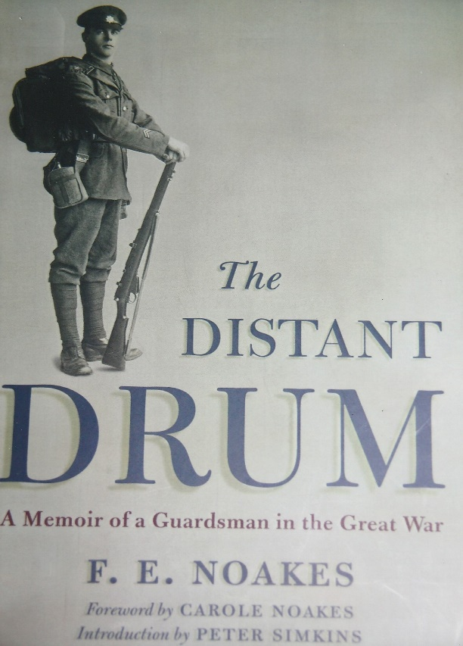
Written in 1952 by Frederick Elias Noakes, this excellent memoir chronicles the events of his period of service in the Army during the Great War from 1917-1919. He was born in Tunbridge Wells in 1896 and into a family drapery business and affectionately known as ‘Fen’. After the outbreak of the First World War, he reported to a recruiting depot in September 1914 to serve his King and Country but was rejected for medical reasons as he was again in 1915 and 1916, due to asthma. The Army relaxed its medical standards as more men were needed for war duties and in the Spring of 1917, Fen was called for service under the Military Service Act and classed as “A.1”!
After a further medical examination at an Army depot in Maidstone, he was surprised and elated to be assigned to the Guards ‘Household Battalion’ stationed at Windsor. The battalion, who were serving in France, had been independently formed from the Life Guards and Household Cavalry. Windsor was the training depot for reinforcement drafts and number 3157, Private Noakes duly arrived there, issued with his kit, and underwent training for service abroad. Fen found that the intense training gradually improved his physical fitness, general health as gradually he adapted to the rigours Army life and the high standards of a Guards battalion.
On completion of his training, he embarked with a draft of two hundred on the S.S. Antrim from Southampton on the 22nd October 1917. Disembarking at Le Harve, they marched to the Guards base camp at Harfleur. Six days later they entrained and then marched to join their battalion at the battle-scarred town of Arras. For his first experience abroad, he found it to be an invigorating experience, nullified by the reality of war as he passed through devastated towns and villages. The Household Battalion were a unit of the 4th Division, deployed along a front east of Arras. Fen was in No.1 Company, No.2 Platoon. He was conscious of the eeriness of marching ‘up the line’ through the network of trenches to the Support Line and to their deployment position in ‘Hoe Trench’. On being relieved from trench duty his platoon was billeted in caves under Fosse Farm, which reminded Fen of Wookey Hole, in Somerset. The battalion returned to Arras where they were quartered in Schramm Barracks. Fen describes the devastation and destruction he witnessed in Arras and of their duties, fatigues and what he calls the ‘migration’ from one camp to another, places of rest and to others.
Apart from the horrors of war, Fen and his comrades found the most irritating and unavoidable addition to trench life was lice. Hot baths and a change of clothing were a relief but often the issue of clean clothing was in a worse condition than those handed in! Sentry duties in the cold and bitter winter of 1917-1918 were a test of stamina and resolve. Christmas 1917 was a very different one from those Fen had spent at home but did his best to make merry and enjoy. At Church parades Fen found it difficult to accept the Christian message amongst the slaughter, bloodshed, and the hypocrisy of the ‘Prince of Peace’. ‘Pin-prick’ raids, as he termed them ordered by senior officers to foster an offensive spirit were of waste of life.
In late December a scratch on his hand from rusty barbed wire became inflamed and combined with sores on his legs he was sent to an American Red Cross Hospital at Le Tréport near Dieppe. He spent three restful and relaxing weeks there giving him the opportunity to reflect about his active service and the war. During his stay in hospital the Household Battalion had been dissolved and when he returned to the reinforcement camp, he was drafted to the 3rd Battalion Coldstream Guards, who were part of 4th Guards Brigade. He joined the battalion at Tincques on the 19th March 1918, two days before the Germans launched their Spring Offensive.
In the ensuing action in which his battalion was involved Fen was again wounded by shell splinters. He had hazy memories of what happened and joined the walking wounded to a dressing station at Ayette. From there he was taken to a Casualty Clearing Station and then onto a hospital at Wimille near Boulogne. He considered himself fortunate to be alive although his wound was not serious it took several weeks to heal. After convalescence and further treatment for sores he returned to the Guards base depot at Harfleur in mid-June. His brigade moved from the war zone to a quiet sector at Criel Plage where they spent several weeks and were reinforced by a large draft of newly trained men. Following a reorganisation of the battalions Fen joined No.2 Company, 6th Platoon of the 1st Battalion Coldstream Guards which he considered was a turning point in his Army career. As the German Spring Offensive petered out, the Allies began to take the offensive and for their part the Guards prepared to move forward to the Hindenburg Line and the crossing of the Canal-du-Nord. Fen describes his feelings under an intense enemy barrage as they waited to move off across open ground towards their objective on the 27th September 1918. His company was temporarily held up by intense machine-gun fire until Captain Cyril Frisby and Corporal Thomas Jackson rushed the outpost. For their gallantry, both were awarded the Victoria Cross, Corporal Jackson’s was a posthumously award as he was later killed during the morning’s advance.
Fen’s next action was at Cambrai, where he sustained a leg wound from a shell explosion. Bleeding profusely, he made his way to the Guards Dressing Station at Masnieres and eventually was transferred to a Canadian Convalescent Depot at Etaples. He had also sustained mustard burns from gas shells and was moved to a hospital at Abbeville. Whilst there, news filtered through that the Germans had surrendered, which for Fen was the ‘happiest’ moment in his life. He vividly relates the celebration at the tented hospital encampment which took place on the 11th November.
Declared fit, he returned the Guards base depot on the 19th November and a few days later was placed under arrest for writing a disgruntled letter to his family. Appearing before the commanding officer he was given seven days Field Punishment No.1! However, he suffered no discomfort as along with other defaulters he was sent to join his unit at Solemes which was a temporary Guards Reinforcement Camp. From there he re-joined the regiment, stationed at Riehl Barracks, Cologne. He was granted Christmas leave and gives an account of the eventful journey home to Tunbridge Wells.
After returning to Cologne, news was announced that the Guards Division would be returning to England on the 1st March, 1919. A victory parade was held in London for the division on the 22nd followed by a special banquet at their barracks. Upper most in the minds of those who had served in the war, was demobilisation which for the Guards was slow. Fen gained his release from the Army at Crystal Palace on the 9th October and was subjected to a search for any government property which made him feel like a convict rather than as a soldier who had served his country honourably. He kept control of himself and then walked out and away from army life a ‘free man’ once again.
Fen’s memoir is a very personal, told in exceptional detail on a more-or-less day-to-day basis about his war time service in the Army. He recollects with pride the comradeship of his former fellow guardsmen. War for him was a tragedy and the subsequent peace treaty he considered to be a betrayal of all who had fought, and the sacrifices made by so many on both sides. The Germans were fighting for their country as he himself was and did not see them as pariahs and held no grudges against them. Army life at times he found difficult to accept but such was the system, which had more positives than negatives. Fen’s account has no unnecessary embellishments and is told with honesty as he recalls and confides to the reader. In so doing it occurred to him what in fact he had achieved and discovered about himself which possibly would have remained dormant but for his war service. As a civilian going to war, he was at first uncertain of what to expect from a disciplined Army life. He graduated to become a ‘guardsman’ and was proud to be one and the esprit de corps remained with him for the rest of his life. Fen died in 1953 and his memoir is an explementary and worthy contribution for future generations from a soldier of the Great War.
Roger Coleman

